Southeastern Modeling, Analysis and Planning Project

WRF Meteorological Modeling Performance Evaluation and Documentation

Prepared for:

Southeastern States Air Resource Managers, Inc.
526 Forest Pkwy, Ste F
Forest Park, GA 30297-6140

Prepared by:

Atmospheric and Environmental Research, Inc.
131 Hartwell Ave.
Lexington, MA 02421

19 December 2011

Table of Contents
1 Introduction 3
2 WRF model and Observational dataset descriptions 3
2.1 Model configuration and verification methodology 3
2.2 Modeling domains 5
2.2.1 Horizontal Grid 5
2.2.2 Vertical Layers 7
2.3 Data Nudging 8
2.3.1 Objective Analysis 9
2.3.2 Four-Dimensional Data Assimilation 9
2.3.3 Nudging Coefficients 9
2.4 Period of analysis 10
2.4.1 Production Run 10
2.4.2 Sensitivity Runs 10
2.5 Observational dataset 11
2.6 Meteorological variables and assessment measures 12
3 Evaluation techniques 12
3.1 Subjective 12
3.2 Objective 13
3.3 Spatial Averaging 14
4 Inspection of model configuration 15
5 Evaluation of Annual Production Run Meteorological Model Performance 16
5.1 Statistical analysis of WRF full-year production run 16
5.1.1 Task 2 A: Time series of spatial averages over all regions 16
5.1.2 Task 2 B: Monthly Bakergrams 28
5.1.3 Task 2 C: Bubble spatial plots of error statistics 40
5.1.4 Task 2 E: Time series at individual sites of forecast/observed values 47
5.1.5 Task 2 G: Scatter plots 63
5.1.6 Tasks 2 I and 5 C: Line plots of error statistics 85
5.1.7 Task 5 B 4: Tables of Annual Statistics 94
6 Evaluation of Sensitivity Runs Meteorological Model Performance 106
6.1 Statistical analysis of WRF sensitivity runs 106
6.1.1 Tasks 2 H 1 and 2 H 7 Statistical tables for FULL model domain 107
6.1.2 Tasks 2 H 1 and 2 H 7 Surface Statistical tables for SEMAP region 123
6.1.3 Task 2 H 2: Bakergrams 128
6.1.4 Task 2 H 4: Mean bias plots 140
6.1.5 Task 2 H 5: Wind speed plots 147
6.1.6 Task 2 H 6: Bubble spatial plots of error statistics 150
7 Meteorological modeling website and other technical aspects 155
7.1 Website development and documentation 155
7.2 Supplemental Dataset 155
8 Summary and conclusions 155
9 Appendix A 157
10 Appendix B 201
11 References 202

Introduction

The purpose of this Contract is for meteorological model performance evaluation and documentation services in support of modeling analyses, control strategy assessments, and other air quality management needs.

Technical air quality analysis projects generally include compilation and analysis of existing ambient air quality monitoring data, collection of additional monitoring data as needed, assessment of air quality trends, preparation of emission inventories, development of emissions control scenarios, modeling of meteorology, emissions, and air quality, and completion of reports revealing the impact of emissions and the air quality benefits of varying emission control levels. This meteorological modeling performance project will support this larger group of tasks.

SESARM intends to concurrently address, to the extent feasible, national ambient air quality standard (NAAQS) requirements and to evaluate progress towards long-term regional haze goals. Because similar pollutant emissions and atmospheric processes control chemical formation and transport for fine particles, ozone, and regional haze, similar technical analyses are necessary to evaluate air quality benefits of emissions controls. SESARM will develop and operate a single integrated, one-atmosphere air quality modeling platform to provide the states with technical analyses that support the required air quality demonstrations.

Prior to this contract, an annual WRF model simulation was performed for 2007. The project supported by this Contract provides a detailed, quantitative and qualitative analysis of these simulated meteorological fields and their suitability for application to air quality modeling.

WRF model and Observational dataset descriptions

Model configuration and verification methodology

The WRF v. 3.1 mesoscale meteorology model is a fully compressible, non-hydrostatic model with an Eulerian mass dynamical core [Skamarock et al. 2008]. Two dynamical cores are available: the Advanced Research WRF (ARW) core, developed and supported by NCAR, and the Nonhydrostatic Mesoscale Model (NMM) core, whose development is centered at NCEP’s Environmental Modeling Center (EMC) and support is provided by NCAR’s Development Testbed Center (DTC). The WRF-NMM is designed to be a real-time forecast model so physics schemes are preset. WRF-ARW (hereinafter WRF) was chosen because it includes multiple physics options for turbulence/diffusion, radiation (long and shortwave), land surface, surface layer, planetary boundary layer, cumulus, and microphysics.

Time integration is performed with a 3rd-order Runge-Kutta scheme. WRF has split time integration, which uses smaller time steps used for fast processes like sound waves or gravity waves. WRF was designed to conserve mass, momentum, entropy, and scalars using flux form prognostic equations.

WRF uses Eta (η) as a vertical coordinate, which is defined as the hydrostatic pressure difference from the layer to the top divided by the difference in the entire vertical domain so it is always between 1 (surface) and 0 (top). This vertical coordinate is terrain following hydrostatic pressure system.

The grid format is Arakawa- C with all variables in the center of the grid except for wind velocity, which is defined on the edges of the grid, and shared between adjacent grids.

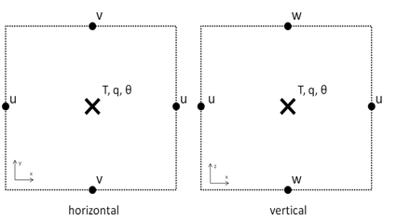

The WRF core uses a 3rd-order Runge-Kutta split-explicit time integration scheme, high-order advection scheme, and is scalar conserving. It contains complete Coriolis, curvature, and mapping terms. Domain nesting is possible with one-way and two-way capabilities. Full physics options are available to represent atmospheric radiation, surface and boundary layers, and cloud and precipitation processes. The model contains gridded analysis and observational nudging four dimensional data assimilation (FDDA) capabilities that allow users to perform enhanced retrospective analyses.

The WRF modeling system is divided into two main components: the WRF Preprocessing System (WPS) and the WRF modeling core. WPS contains three processors that define the WRF modeling domain, generate map, elevation/terrain, and land-use data, and generate horizontally interpolated input meteorological fields to the WRF grid. The WRF modeling core interpolates the meteorological fields processed by WPS to the WRF vertical levels and generates initial and lateral boundary conditions. The model solver integrates the atmospheric equations and interfaces with the physics parameterizations to generate forecasts of meteorological variables.

WRF uses physics sub-models to simulate land surface, surface layer, and boundary layer dynamics, along with cumulus convection, microphysics, and radiation. For each of these sub-models, WRF offers from 3 to 9 different parameterizations from which the modeler may select. To make these choices, the modeler must consider not only the individual merits of each parameterization but also how it interacts with the other physics sub-model options. The following flow chart illustrated the interaction of the WRF physics sub-modules.

WRF version 3.1.1 (July 2009) was used for the sensitivity tests and the annual simulations. The main update to the model in this release was the addition of objective analysis (OBSGRID) and surface analysis nudging capabilities, an option preferred for generating meteorological data for input to air quality simulations

Modeling domains

The domain used by the SEMAP has been expanded from the domain used for the 2002 State Implementation Plan modeling. This was done to coordinate with the other members of the WRF Work Group, which including LADCO, SESARM, and the State of Iowa.

Horizontal Grid

The computational domain for this simulation consists of a coarse and fine grid nested domains. The coarse domain consists of a Lambert conic conformal projection with specifications used in previous regional modeling studies, which is centered at 40° N and 97° W with true latitudes of 33 and 45° N. The coarse grid structure consists of an array of 165 cells in the east-west direction and 129 cells in the north-south direction with a grid spacing of 36 kilometers (km). This domain was designed maximize the usage of the Eta analysis region.
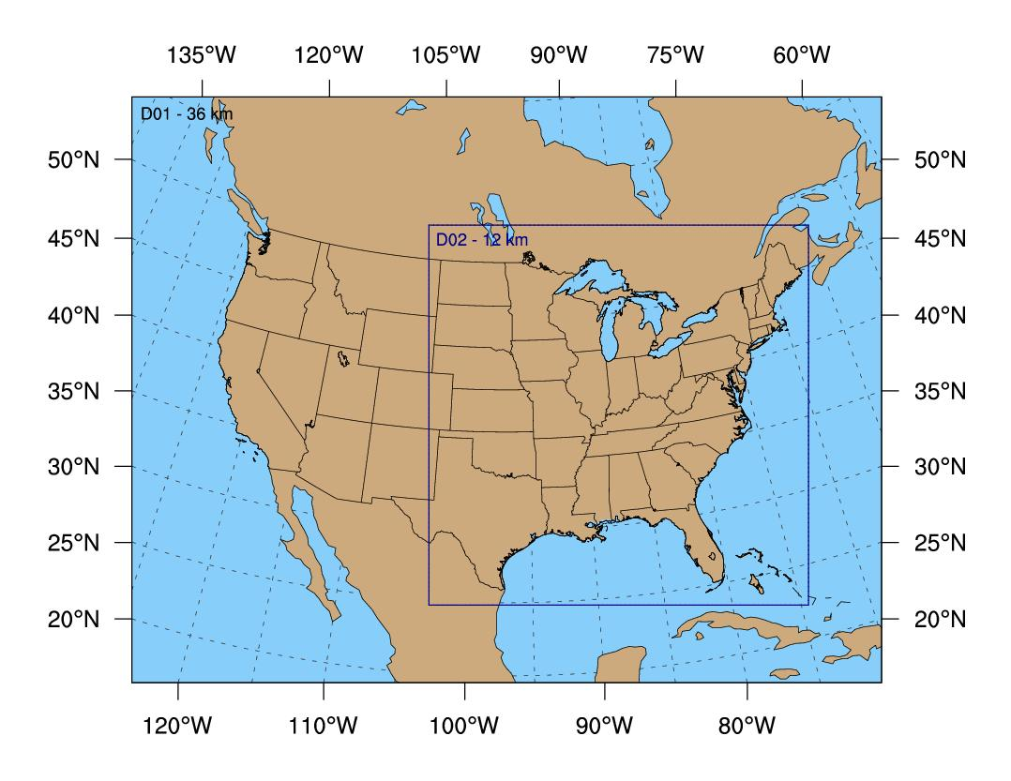

A nested domain is implemented to resolve finer scale meteorological features. The nested domain grid structure is a 250 by 250 array of grid cells with a grid spacing of 12 km. This domain begins at node (66, 18) of the course domain. The nested domain shares the northern, eastern, and southern boundaries of the EPA 12 km Eastern domain and western boundary of the Iowa/LADCO 12 km domain. A summary of the horizontal structure of the modeling domain is given in Table below.

Domains | Outer (1) | Inner (2)
Resolution (km) | 36 | 12
Starting Location (i,j) | 1,1 | 66,18
nx (E-W) | 165 | 250
ny (N-S) | 129 | 250
SW Coordinate (km) | -2952, -2304 | -612, -1692
NE Coordinate (km) | 2952, 2304 | 2376, 1296

Using 12 km horizontal resolution is sufficiently high to simulate mesoscale features and is also in range to use both WRF microphysics and cumulus convection schemes.

Vertical Layers

The vertical grid structure consists of 35 layers (34 layers) as shown below.

Each dot signifies one level. The height of the level is shown on the y-axis and the mass between layers is shown on the x-axis. The number of levels is more concentrated below 1 km.

This vertical structure was designed to provide increased resolution in the boundary layer and near the tropopause. The second level is placed at ~20 meters so that the midpoint of the grid cells in the vertical direction is located at 10 meters and corresponds to the standard National Weather Service (NWS) anemometer height. This avoids the use of a surface layer parameterization to vertically interpolate horizontal wind components to the standard NWS observational height. The top of the model is fixed at 50 mb. A summary of the vertical structure of the modeling domain is given below.

Level | Sigma | Height (m) | Pressure (mb) | Depth (m)
35 | 0.0000 | 18663 | 50 | 2034
34 | 0.0332 | 16629 | 82 | 1715
33 | 0.0682 | 14914 | 115 | 1515
32 | 0.1056 | 13399 | 150 | 1375
31 | 0.1465 | 12024 | 189 | 1255
30 | 0.1907 | 10769 | 231 | 1145
29 | 0.2378 | 9624 | 276 | 1045
28 | 0.2871 | 8579 | 323 | 955
27 | 0.3379 | 7624 | 371 | 870
26 | 0.3895 | 6754 | 420 | 790
25 | 0.4409 | 5964 | 469 | 715
24 | 0.4915 | 5249 | 517 | 645
23 | 0.5406 | 4604 | 564 | 580
22 | 0.5876 | 4024 | 608 | 520
21 | 0.6323 | 3504 | 651 | 465
20 | 0.6742 | 3039 | 690 | 415
19 | 0.7133 | 2624 | 728 | 370
18 | 0.7494 | 2254 | 762 | 330
17 | 0.7828 | 1924 | 794 | 293
16 | 0.8133 | 1631 | 823 | 259
15 | 0.8410 | 1372 | 849 | 228
14 | 0.8659 | 1144 | 873 | 200
13 | 0.8882 | 944 | 894 | 174
12 | 0.9079 | 770 | 913 | 150
11 | 0.9252 | 620 | 929 | 128
10 | 0.9401 | 492 | 943 | 108
9 | 0.9528 | 384 | 955 | 90
8 | 0.9635 | 294 | 965 | 74
7 | 0.9723 | 220 | 974 | 60
6 | 0.9796 | 160 | 981 | 48
5 | 0.9854 | 112 | 986 | 38
4 | 0.9900 | 74 | 991 | 30
3 | 0.9940 | 44 | 994 | 24
2 | 0.9974 | 20 | 998 | 20
1 | 1.0000 | 0 | 1000 | 0

Data Nudging

To minimize the accumulation of model errors and retain as many mesoscale circulations as possible, the Objective Analysis and Four-Dimensional Data Assimilation (FDDA) techniques were used to include observations of the surface winds and upper-level meteorological information. The datasets used are high resolution (in time and space) and the technique has been applied in previous air quality modeling studies. Gilliam et al. (2009) found big improvements in WRF results when OBSGRID, was used to lower error of analyses.

Objective Analysis

The OBSGRID option, just introduced in WRF v. 3.1, is used for objective analysis. The goal of OBSGRID is to improve the first-guess gridded analysis by incorporating high-resolution observations with the low-resolution global analysis [Wang et al. 2009]. It also prepares the input files for surface nudging.

The Cressman style objective analysis was used, in which several successive scans nudge a “first-guess” field toward each neighboring observed value within a circular radius of influence from each grid point. A distance-weighted average of the difference between the “first guess” and the observations is added to the value of the “first guess” at each grid point. Once all grid points have been adjusted, the adjusted field is used as the “first guess” for another adjustment cycle with a smaller radius of influence.

Four-Dimensional Data Assimilation
In contrast to objective analysis, which is used to improve initial and boundary conditions, FDDA incorporates observations during model integration [Stauffer et al. 1991]. The FDDA options chosen for the OTC WRF runs were analysis and surface nudging. The surface FDDA option creates a separate surface analysis that has a higher temporal resolution than full 3D analyses. The analysis nudging uses 3D gridded variables above the surface layer that are used throughout the WRF run to nudge model outputs toward the analysis, which is based on observations [Wang et al. 2009].

The input data was set at 3-hour intervals. In the boundary layer, only U and V winds were nudged. Nudging of temperature at the surface was not used because it can cause static instability if it is not consistent with temperature above the surface layer [Stauffer et al. 1991]. The water vapor mixing ratio is also not nudged in the PBL because supersaturation may occur when surface temperature is not nudged. In the free troposphere, nudging was used for U and V winds, temperature, and water vapor mixing ratio to help minimize large-scale errors.

Nudging Coefficients

The strength of dynamical nudging depends on the magnitude of the nudging coefficients selected. The nudging coefficient for wind should not exceed that of the Coriolis parameter [Gupta et al. 1997]. The nudging coefficients used for the SEMAP WRF runs are listed below.

Domain | Variable Nudged | Nudging Coefficient
Outer Domain | U and V winds | 5.0 x 10⁻⁴
Outer Domain | Temperature | 5.0 x 10⁻⁴
Outer Domain | Water vapor mixing ratio | 1.0 x 10⁻⁵
Outer Domain | Surface U and V winds | 5.0 x 10⁻⁴
Inner Nest | U and V winds | 3.0 x 10⁻⁴
Inner Nest | Temperature | 3.0 x 10⁻⁴
Inner Nest | Water vapor mixing ratio | 1.0 x 10⁻⁵
Inner Nest | Surface U and V winds | 3.0 x 10⁻⁴

The inner nest nudging coefficients are similar to those used in air quality retrospective studies. Gupta et al. (1997) tested various nudging coefficients for wind and found that 2.778 x 10⁻⁴ best replicated the energy spectrum. Mao et al. (2006) used 2.5 x 10⁻⁴ for temperature and wind and 1.0 x 10⁻⁵ for water vapor mixing ratio. However, Gilliam and Pleim (2010) used a slightly higher nudging coefficient for temperature and wind (3.0 x 10⁻⁴) but the same for moisture (1.0 x 10⁻⁵).

The outer domain nudging coefficients were determined after testing at different levels. Using lower coefficients, the SEMAP found that the 3D analysis and surface nudging had very little impact on surface and upper air variables. As a result, higher settings were chosen for the outer domain to improve WRF performance

Period of analysis

SEMAP provided AER with WRF model output for domains 1 and 2 from the year-long production run and nine sensitivity runs of the WRF model for selected periods during 2007.

Production Run

Detailed model evaluation of the production run was performed for the 365-day period comprising the entire calendar year of 2007 for both domains. The full year of simulations was pieced together from 73 individual WRF runs of length five and a half days each. To avoid meteorological field contamination due to model spin-up, data from the first twelve hours of each model run were not analyzed. Thus, each five-day model segment contained data with forecast lengths of between 12 and 131 h.

Sensitivity Runs

Detailed model comparison amongst the nine sensitivity runs was carried out for domain 2 for two evaluation periods of 20 days each, hereafter, the ‘Summer’ and ‘Winter’ periods. Respectively, these two sets of four individual WRF runs were valid for the calendar days 28 July 2007 through 16 August 2007, and 5 December 2007 through 24 December 2007. These dates were selected by the WRF Working Group based on known air quality exceedances throughout the Eastern US.

Observational dataset

The WRF-MET meteorological evaluation software that was used in this study (refer to Section 3.2) was designed to ingest observations in prepBUFR format. A readily available and valuable source of observations in prepBUFR format was obtained from the UCAR web server (http://dss.ucar.edu/datasets/ds337.0/). While the observation types available in the prepBUFR files include the following platforms for 2007, version 2 of WRF-MET does not decode visibility, precipitable water, snow cover, or cloud elements:

Air Temperature | Dew Point
Atmospheric Pressure Measurements | Temperature
Cloud Amount/Frequency | Geopotential Height
Cloud Base | Precipitable Water
Cloud Types | Precipitation Amount
Sea Level Pressure | Surface Winds
Sea Surface Temperature | Upper Level Winds
Snow | Visibility
Station Height

The following is the general description from the UCAR web server that accompanies this dataset:

NCEP ADP Global Upper Air and Surface (PREPBUFR format) Weather Observations are composed of a global set of surface and upper air reports operationally collected by the National Centers for Environmental Prediction (NCEP). These include land surface, marine surface, radiosonde, pibal and aircraft reports from the Global Telecommunications System (GTS), profiler and US radar derived winds, SSM/I oceanic winds and TCW retrievals, and satellite wind data from the National Environmental Satellite Data and Information Service (NESDIS). The reports can include pressure, geopotential height, temperature, dew point temperature, wind direction and speed. Report time intervals range from hourly to 12 hourly. These data are the primary input to the Global Data Assimilation System (GDAS), which is used to create the NCEP Final Analyses (FNL).

WRF-MET was designed for the direct ingest of this dataset and so use of these data for the entire verification exercise minimized the time-consuming and error-prone task of aggregating and reformatting observations. This dataset spans the time period and geographical region of interest and thus the verification techniques maintained data integrity from a single source across all verification stratifications.

This dataset has undergone quality control procedures as part of preprocessing for NCEP’s Grid Point Statistical data assimilation system and, as a result, contains an estimation of the observational error. Below is a description from the UCAR web server of the quality control procedures:

The "PREPBUFR" processing is the final step in preparing the majority of conventional observational data for assimilation into the Global Forecast System and Global Data Assimilation System unified grid-point statistical interpolation analysis (GSI) (the "GFS" and "GDAS" networks). This step involves the execution of series of programs designed to assemble observations dumped from a number of on-line decoder databases, encode information about the observational error for each data type as well the background (first guess) interpolated to each data location, perform both rudimentary multi-platform quality control and more complex platform-specific quality control, and store the output in a monolithic BUFR file, known as PREPBUFR. The background guess information is used by certain quality control programs while the observation error is used by the analysis to weigh the observations. The structure of the BUFR file is such that each PREPBUFR processing step which changes a datum (either the observation itself, or its quality marker) records the change as an "event" with a program code and a reason code. Each time an event is stored, the previous events for the datum are "pushed down" in the stack. In this way, the PREPBUFR file contains a complete history of changes to the data throughout all of the PREPBUFR processing. The most recent changes are always at the top of the stack and are thus read first by any subsequent data decoder routine. It is expected that the data at the top of the stack are of the highest quality.

It should be noted that a software bug in WRF-MET inverted the stack. This resulted in a small number of observations of lower quality being used. Detailed evaluation by the UCAR software developers during their attempt to correct the problem determined that less than 10% of all observations were incorrectly selected and that temperature observations were the most affected. We believe that this is the source of some of the gross outliers, which are often unphysical, that are most readily seen in the scatter plots (Section 5.1.5).

Meteorological variables and assessment measures

Quantitative Assessment Metrics
Wind Speed | RMSE | ≤ 2 m/s
Wind Speed | Mean Bias | ≤ ±0.5 m/s
Wind Direction | Gross Error | ≤ 30 deg
Wind Direction | Mean Bias | ≤ ± 10 deg
Temperature | Gross Error | ≤ 2 K
Temperature | Mean Bias | ≤ ±0.5 K
Specific Humidity | Gross Error | ≤ 2 g/kg
Specific Humidity | Mean Bias | ≤ ±1 g/kg
The following six meteorological fields were objectively analyzed by WRF-MET: temperature (degrees Celsius), dew point temperature (degrees Celsius), specific humidity (g/kg), relative humidity (%), wind speed (m/s), and wind direction (degrees). Not all tasks required the evaluation of all fields, however. The following Quantitative Assessment Metrics were considered as important thresholds during the analysis of the errors, including the choice of colors in plot legends:

Evaluation techniques

Subjective

A subset of the production and sensitivity run WRF output files, as well as input namelist files, were subjectively inspected to ensure that the WRF model was configured as intended, and also that the intended configuration is consistent with established combinations of model options. The following aspects of the model configuration were inspected:

- initialization data (horizontal grid spacing, frequency of boundary conditions)
- application of data assimilation
- time step
- placement and number of vertical levels
- one-way or two-way nested grid interaction
- strategy for piecing together coincident model runs
- physical parameterizations for cumulus convection, the planetary boundary layer scheme, explicit moisture, radiation and land-surface scheme.

Objective

Version 2.0 of the WRF-MET meteorological modeling verification software (available from http://www.dtcenter.org/met/users/) was used to carry out the initial steps of the objective statistical analysis. A logical depiction of the components of the WRF-MET software package is shown below. Green indicates software and modules, and gray represents input and output files.

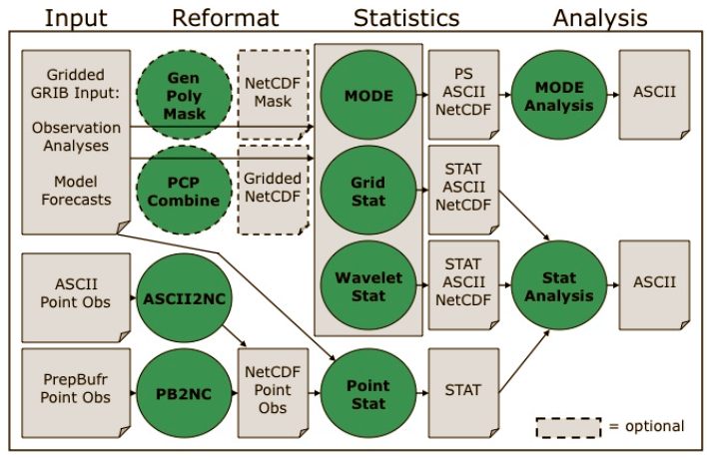
WRF-MET expects GRIB1 format model data, which was generated by processing all raw model runs received from SESARM in netCDF format through software named WRF-WPP. This is an NCEP-developed post processor that also converts the native model sigma level data to standard pressure levels. This will facilitate generation of statistics at levels typically available from radiosondes.

The WRF-MET software is composed of a number of individual processing steps. The input data – both point and gridded observations - first are converted into internal intermediate formats, and then raw statistics files are generated. These raw statistics are named “STAT” in the above flowchart and ultimately represent top-of-the-hour pairs of modeled and observed values. These take the form of both spatially-averaged modeled and observed values and, more fundamentally, matched pairs of true single-time modeled and observed values. These raw statistics have been provided to SESARM in zipped files on suitable media.

The STAT files were then aggregated and temporally averaged to produce summary statistics presented in the form of plots, charts, maps and tables. The aggregation and plotting steps were carried out through extensive use of shell and Perl scripts. The R analysis and display software was used to generate all graphics.

Spatial Averaging

Statistics for a number of tasks have been spatially averaged into 27 states and Regional Planning Organization regions (RPOs): Alabama, Arkansas, District of Columbia, Florida, Georgia, Iowa, Illinois, Indiana, Kentucky, Louisiana, Maryland, Michigan, Mississippi, North Carolina, Ohio, Pennsylvania, South Carolina, Tennessee, Virginia, Wisconsin, West Virginia, MANEVU (ME, MA, VT, NH, NY, PA, NJ, MD, DE), CENRAPN (MN, IA, NE, KS, MO), CENRAPS (TX, LA, OK, AR), SEMAP [VISTAS] (VA, WV, KY, TN, NC, SC, GA, AL, MS, FL), MRPO (MI, WI, IN, IL, OH) and FULL (entire model domain)

*Some early plots and tables refer to VISTAS. Subsequently, the term SEMAP has been used.

Computation of statistics inside WRF-MET for different regions is accomplished using grid point masks based on state outlines as defined by the 2000 US Census. Because masking is grid point based, as opposed to observation location based, whether an observation is used in a specific masked region (for instance, a state) depends upon in which state the closest grid point resides. It is thus possible that observations can be used in different states depending on the domain in question. A small number of observations changed states between domains 1 and 2 in this study, but the overall effect on the statistics is negligible.

A second consequence of the grid point method is that statistics are unavailable for domain 1 for the District of Columbia. For domain 1 there are no grid points that lie inside that very small geographic area.

The following illustrates the geographical extent of the five RPOs for which statistics were computed. Note that the red WRAP RPO was not involved in this study:

Inspection of model configuration

In our opinion, the WRF model configuration selected by SEMAP for the production run is acceptable for generation of meteorological fields to be input to air quality models. A reasonable mix of physics options and model configuration parameters was selected using an up-to-date release of the ARW-WRF model. Sufficient documentation in the form of log files and namelist files was provided by SESARM to be confident that the WRF model was run in the manner designed and intended.

While the choice in the production run to turn feedback off between nests allows for independent evaluation of forecasts from each of the two domains, ideally feedback would be active in order for the coarser outer domain fields to incorporate the meteorological fields from the innermost domain that have been influenced by the higher-resolution topography. It is noted that feedback between grids was active for all sensitivity runs. This fact contributes, in part, to the different error statistics between the sensitivity run that was chosen for the production run and the actual production run. The difference in statistics is also attributable to the different model initialization times of the run segments between the sensitivity and production runs.

The dependence on model forecast length is considered a relatively minor factor in the overall quality of the forecast fields, though a degradation in the quality of the model 2-m dew point temperature field was noted (reported below in 5.1.1.2). This may be a result of the lack of nudging moisture in the PBL. Considered more important overall, however, is the quality of the individual initialization field for each run. It is hypothesized that any deleterious effects of the use of relatively long segments (132 h), as opposed to 30-h simulations, for instance, was generally negated by the use of nudging.

Evaluation of Annual Production Run Meteorological Model Performance

Statistical analysis of WRF full-year production run

Detailed analysis of each Production Run Task now follows.

Task 2 A: Time series of spatial averages over all regions

This section discusses verification plots that show time series (of daily averages for annual and monthly plots, and hourly values for plots covering 5-day segments) of spatially averaged forecast and observed values of various surface fields (temperature, dew point, etc). We concentrate here on domain-wide (domain 1 and 2) averages that highlight model performance over the entire model domain. Statements concerning the model performance in this section apply to these domain-wide statistics. The website contains additional plots for averages computed over various geographic regions.

Temperature

The annual observed and modeled temperature for the FULL region of Domains 1 and 2 shows that temperatures are generally well simulated. The model temperatures track the observations well; however, they have a slight high bias during the cooler portions of the year, in January and February and again in December. A slight negative bias is also found during a portion of the warm season from roughly June through early August. The time series also suggests the model has some difficulty predicting periods of lower temperatures as it tends to not predict temperatures as low as the observed values. Differences in the observed performance of the model between domain 1 and domain 2 were found to be minimal.
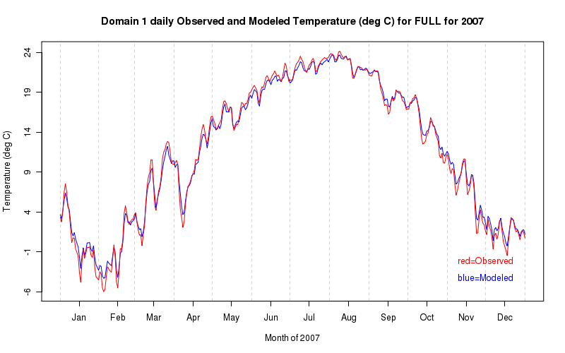
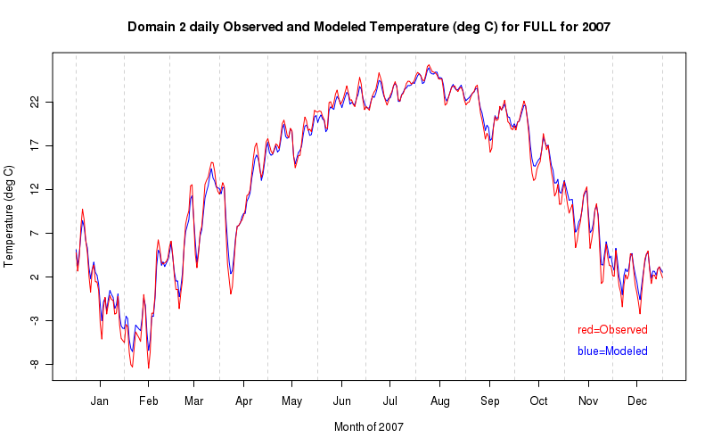

The two plots below demonstrate the different biases of the model prediction of air temperature for two different 5-day runs. The first plot shows an approximate 1-1.5° C high bias in the model prediction for the period January 31 – February 4, 2007. By contrast, a high bias of generally less than 0.5° C is found for the period July 5–9, 2007. The transition from a high bias during the cool season to a negative bias during the warm season highlights the seasonality of the results from the WRF model.
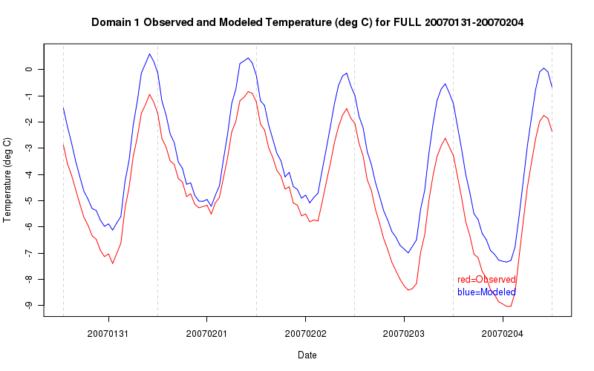
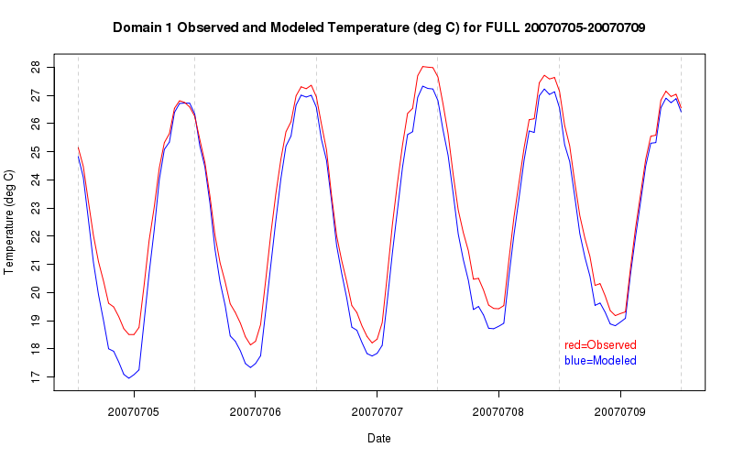

Dew point temperature

The observed and modeled dew point temperature time series for domain 1 appears in the plot below. It shows that there is a slight high bias in the dew point temperature throughout most of the year except during the autumn when the simulation more closely matches the observations.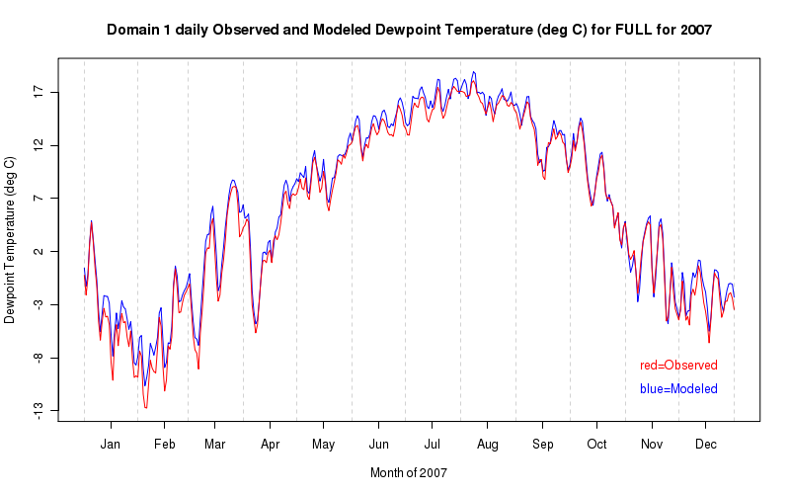
The following plots of monthly dew point temperature further detail the performance of the WRF model. The first plot below shows good performance from the WRF model during the month of October. The plot for the month of July shows that the time series is more disorganized and the model simulation does not track the trends in the observations particularly well. The dew point temperatures in July are forecast about 1° C too warm on average.
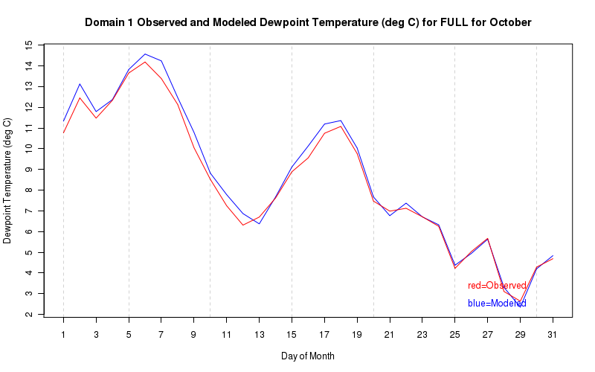
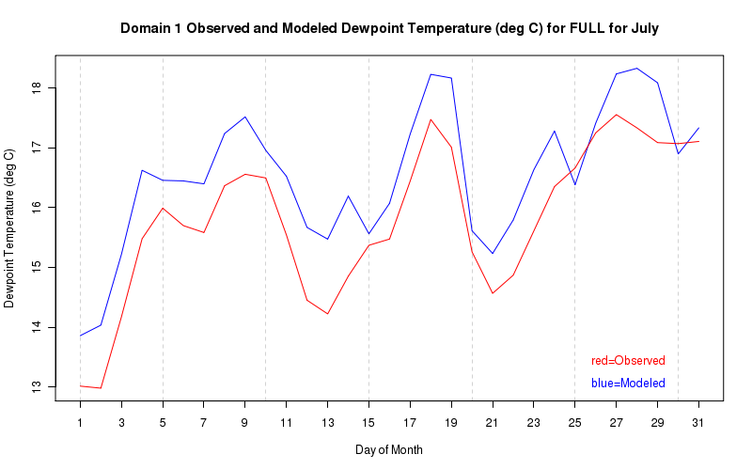
A poor representation of the diurnal cycle appears to be contributing greatly to the observed high bias in the longer time series. The plot below from February 25 – March 1, 2007 shows that the dew point is well simulated during the daytime hours when boundary layer mixing is strongest; however, the WRF simulation predicts the nighttime dew point temperature much too high – on the order of 1° C.
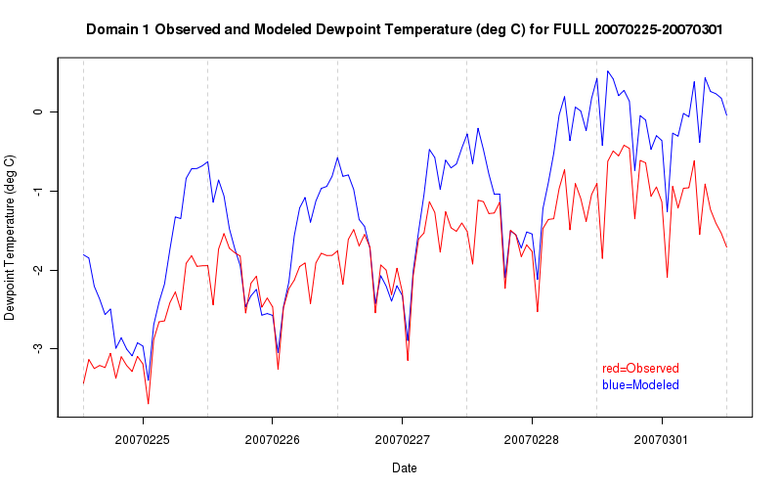
There is also evidence in the 5-day model simulations that the dew point temperature tends to develop a greater spread between the modeled value and the observed value at later forecast times. The plot below shows an example of this tendency. In the first 48 hours of the simulation, the modeled dew point temperature time series follows the observed time series relatively well, but diverges after this time resulting in a significant high bias of approximately 2°C.
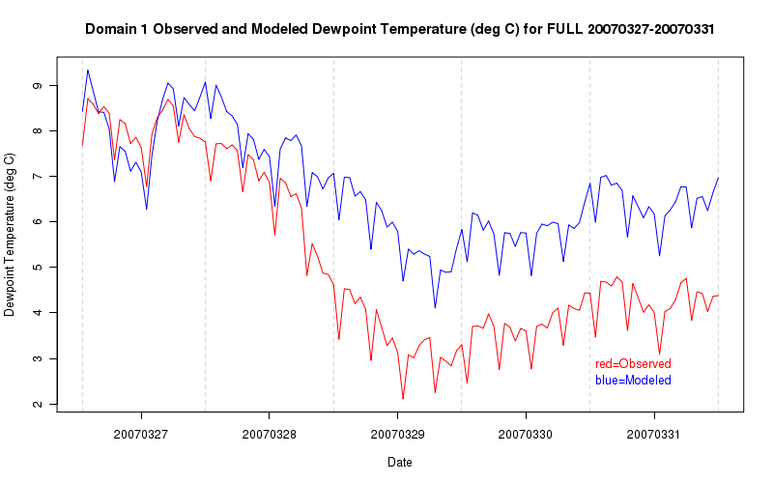

Relative humidity

The modeled relative humidity time series displays many of the same characteristics as the dew point temperature time series in that it carries a high bias relative to the observed values for much of the year excluding much of the autumn season. The combination of air temperatures that are simulated near or below the observed values and dew point temperatures that are generally above the observed values is consistent with a heightened relative humidity profile, especially during the January through August time frame. Comparing the two domains in the plots below, the modeled and observed relative humidity increases slightly for domain 2, but the trends are quite similar.
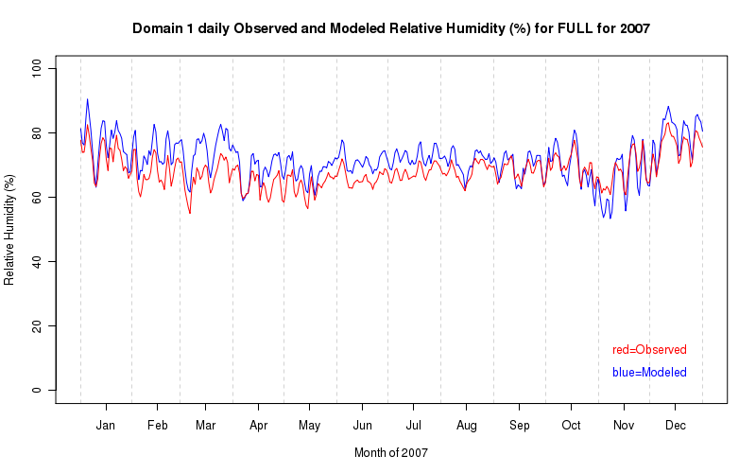
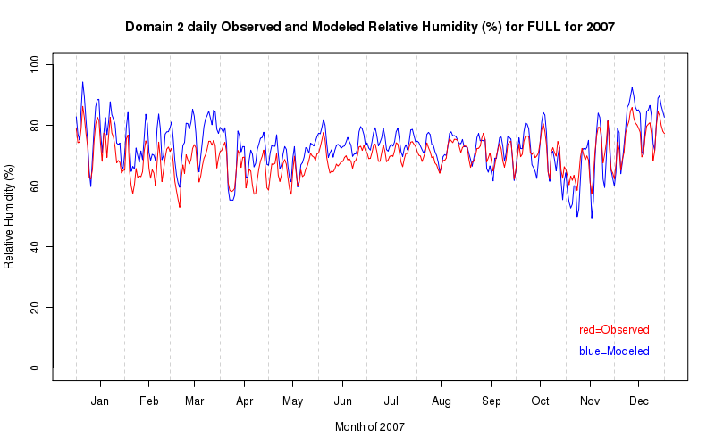
The plots below show 5-day model simulations of relative humidity during the summer and autumn to highlight the differences on a shorter time scale. The top plot shows the relative humidity time series for June 30 – July 4, 2007. The modeled relative humidity is slightly higher than the observed relative humidity with good performance during the daytime hours and poorer performance during the nighttime hours. Similarly in the bottom plot, the model performance is better during the daytime in the autumn. The modeled relative humidity, however, is predicted lower than the observations.
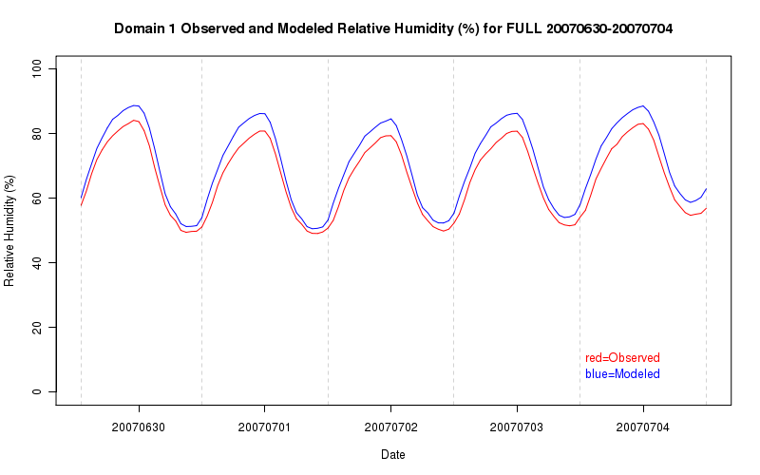
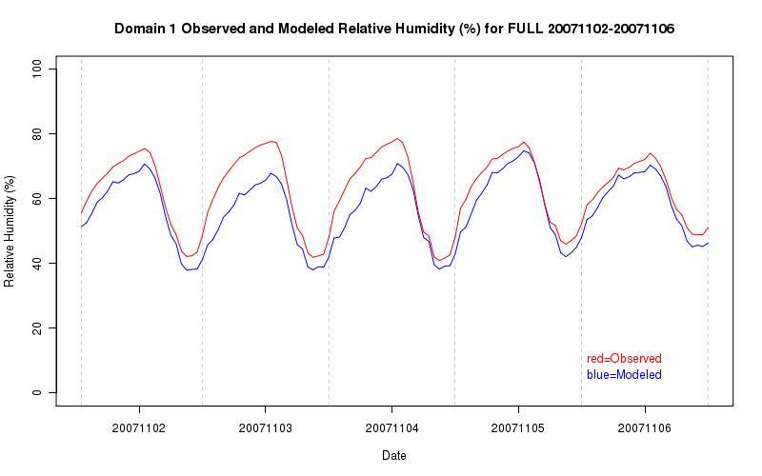

Specific humidity

The modeled and observed specific humidity time series is shown in the plot below. The WRF model performs well at predicting the specific humidity especially during the cooler portions of the year, however, there is a slight high bias in the model simulation during the warmer months especially during June and July for domain 1. The performance of the WRF model for domain 2 in the lower plot is significantly better during the warmer months.
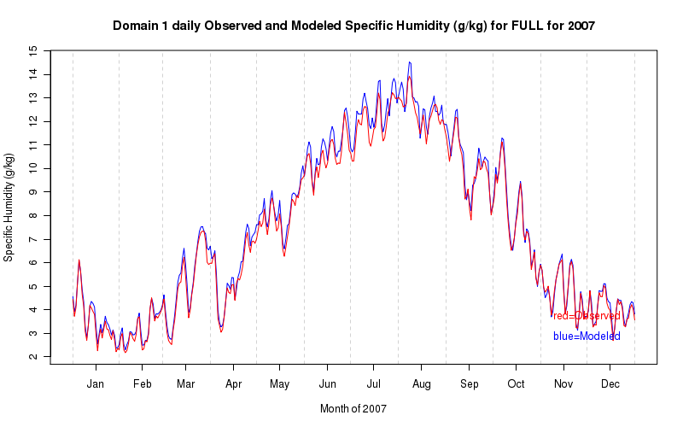
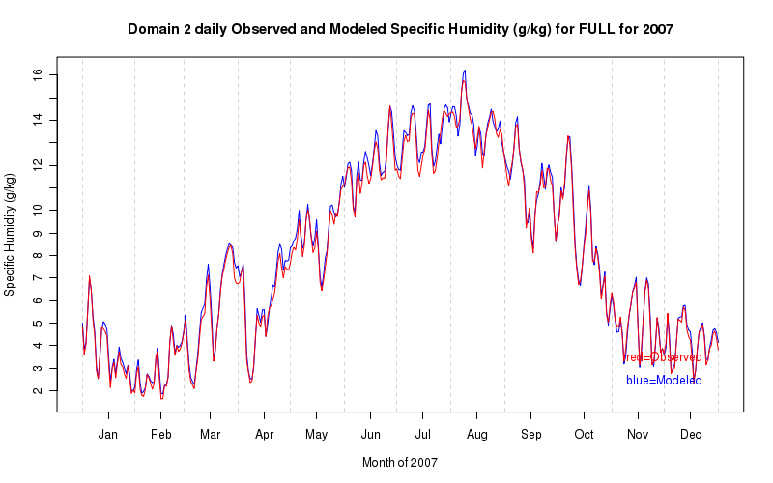

Wind direction

The averaging procedure for wind direction differs from those of the other variables, since a simple arithmetic average of wind direction is not a meaningful quantity; instead, the time series show the wind direction of the averaged (in space and time, if applicable) wind vector. Despite of the somewhat noisy appearance of these plots caused wind direction near south (+/- 180), some general observations are possible. In the plot below it can be seen that the WRF model accurately captures the westerly wind tendency in domain 1 as indicated by the collection of data points between -180° and 0° in the lower portion of the plot which indicates winds with a westerly component. The corresponding plot for domain 2 shows a greater tendency for a southerly component to the wind especially during the warmer months than domain 1.
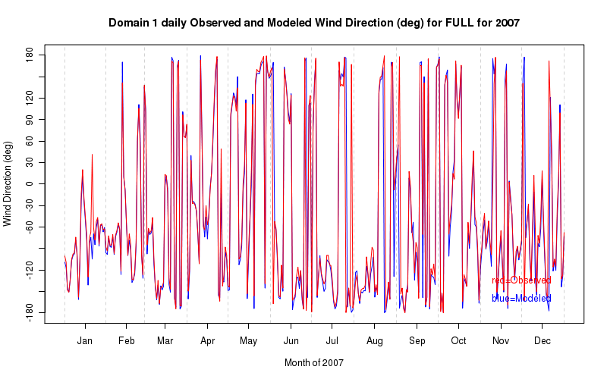
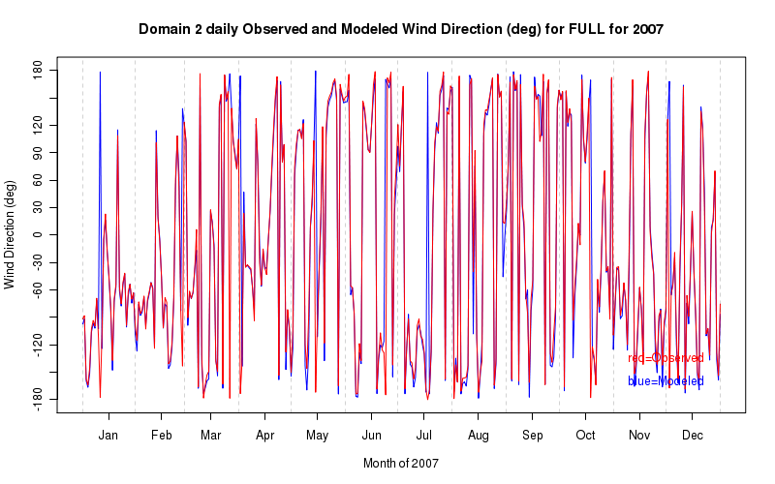

Wind speed

The annual plot of wind speed for the observations and WRF model is shown below. There is a consistent negative bias throughout the year in domain 1 and this is similar to the negative bias in wind speed found at many of the individual locations. It appears that the negative bias is most pronounced during the early spring. The lower plot shows the time series for domain 2 and it is apparent that the performance is better with significant improvement during the late winter and spring and excellent simulation of the wind speeds during the warmer months.

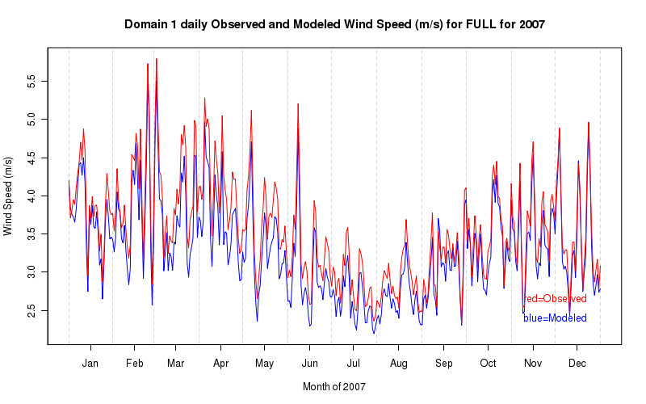
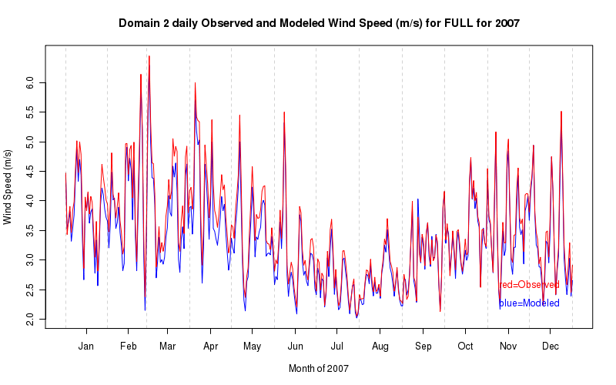

A closer examination of a shorter time scale reveals some important diurnal characteristics of the modeled wind speed. First, there is a short period of time when the wind speed decreases in the early afternoon before resuming its increase to an evening maximum. This pattern is observed in a majority of the individual 5-day runs throughout the year and results in the model having a negative bias during the entire year because the negative bias in the afternoon is so significant. Also, in the warmer months there seems to be a high bias during the night as the modeled wind speeds are slightly higher than the observed wind speeds.
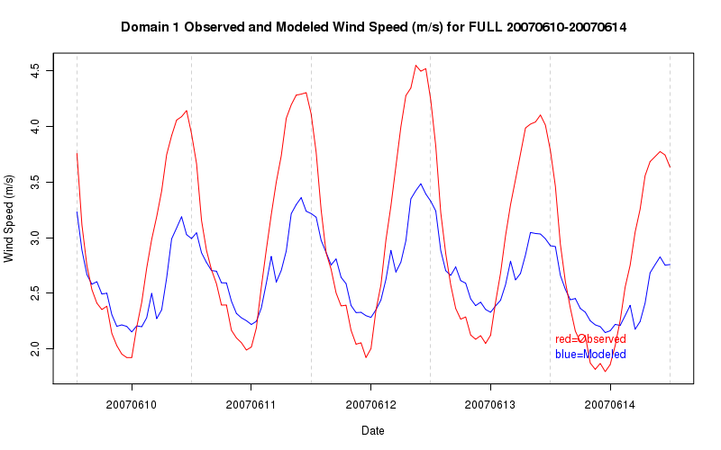

Task 2 B: Monthly Bakergrams

The next section describes the variability of the daily mean absolute error and the daily mean bias for the production run through a series of Bakergrams. The discussion focuses primarily on the “FULL” region (entire model domain) for Domains 1 and 2.

Temperature

The daily mean absolute errors (MAE) for the production run of the WRF model are greatest during the winter months and are approximately 2-3°C for this period. The errors decrease to roughly 1.5-2°C on average during the summer months. The daily mean bias in temperature shows a similar seasonal pattern to the mean absolute errors. The temperatures have a high bias from the early autumn through about mid-winter. The remaining portion of the year presents a negative bias. The mean absolute error variability is very similar for domain 2 except the mean errors are slightly smaller, perhaps 0.5°C smaller on average; however, the mean bias over domain 2 increases slightly. Additional Bakergrams below of the daily mean absolute errors and mean bias over Ohio are examples of greater variance over the individual states and smaller RPOs in these parameters.
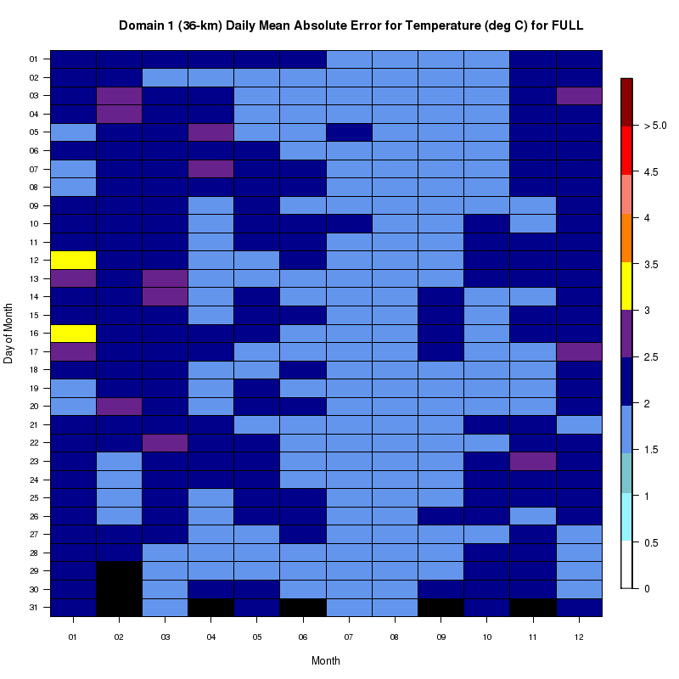
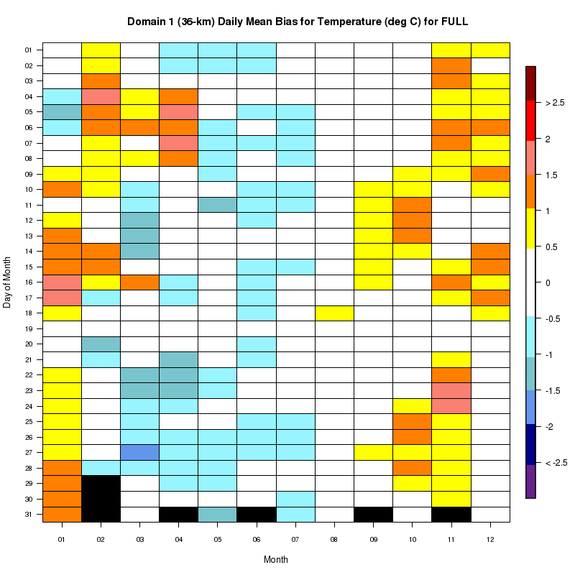

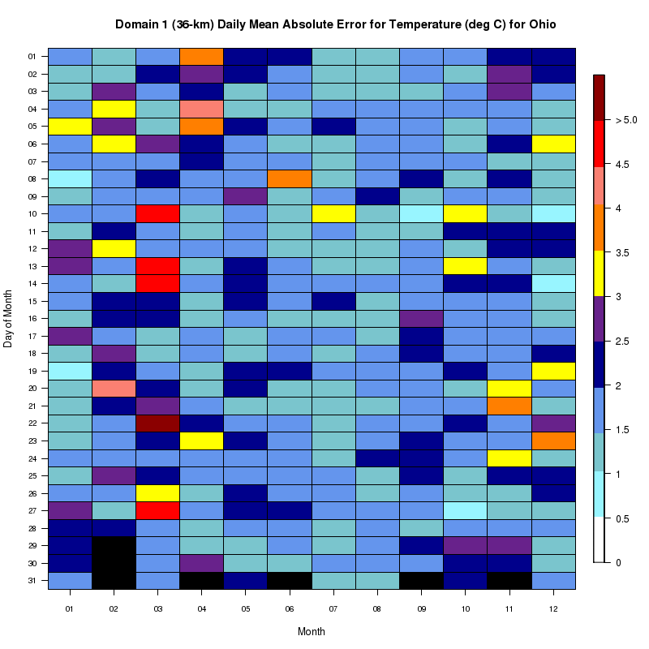

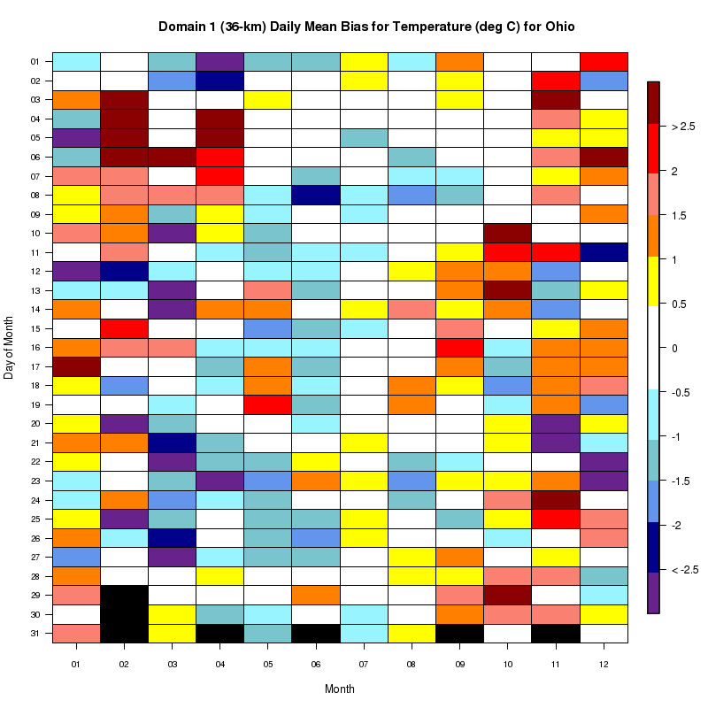

Relative humidity

The relative humidity plots below show that the daily mean absolute errors are largest during the late winter and early spring with errors up to 15-20%. The errors are smallest during the summer and early autumn time frame generally around 10%. The relative humidity parameter in the WRF model has a high bias over most of the year in the daily mean except during the autumn when it has a slight negative bias. The daily mean absolute errors and mean biases are slightly increased for domain 2, although they retain a similar seasonal pattern. Comparing the daily mean bias Bakergrams from Florida and Ohio shows that there is a much more significant high bias over Ohio during the winter consistent with the overall pattern from the full domain. In contrast, no obvious bias exists over Florida at any time during the year.
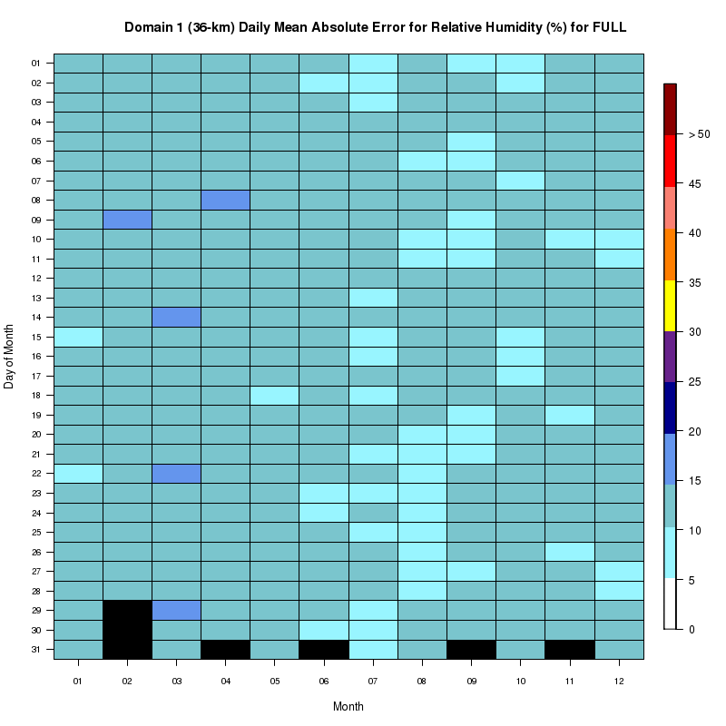

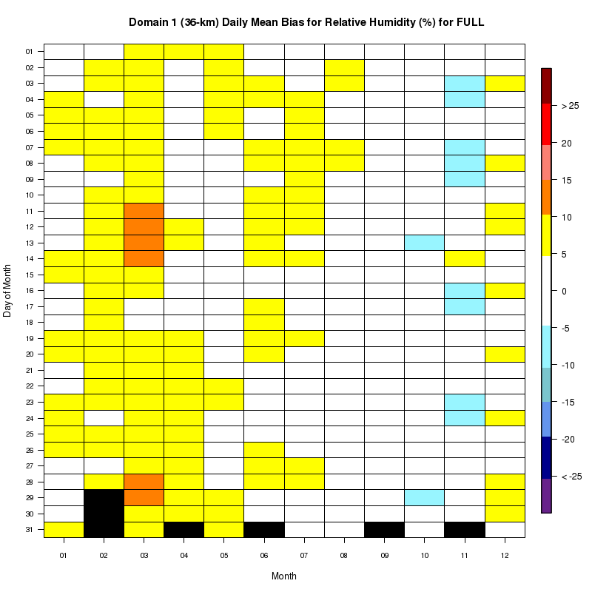
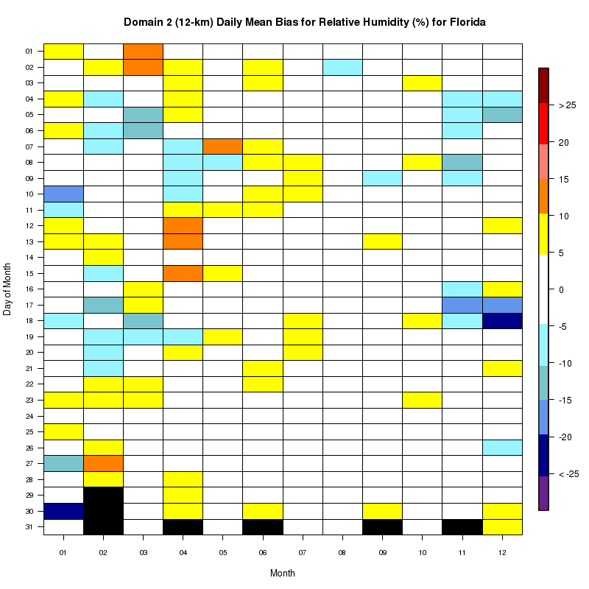
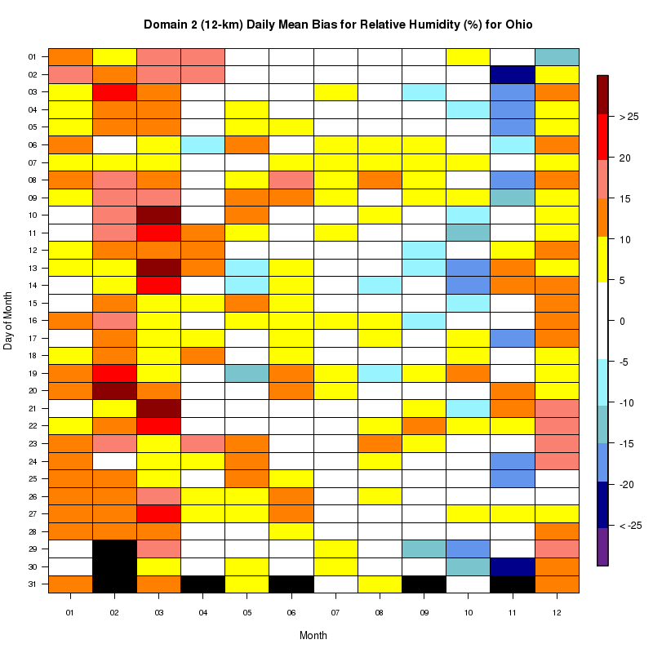

Wind Speed

The daily mean absolute error for wind speed in the WRF model is generally higher in the winter and spring than during the warmer months and this is most likely a result of higher average wind speeds that occur at these times of the year. The mean absolute errors are generally under about 2 m/s. The mean bias is quite small (under 0.5 m/s), with the only significant bias to appear on the plot being a negative bias during the spring months. These statistics for domain 2 are very similar to domain 1. Two additional plots below comparing wind speed bias over Ohio and West Virginia highlight the effect of elevated terrain on the WRF model results. There is a consistent positive bias throughout the year over West Virginia (especially during the late summer and early autumn), while over Ohio the wind speed bias is generally negative.
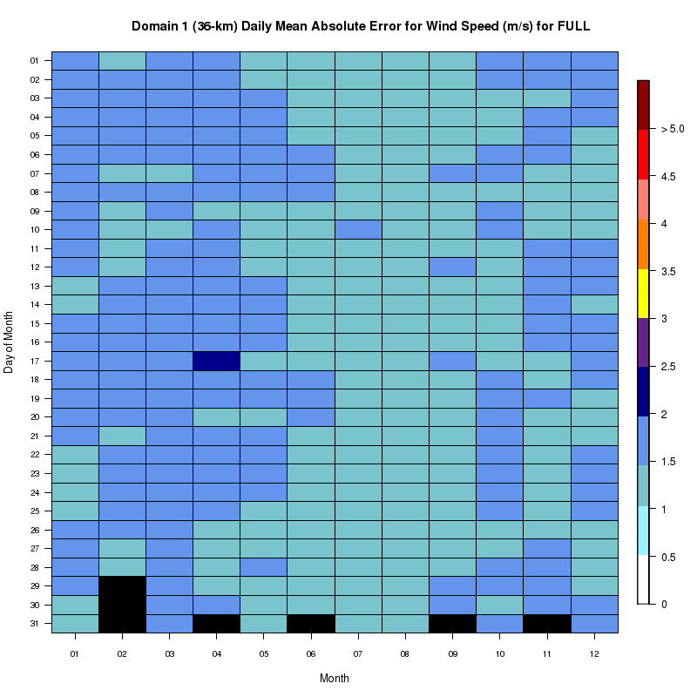
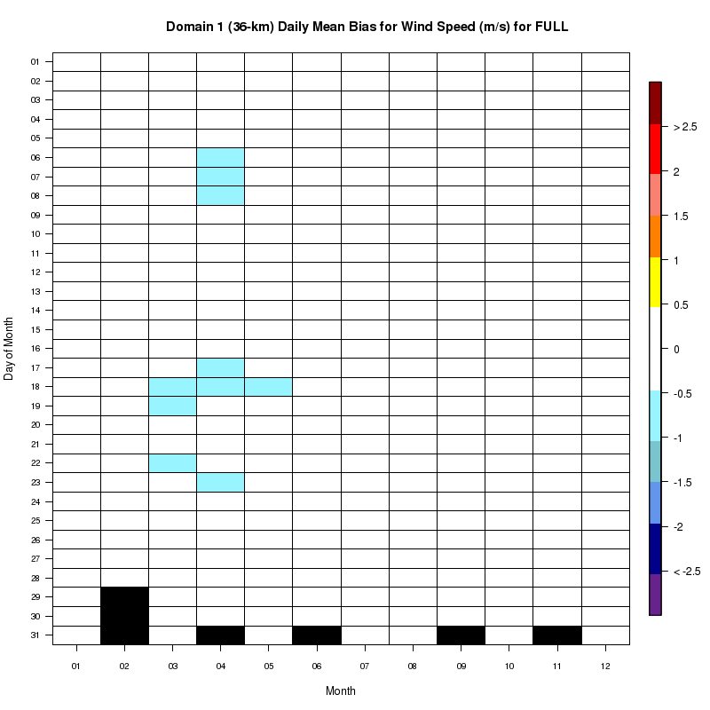
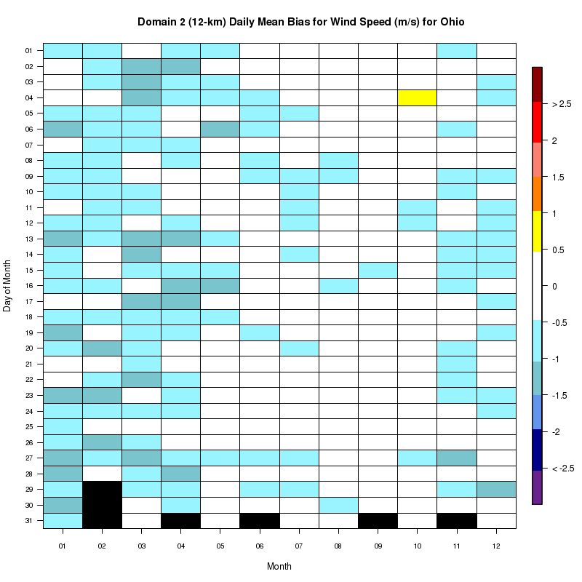
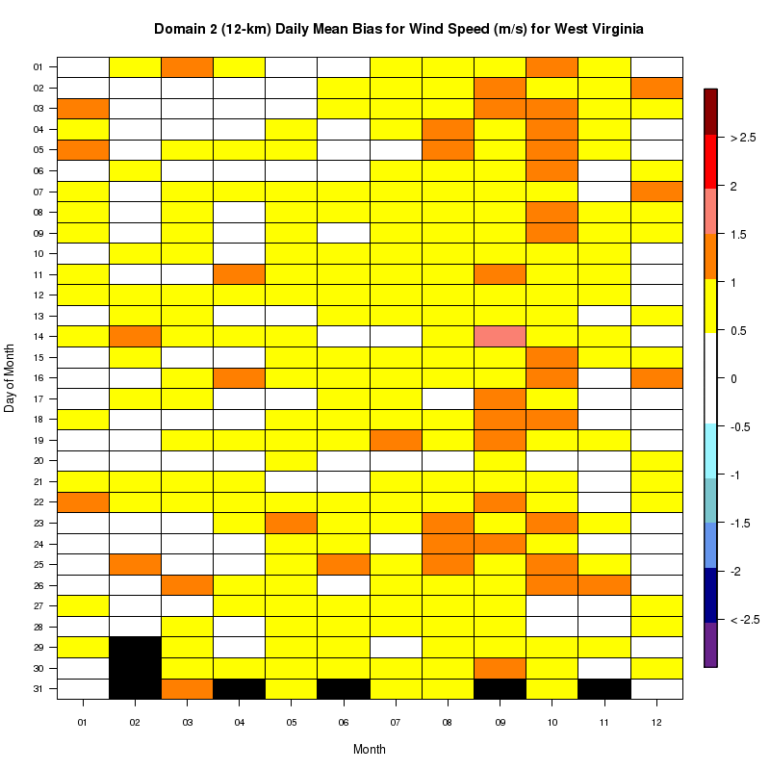

Task 2 C: Bubble spatial plots of error statistics

These plots show maps covering the entire modeling region (domain 1 and 2), with color-coded symbols at surface observation sites. The color-coding corresponds to the value time-averaged error statistics (e.g., mean bias, MAE) at each observations site. These plots help to identify spatial patterns of different error characteristics.

Temperature

The 2-meter / surface temperatures simulated by the WRF-MET model were generally accurate to within 3.0 °C of the observations for all U.S. stations within the model’s inner domain (12 km). The agreement between the simulated and observed temperatures was somewhat poorer in the cooler seasons than during the summer as the mean absolute error (MAE) for many locations was between 2 – 3 °C in winter, spring, and fall (see Figure below) but decreased to generally < 1.5 °C in all regions during the summer (see Figure below). The MAEs in Southern Canada were notably higher during winter peaking at > 3.0 °C, but of the same magnitude as those in the U.S. during the other seasons. Much of the temperature error during the winter and fall could be explained by warm biases of 1- 2 °C in the U.S., particularly in the Great Plains and Midwest, and 1– 3 °C in Southern Canada. During the spring, biases of -1 to -2 °C were produced for many locations in the Midwest and Northeast. As will be discussed in Section 5.1.4.1, some sites in the South and Southeast, particularly Tennessee and Alabama, showed a tendency towards a negative bias in temperature. The spatial plots, however, did not show evidence of substantial widespread cool biases (< -1.0 °C) across that part of the U.S. during the warm months (see Figure for July mean bias below).

January Temperature MAE for Domain 2:
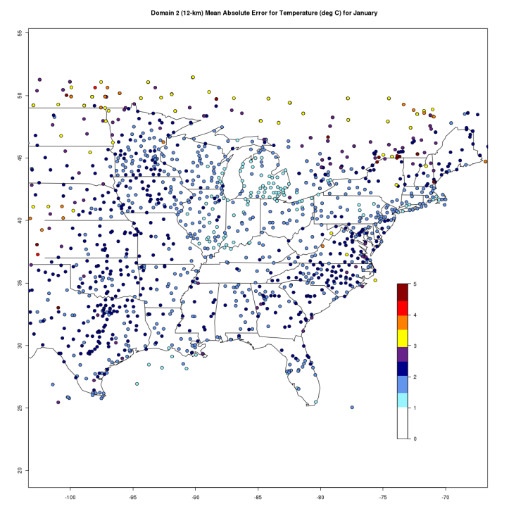

July Temperature MAE for Domain 2:
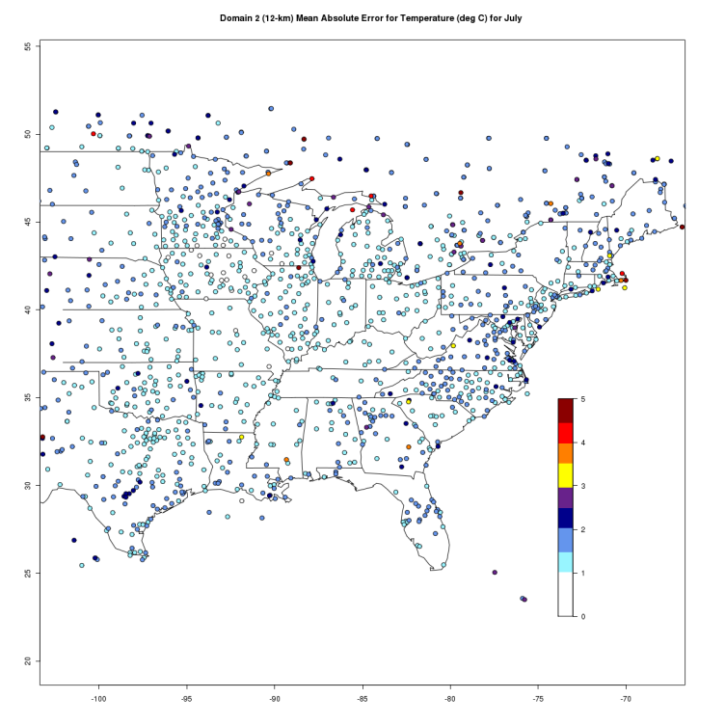
July Temperature Mean Bias for Domain 2:
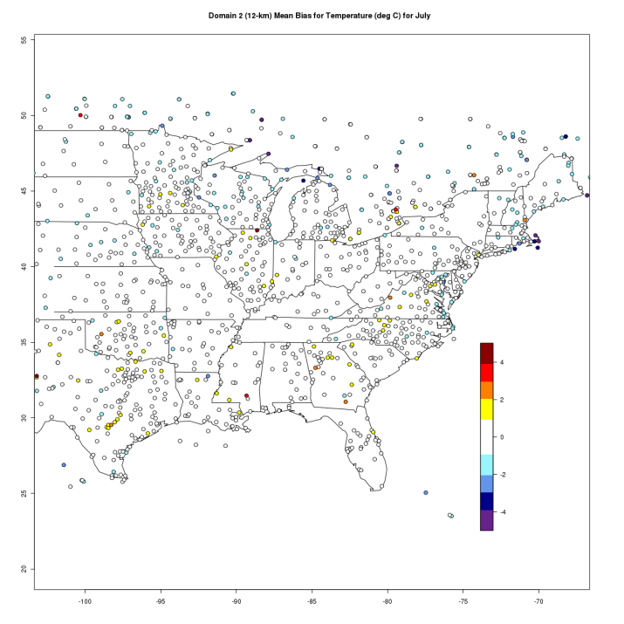

The error characteristics in the portion of the outer domain (36km) that overlapped domain 2 were similar to those in domain 2 but of a slightly greater magnitude (~ 0.5 °C) presumably due to the coarser grid spacing. Domain 1 covered the entire contiguous U.S. and MAEs were generally > 3.0 °C over the Rocky Mountains but < 2.5 °C along the immediate West Coast.

Relative humidity and dew point temperature

The WRF-MET 2-meter / surface relative humidity (RH) errors exhibited well-defined seasonal and spatial variability peaking in the northern half of domain 2 during late winter and early spring of 2007. The larger late winter/early spring errors were primarily due to positive biases ranging from 20 - 40 % (see Figure below) and corresponding positive biases in dew point of 2 C to > 4 C indicated that the RH biases were due to an overprediction of absolute moisture content rather than an under prediction in temperature. In addition the locations of the high positive RH biases were mostly over snow-covered areas suggesting that the model may not accurately simulate the moisture flux from snow (see Figure below).

February Relative Humidity Mean Bias for Domain 2:
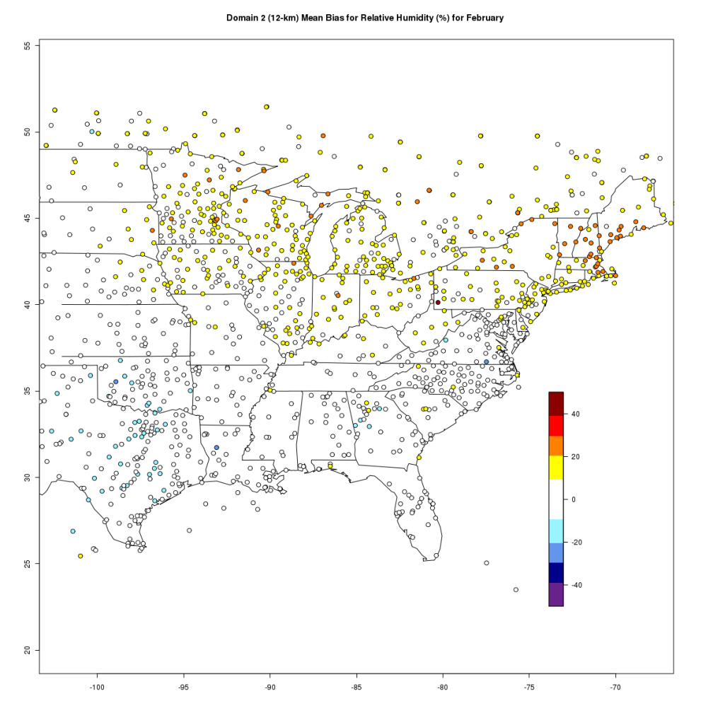

National Snow Analysis for February 28, 2007 - While the area of snow cover varied in time this plot was representative of the areas of most persistent snow cover during February and early March of 2007. (Available from National Weather Service National Operational Hydrologic Remote Sensing Center, http://www.nohrsc.noaa.gov/nsa/.)
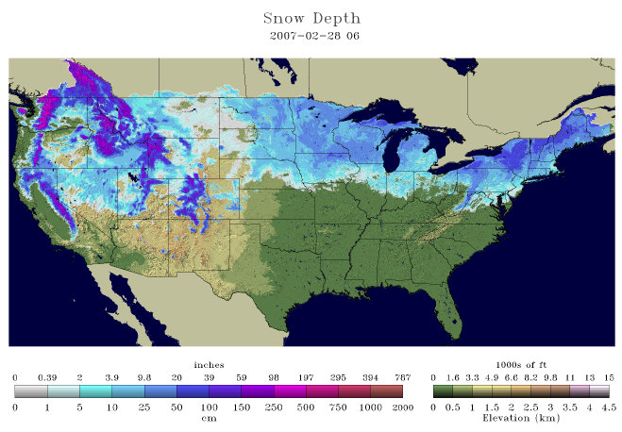

The unusually mild early winter of 2006 -2007 (see statewide temperature rankings at http:// www.ncdc.noaa.gov) in the Midwest and Northeast caused a delay in the usual spread of snow cover in the region. As temperatures cooled to slightly below normal in February the area of snow cover began to increase substantially. It is interesting to note that the increase in the WRF-MET positive RH biases seemed to follow the increase in snow cover in the region, which provides further evidence that the model may have a tendency to overpredict the surface moisture flux over snow-covered land.

Wind speed

The MAEs for the WRF-MET 10- meter / surface wind speed were generally < 1.5 m/s throughout domain 2 with a few exceptions. Along the coast of the northeastern U.S. and in southern Canada during the cooler months of January – April and November – December the MAEs generally ranged from 1.5 – 2.5 m/s with a few locations > 3.0 m/s. The errors seemed random with no consistent biases and were not dependent on the time of day. For domain 1 the wind speed MAEs were similar to those of domain 2 in the eastern U.S, but were generally > 2.5 m/s over the Rocky Mountains.

Wind direction

During the winter months substantial directional errors in the WRF-MET 10-meter/surface winds were limited to the lee side of the Appalachian Mountains. In this region the directional errors generally ranged from 40 – 60° (see Figure below). With the juxtaposition of cold continental polar air and the warmer maritime air of the Gulf Stream, this region is an area of frequent cyclone development, and because of these dynamics and the complexity involved in simulating them larger wind errors are not surprising.

January Wind Direction Mean Absolute Error for Domain 2:
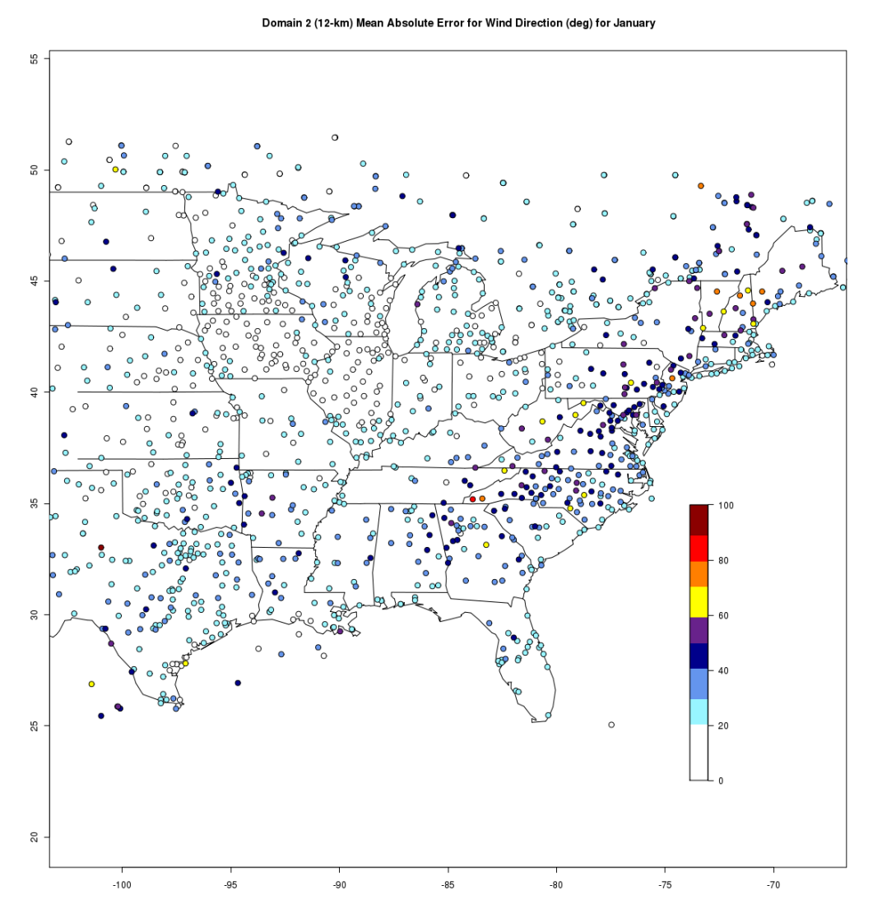

During the warmer months the large errors in the lee of the Appalachians persisted, and another area spanning the Gulf Coast states developed with errors exceeding 60° at many locations (see Figure below). It is possible that the large directional errors in the Gulf Coast states were due in part to frequent convective activity that was unresolved at the model grid scale. As with other variables, in domain 1 the Rocky Mountains caused substantial wind directional errors that in most locations exceeded 70 °.
July Wind Direction Mean Absolute Error for Domain 2:
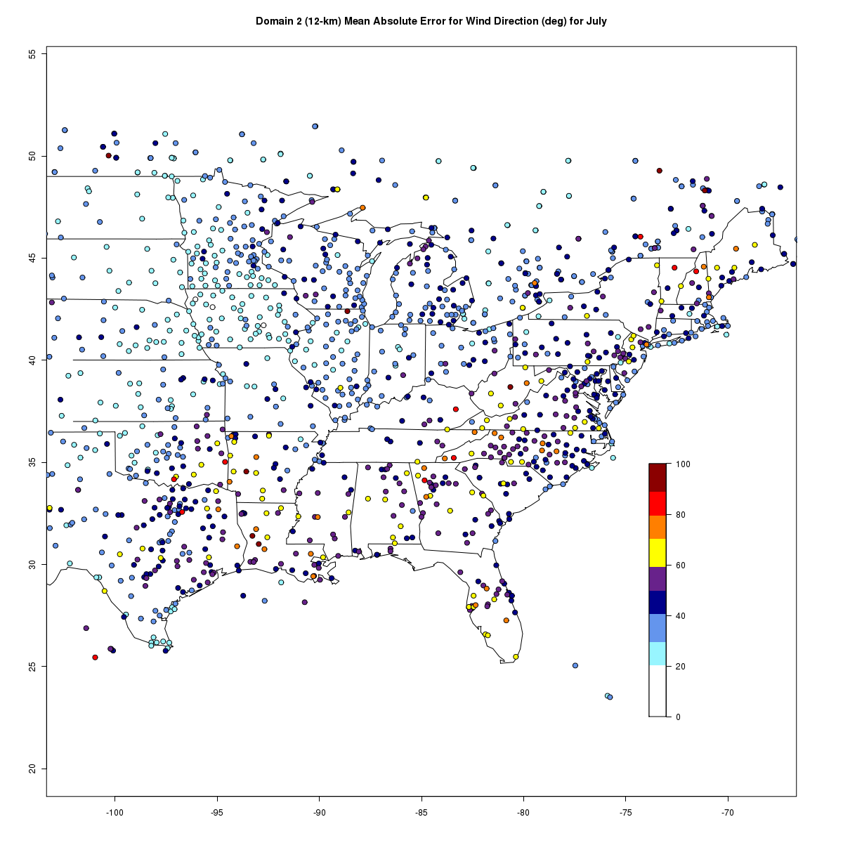

Task 2 E: Time series at individual sites of forecast/observed values

This task focuses on model evaluation at a limited number of individual METAR sites. The sites are identified in the following table.

State | City | Observation Station | State | City | Observation Station
AL | BIRMINGHAM | KBHM | MO | ST. LOUIS | KSTL
AL | MOBILE/BATES | KMOB | MN | MINNEAPOLIS | KMSP
AR | LITTLE ROCK | KLIT | MS | JACKSON | KJAN
DC | WASHINGTON/NATL | KDCA | NC | CHARLOTTE | KCLT
FL | ORLANDO | KMCO | NE | NORTH PLATTE | KLBF
FL | TALLAHASSEE | KTLH | OH | CLEVELAND | KCLE
FL | MIAMI | KMIA | OK | OKLAHOMA CITY | KOKC
GA | ATLANTA | KATL | SC | COLUMBIA | KCAE
IA | DES MOINES | KDSM | SC | GREEN/SPARTANSBG | KGSP
IL | CHICAGO O'HARE | KORD | TN | CHATTANOOGA | KCHA
IL | PEORIA | KPIA | TN | KNOXVILLE | KTYS
IN | FORT WAYNE | KFWA | TN | MEMPHIS | KMEM
KS | DODGE CITY | KDDC | TN | NASHVILLE | KBNA
KY | COVINGTON | KCVG | TX | DALLAS/FT WORTH | KDFW
KY | LOUISVILLE | KSDF | VA | RICHMOND | KRIC
LA | SHREVEPORT | KSHV | WI | ASHWAUBENON | KGRB
MI | DETROIT/WAYNE | KDTW | WI | WAUSAU | KAUW
MI | HOUGHTON LAKE | KHTL | WV | CHARLESTON | KCRW
MO | KANSAS CITY/INTL | KMCI | WV | HUNTINGTON | KHTS

Temperature

The temperatures produced by the WRF simulations were comparable to the temperature observations at most of the individual METAR locations. The model temperatures track the observations relatively well; however, the variability of the model temperatures is generally lower than the observed values meaning the model simulations have difficulty replicating temperature extremes both high and low.

The WRF model performed the best at simulating temperatures at locations in the Great Lakes, Midwest, and central Plains regions. At the sites in these regions, significant temperature biases were absent as the mean and variability are well represented. For example, at KORD (Chicago, IL) the annual observed temperatures are well predicted by the model and there is no apparent bias at any period of time during the year.
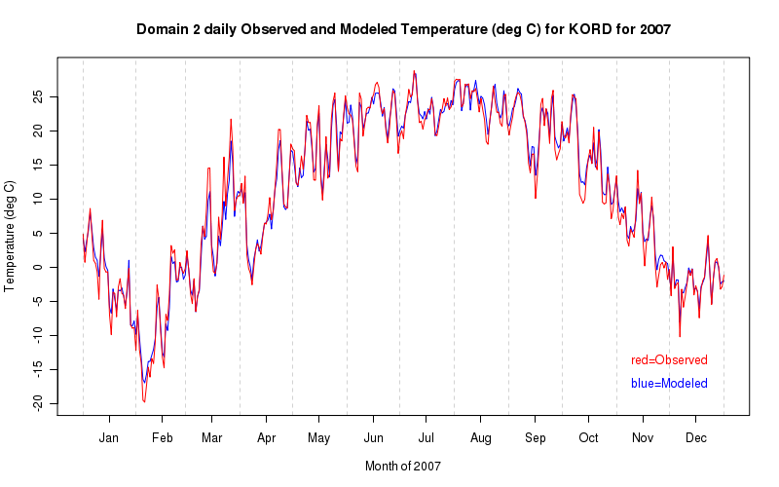

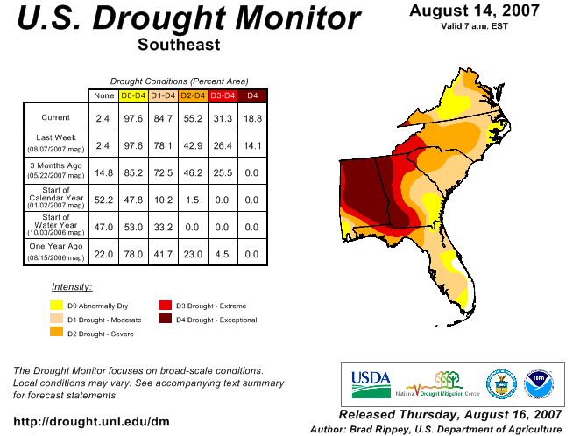
At sites across the South and Southeast, especially during the warmer months, a negative temperature bias appears to be present in the WRF model. This negative temperature bias is most apparent in the KBHM, KCHA, and KMEM annual observed and modeled temperature plots. The KMEM (Memphis, TN) plot appears below. Notice the consistent negative bias from late May through the middle of August in the modeled temperature relative to the observed temperature. The results discussed in Section 5.1.3.1, however, indicate that errors of this magnitude are not typical of most stations in that region. During 2007, a major hydrological drought affected a large portion of the southeastern United States. The drought monitor map (at right, valid 14 August 2007) indicates the expanding moderate through exceptional drought during the summer of 2007. Failure of the WRF model to accurately initialize the surface and boundary layer conditions (e.g., dry soil) could have lead to or contributed further to this error.

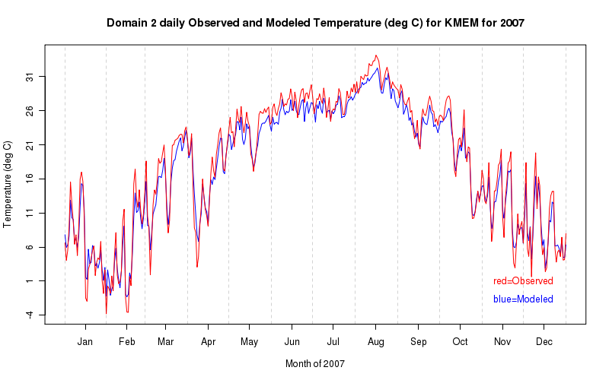

As previously mentioned, the WRF-modeled temperatures tend to exhibit less variability than the observed temperatures. The most obvious example of this is shown in the annual observed and modeled temperature plot for KMIA (Miami, FL) in the plot below. The plot shows that the model has a poor representation of the periodic highs and lows. This poor performance appears to be greatest during the summer and this is likely due to the inability of the model to accurately model the boundary layer moisture characteristics. As will be discussed in a subsequent section, the WRF model grossly over predicts the dew point temperature at KMIA during June through October and this would contribute to a lower modeled diurnal range.

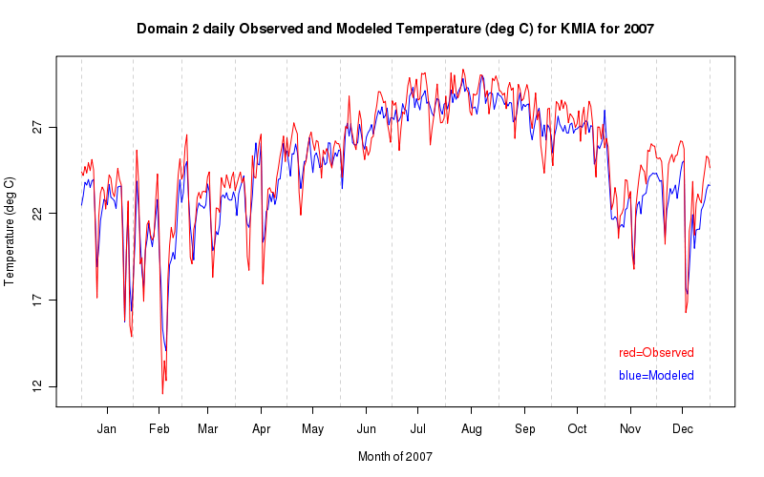

The 5-day model run from June 15-19, 2007 at KMIA shown below exemplifies the problem of modeling the diurnal cycle and summertime air mass convection. With the exception of the first daytime period, the high temperatures are close to the modeled values or under predicted and the low temperatures are over predicted for all days.

The observed diurnal temperature trace is sharply interrupted by the cooling effects of rainfall that are absent in the modeled fields. The related effect on the dew point temperature and relative humidity fields is also not captured by the model (not shown). Convective rainfall occurred on all days during this period except for the 19th. The correct placement and timing of convection is a particularly difficult task for meteorological models and this example does not necessarily suggest a chronic problem in the WRF model. A detailed analysis of precipitation was out of the scope of this project.

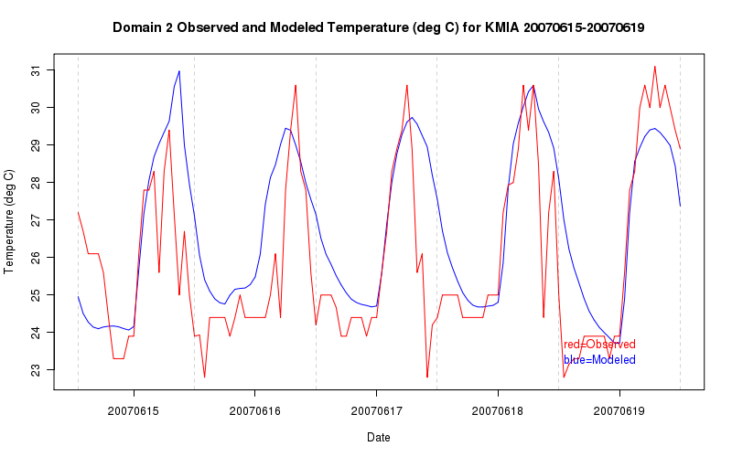

Dew point temperature

The WRF model results for the dew point variable generally indicate that it has a slight positive bias across a majority of the individual METAR sites, especially during the warm season. As with temperatures, the best representations of dew point in the WRF simulations were found outside of the southeastern United States. The plot below of the annual modeled and observed dew point at KORD (Chicago, IL) is an example of a particularly good dew point simulation.
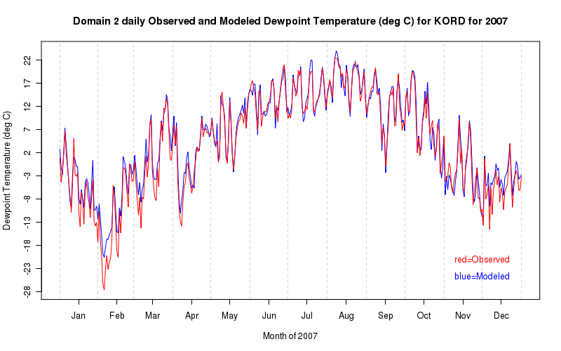

The number of individual METAR sites that have positive dew point biases suggests that the WRF model potentially has an issue with the parameterization of moisture fluxes at the surface. This bias is most noticeable across the Southeast, but also can be seen in the central Plains during the warm season. The annual dew point plots below demonstrate that KMIA (Miami, FL) has a very strong positive dew point bias during the June through October time frame while KCAE also has a consistent positive bias during the late spring and summer.
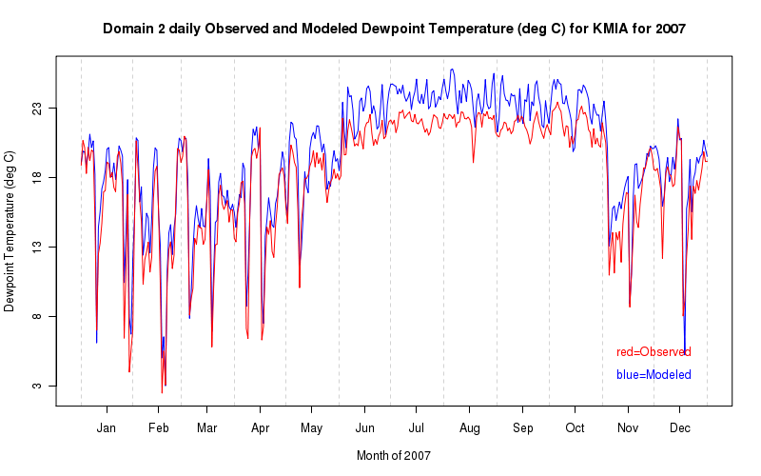
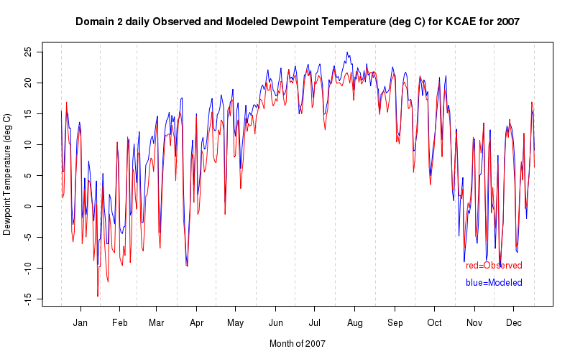

A partial reason for the lack of skill in the WRF simulation of dew points during the warm season in the Southeast may be that the baseline model dew point temperature is too high. In both plots below from KBHM (Birmingham, AL) – June 20–24, 2007 – and KCAE – June 25–29, 2007, the nocturnal rise in dew point is quantitatively similar for both the model results and observations; however, the model doesn’t simulate the drop in dew point associated with a well-mixed daytime boundary layer resulting in dew points that are generally too high.

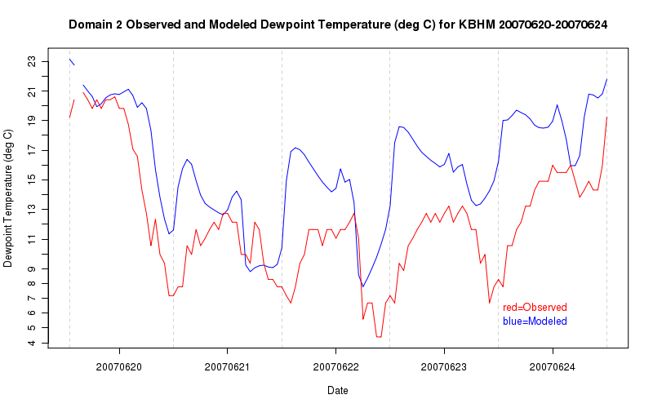
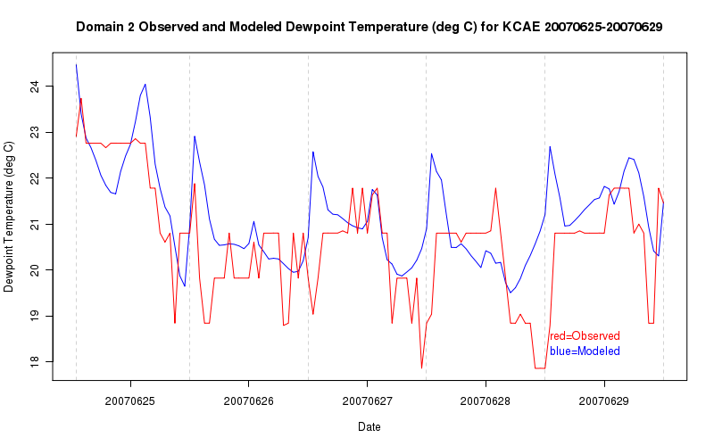

Relative humidity

The trends observed in relative humidity for the WRF simulations closely resemble those of the dew point trends. A number of the individual locations exhibit a positive relative humidity bias during the warm season especially over the southeastern portions of the United States. A couple less common observations that differ from the dew point results are also found: a number of sites are associated with a positive bias during the winter or a transition to a neutral or negative bias during the autumn. An example of each case is shown discussed further below. It is also worth noting that the variability in the WRF relative humidity tends to be greater than the variability in the observed values.

The plot below shows the annual observed and modeled relative humidity for KAUW (Wausau, WI). A strong positive bias is noted from January through the end of April and again starting in December. Although it appears that a higher relative humidity as compared with the observations is seen throughout the year, the distinction is most pronounced during the cool season. This effect could possibly be due to how the WRF handles snow cover in its simulation. Another station that exhibits a significant positive bias throughout the year is KCLE (Cleveland, OH), which could be the result of its location along Lake Erie in which poor simulation of the moisture fluxes off of the lake could result in a persistently high relative humidity as compared with observations.

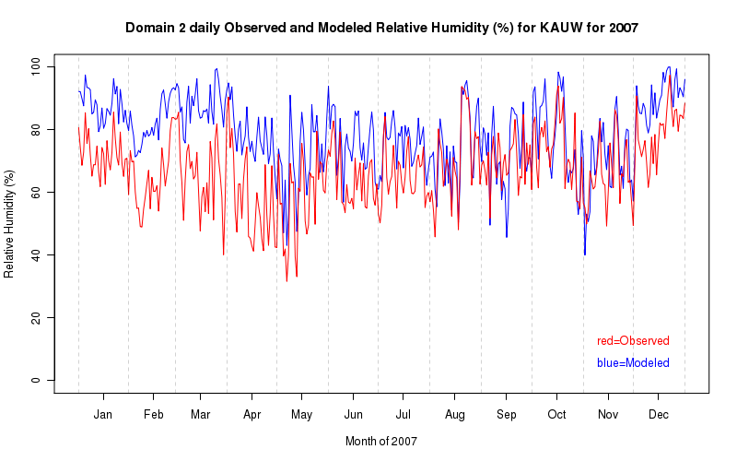
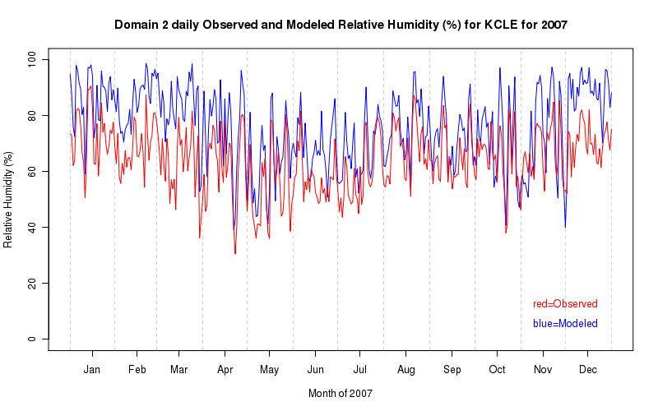

The 5-day run for KAUW during a period of relatively poor performance (Feb 5–9, 2007) shown in the plot below shows that there do not appear to be any problems simulating the diurnal cycle, but the overall relative humidity is forecast too high at all time periods.

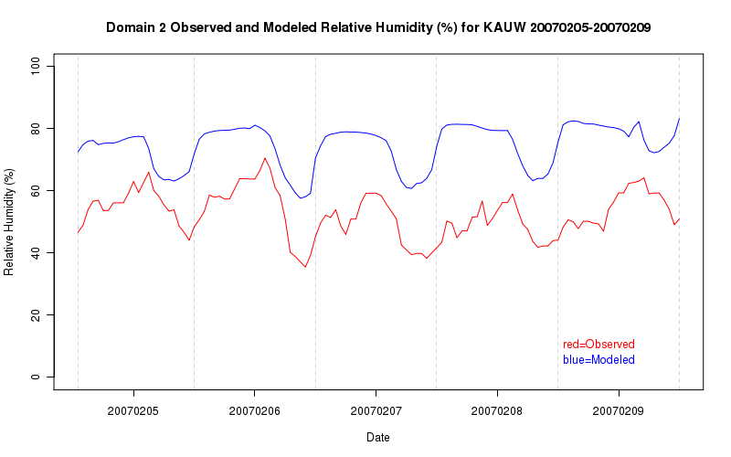
The following plot from KBHM (Birmingham, AL) is a prime example of a station that has a positive relative humidity bias during the summer and transitions to a neutral or slightly negative bias during the autumn season. Notice also the relatively large variability in the modeled relative humidity as compared with the observations especially during the winter and later in the fall. It is important to keep in mind KBHM was under a significant drought during 2007, so this may have had an influence on these modeling results.

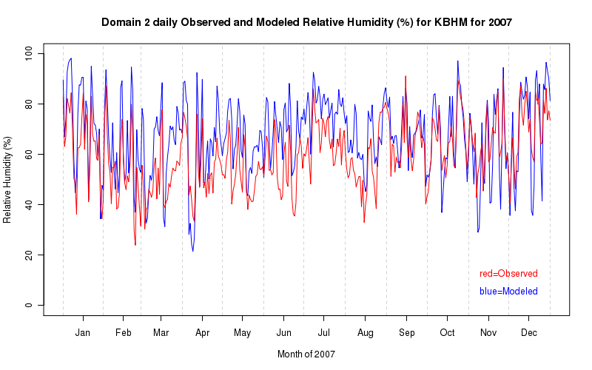
A 5-day model run depicting the modeled and observed relative humidity at KBHM for June 10–14, 2007 is shown in the plot below. There is a noticeable positive bias in the relative humidity in the early morning time period and although the diurnal cycle seems to be well represented, the values remain fairly high because the dew points are modeled too close to the air temperatures resulting in over predicted relative humidity values. This type of behavior is observed at a number of individual stations in the Southeast during the warm season.

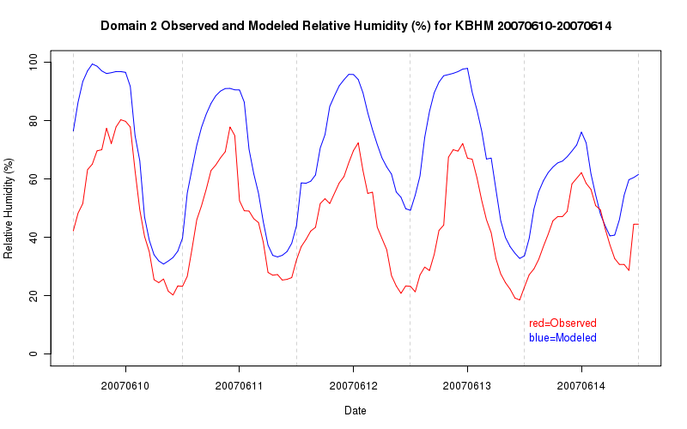

Specific humidity

The specific humidity is generally modeled better than the relative humidity in the WRF model; however, it exhibits some of the same biases seen with the relative humidity when compared to the observations. Many locations in the Southeast and the central Plains into the Midwest display a positive bias during the warmer months. A plot of the specific humidity for KORD is shown in the plot below and represents an excellent fit between the model results and the observations.

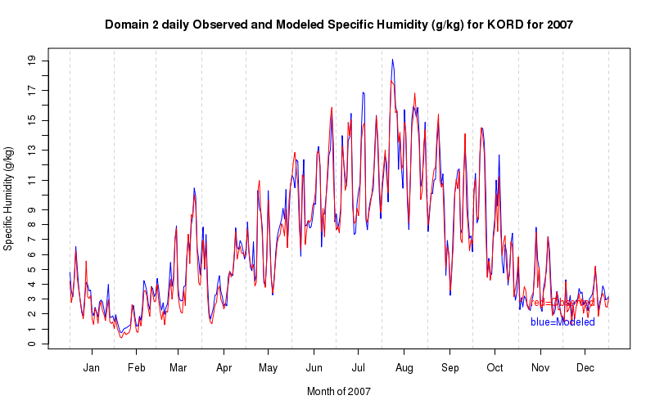

The annual modeled and observed specific humidity plot for KDDC (Dodge City, KS) is shown in the below plot and is representative of a majority of the individual locations especially those in the central Plains and Southeast. Notice how the specific humidity is well modeled in the early portion of the year, but from May to September it shows a positive bias and then from October to December the model results match the observations quite well.
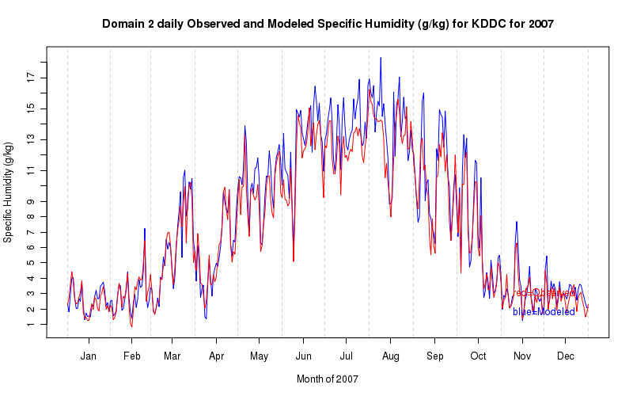

Wind direction

The wind direction as modeled by the WRF simulations was good overall, but there were a few locations that had directional biases, one of which was likely related to topography. At KCRW (Charleston, WV) shown below, the mean observed wind direction is generally westerly, between -30° and -150°, but the model simulates too many wind directions that are southerly – near -180° or 180°. As this location is at a higher elevation, it is somewhat likely that terrain effects are contributing to the poor performance of the model.
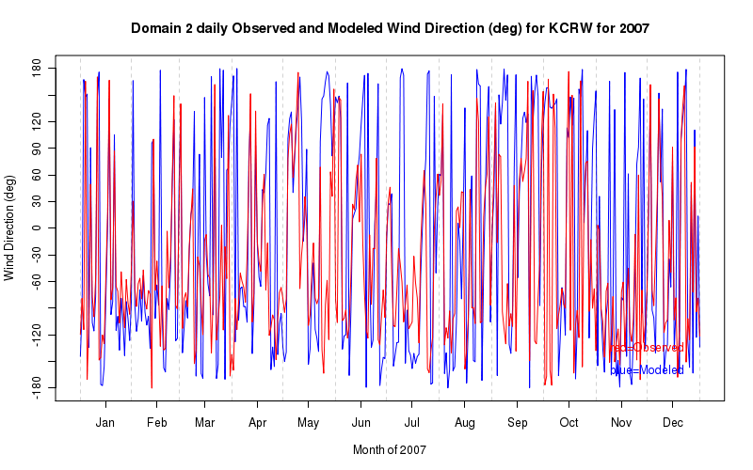

The modeled wind direction at KORD (Chicago, IL) is particularly good, especially during the cool season. The plot below shows that wind direction simulated by the model is very close to the observations from January through June and the model only experiences a slight decline in skill during the late summer and autumn and then recovers during the month of December.
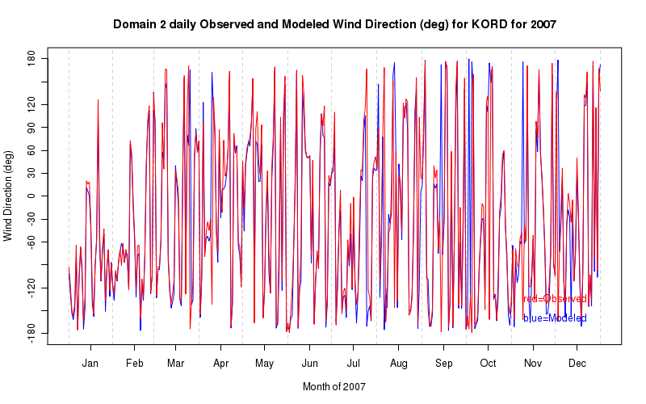

Wind speed

The wind speeds depicted in simulations of the WRF model generally were under predicted by as much as 1–2 m/s relative to the observations of wind speeds at each of the individual METAR locations. There are no particular regional trends observed for this variable, but it appears to be closely linked to local topography. A typical example is shown below from KATL (Atlanta, GA). Notice how the modeled wind speed is approximately 1 m/s below the observations and this is a consistent relationship year round.
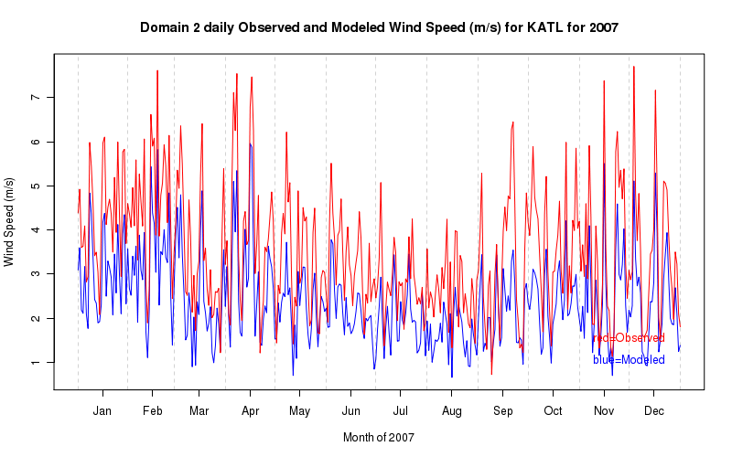
A 5-day run plot below of the wind speed at KATL from August 19–23, 2007 shows in some detail that a possible reason the wind speeds are under predicted at KATL and a number of other locations is that the WRF model fails to capture the higher wind speeds with much accuracy. Notice that over a 3-day period maximum observed wind speeds are near 5 m/s, however, the model predicts a maximum wind speed roughly one half of this value near 2.5 m/s.

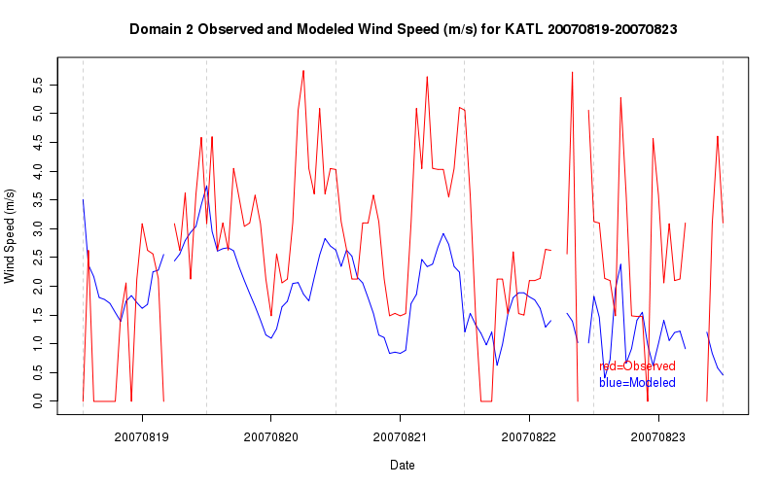
The northern and central Plains as well as the Midwest tended to have the best representations of wind speeds in the model as these areas have relatively flat terrain and the presence of tall vegetation is generally less than in other regions. As a result, wind speed observations at METAR sites in these locations are not greatly influenced by small-scale local effects. Below is the plot from KPIA (Peoria, IL), which indicates that the model performed exceptionally at this location with regard to wind speed.
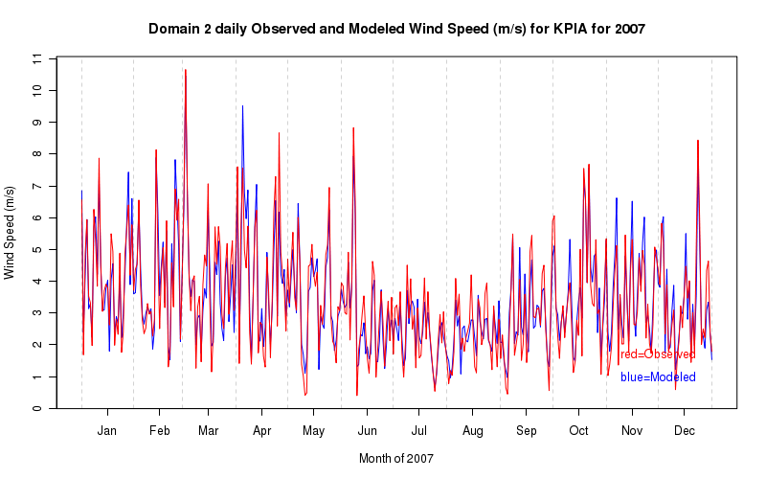
Although most sites conform to the overall 1–2 m/s negative bias in wind speed, a notable exception is KCRW (Charlestown, WV). Figure 13 below indicates that the WRF model simulates wind speeds slightly above the observations, especially during the warm season. Since KCRW is one of the locations at a higher elevation this may play a role in how the model simulates the wind speed at this location.

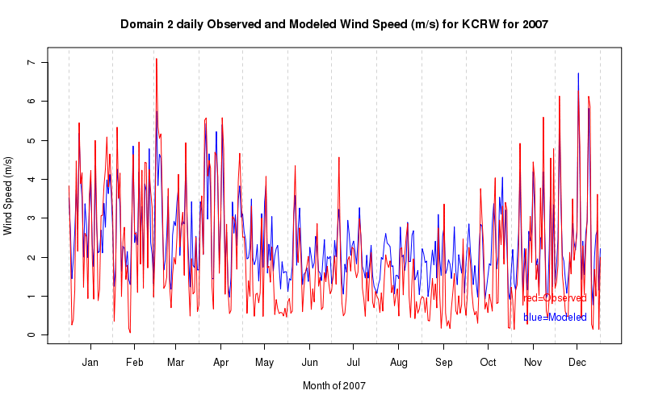

Task 2 G: Scatter plots

Surface

The following scatter plots show the observed value relative to the modeled value of each variable.

Temperature

Surface temperatures simulated by the WRF model generally track the observations well and larger errors are often the result of bad observations. In the monthly plot for January below, there is a fairly linear relationship; however, at the coldest temperatures the model simulates the temperature too warm relative to the observations. The monthly plot for July shows no significant bias for the errors at the low end of the temperature scale, but the number of observational errors appears to increase with a greater number of values far to the left and right of the red 1:1 line.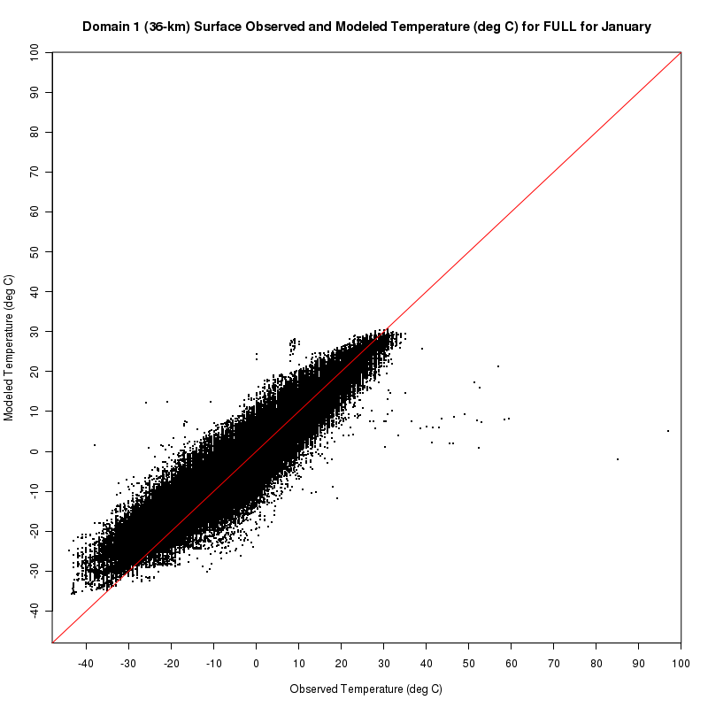
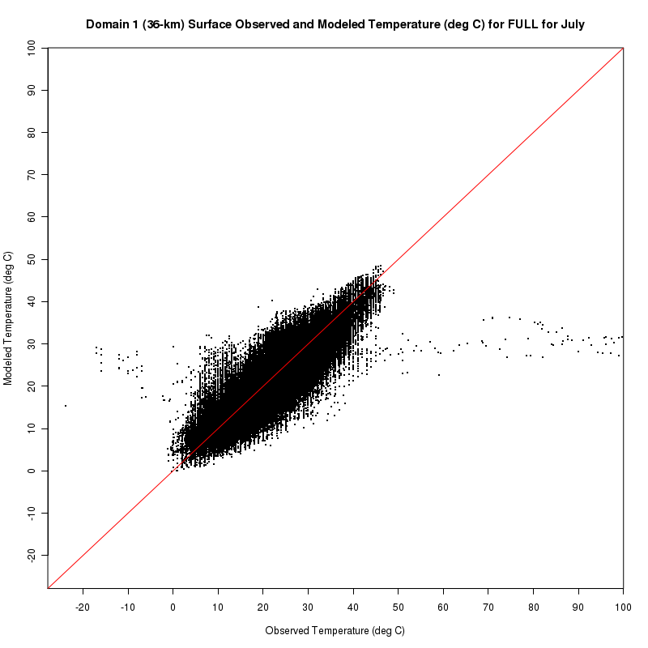

Relative Humidity

The scatter plots for surface relative humidity show that the observed and modeled values are generally close to each other at low relative humidity. The errors increase significantly above an observed relative humidity of approximately 30%. The plot for July is similar except that the largest errors are reduced and there appears to be more of a bias towards higher modeled relative humidity values versus the observed values meaning a tendency for the value to fall above the red 1:1 line. It is less obvious for the relative humidity data which values are related to errors in the observations and which are related to errors in the WRF model output.
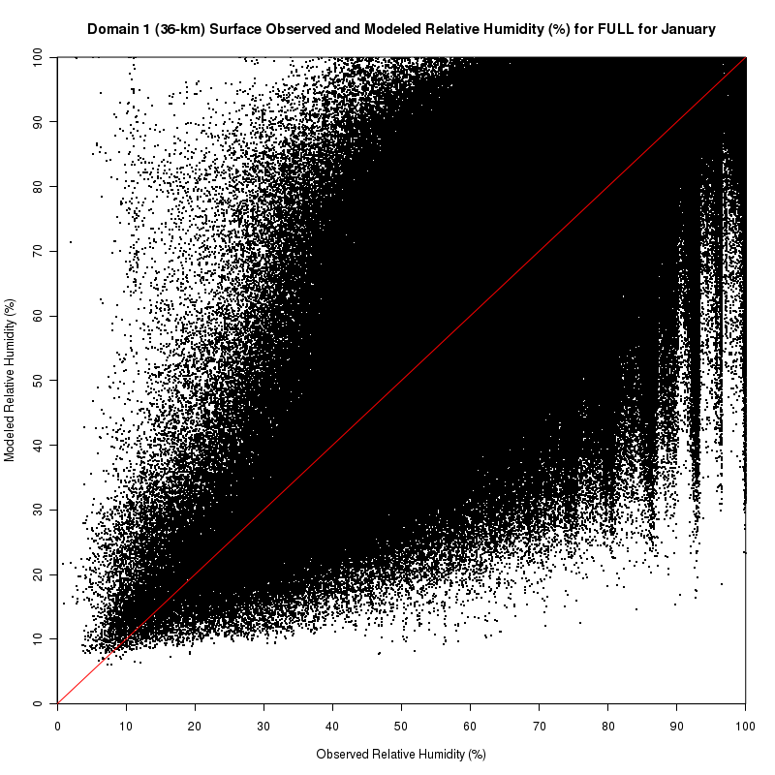
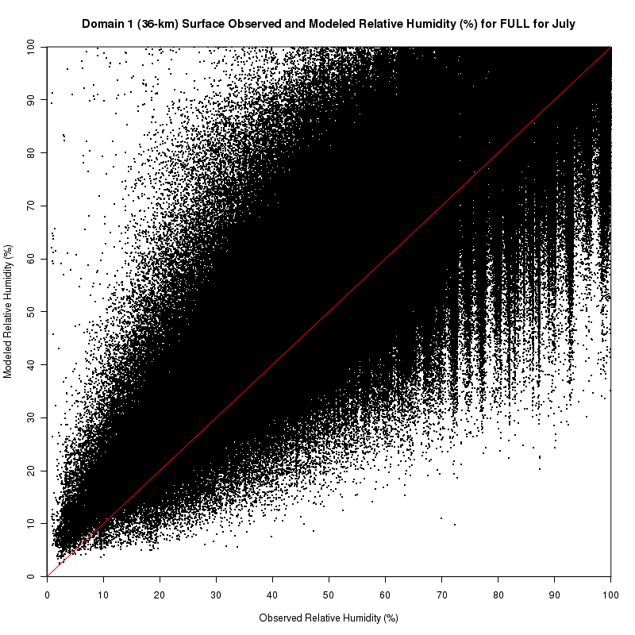

Specific humidity

The surface specific humidity plots below show a good correlation between the observed and modeled values for the month of January. As with the temperature data, there are a number of outlier observations especially to the right of the red 1:1 line. In the month of July, the correlation between the observations and WRF values weakens and as with the relative humidity there appears to be a slight bias towards higher model values versus the observations.
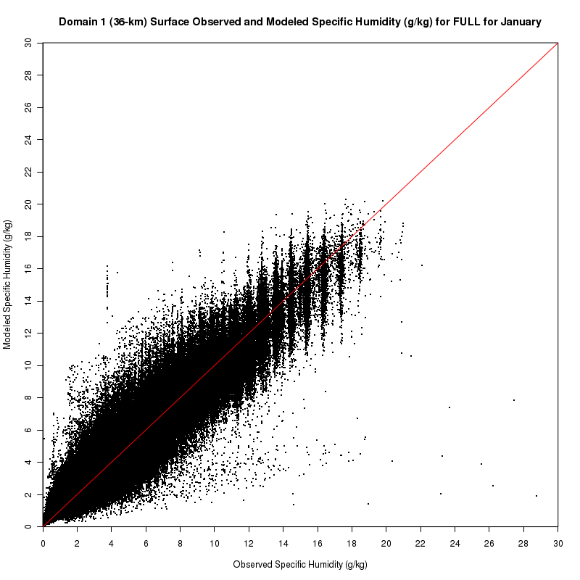

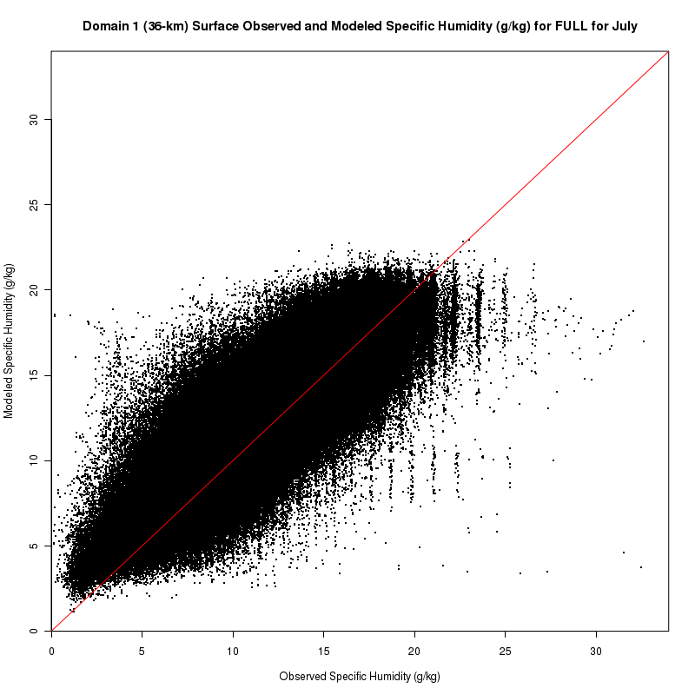

Wind speed

The wind speed scatter plots for the months of January and July show that the WRF model performs relatively poorly at simulating wind speeds that are near zero as there are modeled values upwards of 10 m/s where the observations indicate calm winds. Conversely, there is a tendency to underpredict wind speeds that are in excess of 10 m/s, as a majority of the points fall to the right of the 1:1 line.
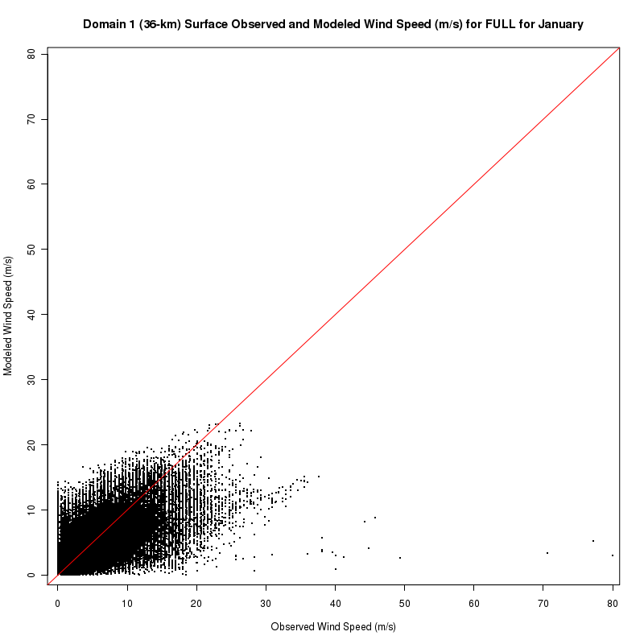
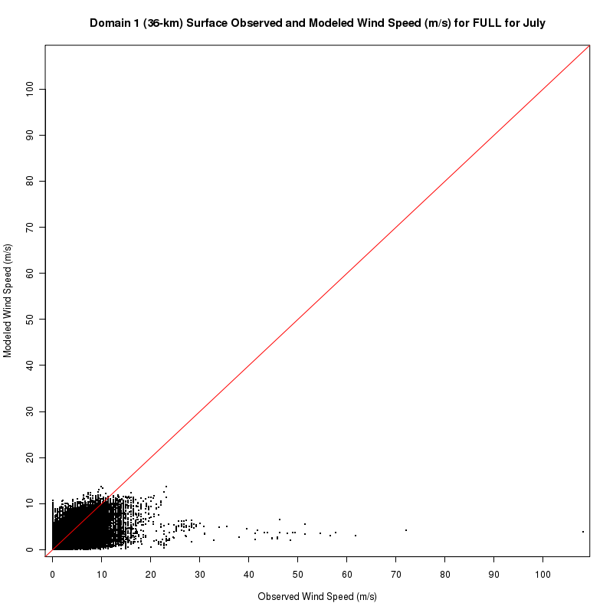

850 mb and 700 mb

The following section will only show scatter plots at the 850-mb level as these are representative of the scatter plots at 700 mb.

Temperature

The observed and modeled temperatures are well correlated at the 850 and 700-mb levels. There appears to be a slight tendency for more outliers left of the 1:1 line especially in January most likely indicating that observations are erroneously cold or the WRF simulation is producing temperatures that are too warm.
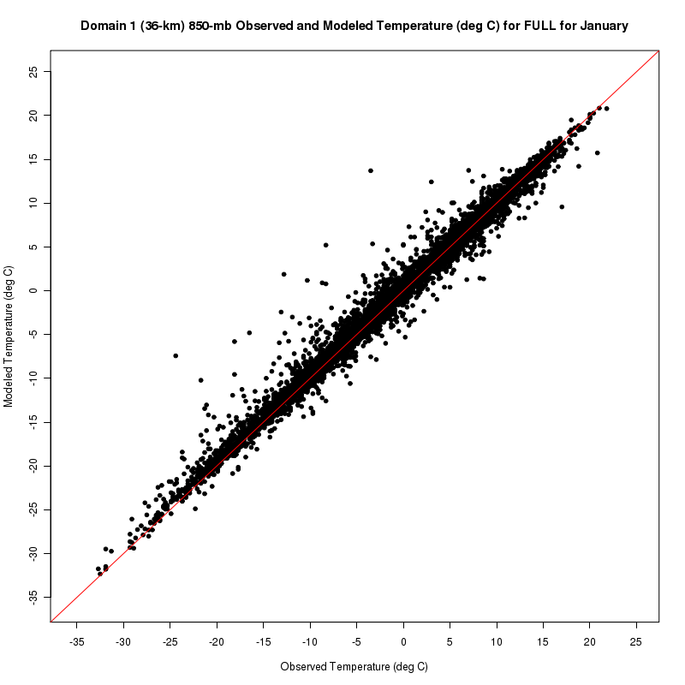

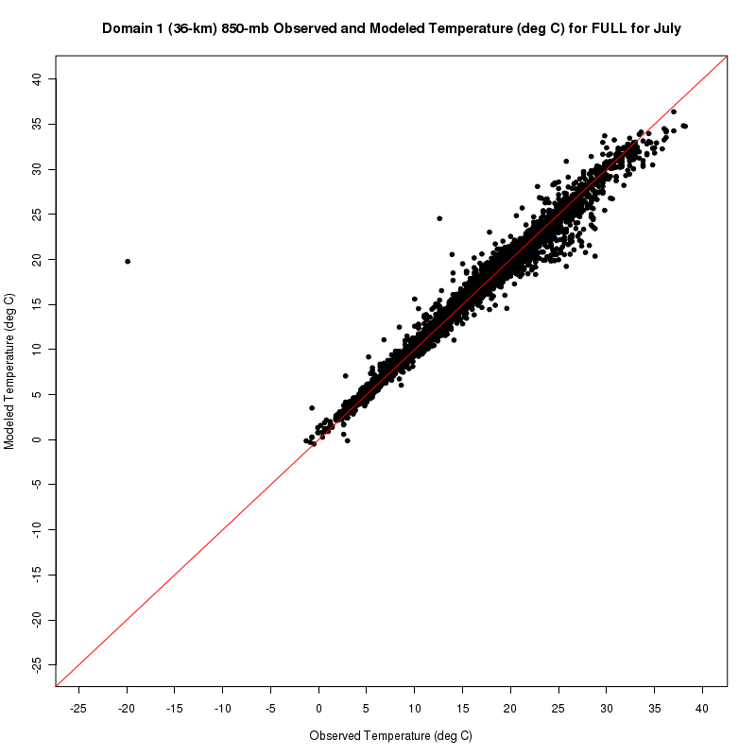

Specific Humidity

The 850-mb scatter plot for January indicates that the observations and modeled values are more closely related at low moisture levels, generally under 5 g/kg. The correlation between these data becomes weaker at high moisture levels indicated by the large number of outliers especially those to the right of the red 1:1 line suggesting observed values are erroneously high or the WRF simulation is producing values that are too low. The July scatter plot shows that while the correlation appears to be slightly weaker where most of the data lies, there are fewer extreme outliers.
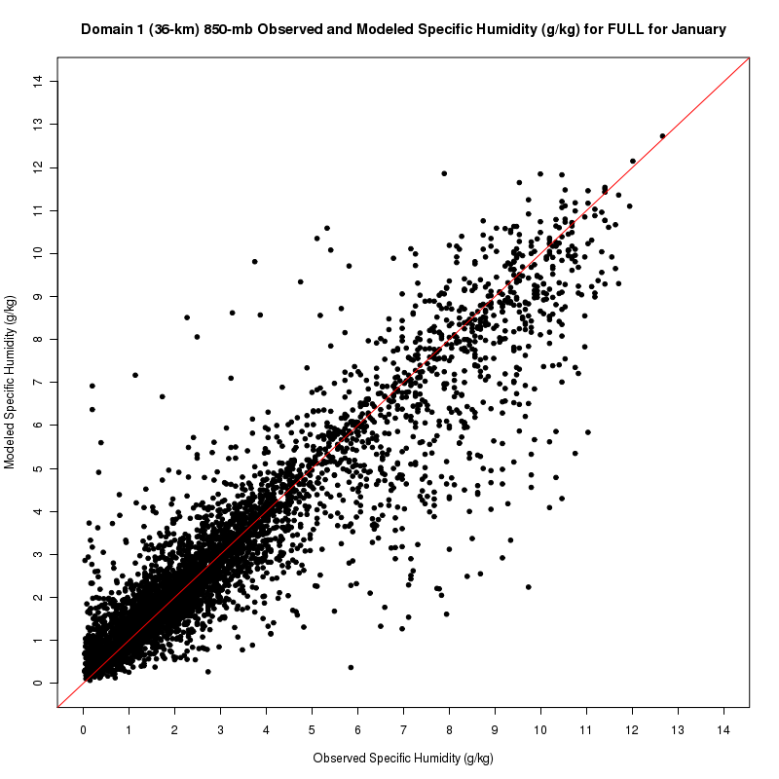

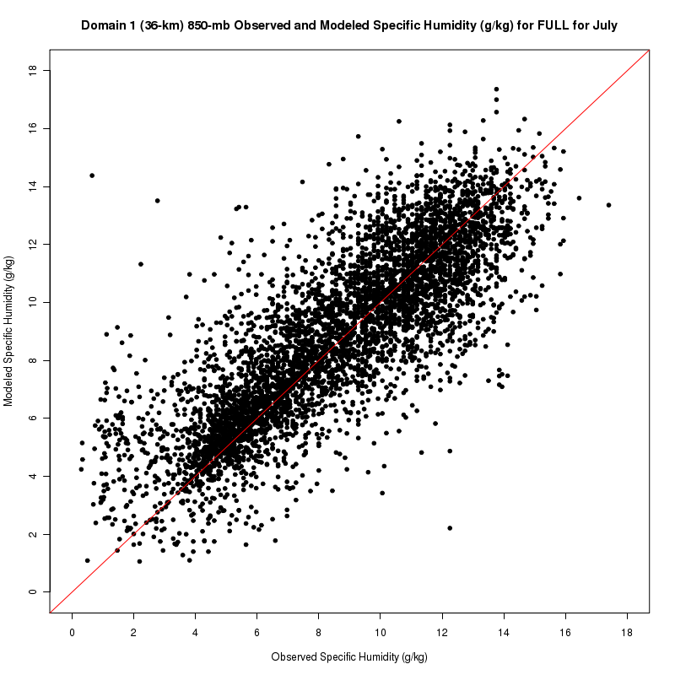

Wind Speed

The 850-mb scatter plots for wind speed show a stronger correlations between the observed wind speeds and the wind speeds simulated by the WRF model with perhaps a slight negative bias indicating that the model slightly underestimates the actual wind speed. The correlation becomes slightly weaker in July as mean wind speeds decrease. There is a larger number of significant outliers to the right of the 1:1 line in July suggesting that the WRF model may have a greater tendency to under predict wind speeds at this level in the warmer months. The 700-mb wind speed scatter plots are similar except the correlation between the observed and modeled wind speeds improves because it is in most cases removed from the influence of the boundary layer.
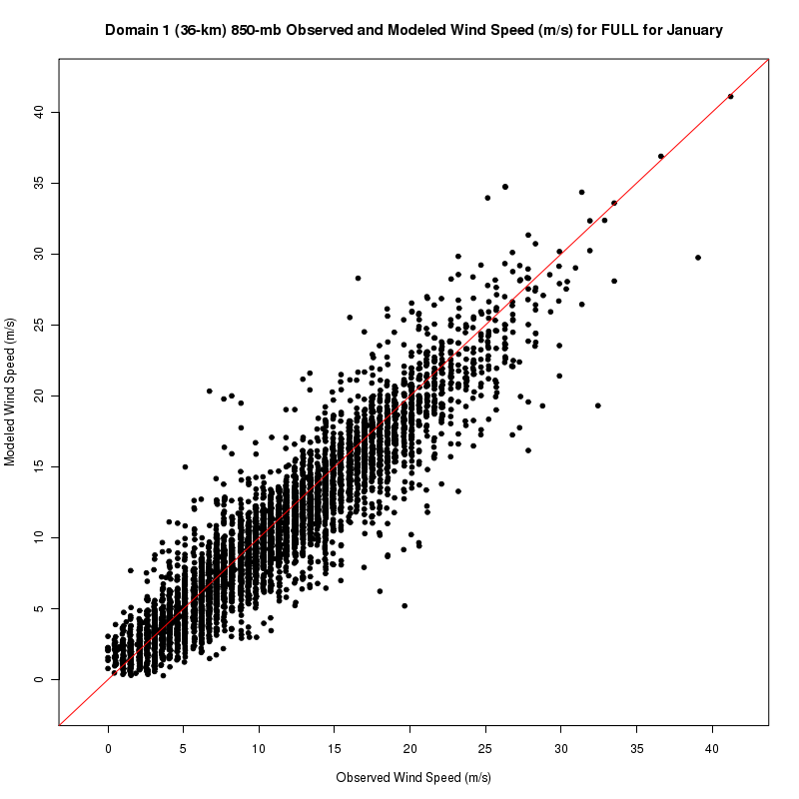
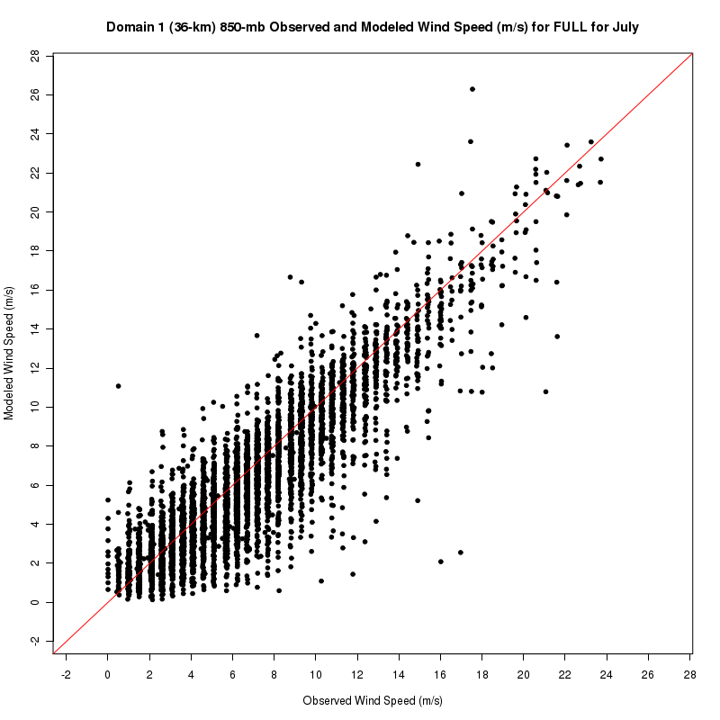

500 mb and 300 mb

Similarly to the previous section, the following section will mostly show scatter plots at the 500-mb level as these are very representative of the scatter plots at 300 mb.

Temperature

The scatter plots of temperature for both the 500-mb and 300-mb levels show that the observations and model data are well correlated with just a few significant outliers. The correlation weakens a bit during July especially at locations with colder 500 mb temperatures at the low end of the plot. The last plot shows the 300 mb temperature scatter plot which shows a slight positive bias at the coldest temperatures with observations slightly colder than the WRF simulation.
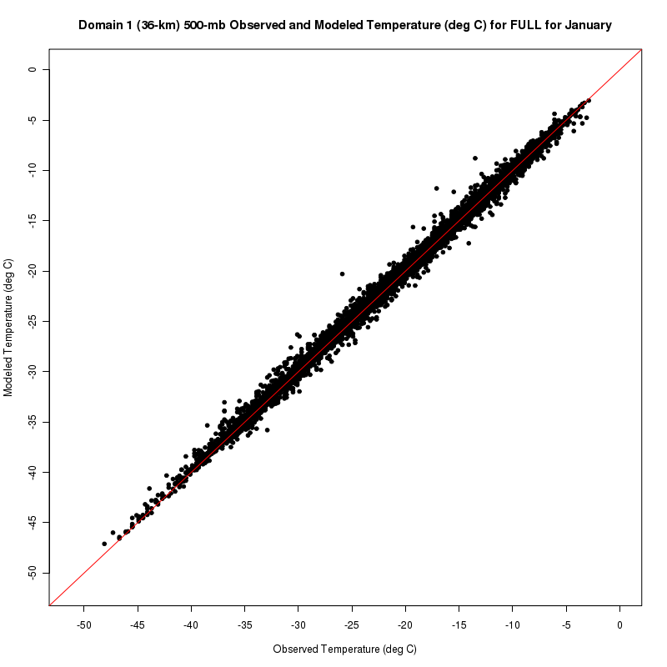
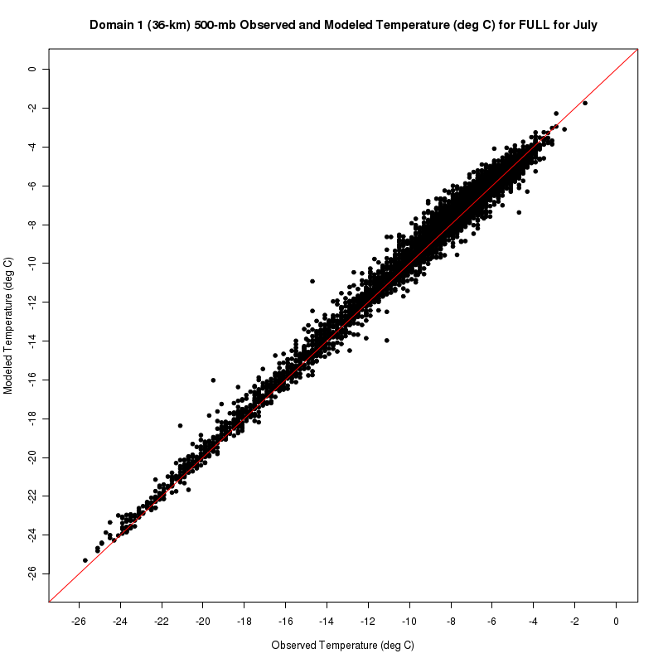

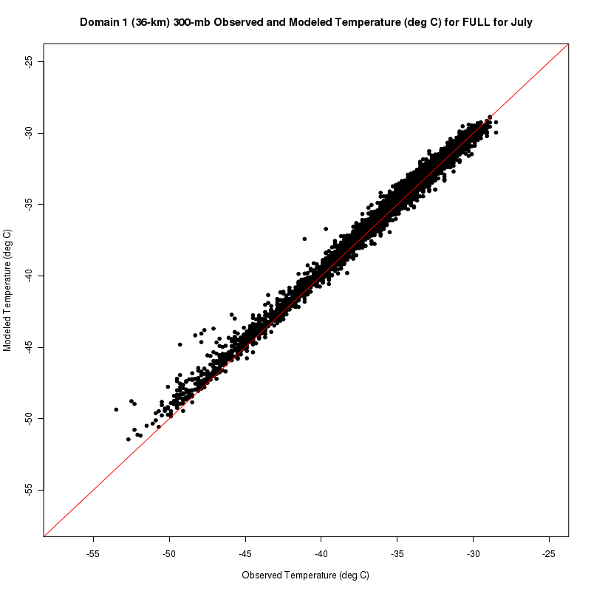

Specific Humidity

The specific humidity scatter plots for the 500-mb and 300-mb levels similar to the previous section show that the correlation between the observed and modeled data is better at low moisture values, in this case under about 1.5 g/kg. There does not appear to be any significant bias in these data as the points are evenly distributed to the left and right of the red 1:1 line. As with the July scatter plot for 850 mb, the data is more spread out and the correlation appears a bit weaker. At 300 mb, a significant positive bias in the specific humidity is noted for July with a majority of the points left of the 1:1 line indicating that the model is producing values that are higher than the observed values.
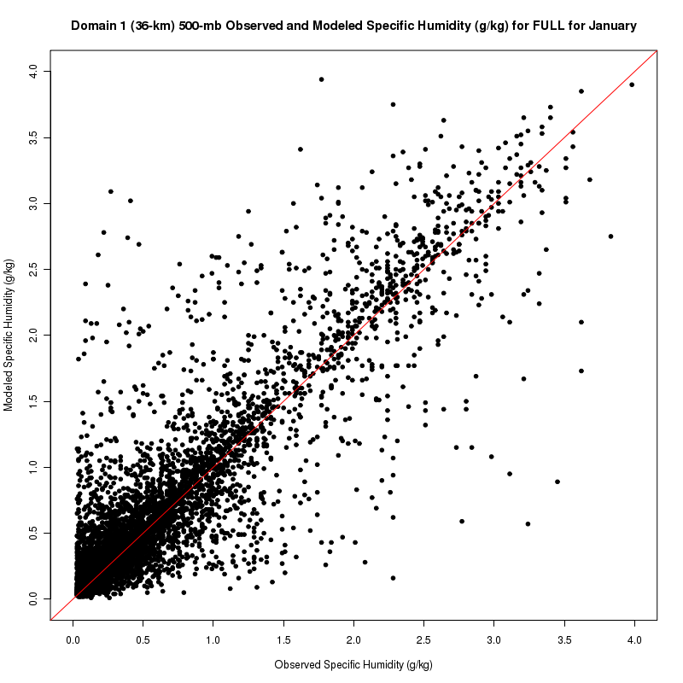

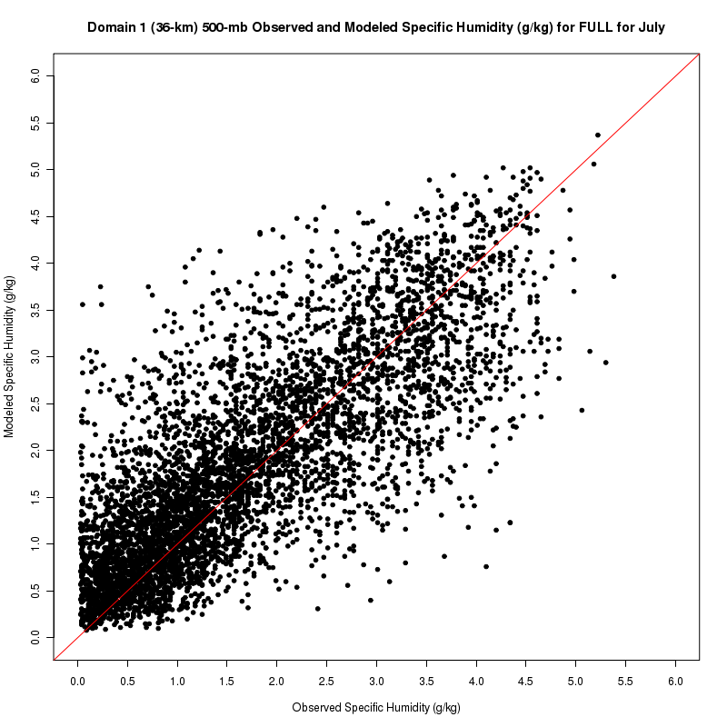

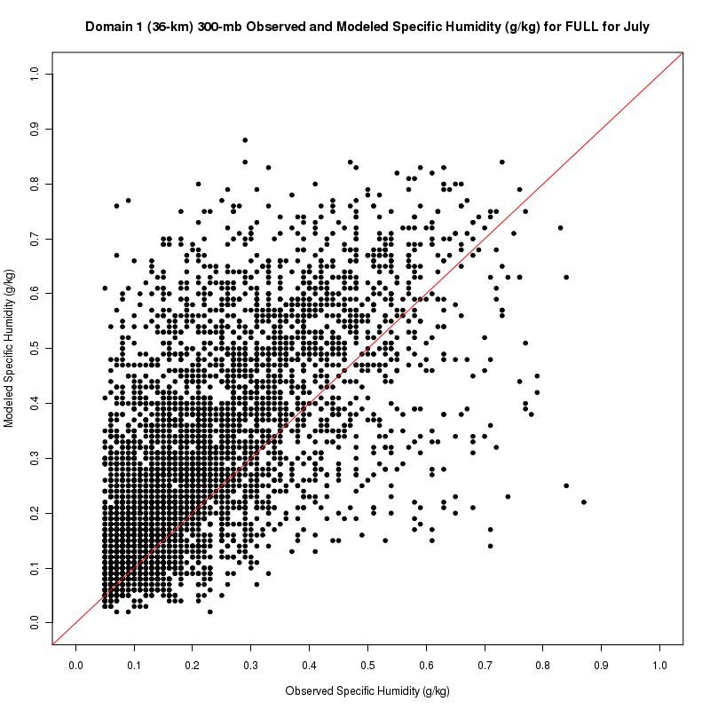

Wind Speed

At the 500-mb level, the observed and modeled wind speeds are well correlated with perhaps a slight negative bias in the WRF model output at wind speeds in excess of about 50 m/s. This pattern is similar for the month of July with observed wind speeds greater than the modeled wind speeds at the high end of the plot as well.
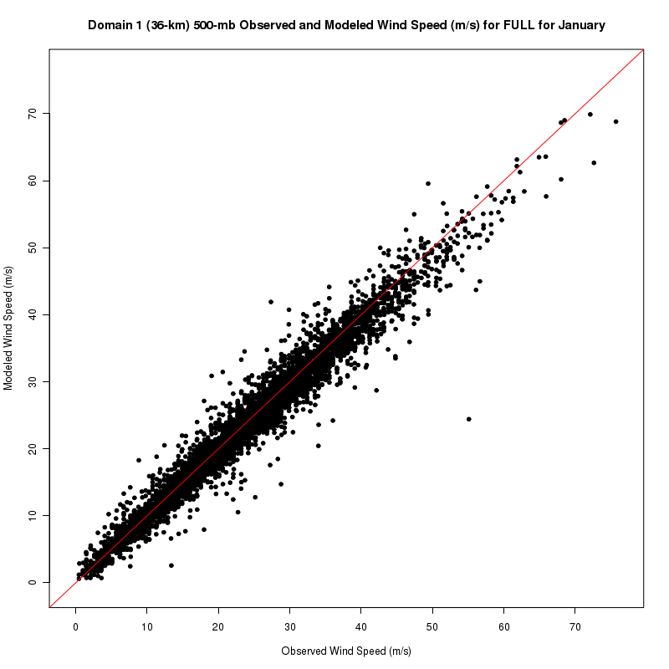
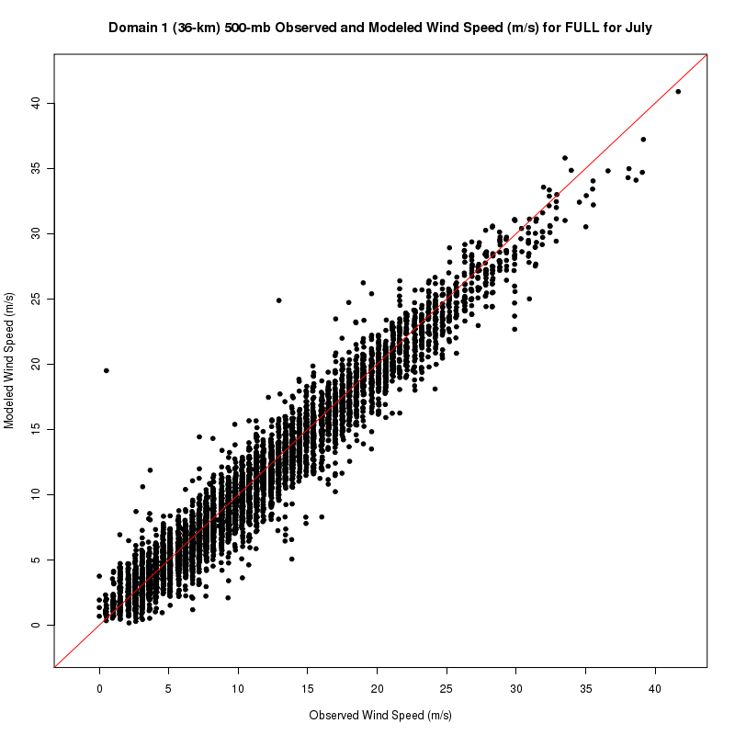

Tasks 2 I and 5 C: Line plots of error statistics

The following section reports on the error statistics of the FULL region (the entire model domains) of both domains 1 and 2. The analysis is conducted on 4 different pressure levels as well as the surface. The pressure levels analyzed with an approximate height levels in parenthesis are: 300 mb (9500 m), 500 mb (5750 m), 700 mb (3000 m), and 850 mb (1500 m). Additional plots for geographic sub-regions are available on the website.

300 mb

The temperature time series shows that the WRF model has a slight, but consistent positive bias relative to the observations. The errors for temperature at this level are quite small between 0.5° C and 1.0° C below the 2.0° C maximum error target. The errors for the dew point temperature are quite large with a mean absolute error averaging about 6° C. The dew point temperature profile also shows that the modeled dew point transitions from a negative to neutral bias during the winter to a positive bias from late spring through summer. The error statistics for relative humidity are consistent with those for the dew point temperature. The positive bias in dew point contributes to a positive bias of 15-20% in relative humidity. The specific humidity, wind speed, and wind direction are generally well simulated at the 300 mb level. Correlations between the modeled and observed parameters are very high for temperature and wind speed, but indicate a weakened relationship for dew point and relative humidity. Differences between domain 1 and domain 2 at the 300 mb level were found to be minimal.

Domain 1
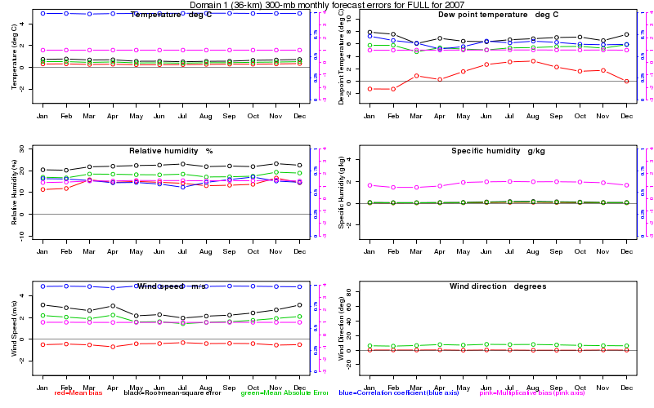

Domain 2
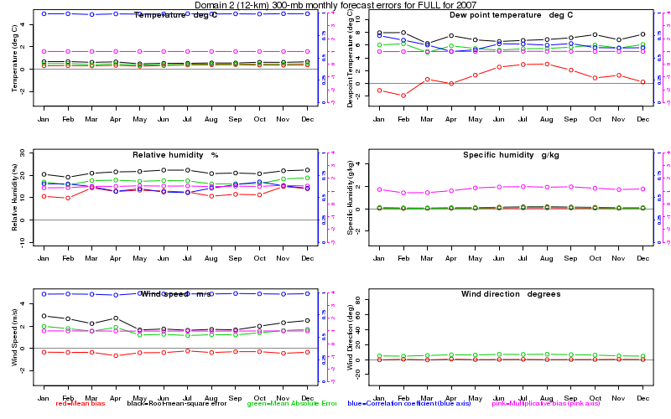

500 mb

The error statistics at 500 mb are very similar to those at 300 mb. The temperature is well predicted by the WRF model with errors consistently below the 2° C error metric and the bias at this level is minimal. The mean absolute errors for the dew point temperature are similarly high to the errors at 300 mb averaging near 6° C. The root mean squared error (RMSE) is somewhat higher than at 300 mb suggesting that very large errors in the dew point temperature are possible at the 500-mb level. The mean absolute error of the relative humidity field at the 500-mb level is slightly lower between 10 and 15% and the correlations between the WRF model simulation and the observations are significantly improved over those at the 300 mb. Specific humidity, wind speed, and wind direction continue to be well simulated at this level as well. Differences between domain 1 and domain 2 at the 500-mb level are minimal.

Domain 1
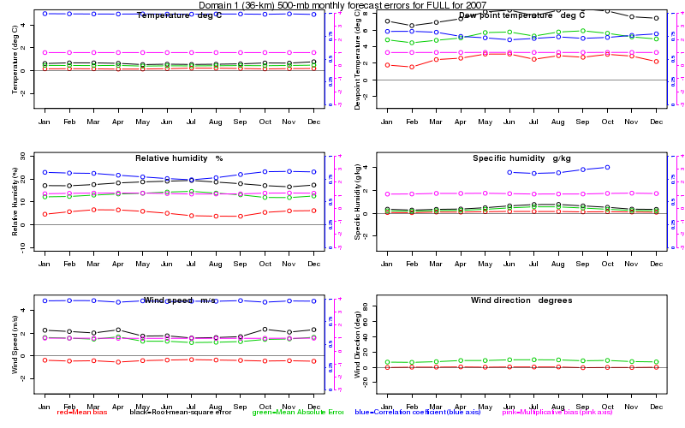

Domain 2
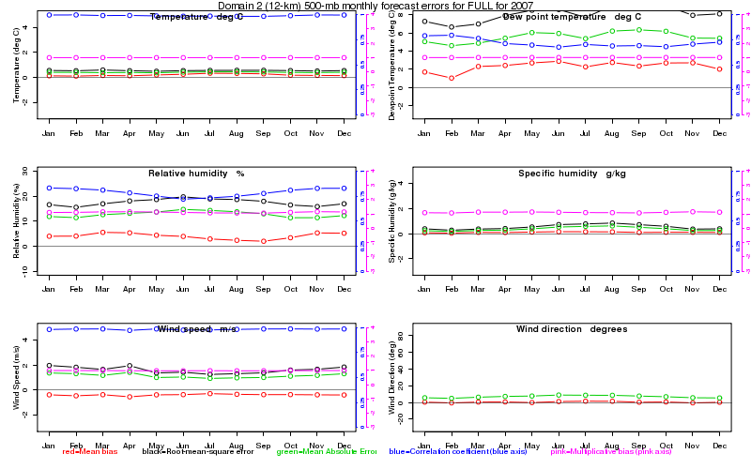

700 mb

The error statistics for temperature at the 700-mb level show the parameter to be well simulated by the WRF model. Absolute mean errors generally remain under 1° C and the model results are highly correlated with the observations. The dew point temperature has a positive bias during the cool season with errors that are quite large, generally exceeding 4° C. The observed bias also appears to be more significant for domain 1 than domain 2. The relative humidity has a mean absolute error of near 10% at this level, but the bias is neutral. At the 700-mb level, the specific humidity has nearly a 1 g/kg mean absolute error during the summer months. The modeled wind speed remains highly correlated with the observations at this level although the bias is slightly negative and the RMSE is close to the maximum RMSE target of 2 m/s. The wind direction errors are larger than at higher pressure levels, but have a mean absolute error of less than 20°. The wind parameters are generally modeled better in domain 2 than in domain 1.

Domain 1
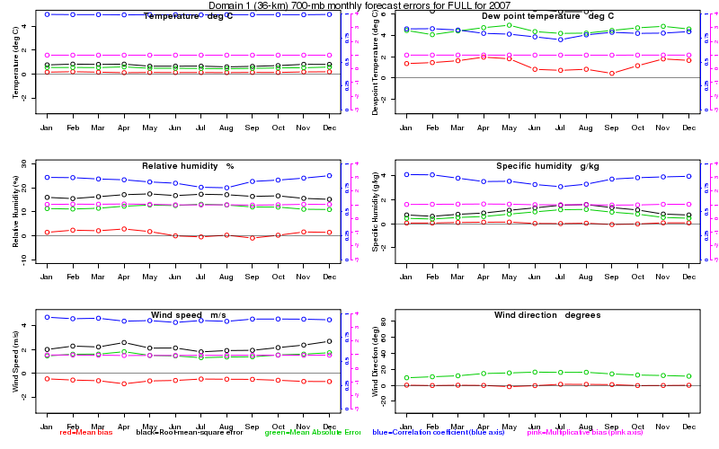

Domain 2
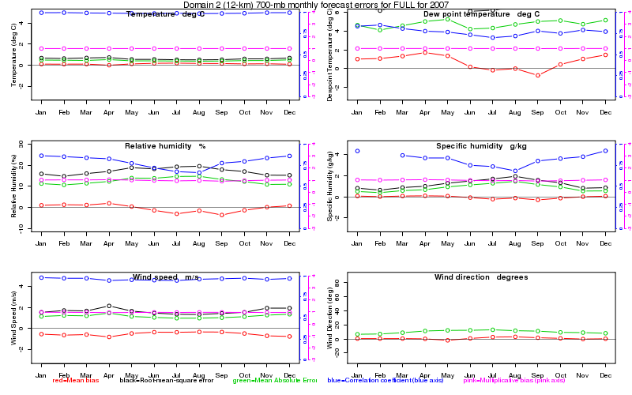

850 mb

The 850-mb temperature is well simulated by the WRF model and remains highly correlated with the observations. The 850-mb dew point temperature maintains a slight positive bias in domain 1 that does not appear in domain 2. The mean absolute errors and RMSE are moderately reduced as compared with those at the 700-mb level. The correlation between the modeled dew point and the observations also improves slightly. The relative humidity at this level has small bias and mean absolute errors that are near 10%. Although the bias is small, the mean absolute errors for specific humidity during the summer months approach 2 g/kg. The correlations for relative humidity and specific humidity are much higher during the same period for domain 1 than domain 2. The WRF model wind speed remains highly correlated with the observations at the 850-mb level although the bias is slightly negative and the RMSE is near the maximum RMSE target of 2 m/s. Wind direction errors are near 20° in domain 1, but decrease somewhat for domain 2. The wind parameters are, similar to the 700-mb level, modeled better in domain 2 than in domain 1.

Domain 1
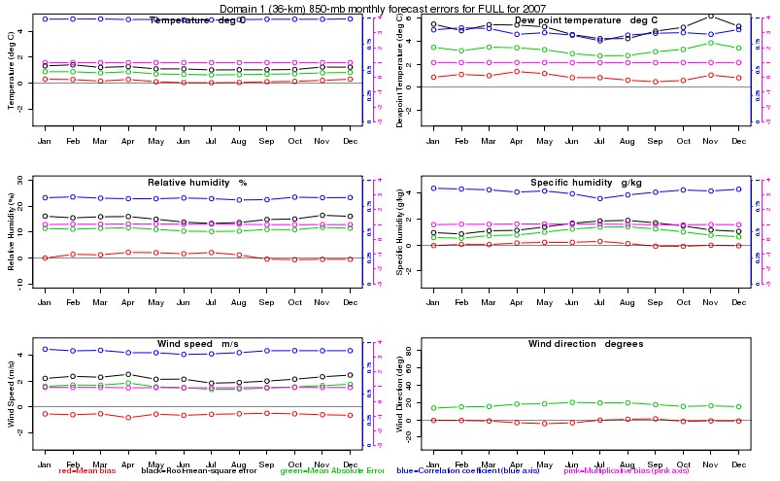

Domain 2
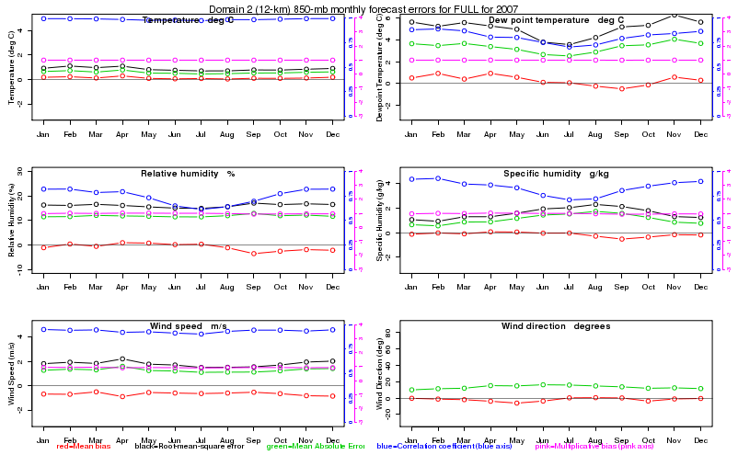

Surface

The temperature errors increase significantly at the surface as compared with pressure levels above the surface. Although the bias remains relatively small, the mean absolute errors are close to 2° C, which is very near the maximum error target. The modeled temperatures have slightly better error statistics for domain 2 than domain 1. The dew point temperatures simulated by the WRF model have a positive bias during the winter months, but a more nearly neutral bias the rest of the year. The mean absolute errors are highest during the cool season with values approaching 3° C, larger than the target threshold of 2° C. The biases found in the relative humidity field are similar to the dew point temperature – larger in the winter months and more neutral during the remainder of the year. The correlations for the relative humidity parameters fall significantly for domain 2. The mean absolute errors for specific humidity are largest during the summer and slightly larger for domain 2. The bias in the specific humidity field at the surface is neutral. The surface wind speed mean absolute errors are near 2 m/s, but the bias is minimal. The modeled wind direction at the surface has the largest error of any of the levels that have been examined. There is a mean absolute error of roughly 40° that far exceeds the maximum target given for gross error in wind direction.

Domain 1
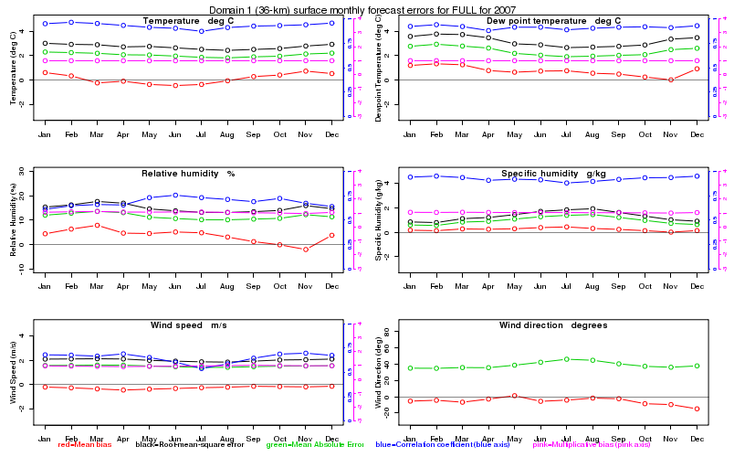

Domain 2
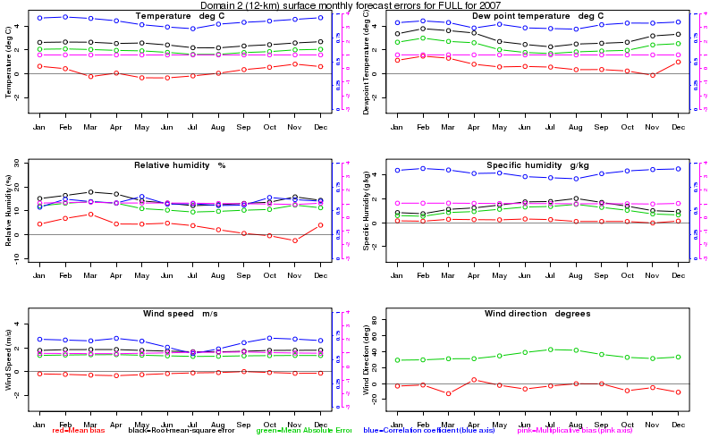

Monthly plots (surface)

Monthly plots from January and July in domain 1 are shown below to highlight the seasonality of the WRF model performance at the surface. The January plot shows that temperatures at the surface are more strongly correlated with the observations than in July; however, the mean absolute error remains relatively large near 2° C. The dew point temperature shows a similar pattern except that it runs a more consistent positive bias especially during the month of January. The mean absolute errors in relative humidity are larger in the month of January and, as with dew point temperature, there is a slight positive bias for this period. The correlation coefficient between the relative humidity modeled by WRF and the observations are depressed especially in January, most likely a result of the larger absolute error and observed variability in dew point temperature errors. The mean absolute errors in the specific humidity are slightly larger in July, but this is likely due to higher moisture availability during the warm season. The mean bias data for specific humidity shows that generally the WRF over predicts the specific humidity in July. Wind speeds, consistent with earlier results, have mean absolute errors of under 2 m/s, with very small bias during both January and July. Wind direction errors are quite large around 40° at the surface, as the model is likely not simulating the frictional effects near the surface particularly well.

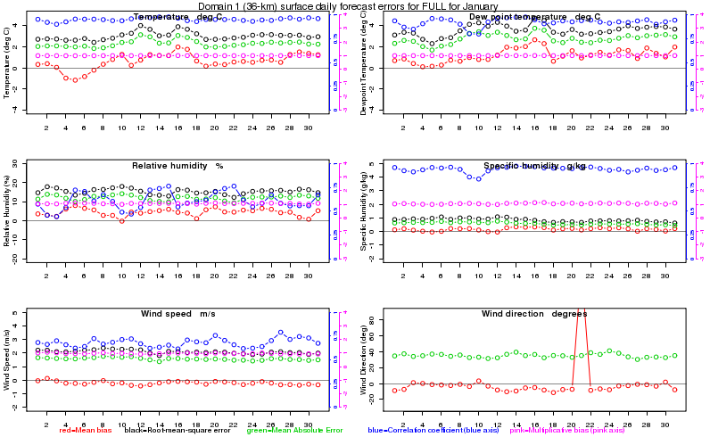

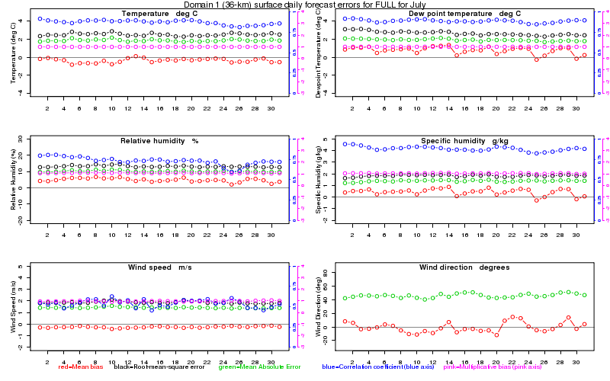

Task 5 B 4: Tables of Annual Statistics

This section presents summary tables of annual statistics for domain 2 modeled fields for each region. These tables are available on the project web site in Task 5 B 4. Brief discussion is provided for the regions FULL and SEMAP. For the metrics that are compared to the target ranges in Section 2.6, green indicates that the modeled error lies within the target range, while red indicates that is lies outside the target range. This simple color coding is only designed to highlight model performance and should not be construed as a simple pass/fail judgment. The reader should be reminded that the values contained in Section 2.6 are target values from the historical record. Note that rounding may introduce small disagreements between values in different columns.

FULL
Field | Number of Obs | Model Mean | Obs Mean | Mean Bias | Mean Absolute Error | Root-Mean-Squared Error | Correlation Coefficient | Multiplicative Bias
Temperature (degrees C) | 18082480 | 12.7 | 12.6 | 0.2 | 1.9 | 2.5 | 0.92 | 1.001
Dew Point Temperature  (degrees C) | 16272421 | 7.4 | 6.8 | 0.7 | 2.2 | 3.0 | 0.89 | 1.002
Relative Humidity (%) | 16272365 | 73.2 | 69.8 | 3.4 | 11.4 | 14.6 | 0.59 | 1.049
Specific Humidity (g/kg) | 17015610 | 8.0 | 7.9 | 0.2 | 1.0 | 1.3 | 0.90 | 1.028
Wind Speed (m/s) | 17648777 | 3.4 | 3.5 | -0.2 | 1.4 | 1.8 | 0.68 | 0.994
Wind Direction (degrees) | 17648777 |  |  | -4.2 | 34.6

Temperature

Annual MAEs for temperature lie within the target value and daily values do not exhibit any unexpected characteristics. Daily MAE values are largest, often upwards of 2.5 degrees Celsius, for a number of days during the cold months of November through April, with summertime values at times below 1.5 degree Celsius. Some of the larger daily errors are clustered together in time, often in five-day segments, which strongly indicates that individual model runs suffered from poor initialization. Annual values of mean bias are small. Daily values during the summer almost exclusively are within 1 degree Celsius, while the most extreme values occurred during the three other seasons. The spring and early summer from March through July produced the vast majority of days with a negative temperature bias. Days with the largest positive bias occurred mostly from October through April. An especially poor period with large (positive) forecast errors occurred in early April.

Dew Point Temperature

The annual mean bias of 0.7 degrees indicates that, on average, modeled dew point temperatures were higher than observed. Significantly contributing to this domain-wide bias is the widespread over-prediction of dew point temperatures in the northern parts of the modeling domain during the colder months. This problem persists from December through April. The MAEs are notably larger during the winter months, again predominantly in the northern part of the modeling domain. Problems with snow cover in the model may be a contributing factor.

Relative Humidity

Annual mean bias values also indicate modeled fields with slightly higher levels of relative humidity than observed. The occurrence of days with over-predicted relative humidity is concentrated strongly in December and from January through May and, again, in the northern parts of the modeling domain. March, by far, has the most days with the largest mean bias values. The only months with daily negative mean bias values of magnitude greater than 5% are October and November. The overall annual MAE of 11.4% is generally representative of individual daily MAE values. As might be expected, there is a minimum during the summer months, while maximum winter gross errors exceed 15% on a handful of days.

Specific Humidity

A small positive mean bias, well within the target range, is seen in the annual specific humidity field, which agrees with the characteristics of the dew point temperature and relative humidity. A positive bias in the Northeastern states is present during March and April. The magnitude, persistence and large-scale nature of this bias, especially during the cold season when absolute values of the atmospheric moisture are at a minimum, again suggests a link to how the model handles snowcover. MAE values overall are very close to the target value and are largest south of 40 ºN latitude during the months of August and September. The lack of a widespread and persistent mean bias signature at this time, indicative of errors all of the same sign, suggests that the larger MAE values may be largely due to the fact that atmospheric moisture content is close to its maximum and thus subject to the largest error.

Wind Speed

The annual mean bias lies within the target range, and both it and the MAE are quite small and show no significant temporal variability during the course of the year. MAE errors overall are slightly higher in the northern parts of the modeling domain in the winter and spring when overall wind speeds are highest and the passage of synoptic weather systems increases the variability of the wind field. The annual RMSE is slightly less than the target of 2 m/s.

Wind Direction

(Note that, by convention, wind direction indicates the direction from which the wind is blowing. Here we denote, for instance, zero degrees as a North wind, 90 degrees as an East wind and -90 degrees as a West wind.) While the mean bias is well inside the target range, the MAE is slightly larger than the target value of 30 degrees. Thus, while there are substantial deviations from the observed wind, they do not exhibit a substantial bias in direction. The wind direction field is strongly affected by local topography, and, while there are no expansive and persistent regions of significant mean bias, individual stations for any one day can exhibit large biases. These individual episodes of large bias are likely tied to poor modeling of synoptic features and can be sufficiently persistent to affect monthly averages, especially in mountainous or otherwise elevated terrain. Indeed, such areas suffer from the largest and most persistent MAE values. This is most noticeable in the Appalachian mountains throughout the year. During the summer months with lighter winds, individual sites throughout the modeling domain can suffer at times from large MAE values.

SEMAP

Field | Number of Obs | Model Mean | Obs Mean | Mean Bias | Mean Absolute Error | Root-Mean-Squared Error | Correlation Coefficient | Multiplicative Bias
Temperature | 3250685 | 17.9 | 17.6 | 0.3 | 1.8 | 2.3 | 0.81 | 1.001
Dew Point Temperature | 3104743 | 10.9 | 10.6 | 0.4 | 2.2 | 2.8 | 0.78 | 1.001
Relative Humidity | 3104716 | 68.9 | 67.5 | 1.5 | 11.2 | 14.2 | 0.47 | 1.021
Specific Humidity | 3107904 | 9.6 | 9.5 | 0.2 | 1.2 | 1.5 | 0.76 | 1.019
Wind Speed | 3139180 | 2.5 | 2.6 | -0.0 | 1.3 | 1.6 | 0.52 | 1.115
Wind Direction | 3139180 |  |  | -1.5 | 42.8

Temperature

Annual MAEs for temperature lie within the target value and daily values do not exhibit any unexpected characteristics. Daily MAE values are largest, often upwards of 2.5 degrees Celsius, for a number of days during the cold months of October through April, with summertime values mostly below 2 degrees Celsius. Some of the larger daily errors are clustered together in time, often in five-day segments, strongly indicating that individual model runs suffered from poor initialization. As for FULL, an especially bad forecast segment occurred in early April. Annual values of mean bias are small and, again, do not indicate a problem. Daily values during the summer almost exclusively are within 1 degree Celsius, while the most extreme values occurred during the three other seasons. During these cooler seasons, individual days exhibit the largest mean biases, sometimes in excess of 2.5 degrees Celsius.

Dew Point Temperature

The annual mean bias of 0.4 degrees indicates that, on average, modeled dew point temperatures were higher than observed. Of note are the episodes of poorly predicted dew point temperatures centered over North Carolina during November. Detailed analysis is beyond the scope of this project, but during this month there were a number of consecutive days that exhibited large negative mean bias values. The largest MAEs are found in the mountainous or otherwise elevated regions.

Relative Humidity

Annual mean bias values also indicate modeled fields with slightly higher levels of relative humidity than observed. The occurrence of days with under-predicted relative humidity is concentrated strongly in November, as noted above for dew point temperature. During the rest of the year, there is a predominance of positive daily mean bias of up to 10-15%. The annual MAE of 11.2% is generally representative of individual daily MAE values. As might be expected, there is a minimum during the summer months, while maximum winter gross errors exceed 15% on a handful of days. These are focused somewhat during the month of November.

Specific Humidity

A small positive mean bias, well within the target range, is seen in the annual specific humidity field, which agrees with the characteristics of the dew point temperature and relative humidity. A positive bias, with a corresponding increase in MAE, in some individual locations that are mostly located in mountainous terrain or plateaus, develops during the summer, peaks in August, then diminishes during the fall. Mean bias values in the fall and early winter are then near zero or slightly negative. It is hypothesized that the positive bias that peaks in August may reflect inadequate model representation of topography, with model locations being positioned at lower elevations than in reality and subjected to higher values of PBL moisture in an otherwise horizontally-uniform moisture environment.

Wind Speed

The annual mean bias and MAE both lie within the target range and show no important temporal variability during the course of the year. The annual RMSE is acceptably less than the target of 2 m/s.

Wind Direction

The mean bias for SEMAP lies within the target range, while, as for FULL, the MAE is slightly larger than the target of 30 degrees. As for FULL, deviations of the wind from observed while large do not exhibit a substantial bias in direction. This meteorological field is strongly affected by local topography, and, while there are no expansive and persistent regions of significant mean bias (since the signs of the individual errors often cancel), regions of mountainous topography do suffer from the largest and most persistent MAE values. Along the spine of the Appalachian mountains, it is commonplace throughout the year to exceed the target MAE value. During the summer months with lighter winds, individual sites throughout the modeling domain can suffer at times from large MAE values.

CENRAPN
Field | Number of Obs | Model Mean | Obs Mean | Mean Bias | Mean Absolute Error | Root-Mean-Squared Error | Correlation Coefficient | Multiplicative Bias
Temperature | 3251073 | 9.4 | 9.2 | 0.2 | 2.0 | 2.4 | 0.82 | 1.001
Dew Point Temperature | 3246133 | 4.2 | 3.4 | 0.8 | 2.3 | 2.8 | 0.74 | 1.003
Relative Humidity | 3246133 | 74.3 | 70.4 | 3.9 | 11.2 | 13.8 | 0.52 | 1.054
Specific Humidity | 3246299 | 6.9 | 6.7 | 0.2 | 0.9 | 1.1 | 0.74 | 1.052
Wind Speed | 3232104 | 3.8 | 4.0 | -0.2 | 1.3 | 1.6 | 0.63 | 0.999
Wind Direction | 3232104 |  |  | -5.7 | 31.0

CENRAPS
Field | Number of Obs | Model Mean | Obs Mean | Mean Bias | Mean Absolute Error | Root-Mean-Squared Error | Correlation Coefficient | Multiplicative Bias
Temperature | 3034465 | 18.4 | 18.0 | 0.5 | 1.8 | 2.3 | 0.74 | 1.002
Dew Point Temperature | 3014970 | 11.4 | 11.7 | -0.3 | 2.1 | 2.7 | 0.75 | 0.999
Relative Humidity | 3014970 | 68.5 | 70.5 | -2.0 | 10.8 | 13.6 | 0.50 | 0.967
Specific Humidity | 3015096 | 10.1 | 10.3 | -0.2 | 1.2 | 1.5 | 0.70 | 0.975
Wind Speed | 2969315 | 3.1 | 3.3 | -0.2 | 1.3 | 1.6 | 0.60 | 1.013
Wind Direction | 2969315 |  |  | -1.0 | 35.9

MANEVU
Field | Number of Obs | Model Mean | Obs Mean | Mean Bias | Mean Absolute Error | Root-Mean-Squared Error | Correlation Coefficient | Multiplicative Bias
Temperature | 2002709 | 9.8 | 9.9 | -0.2 | 1.8 | 2.3 | 0.82 | 0.999
Dew Point Temperature | 1914305 | 5.2 | 3.5 | 1.7 | 2.6 | 3.2 | 0.66 | 1.006
Relative Humidity | 1914304 | 77.4 | 68.0 | 9.4 | 13.4 | 16.4 | 0.44 | 1.157
Specific Humidity | 1923324 | 6.8 | 6.3 | 0.4 | 0.9 | 1.2 | 0.64 | 1.132
Wind Speed | 1895332 | 3.0 | 3.1 | -0.1 | 1.4 | 1.7 | 0.49 | 1.049
Wind Direction | 1895332 |  |  | -4.3 | 41.0

MRPO
Field | Number of Obs | Model Mean | Obs Mean | Mean Bias | Mean Absolute Error | Root-Mean-Squared Error | Correlation Coefficient | Multiplicative Bias
Temperature | 2919819 | 9.9 | 9.8 | 0.1 | 1.9 | 2.5 | 0.77 | 1.000
Dew Point Temperature | 2750615 | 5.1 | 4.0 | 1.1 | 2.3 | 3.0 | 0.67 | 1.004
Relative Humidity | 2750615 | 75.6 | 69.8 | 5.8 | 11.8 | 14.5 | 0.48 | 1.085
Specific Humidity | 2751158 | 6.9 | 6.6 | 0.3 | 0.9 | 1.1 | 0.69 | 1.074
Wind Speed | 2898290 | 3.4 | 3.5 | -0.1 | 1.3 | 1.7 | 0.53 | 1.063
Wind Direction | 2898290 |  |  | -9.3 | 37.2

AL
Field | Number of Obs | Model Mean | Obs Mean | Mean Bias | Mean Absolute Error | Root-Mean-Squared Error | Correlation Coefficient | Multiplicative Bias
Temperature | 267984 | 18.5 | 18.1 | 0.4 | 1.9 | 2.2 | 0.54 | 1.002
Dew Point Temperature | 259275 | 11.5 | 11.0 | 0.6 | 2.2 | 2.6 | 0.52 | 1.002
Relative Humidity | 259269 | 68.4 | 66.8 | 1.5 | 11.1 | 13.4 | 0.28 | 1.029
Specific Humidity | 259281 | 9.9 | 9.5 | 0.4 | 1.2 | 1.5 | NA | 1.039
Wind Speed | 257290 | 2.3 | 2.4 | -0.1 | 1.2 | 1.5 | 0.29 | 1.303
Wind Direction | 257290 |  |  | 4.8 | 47.1

AR
Field | Number of Obs | Model Mean | Obs Mean | Mean Bias | Mean Absolute Error | Root-Mean-Squared Error | Correlation Coefficient | Multiplicative Bias
Temperature | 329163 | 16.6 | 16.3 | 0.3 | 1.8 | 2.2 | 0.57 | 1.001
Dew Point Temperature | 328968 | 10.0 | 9.9 | 0.1 | 1.9 | 2.3 | 0.53 | 1.000
Relative Humidity | 328968 | 69.8 | 69.1 | 0.7 | 10.6 | 12.7 | 0.33 | 1.003
Specific Humidity | 328984 | 9.3 | 9.2 | 0.1 | 1.0 | 1.2 | NA | 1.006
Wind Speed | 316425 | 2.7 | 2.7 | -0.0 | 1.2 | 1.5 | 0.40 | 1.164
Wind Direction | 316425 |  |  | -5.4 | 42.3

DC
Field | Number of Obs | Model Mean | Obs Mean | Mean Bias | Mean Absolute Error | Root-Mean-Squared Error | Correlation Coefficient | Multiplicative Bias
Temperature | 12369 | 14.5 | 14.8 | -0.3 | 1.8 | 1.9 | 0.00 | 0.999
Dew Point Temperature | 12369 | 6.4 | 6.5 | -0.2 | 2.3 | 2.3 | 0.00 | 1.000
Relative Humidity | 12369 | 63.7 | 60.4 | 3.3 | 11.9 | 11.9 | 0.00 | 1.063
Specific Humidity | 12369 | 7.2 | 7.4 | -0.2 | 1.0 | 1.0 | NA | 1.015
Wind Speed | 12342 | 2.5 | 3.8 | -1.3 | 1.6 | 1.6 | 0.00 | 0.591
Wind Direction | 12342 |  |  | 27.6 | 32.2

FL
Field | Number of Obs | Model Mean | Obs Mean | Mean Bias | Mean Absolute Error | Root-Mean-Squared Error | Correlation Coefficient | Multiplicative Bias
Temperature | 677614 | 22.4 | 22.1 | 0.3 | 1.6 | 2.0 | 0.64 | 1.001
Dew Point Temperature | 582110 | 16.4 | 16.1 | 0.3 | 1.9 | 2.4 | 0.48 | 1.001
Relative Humidity | 582110 | 72.6 | 71.5 | 1.1 | 9.7 | 11.9 | 0.36 | 1.015
Specific Humidity | 582161 | 12.4 | 12.3 | 0.1 | 1.3 | 1.7 | 0.51 | 1.009
Wind Speed | 657579 | 2.6 | 3.2 | -0.5 | 1.4 | 1.7 | 0.41 | 0.918
Wind Direction | 657579 |  |  | 0.2 | 41.7

GA
Field | Number of Obs | Model Mean | Obs Mean | Mean Bias | Mean Absolute Error | Root-Mean-Squared Error | Correlation Coefficient | Multiplicative Bias
Temperature | 403666 | 18.7 | 18.2 | 0.4 | 1.9 | 2.4 | 0.57 | 1.002
Dew Point Temperature | 399664 | 11.3 | 11.2 | 0.1 | 2.4 | 3.0 | 0.51 | 1.000
Relative Humidity | 399653 | 67.1 | 67.6 | -0.5 | 11.6 | 14.4 | 0.29 | 0.995
Specific Humidity | 399751 | 9.8 | 9.7 | 0.1 | 1.3 | 1.7 | 0.65 | 1.001
Wind Speed | 388828 | 2.4 | 2.2 | 0.2 | 1.2 | 1.5 | 0.34 | 1.589
Wind Direction | 388828 |  |  | -4.5 | 46.9

IA
Field | Number of Obs | Model Mean | Obs Mean | Mean Bias | Mean Absolute Error | Root-Mean-Squared Error | Correlation Coefficient | Multiplicative Bias
Temperature | 791648 | 10.3 | 10.1 | 0.2 | 1.9 | 2.2 | 0.65 | 1.001
Dew Point Temperature | 791118 | 5.0 | 4.7 | 0.4 | 2.2 | 2.6 | 0.50 | 1.001
Relative Humidity | 791118 | 74.5 | 71.8 | 2.8 | 10.6 | 12.5 | 0.34 | 1.034
Specific Humidity | 791118 | 7.2 | 7.1 | 0.1 | 0.9 | 1.1 | NA | 1.031
Wind Speed | 789918 | 3.8 | 4.0 | -0.2 | 1.3 | 1.6 | 0.46 | 1.022
Wind Direction | 789918 |  |  | -4.8 | 30.9

IL
Field | Number of Obs | Model Mean | Obs Mean | Mean Bias | Mean Absolute Error | Root-Mean-Squared Error | Correlation Coefficient | Multiplicative Bias
Temperature | 812881 | 12.5 | 12.1 | 0.4 | 1.9 | 2.6 | 0.63 | 1.001
Dew Point Temperature | 810870 | 6.5 | 5.6 | 0.9 | 2.5 | 3.4 | 0.45 | 1.003
Relative Humidity | 810870 | 71.9 | 68.0 | 3.8 | 11.8 | 14.3 | 0.32 | 1.056
Specific Humidity | 810884 | 7.5 | 7.2 | 0.3 | 1.0 | 1.4 | 0.61 | 1.061
Wind Speed | 808417 | 3.2 | 3.6 | -0.3 | 1.3 | 1.8 | 0.41 | 0.997
Wind Direction | 808417 |  |  | -7.7 | 40.4

IN
Field | Number of Obs | Model Mean | Obs Mean | Mean Bias | Mean Absolute Error | Root-Mean-Squared Error | Correlation Coefficient | Multiplicative Bias
Temperature | 226668 | 11.9 | 11.9 | 0.0 | 1.8 | 2.1 | 0.58 | 1.000
Dew Point Temperature | 211546 | 6.6 | 5.6 | 1.0 | 2.2 | 2.5 | 0.53 | 1.004
Relative Humidity | 211546 | 74.2 | 68.3 | 5.9 | 11.7 | 13.5 | 0.35 | 1.089
Specific Humidity | 211562 | 7.5 | 7.1 | 0.3 | 0.9 | 1.1 | NA | 1.077
Wind Speed | 225658 | 3.2 | 3.7 | -0.5 | 1.3 | 1.6 | 0.36 | 1.083
Wind Direction | 225658 |  |  | -9.8 | 36.3

KY
Field | Number of Obs | Model Mean | Obs Mean | Mean Bias | Mean Absolute Error | Root-Mean-Squared Error | Correlation Coefficient | Multiplicative Bias
Temperature | 185936 | 14.6 | 14.6 | -0.0 | 1.9 | 2.2 | 0.49 | 1.000
Dew Point Temperature | 185352 | 8.4 | 7.4 | 0.9 | 2.3 | 2.7 | 0.45 | 1.003
Relative Humidity | 185352 | 70.9 | 65.3 | 5.6 | 12.6 | 14.8 | 0.27 | 1.090
Specific Humidity | 185355 | 8.3 | 7.9 | 0.4 | 1.1 | 1.3 | NA | 1.069
Wind Speed | 178798 | 2.5 | 2.6 | -0.1 | 1.2 | 1.5 | 0.30 | 1.404
Wind Direction | 178798 |  |  | -19.9 | 44.1

LA
Field | Number of Obs | Model Mean | Obs Mean | Mean Bias | Mean Absolute Error | Root-Mean-Squared Error | Correlation Coefficient | Multiplicative Bias
Temperature | 340415 | 20.1 | 19.8 | 0.3 | 1.8 | 2.2 | 0.51 | 1.001
Dew Point Temperature | 325728 | 14.7 | 14.5 | 0.2 | 1.8 | 2.3 | 0.43 | 1.001
Relative Humidity | 325728 | 75.0 | 74.1 | 0.8 | 10.3 | 12.6 | 0.26 | 1.011
Specific Humidity | 325736 | 11.6 | 11.5 | 0.1 | 1.2 | 1.5 | NA | 1.010
Wind Speed | 326209 | 2.6 | 2.6 | 0.1 | 1.2 | 1.5 | 0.39 | 1.355
Wind Direction | 326209 |  |  | 0.1 | 41.9

MD
Field | Number of Obs | Model Mean | Obs Mean | Mean Bias | Mean Absolute Error | Root-Mean-Squared Error | Correlation Coefficient | Multiplicative Bias
Temperature | 244761 | 13.7 | 13.8 | -0.0 | 1.9 | 2.3 | 0.53 | 1.000
Dew Point Temperature | 227744 | 7.5 | 7.1 | 0.4 | 2.1 | 2.5 | 0.34 | 1.001
Relative Humidity | 227743 | 69.8 | 67.4 | 2.4 | 11.6 | 13.8 | 0.27 | 1.046
Specific Humidity | 227748 | 7.7 | 7.7 | 0.0 | 1.0 | 1.2 | NA | 1.031
Wind Speed | 232396 | 2.9 | 2.9 | -0.0 | 1.3 | 1.6 | 0.32 | 1.322
Wind Direction | 232396 |  |  | -13.1 | 42.1

MI
Field | Number of Obs | Model Mean | Obs Mean | Mean Bias | Mean Absolute Error | Root-Mean-Squared Error | Correlation Coefficient | Multiplicative Bias
Temperature | 838372 | 8.2 | 8.4 | -0.1 | 1.9 | 2.3 | 0.68 | 1.000
Dew Point Temperature | 719683 | 4.2 | 2.9 | 1.3 | 2.1 | 2.6 | 0.63 | 1.005
Relative Humidity | 719683 | 77.9 | 70.7 | 7.2 | 11.7 | 13.9 | 0.42 | 1.112
Specific Humidity | 720172 | 6.3 | 6.0 | 0.4 | 0.8 | 0.9 | NA | 1.099
Wind Speed | 834088 | 3.7 | 3.6 | 0.1 | 1.4 | 1.7 | 0.44 | 1.164
Wind Direction | 834088 |  |  | -13.1 | 37.7

MS
Field | Number of Obs | Model Mean | Obs Mean | Mean Bias | Mean Absolute Error | Root-Mean-Squared Error | Correlation Coefficient | Multiplicative Bias
Temperature | 189575 | 19.1 | 18.6 | 0.5 | 1.8 | 2.2 | 0.54 | 1.002
Dew Point Temperature | 189113 | 12.7 | 12.3 | 0.4 | 2.0 | 2.4 | 0.53 | 1.001
Relative Humidity | 189113 | 70.7 | 69.9 | 0.8 | 10.5 | 12.5 | 0.31 | 1.011
Specific Humidity | 189124 | 10.5 | 10.2 | 0.3 | 1.1 | 1.4 | NA | 1.024
Wind Speed | 182594 | 2.4 | 2.5 | -0.1 | 1.2 | 1.5 | 0.38 | 1.366
Wind Direction | 182594 |  |  | -2.4 | 43.7

NC
Field | Number of Obs | Model Mean | Obs Mean | Mean Bias | Mean Absolute Error | Root-Mean-Squared Error | Correlation Coefficient | Multiplicative Bias
Temperature | 603286 | 16.8 | 16.4 | 0.3 | 1.9 | 2.3 | 0.62 | 1.001
Dew Point Temperature | 594875 | 9.2 | 8.8 | 0.4 | 2.3 | 2.9 | 0.58 | 1.001
Relative Humidity | 594875 | 65.8 | 64.7 | 1.0 | 11.5 | 13.9 | 0.37 | 1.024
Specific Humidity | 594968 | 8.8 | 8.5 | 0.3 | 1.1 | 1.4 | 0.68 | 1.029
Wind Speed | 583869 | 2.5 | 2.3 | 0.2 | 1.3 | 1.6 | 0.40 | 1.518
Wind Direction | 583869 |  |  | -1.2 | 45.5

OH
Field | Number of Obs | Model Mean | Obs Mean | Mean Bias | Mean Absolute Error | Root-Mean-Squared Error | Correlation Coefficient | Multiplicative Bias
Temperature | 339806 | 11.4 | 11.3 | 0.1 | 1.8 | 2.1 | 0.59 | 1.000
Dew Point Temperature | 335165 | 6.0 | 5.2 | 0.8 | 2.2 | 2.6 | 0.38 | 1.003
Relative Humidity | 335165 | 74.1 | 69.0 | 5.1 | 12.1 | 14.2 | 0.30 | 1.076
Specific Humidity | 335177 | 7.2 | 6.9 | 0.2 | 0.9 | 1.1 | NA | 1.066
Wind Speed | 333355 | 3.0 | 3.4 | -0.4 | 1.3 | 1.5 | 0.43 | 1.038
Wind Direction | 333355 |  |  | -10.1 | 37.8

PA
Field | Number of Obs | Model Mean | Obs Mean | Mean Bias | Mean Absolute Error | Root-Mean-Squared Error | Correlation Coefficient | Multiplicative Bias
Temperature | 371524 | 10.5 | 10.7 | -0.2 | 1.8 | 2.1 | 0.72 | 0.999
Dew Point Temperature | 365735 | 6.1 | 4.0 | 2.1 | 2.8 | 3.6 | 0.39 | 1.008
Relative Humidity | 365735 | 77.9 | 67.3 | 10.6 | 14.1 | 17.3 | 0.33 | 1.181
Specific Humidity | 365743 | 7.2 | 6.5 | 0.7 | 1.0 | 1.3 | NA | 1.162
Wind Speed | 353747 | 2.8 | 2.9 | -0.2 | 1.3 | 1.6 | 0.41 | 1.133
Wind Direction | 353747 |  |  | -4.4 | 42.2

SC
Field | Number of Obs | Model Mean | Obs Mean | Mean Bias | Mean Absolute Error | Root-Mean-Squared Error | Correlation Coefficient | Multiplicative Bias
Temperature | 177570 | 18.2 | 17.9 | 0.3 | 1.7 | 2.1 | 0.44 | 1.001
Dew Point Temperature | 168137 | 10.3 | 10.1 | 0.2 | 2.2 | 2.6 | 0.62 | 1.001
Relative Humidity | 168128 | 65.3 | 64.5 | 0.8 | 10.7 | 12.7 | 0.35 | 1.019
Specific Humidity | 168145 | 9.3 | 9.1 | 0.2 | 1.1 | 1.3 | NA | 1.018
Wind Speed | 170346 | 2.6 | 2.9 | -0.3 | 1.2 | 1.5 | 0.33 | 1.148
Wind Direction | 170346 |  |  | -0.2 | 41.2

TN
Field | Number of Obs | Model Mean | Obs Mean | Mean Bias | Mean Absolute Error | Root-Mean-Squared Error | Correlation Coefficient | Multiplicative Bias
Temperature | 167722 | 16.3 | 16.1 | 0.1 | 1.8 | 2.2 | 0.64 | 1.001
Dew Point Temperature | 167612 | 9.2 | 8.6 | 0.6 | 2.1 | 2.5 | 0.52 | 1.002
Relative Humidity | 167612 | 67.7 | 64.4 | 3.3 | 11.4 | 13.6 | 0.35 | 1.052
Specific Humidity | 167631 | 8.7 | 8.4 | 0.3 | 1.1 | 1.3 | NA | 1.043
Wind Speed | 160097 | 2.4 | 2.4 | -0.0 | 1.3 | 1.5 | 0.34 | 1.440
Wind Direction | 160097 |  |  | -15.0 | 46.4

VA
Field | Number of Obs | Model Mean | Obs Mean | Mean Bias | Mean Absolute Error | Root-Mean-Squared Error | Correlation Coefficient | Multiplicative Bias
Temperature | 403095 | 14.7 | 14.7 | -0.0 | 2.0 | 2.4 | 0.62 | 1.000
Dew Point Temperature | 384814 | 7.4 | 7.5 | -0.1 | 2.2 | 2.8 | 0.54 | 1.000
Relative Humidity | 384813 | 66.5 | 65.9 | 0.5 | 12.0 | 14.6 | 0.31 | 1.008
Specific Humidity | 387698 | 7.9 | 8.0 | -0.1 | 1.1 | 1.3 | 0.75 | 0.987
Wind Speed | 391915 | 2.6 | 2.5 | 0.1 | 1.3 | 1.6 | 0.43 | 1.289
Wind Direction | 391915 |  |  | -1.9 | 47.0

WI
Field | Number of Obs | Model Mean | Obs Mean | Mean Bias | Mean Absolute Error | Root-Mean-Squared Error | Correlation Coefficient | Multiplicative Bias
Temperature | 702092 | 7.3 | 7.5 | -0.1 | 1.9 | 2.3 | 0.62 | 1.000
Dew Point Temperature | 672962 | 3.2 | 2.0 | 1.2 | 2.3 | 2.7 | 0.54 | 1.004
Relative Humidity | 672962 | 78.1 | 71.0 | 7.1 | 12.0 | 14.2 | 0.33 | 1.114
Specific Humidity | 672975 | 6.2 | 6.0 | 0.2 | 0.8 | 0.9 | NA | 1.097
Wind Speed | 696772 | 3.6 | 3.3 | 0.3 | 1.2 | 1.6 | 0.42 | 1.277
Wind Direction | 696772 |  |  | -2.3 | 36.0

WV
Field | Number of Obs | Model Mean | Obs Mean | Mean Bias | Mean Absolute Error | Root-Mean-Squared Error | Correlation Coefficient | Multiplicative Bias
Temperature | 174258 | 12.1 | 12.2 | -0.1 | 2.0 | 2.4 | 0.54 | 1.000
Dew Point Temperature | 174172 | 7.0 | 5.7 | 1.3 | 2.4 | 2.9 | 0.41 | 1.005
Relative Humidity | 174172 | 75.1 | 68.4 | 6.7 | 13.6 | 16.1 | 0.26 | 1.116
Specific Humidity | 174172 | 7.8 | 7.3 | 0.5 | 1.1 | 1.3 | NA | 1.100
Wind Speed | 167864 | 2.7 | 2.0 | 0.6 | 1.5 | 1.8 | 0.26 | 2.436
Wind Direction | 167864 |  |  | -28.9 | 53.5

Disregarding wind direction, there is excellent model performance in the tables above relative to the target metrics. All variables for each region have error values (mean bias or MAE/RMSE) less than or equal to the target metrics, except for the one isolated case of Washington DC’s wind speed bias. Note that the sample size for this region is between one and two orders of magnitude smaller than for other regions and oftentimes there is only one available observing site.

Across most regions, wind direction MAE are larger than the target of 30 degrees, though most often this statistic is marginally outside the target range. The mean bias, on the other hand, does not indicate a chronic problem with the modeled wind vectors, thus the large MAE values may be associated in general with poor model representation of topography, including coastlines and perhaps the occurrence and timing of sea breezes.

Evaluation of Sensitivity Runs Meteorological Model Performance

Statistical analysis of WRF sensitivity runs

The model configurations for each sensitivity run, as retrieved from raw WRF netcdf files, are listed in the following table. Note that sensitivity run 7 was not available for the summer period.

CENTER |  | Sensitivity run number/name | MOIST PHYSICS | LONG WAVE | SHORT WAVE | LAND SURFACE | SOIL LAYERS | PBL | SURFACE LAYER | CUMULUS
IA | 1 - px-acm2_wsm5 |  | WSM5(4) | RRTM(1) | Dudhia(1) | PX(7) | 2 | ACM2(7) | PX(7) | KF (1)
IA | 2 - px-acm2_wsm6 |  | WSM6(6) | RRTM(1) | Dudhia(1) | PX(7) | 2 | ACM2(7) | PX(7) | KF (1)
IA | 3 - px_acm2_morr_  rrtmg |  | Morrison  (10) | RRTMG(4) | RRTMG(4) | PX(7) | 2 | ACM2(7) | PX(7) | KF (1)
IA | 4 - px-acm2_morr_  rrtmg_ipxwf |  | Morrison  (10) | RRTMG(4) | RRTMG(4) | PX(7) IPXWRF | 2 | ACM2(7) | PX(7) | KF (1)
NY/  UMD | 5 - myj.wsm5 |  | WSM5(4) | RRTM(1) | Dudhia(1) | Noah(2) | 4 | MYJ(2) | MO(2) | KF (1)
NY/  UMD | 6 - myj.wsm6 |  | WSM6(6) | RRTM(1) | Dudhia(1) | Noah(2) | 4 | MYJ(2) | MO(2) | KF (1)
NY/  UMD | 7 - ysu.wsm5 |  | WSM5(4) | RRTM(1) | Dudhia(1) | Noah(2) | 4 | YSU(1) | MO(1) | KF (1)
NY/  UMD | 8 - ysu.wsm6 |  | WSM6(6) | RRTM(1) | Dudhia(1) | Noah(2) | 4 | YSU(1) | MO(1) | KF (1)
NY/  UMD | 9 - OTC |  | WSM6(6) | RRTM(1) | Dudhia(1) | PX(7) | 2 | Blackadar  (11) | PX(7) | KF (1)

Based on experience, clearly identifying a single model configuration that minimizes model error for all meteorological fields for large geographical areas and for long periods of time is frequently a futile exercise. Model errors for a specific choice of model parameters can only be minimized over individual runs for short periods of time in limited geographical areas. Results of the objective statistical analysis for the nine sensitivity runs presented to AER bear out the belief that there are simply no clearly identifiable ‘best’ model configurations that minimize errors in all fields.

AER does not disagree with the method that identified sensitivity run 3 (px_acm2_morr_rrtmg) as the ‘best’ one, and therefore the one that should be used as the Production Run. It is important to remember that, in general, the best means to minimize model error is to use a state-of-the-art model with accepted combinations of recent model physics’ schemes, since some are not compatible with others either by software design or because of scientific limitations. Acceptance is conveyed by the model and physics algorithm developers and peer-reviewed literature. All configurations above meet these basic requirements, except the modified Blackadar scheme. This scheme from the OTC run is not available as a standard PBL option in WRF and therefore lacks both a long history of use in conjunction with the other options and has not undergone full vetting by the WRF Developers’ Committee.

Tasks 2 H 1 and 2 H 7 Statistical tables for FULL model domain

This section describes the performance of sensitivity runs of the WRF model as characterized by tables of their error statistics. The discussion here focuses on statistics computed over the entire model domain (“FULL”) for model domain 2, at four pressure levels and at the surface. These analyses are performed for the summer and winter episodes as described above. The pressure levels analyzed with approximate height levels in parentheses are: 300 mb (9500 m), 500 mb (5750 m), 700 mb (3000 m), and 850 mb (1500 m).

300 mb

The temperature fields at 300 mb for all of the sensitivity runs including the production run are very similar although the bias and standard errors are smallest for the production run itself. The WRF temperatures are highly correlated with the observations. The statistics are quite similar between the summer and winter episode. The sensitivity runs have a similar bias to the production run in the relative humidity field at 300 mb at roughly a 10% positive bias. The mean absolute error for the production run is slightly larger than the other sensitivity runs, upwards of over 2% larger. The relative humidity field at this level is, however, not well correlated with the observed relative humidity with a correlation coefficient of approximately 0.6. The mean absolute errors are also slightly larger for the winter episode.

Temperature

Summer
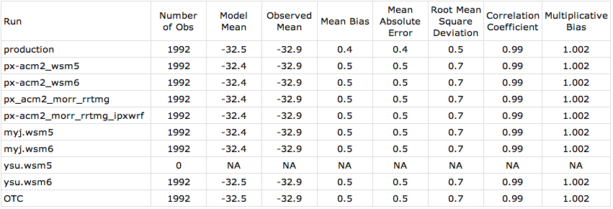
Winter
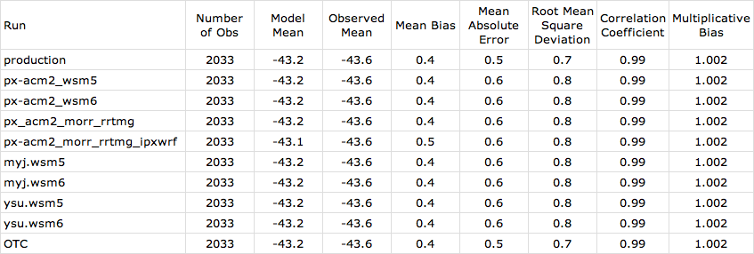

Relative humidity

Summer
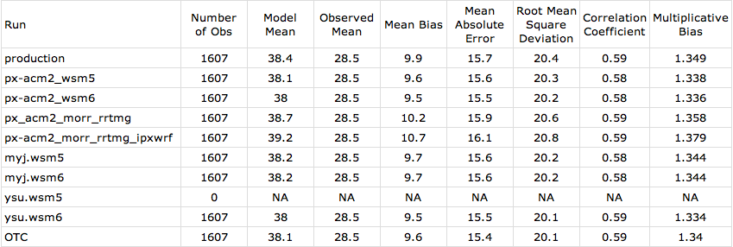
Winter
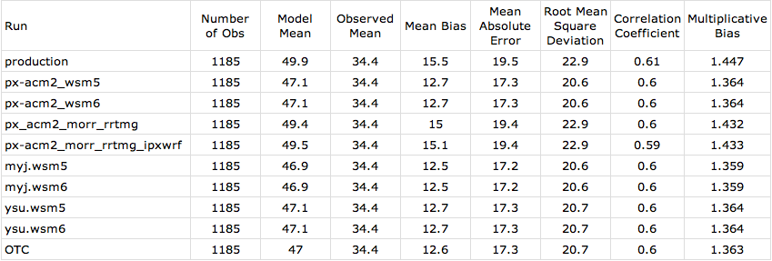

For the wind field statistics, the production run and the other sensitivity runs display a slight negative bias in their wind speeds relative to observed values. The mean absolute errors for the wind speeds average slightly less than 1.5 m/s for the summer episode, but are slightly larger for the winter episode at just under 2.0 m/s. The wind speeds from the production run have the least error in either season. The WRF wind speeds are highly correlated with the observations at 0.97 and 0.98 for the summer and winter, respectively. For the wind direction, the production and sensitivity runs have very small biases and the mean absolute errors range from 4-5 degrees in the winter episode to 8-9 degrees in the summer episode.

Wind speed

Summer
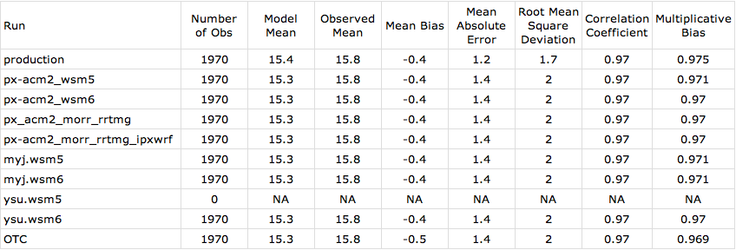
Winter
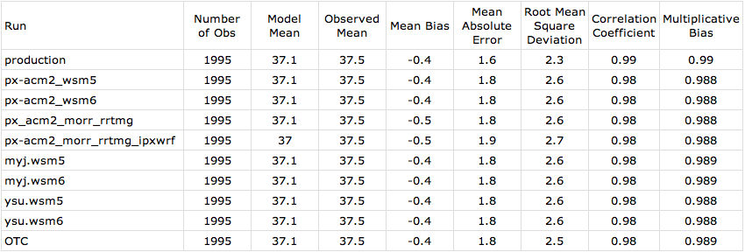

Wind Direction

Summer
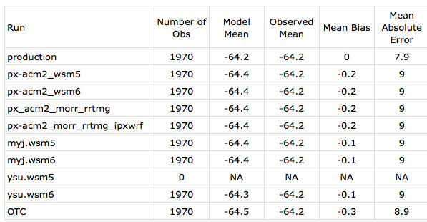
Winter
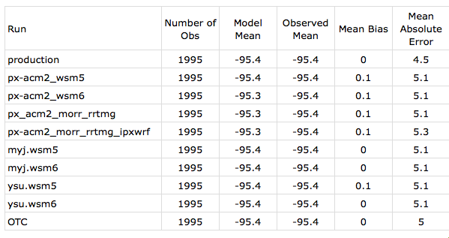

500 mb

The statistics from the WRF sensitivity runs at 500 mb for temperature are quite similar to those at the 300-mb level. The temperature biases are smaller than at 500 mb and range from 0.1-0.2 °C in the winter episode to 0.3-0.4 °C in the summer episode. The production run has the smallest mean absolute errors of all of the runs. The correlation coefficients for all runs remain very high at 0.98 or above. The relative humidity fields show significant improvement over those at the 300-mb level with mean bias reduced to 2% and 6% above the observed value for summer and winter, respectively. The mean absolute errors and the correlation coefficients are better for the relative humidity than at 300 mb over both the summer and winter episodes.

Temperature

Summer
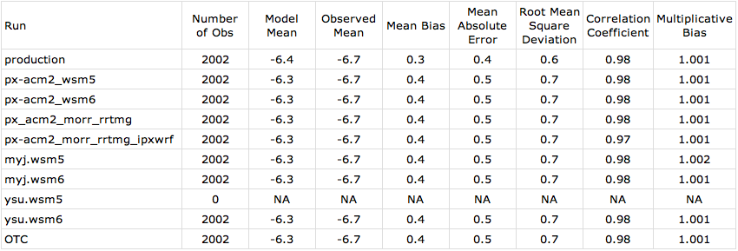
Winter
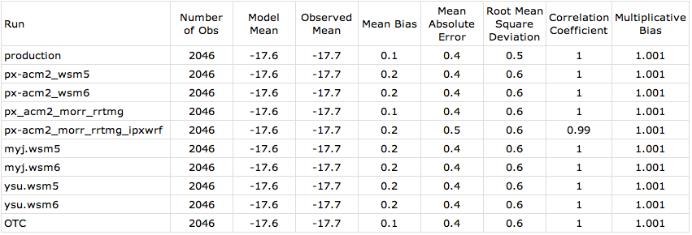

Relative Humidity

Summer
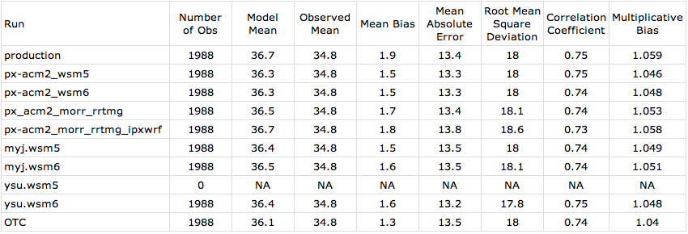
Winter
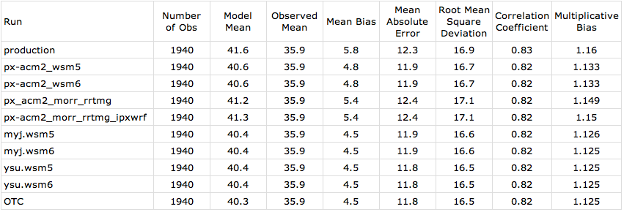

The wind speeds at 500 mb are strongly correlated with the observations during both the summer and winter sensitivity runs. The mean absolute error for both periods is slightly reduced as compared with 300 mb, but this may be more due to the lower average wind speed at the 500-mb level. The mean absolute error in the wind direction increases slightly at 500 mb, but of all the sensitivity runs the production run has the lowest errors at 9.8° and 5.4 m/s, respectively, for the summer and winter episodes, respectively.

Wind Speed

Summer
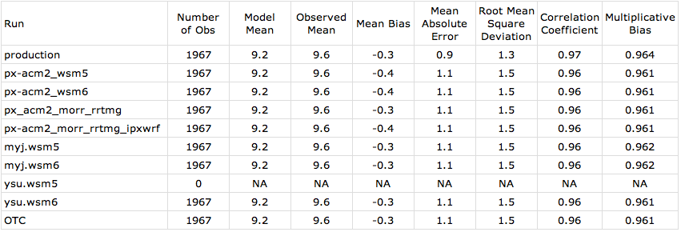
Winter
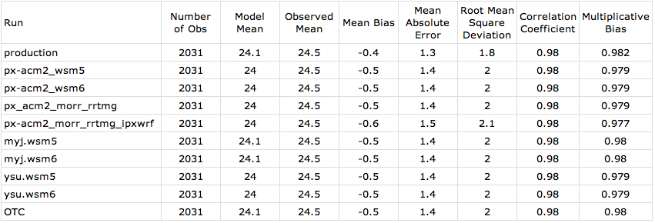

Wind Direction

Summer
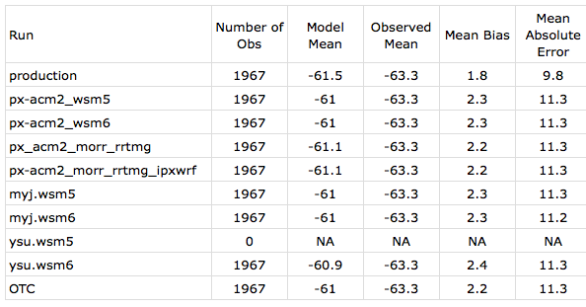
Winter
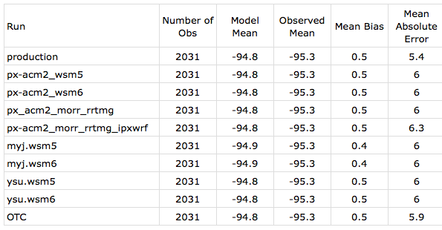

700 mb

At 700 mb, the temperature field shows a slight positive bias of 0.1-0.2 °C, but the mean absolute errors remain small especially for the production run. The mean absolute errors in temperature are slightly larger during the winter episode, but the correlation coefficients indicate a very good relationship with the observations during both periods. In the relative humidity field, there is a slight positive bias during the winter episode; however, this is significantly smaller than either at 300 mb or 500 mb. A negative bias appears for the summer episode at nearly 3% lower than the observed relative humidity on average. Mean absolute errors are greater than those at 500 mb for the summer episode at over 13%, but are reduced for the winter period. Correlation coefficients are similar in this respect with the values for the summer episode especially poor at around 0.65.

Temperature

Summer
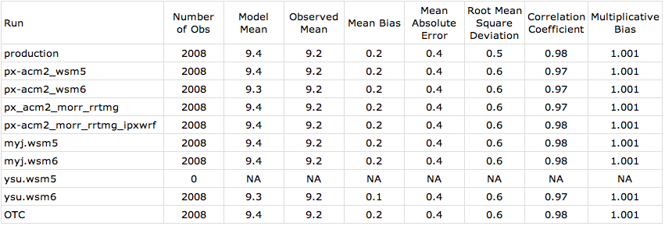
Winter
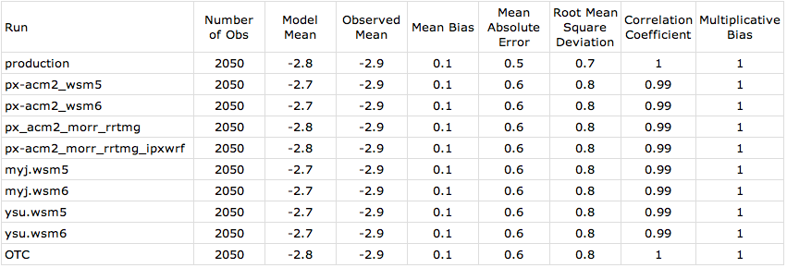

Relative Humidity

Summer
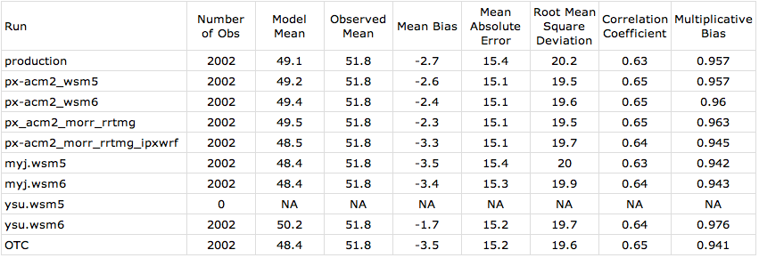
Winter
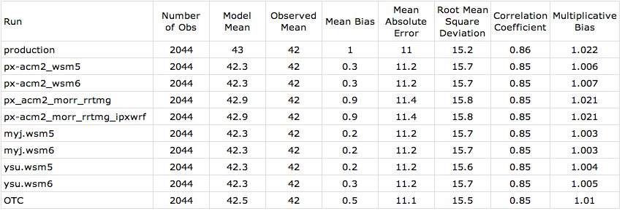

For the wind speeds at 700 mb, the biases remain less than 1 m/s during the winter episode. The mean absolute errors are also relatively small at 700 mb with the production run displaying the smallest errors of all the sensitivity runs. The modeled wind speeds at this level are still well correlated with the observations for both the summer and winter episodes. The wind direction errors at 700 mb are increased relative to those at 500 mb.

Wind Speed

Summer
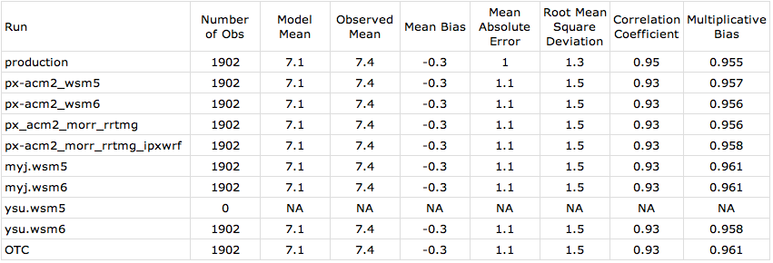
Winter
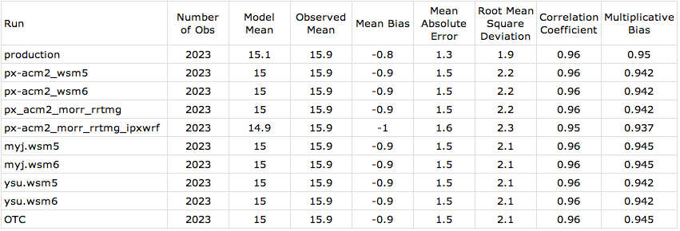

Wind Direction

Summer
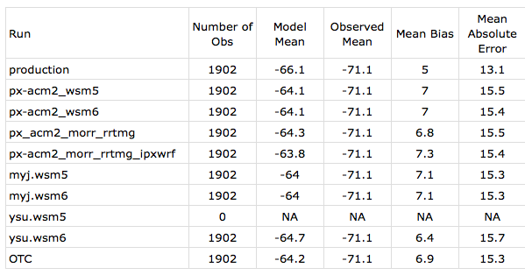
Winter
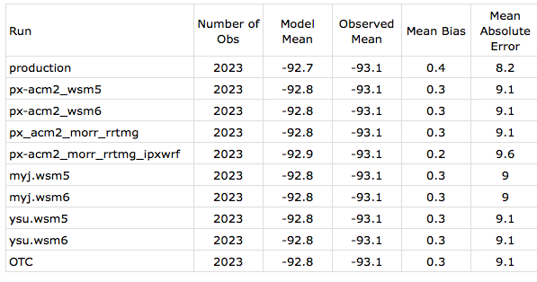

850 mb

The temperatures at 850 mb have mean absolute errors near 0.5 °C for both the summer and winter episode with the production run observed to have the smallest errors of the sensitivity runs. The mean bias is very small during the summer period, but has a slight positive bias during the winter period. Temperatures remain very well correlated with the observations at the 850-mb level. The relative humidity at this level now displays a consistent negative bias for all of the sensitivity runs during both the summer and winter episodes. Mean absolute errors run just over 11% for both episodes. The sensitivity runs are poorly correlated with the observations during the summer period averaging near 0.6; however, this does improve during the winter up to just above 0.8.

Temperature

Summer
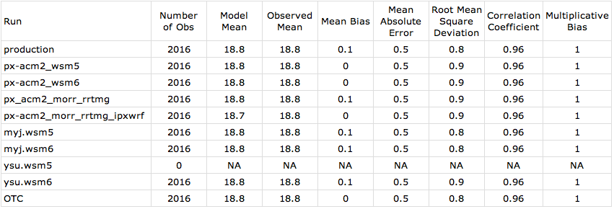
Winter
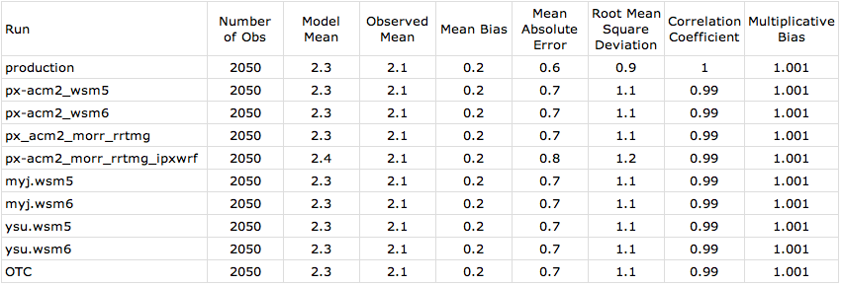

Relative Humidity

Summer
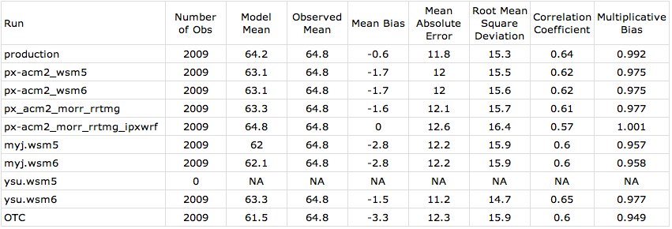
Winter
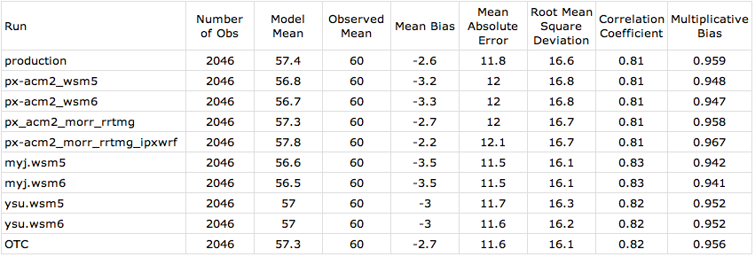

As with the other pressure levels, the wind speed continues to show a consistent negative bias of between 0.5 and 1 m/s. The mean absolute errors remain small with the production run having the smallest error during the winter episode. The wind speeds remain well correlated with the observed wind speeds; however, the correlation coefficients are not as high as at the other pressure levels. The wind direction errors are larger lower in the atmosphere. The production run has the smallest errors, but these are still above 11° for the winter episode and above 15° for the summer episode with larger values found for each of the other sensitivity runs.

Wind Speed

Summer
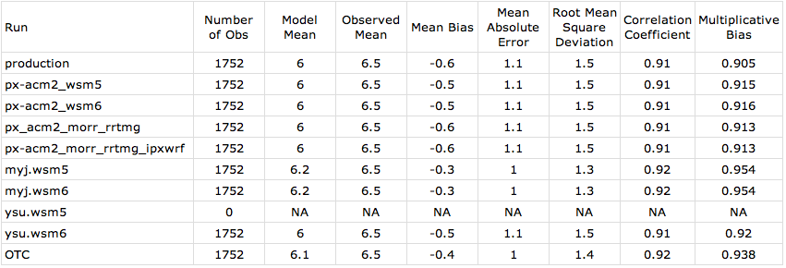
Winter
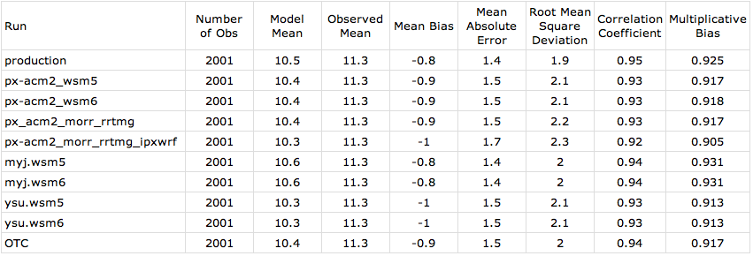

Wind Direction

Summer
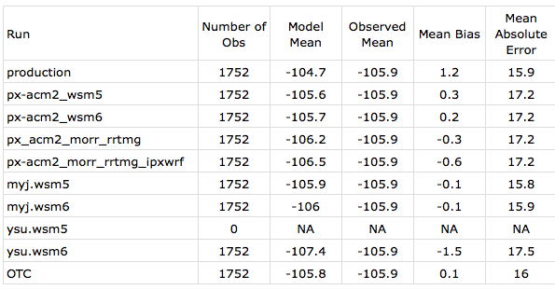
Winter
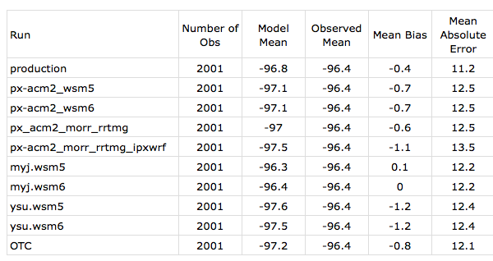

Surface

At the surface, temperatures display a slight, but consistent negative bias during the summer episode with a less obvious bias during the winter period although the production run has a positive bias of 0.6°C. The mean absolute errors increase significantly at the surface relative to those at 850 mb to around 1.5°C in the summer episode and 2°C in the winter episode. The majority of the sensitivity runs including the production run have similar performance in this regard. The temperatures are more strongly correlated in the winter episode than during the summer. The relative humidity fields generally have a positive bias for both periods, but somewhat larger for the winter episode. A number of the sensitivity runs perform more strongly than the production run during the winter with mean absolute errors 1-2% lower. The WRF relative humidity fields are poorly correlated with the observations at the surface with the majority of runs falling under a 0.6 correlation coefficient. An additional variable, specific humidity, is also analyzed at the surface. There is a slight, but consistent positive bias in the specific humidity at the surface during the winter period, but the bias varies between the different sensitivity runs for the summer. The mean error is smaller during the winter, but this is likely a result of lower moisture content in the atmosphere at this time of year. As with the relative humidity, the specific humidity modeled by WRF sensitivity runs is more strongly correlated with the observations during the winter than summer.

Temperature

Summer
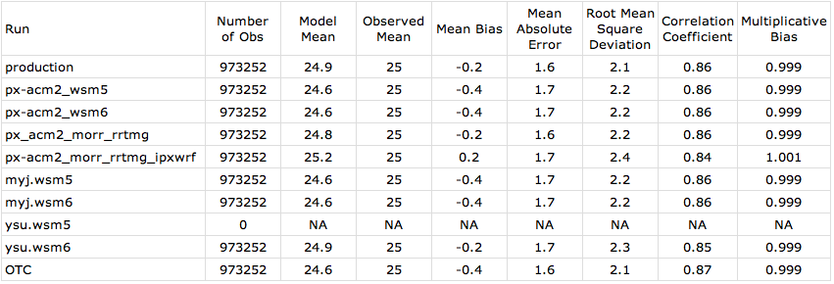
Winter
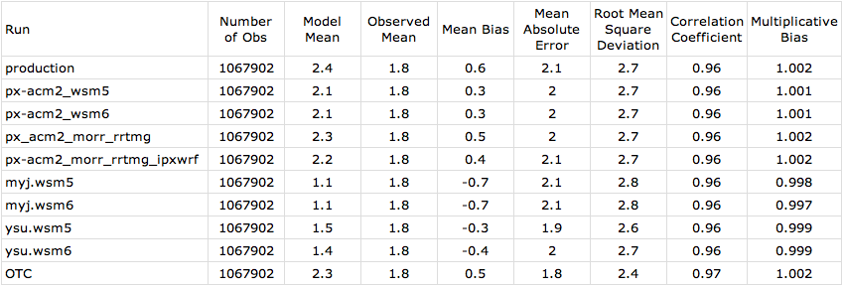

Relative Humidity

Summer
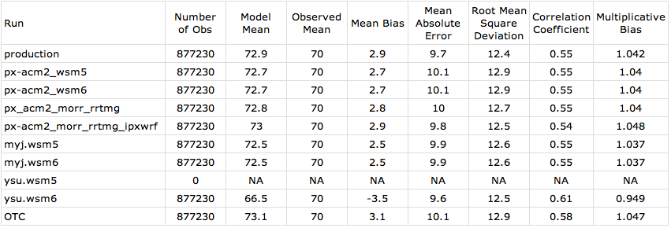
Winter
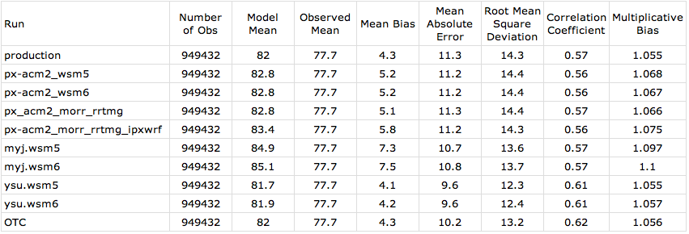

Specific Humidity

Summer
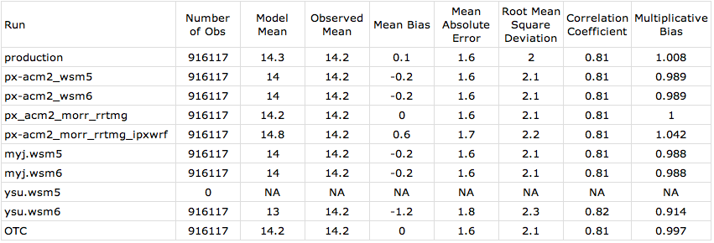
Winter
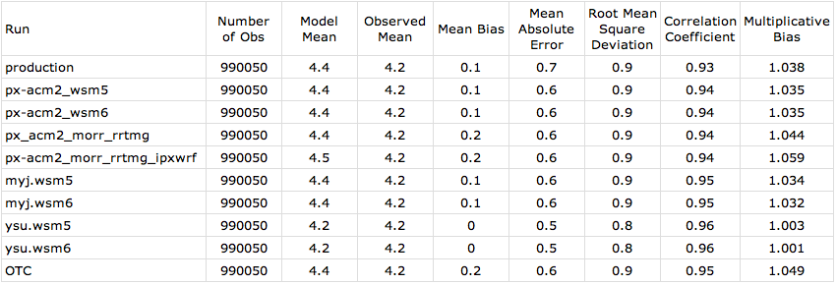

The wind speeds are biased negative for the production run in both the winter and summer episodes, but the remaining sensitivity runs are consistently positive although the absolute value of the bias is relatively small in both cases. The mean absolute errors are between 1.2 and 1.4 m/s. The correlation coefficients are generally low indicating that the relationship between the WRF-modeled and observed winds is not particularly strong. The wind direction data shows the largest deviations between the sensitivity runs and the actual observations with mean absolute errors exceeding 30° in the winter episode and 40° in the summer episode.

Wind Speed

Summer
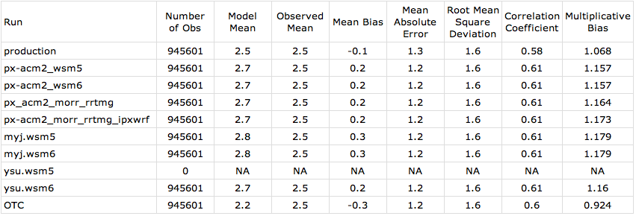
Winter
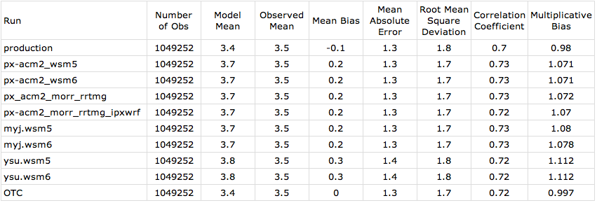

Wind Direction

Summer
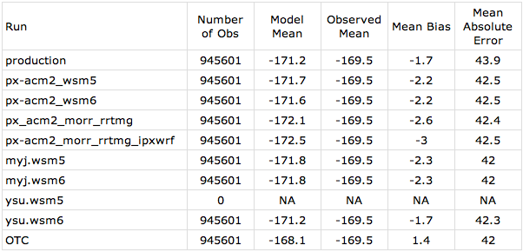
Winter
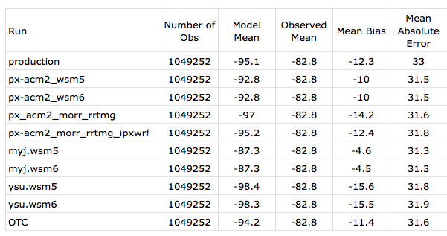

Tasks 2 H 1 and 2 H 7 Surface Statistical tables for SEMAP region

The following tables summarize the domain 2 Summer and Winter statistics at the surface for each sensitivity run for SEMAP. The discussion is limited to noteworthy aspects of the statistics, with a focus on those metrics that can be compared to the target Metrics from Section 2.6.

Temperature

Summer Temperature Celsius
Run | Number of Obs | Model Mean | Observed Mean | Mean Bias | Mean Absolute Error | Root Mean Square Deviation | Correlation Coefficient | Multiplicative Bias
production | 176141 | 27.5 | 27.6 | -0.1 | 1.5 | 2.0 | 0.68 | 1.000
1-px-acm2_wsm5 | 176141 | 27.4 | 27.6 | -0.2 | 1.5 | 2.0 | 0.69 | 0.999
2-px-acm2_wsm6 | 176141 | 27.4 | 27.6 | -0.2 | 1.5 | 2.0 | 0.69 | 0.999
3-px_acm2_morr_rrtmg | 176141 | 27.5 | 27.6 | -0.1 | 1.5 | 1.9 | 0.69 | 1.000
4-px-acm2_morr_rrtmg_ipxwrf | 176141 | 27.8 | 27.6 | 0.2 | 1.6 | 2.1 | 0.67 | 1.001
5-myj.wsm5 | 176141 | 27.5 | 27.6 | -0.1 | 1.5 | 2.0 | 0.71 | 1.000
6-myj.wsm6 | 176141 | 27.5 | 27.6 | -0.1 | 1.5 | 2.0 | 0.71 | 1.000
7-ysu.wsm5 | 0 | NA | NA | NA | NA | NA | NA | NA
8-ysu.wsm6 | 176141 | 27.6 | 27.6 | 0.0 | 1.6 | 2.1 | 0.70 | 1.000
9-OTC | 176141 | 27.2 | 27.6 | -0.4 | 1.5 | 1.9 | 0.71 | 0.999

Winter Temperature Celsius
Run | Number of Obs | Model Mean | Observed Mean | Mean Bias | Mean Absolute Error | Root Mean Square Deviation | Correlation Coefficient | Multiplicative Bias
production | 199175 | 11.4 | 11.0 | 0.4 | 2.1 | 2.7 | 0.89 | 1.001
1-px-acm2_wsm5 | 199175 | 11.0 | 11.0 | 0.0 | 2.1 | 2.7 | 0.89 | 1.000
2-px-acm2_wsm6 | 199175 | 11.0 | 11.0 | 0.0 | 2.1 | 2.7 | 0.89 | 1.000
3-px_acm2_morr_rrtmg | 199175 | 11.3 | 11.0 | 0.3 | 2.1 | 2.6 | 0.89 | 1.001
4-px-acm2_morr_rrtmg_ipxwrf | 199175 | 11.5 | 11.0 | 0.5 | 2.2 | 2.8 | 0.89 | 1.002
5-myj.wsm5 | 199175 | 10.6 | 11.0 | -0.4 | 1.8 | 2.3 | 0.90 | 0.999
6-myj.wsm6 | 199175 | 10.6 | 11.0 | -0.4 | 1.8 | 2.4 | 0.90 | 0.999
7-ysu.wsm5 | 199175 | 10.5 | 11.0 | -0.5 | 1.8 | 2.3 | 0.91 | 0.998
8-ysu.wsm6 | 199175 | 10.5 | 11.0 | -0.5 | 1.8 | 2.3 | 0.91 | 0.998
9-OTC | 199175 | 11.2 | 11.0 | 0.2 | 1.9 | 2.4 | 0.91 | 1.001

Model performance was generally very good for all sensitivity runs for temperature. Summer correlation values were notably lower than for winter. It is anticipated that correlation values will be lower during periods of more uniform temperature, such as during the summer, with short-term periods of cooling driven largely by less predictable diurnal convection. Mean bias values fell within target values, as did MAE values, except for the winter period for runs that utilized the px-acm2 parameterizations. These runs had gross errors of slightly larger than the target of 2 degrees Celsius.

Relative Humidity

Summer RH %
Run | Number of Obs | Model Mean | Observed Mean | Mean Bias | Mean Absolute Error | Root Mean Square Deviation | Correlation Coefficient | Multiplicative Bias
production | 167793 | 72.4 | 69.3 | 3.1 | 9.7 | 12.3 | 0.43 | 1.049
1-px-acm2_wsm5 | 167793 | 72.4 | 69.3 | 3.1 | 10.0 | 12.6 | 0.45 | 1.048
2-px-acm2_wsm6 | 167793 | 72.4 | 69.3 | 3.1 | 10.0 | 12.6 | 0.45 | 1.048
3-px_acm2_morr_rrtmg | 167793 | 72.4 | 69.3 | 3.1 | 10.0 | 12.6 | 0.44 | 1.048
4-px-acm2_morr_rrtmg_ipxwrf | 167793 | 73.4 | 69.3 | 4.1 | 10.3 | 12.9 | 0.38 | 1.070
5-myj.wsm5 | 167793 | 70.2 | 69.3 | 0.9 | 9.5 | 12.1 | 0.48 | 1.015
6-myj.wsm6 | 167793 | 70.1 | 69.3 | 0.8 | 9.5 | 12.1 | 0.48 | 1.015
7-ysu.wsm5 | 0 | NA | NA | NA | NA | NA | NA | NA
8-ysu.wsm6 | 167793 | 64.9 | 69.3 | -4.4 | 9.4 | 12.2 | 0.51 | 0.935
9-OTC | 167793 | 73.6 | 69.3 | 4.3 | 10.5 | 13.3 | 0.45 | 1.069

Winter RH %
- Run | Number of Obs | Model Mean | Observed Mean | Mean Bias | Mean Absolute Error | Root Mean Square Deviation | Correlation Coefficient | Multiplicative Bias
production | 188866 | 74.6 | 75.5 | -0.9 | 12.1 | 15.2 | 0.46 | 0.980
1-px-acm2_wsm5 | 188866 | 77.2 | 75.5 | 1.7 | 12.4 | 15.5 | 0.44 | 1.019
2-px-acm2_wsm6 | 188866 | 77.1 | 75.5 | 1.7 | 12.4 | 15.5 | 0.44 | 1.019
3-px_acm2_morr_rrtmg | 188866 | 76.0 | 75.5 | 0.5 | 11.8 | 14.9 | 0.46 | 1.000
4-px-acm2_morr_rrtmg_ipxwrf | 188866 | 77.3 | 75.5 | 1.9 | 12.0 | 15.1 | 0.41 | 1.019
5-myj.wsm5 | 188866 | 79.3 | 75.5 | 3.8 | 9.6 | 12.2 | 0.49 | 1.056
6-myj.wsm6 | 188866 | 79.5 | 75.5 | 4.0 | 9.8 | 12.4 | 0.48 | 1.060
7-ysu.wsm5 | 188866 | 76 | 75.5 | 0.5 | 8.9 | 11.5 | 0.57 | 1.010
9-ysu.wsm6 | 188866 | 76.2 | 75.5 | 0.7 | 9.0 | 11.6 | 0.56 | 1.013
9-OTC | 188866 | 76.2 | 75.5 | 0.8 | 11.6 | 14.6 | 0.50 | 1.005

Modeled relative humidity forecasts typically exhibited a positive bias of up to 4%, as indicated also by the multiplicative bias scores. It should be kept in mind that relative humidity is dependent not only on the absolute amount of atmospheric moisture, but also the temperature. See the specific humidity tables below for evaluation solely of the amount of moisture. Use of the MYJ planetary boundary layer scheme improved the modeled RH fields in the summer, with the best scores across all statistics. In the winter, on the other hand, this scheme’s large positive mean bias values, but relatively small MAE errors, indicate that the sign of the forecast errors did not cancel and RH was generally overpredicted. The YSU PBL scheme had the best error statistics in the winter.

Specific Humidity

Summer SPFH g/kg
Run | Number of Obs | Model Mean | Observed Mean | Mean Bias | Mean Absolute Error | Root Mean Square Deviation | Correlation Coefficient | Multiplicative Bias
production | 167951 | 16.1 | 15.9 | 0.3 | 1.7 | 2.2 | 0.56 | 1.017
1-px-acm2_wsm5 | 167951 | 15.9 | 15.9 | 0.1 | 1.8 | 2.2 | 0.59 | 1.005
2-px-acm2_wsm6 | 167951 | 15.9 | 15.9 | 0.1 | 1.8 | 2.2 | 0.59 | 1.005
3-px_acm2_morr_rrtmg | 167951 | 16.1 | 15.9 | 0.2 | 1.8 | 2.3 | 0.57 | 1.013
4-px-acm2_morr_rrtmg_ipxwrf | 167951 | 16.8 | 15.9 | 0.9 | 2.0 | 2.5 | 0.50 | 1.057
5-myj.wsm5 | 167951 | 15.5 | 15.9 | -0.3 | 1.8 | 2.3 | 0.61 | 0.980
6-myj.wsm6 | 167951 | 15.5 | 15.9 | -0.3 | 1.8 | 2.3 | 0.61 | 0.979
7-ysu.wsm5 | 0 | NA | NA | NA | NA | NA | NA | NA
8-ysu.wsm6 | 167951 | 14.4 | 15.9 | -1.4 | 2.0 | 2.5 | 0.62 | 0.909
9-OTC | 167951 | 16.1 | 15.9 | 0.3 | 1.9 | 2.4 | 0.57 | 1.016

Winter SPFH g/kg
Run | Number of Obs | Model Mean | Observed Mean | Mean Bias | Mean Absolute Error | Root Mean Square Deviation | Correlation Coefficient | Multiplicative Bias
production | 189058 | 6.7 | 6.8 | -0.1 | 1.0 | 1.2 | 0.83 | 0.983
1-px-acm2_wsm5 | 189058 | 6.8 | 6.8 | 0.0 | 0.9 | 1.2 | 0.84 | 0.997
2-px-acm2_wsm6 | 189058 | 6.7 | 6.8 | 0.0 | 0.9 | 1.2 | 0.84 | 0.997
3-px_acm2_morr_rrtmg | 189058 | 6.8 | 6.8 | 0.0 | 0.9 | 1.2 | 0.84 | 0.999
4-px-acm2_morr_rrtmg_ipxwrf | 189058 | 7.0 | 6.8 | 0.2 | 0.9 | 1.2 | 0.83 | 1.027
5-myj.wsm5 | 189058 | 6.9 | 6.8 | 0.1 | 0.8 | 1.1 | 0.85 | 1.023
6-myj.wsm6 | 189058 | 6.9 | 6.8 | 0.1 | 0.8 | 1.1 | 0.85 | 1.023
7-ysu.wsm5 | 189058 | 6.6 | 6.8 | -0.2 | 0.8 | 1.1 | 0.85 | 0.970
8-ysu.wsm6 | 189058 | 6.6 | 6.8 | -0.2 | 0.8 | 1.1 | 0.85 | 0.970
9-OTC | 189058 | 6.9 | 6.8 | 0.1 | 0.9 | 1.2 | 0.84 | 1.005

All sensitivity runs met the target values for mean bias and mean absolute error (with one exception). Use of the YSU PBL scheme appears to result in the lowest amount of atmospheric moisture, perhaps related to deficiencies in this scheme’s amount of vertical mixing. As expected, error statistics for the winter are smaller, due largely to the significantly smaller amount of atmospheric moisture during this time period. It is suggested, therefore, that statistics for the summer period represent a more rigorous evaluation. Of note is the degradation of the model performance (e.g., increased positive mean bias) through introduction of the IPX-WRF (runs number 4). The IPXWRF software is used to initialize soil moisture in the PX land surface model.

Wind Speed

Summer WSPD m/s
Run | Number of Obs | Model Mean | Observed Mean | Mean Bias | Mean Absolute Error | Root Mean Square Deviation | Correlation Coefficient | Multiplicative Bias
production | 168497 | 1.9 | 1.8 | 0.1 | 1.3 | 1.6 | 0.35 | 1.319
1-px-acm2_wsm5 | 168497 | 2.2 | 1.8 | 0.3 | 1.2 | 1.5 | 0.40 | 1.462
2-px-acm2_wsm6 | 168497 | 2.2 | 1.8 | 0.3 | 1.2 | 1.5 | 0.40 | 1.462
3-px_acm2_morr_rrtmg | 168497 | 2.2 | 1.8 | 0.3 | 1.2 | 1.5 | 0.40 | 1.468
4-px-acm2_morr_rrtmg_ipxwrf | 168497 | 2.2 | 1.8 | 0.3 | 1.2 | 1.6 | 0.41 | 1.475
5-myj.wsm5 | 168497 | 2.3 | 1.8 | 0.5 | 1.2 | 1.5 | 0.42 | 1.496
6-myj.wsm6 | 168497 | 2.3 | 1.8 | 0.5 | 1.2 | 1.5 | 0.42 | 1.496
7-ysu.wsm5 | 0 | NA | NA | NA | NA | NA | NA | NA
8-ysu.wsm6 | 168497 | 2.1 | 1.8 | 0.2 | 1.2 | 1.5 | 0.41 | 1.395
9-OTC | 168497 | 1.6 | 1.8 | -0.3 | 1.2 | 1.6 | 0.40 | 1.015

Winter WSPD m/s
Run | Number of Obs | Model Mean | Observed Mean | Mean Bias | Mean Absolute Error | Root Mean Square Deviation | Correlation Coefficient | Multiplicative Bias
production | 194801 | 2.6 | 2.5 | 0.0 | 1.2 | 1.5 | 0.57 | 1.085
1-px-acm2_wsm5 | 194801 | 2.8 | 2.5 | 0.3 | 1.2 | 1.5 | 0.62 | 1.194
2-px-acm2_wsm6 | 194801 | 2.8 | 2.5 | 0.3 | 1.2 | 1.5 | 0.62 | 1.195
3-px_acm2_morr_rrtmg | 194801 | 2.9 | 2.5 | 0.3 | 1.2 | 1.5 | 0.61 | 1.207
4-px-acm2_morr_rrtmg_ipxwrf | 194801 | 2.9 | 2.5 | 0.3 | 1.2 | 1.5 | 0.61 | 1.209
5-myj.wsm5 | 194801 | 3.0 | 2.5 | 0.5 | 1.2 | 1.5 | 0.62 | 1.257
6-myj.wsm6 | 194801 | 3.0 | 2.5 | 0.5 | 1.2 | 1.5 | 0.61 | 1.255
7-ysu.wsm5 | 194801 | 2.9 | 2.5 | 0.4 | 1.3 | 1.6 | 0.60 | 1.241
8-ysu.wsm6 | 194801 | 2.9 | 2.5 | 0.4 | 1.3 | 1.6 | 0.60 | 1.241
9-OTC | 194801 | 2.5 | 2.5 | 0.0 | 1.2 | 1.5 | 0.60 | 1.034

All sensitivity runs for each time period met the target mean bias and RMSE ranges for wind speed. MAE and RMSE differences amongst the runs were unimportant. Overall mean bias errors were small and positive, likely influenced by the models’ well-known inability to reproduce coincident observations of calm air. Interestingly, the production run had the smallest overall mean bias, especially when compared against the sensitivity run that used same model configuration. As mentioned above, one factor contributing to this difference in error statistics is the different start times for each 5.5-day run segment. Overall, the correlation coefficient scores were significantly better during the winter, likely a result of the predominance of more robust synoptic-scale flow.

Wind Direction

Summer WDIR degrees
Run | Number of Obs | Model Mean | Observed Mean | Mean Bias | Mean Absolute Error
production | 168497 | -128.3 | -132.4 | 4.1 | 54.7
1-px-acm2_wsm5 | 168497 | -132.1 | -132.4 | 0.3 | 52.6
2-px-acm2_wsm6 | 168497 | -131.8 | -132.4 | 0.6 | 52.6
3-px_acm2_morr_rrtmg | 168497 | -133.6 | -132.4 | -1.2 | 52.5
4-px-acm2_morr_rrtmg_ipxwrf | 168497 | -137.7 | -132.4 | -5.3 | 52.3
5-myj.wsm5 | 168497 | -132.1 | -132.4 | 0.3 | 51.7
6-myj.wsm6 | 168497 | -132.2 | -132.4 | 0.2 | 51.7
7-ysu.wsm5 | 0 | NA | NA | NA | NA
8-ysu.wsm6 | 168497 | -133.6 | -132.4 | -1.2 | 52.0
9-OTC | 168497 | -130.7 | -132.4 | 1.7 | 52.1

Winter WDIR degrees
Run | Number of Obs | Model Mean | Observed Mean | Mean Bias | Mean Absolute Error
production | 194801 | -29.0 | -48.0 | 19.0 | 40.9
1-px-acm2_wsm5 | 194801 | -13.0 | -48.0 | 35.0 | 38.2
2-px-acm2_wsm6 | 194801 | -14.1 | -48.0 | 33.9 | 38.3
3-px_acm2_morr_rrtmg | 194801 | -26.5 | -48.0 | 21.5 | 38.4
4-px-acm2_morr_rrtmg_ipxwrf | 194801 | -31.7 | -48.0 | 16.4 | 38.5
5-myj.wsm5 | 194801 | -23.6 | -48.0 | 24.4 | 38.2
6-myj.wsm6 | 194801 | -22.8 | -48.0 | 25.2 | 38.2
7-ysu.wsm5 | 194801 | -71.8 | -48.0 | -23.8 | 38.4
8-ysu.wsm6 | 194801 | -71.7 | -48.0 | -23.7 | 38.4
9-OTC | 194801 | -77.6 | -48.0 | -29.6 | 38.2

The production run, and closely-related sensitivity run number three, exhibit two of the smallest mean bias values during the winter when none of the bias values lie within the target of less than 10 degrees. For the summer, given that the observations for METAR sites are provided only to the nearest 5 degrees, we consider the variability in the mean bias values to be unimportant. For both time periods, MAE errors lie outside the target value of 30 degrees. The inter-run variability is very small and there is no clear “best” choice based solely on that metric.

Task 2 H 2: Bakergrams

The following section describes the variability of the daily mean absolute error and the daily mean bias for the sensitivity runs through a series of Bakergrams. The discussion will focus primarily on the FULL region for domain 2 only.

Temperature

The mean absolute errors of the temperature during summer are indistinguishable for the different sensitivity runs, all showing an MAE between 1.5°C and 2°C. All the sensitivity runs for this period except for the px-acm2_morr_rrtmg_ixpwf demonstrate a consistent negative bias for temperature in their 20-day simulation. The px-acm2_morr_rrtmg_ixpwf has a slight positive bias near the end of the run. For the winter period, the mean absolute errors are somewhat larger overall, ranging from 1.5°C to 3.0°C although there is slightly greater disparity between the individual runs. The OTC run exhibits the lowest mean absolute errors. The sensitivity runs are split in terms of the mean bias in temperature during winter: about half the members show a positive bias, and the other half shows a negative bias.

Summer
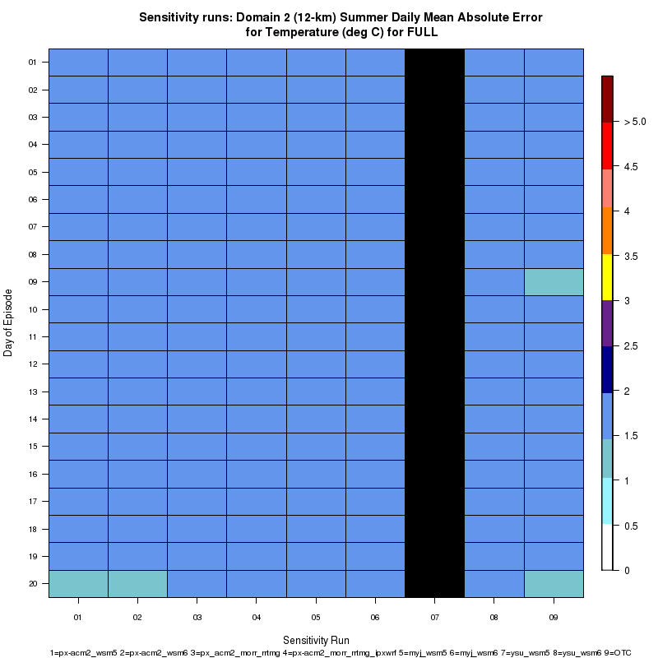
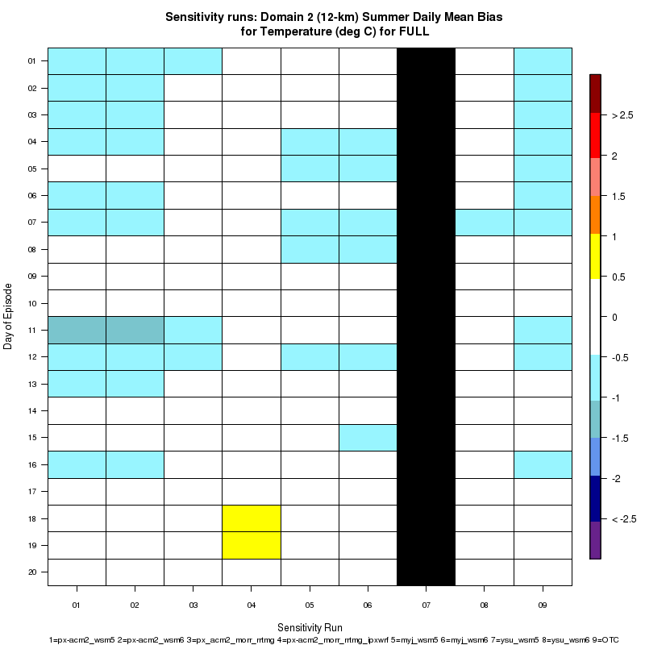

Winter
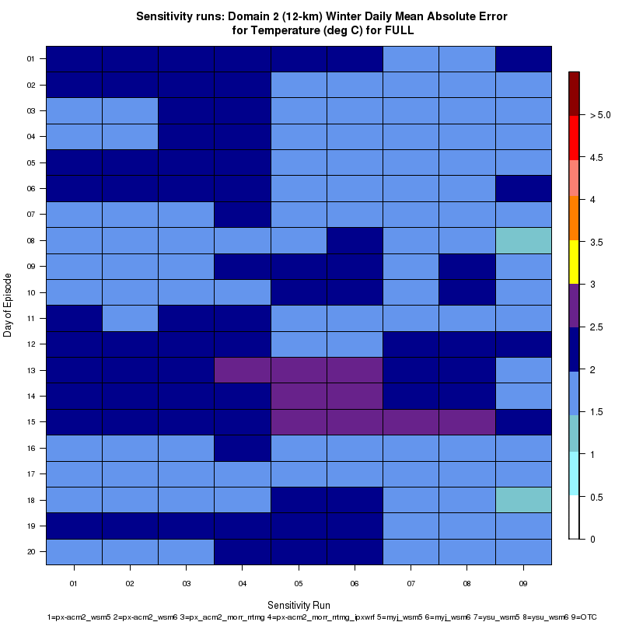
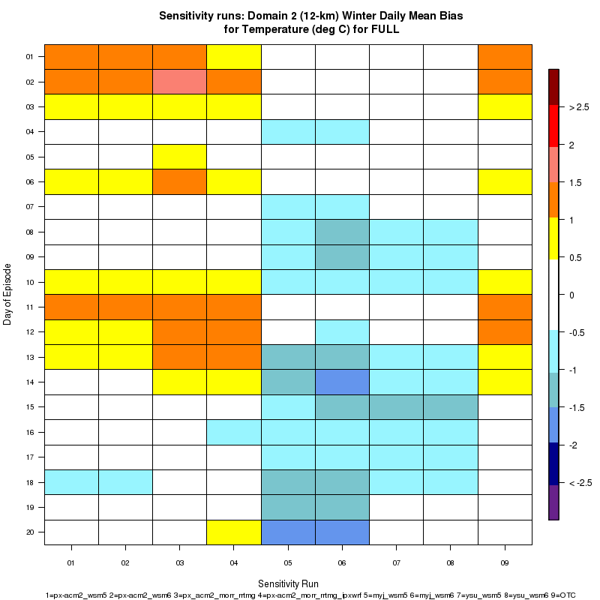

Relative Humidity

The relative humidity fields in the summer sensitivity runs show that the mean absolute error averages less than 15% for all of the runs. There is some variability among the individual members, but no significant outliers. The mean bias plot for the summer episode indicates that there is a neutral to slight positive bias for all of the runs except for the ysu.wsm6 run which has a few daily values that represent a negative bias. Overall, the winter daily values of the mean absolute errors are slightly larger than during summer, upwards of 15-20% in the first 4 sensitivity runs. The mean bias is fairly uniform, however, with all of the runs showing a consistent 5-10% positive bias in the relative humidity.
Summer
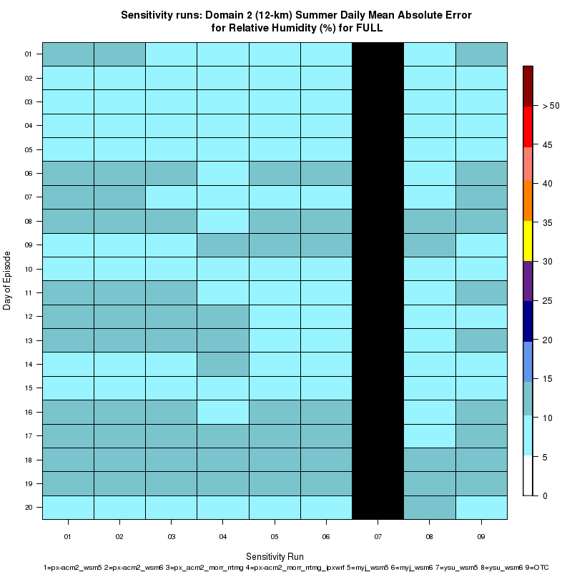
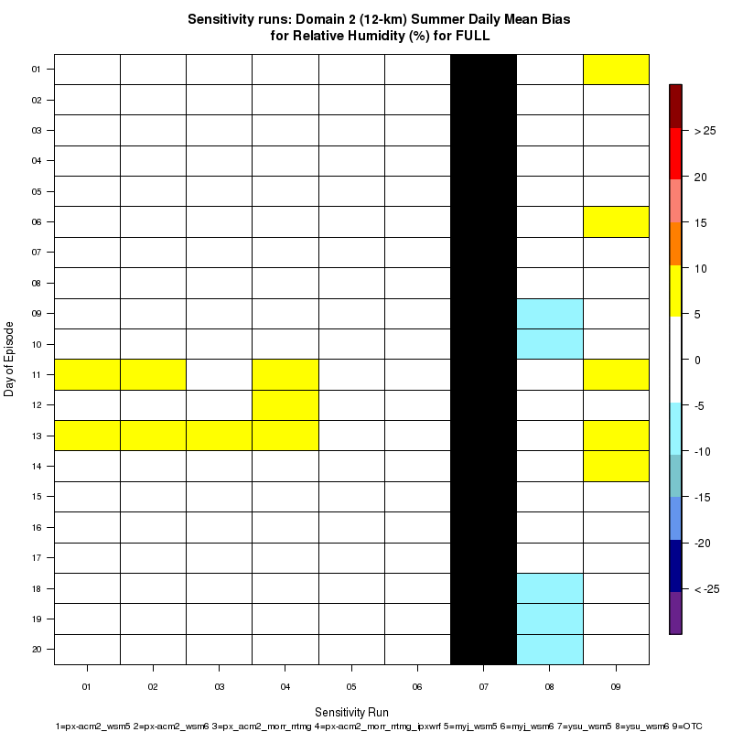

Winter
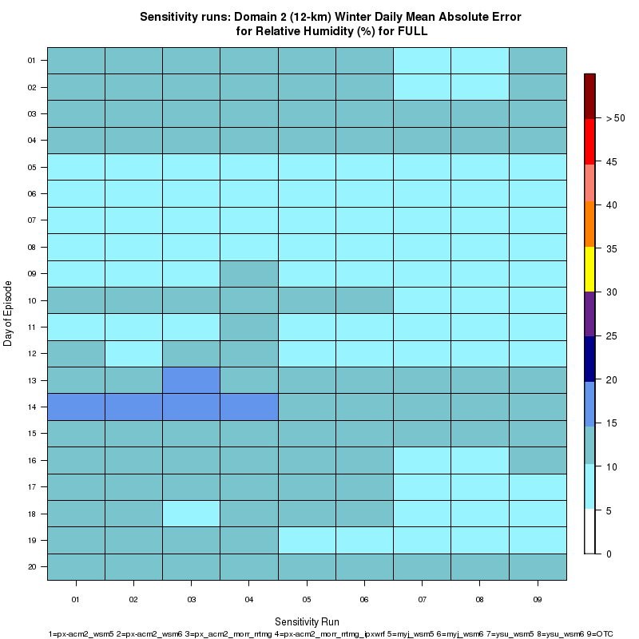
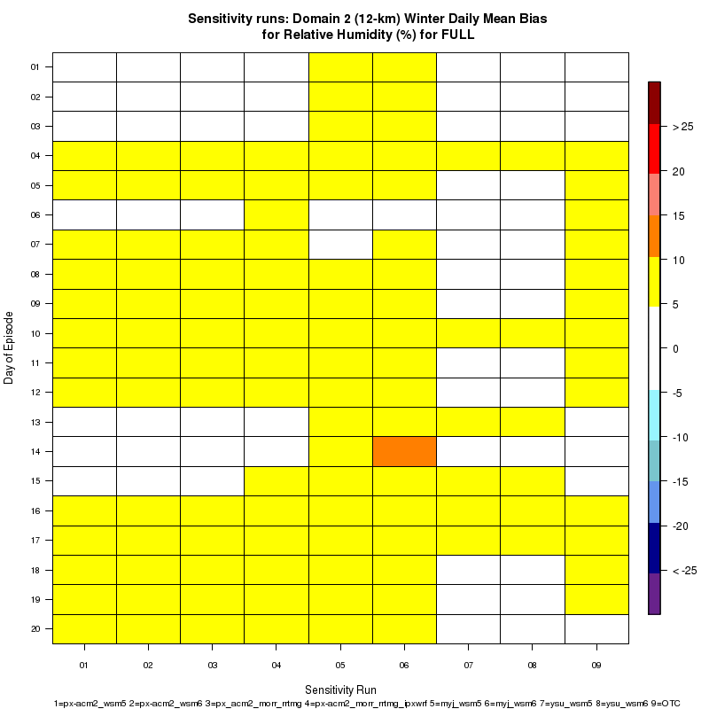

Wind Speed

The summer episode of the sensitivity runs shows that the absolute mean error of the wind speed is very uniform among the individual members. An error of 1-1.5 m/s is given for each of the 8 members with wind speed data at all 20 days of the sensitivity run. The Bakergram for the mean bias during the summer period does not show any significant bias for any of the individual runs. The winter sensitivity runs have slightly larger mean absolute errors, but as with the production run this is likely only due to higher average wind speeds during the winter. A few of the daily values for 4 of the sensitivity runs during this period exhibit a slight positive bias, but otherwise the bias appears to be quite small.

Summer
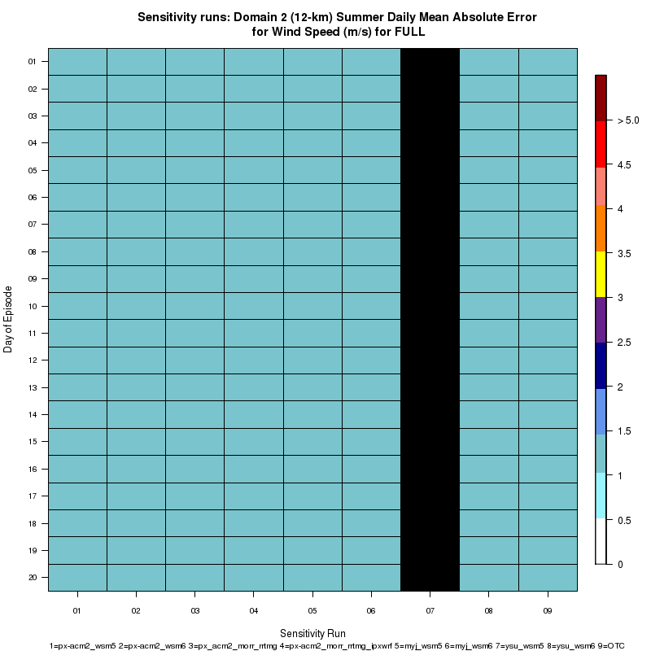
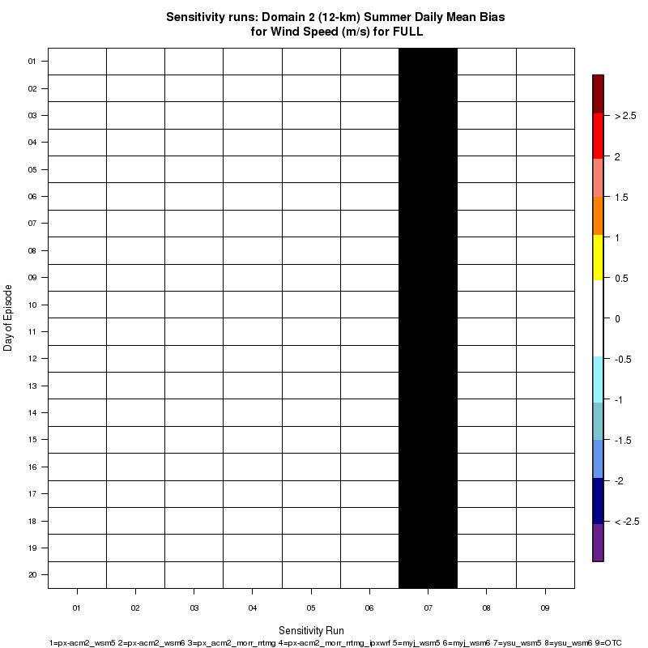

Winter
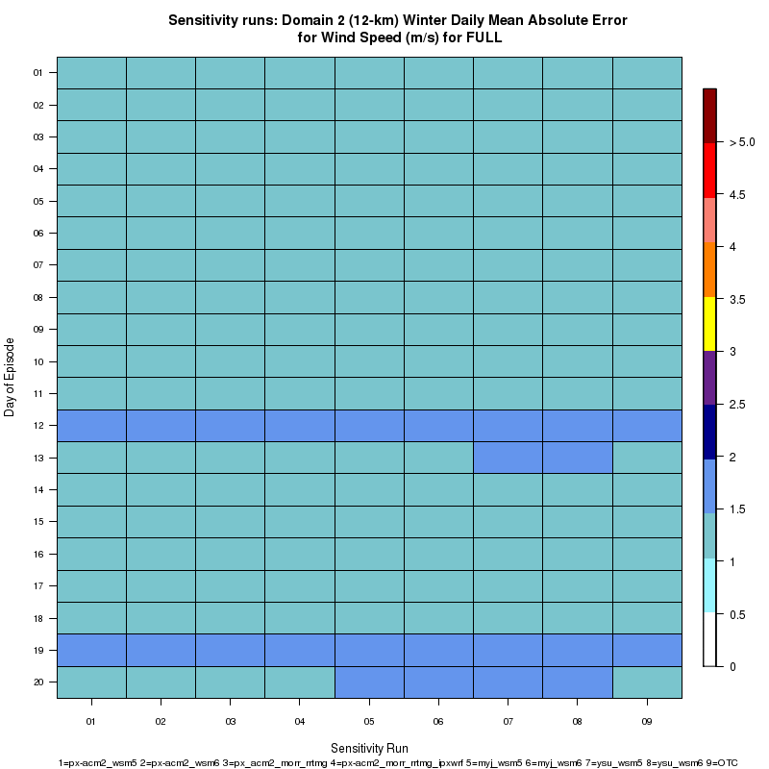
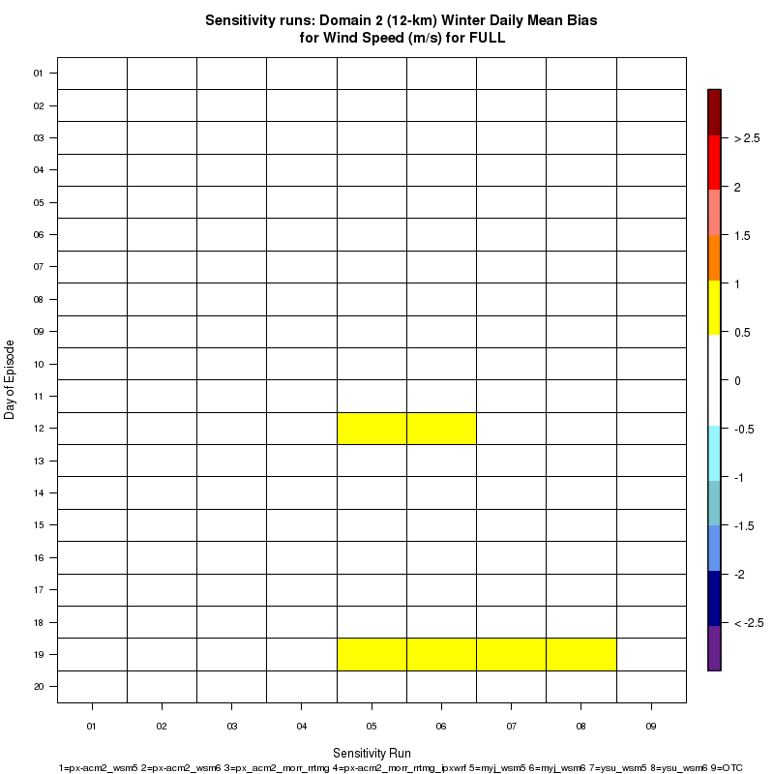

Task 2 H 4: Mean bias plots

This section describes the mean bias for each of the meteorological variables simulated by the WRF model for a summer and winter episode each consisting of 20 consecutive days. The production run, px_acm2_morr_rrtmg, is the red curve in the following plots. The discussion here focuses on the whole domain (“FULL”) - plots for geographic sub-regions are available from the website.

Temperature

The sensitivity runs are generally in line with the production run for the summer episode with a slightly negative mean temperature bias indicating the simulations were slightly too cold. The px-acm2_morr_rrtmg_ipxwrf run contoured in green was the single outlier, but consistently the best run during this episode with a mean temperature bias near zero except near the end of the 20-day period. For the winter run the sensitivity runs appear to be split into two groups with half of the sensitivity runs, including the production run, slightly too warm and the other half slightly too cold. This difference is especially apparent during the 12-20 December period.
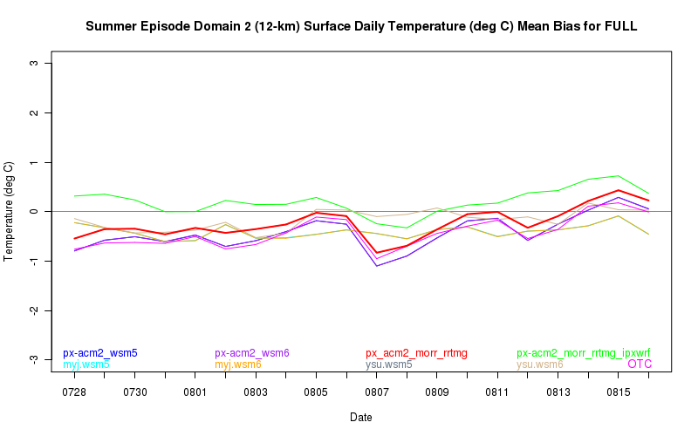
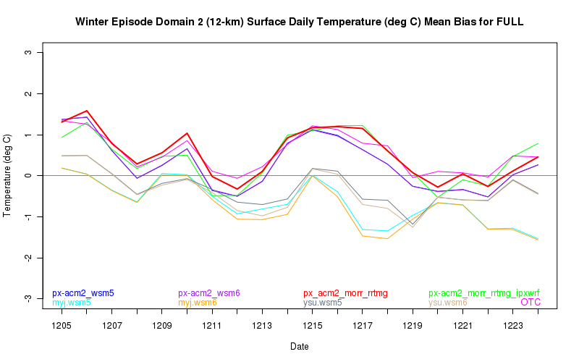

Dew point temperature

The sensitivity runs for the summer episode shows that most runs (including the production run) have a dew point temperature bias near zero. The px-acm2_morr_rrtmg_ipxwrf run has a 1°C warm bias and the ysu.wsm6 run a 1-1.5°C cold bias. The winter episode generally displays a positive dew point temperature bias especially from the production run. About half of the sensitivity runs display a smaller bias than the production run. The positive bias during the winter episode tends to be most consistent over the upper Midwest and Ohio Valley possibly due to the presence of snow cover that may affect the ability of the WRF to simulate dew points. A sample plot from Illinois is included to demonstrate the consistent nature of the positive bias.
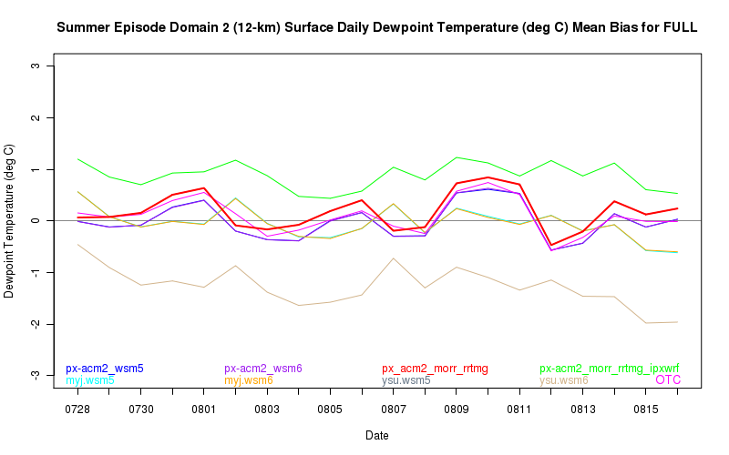
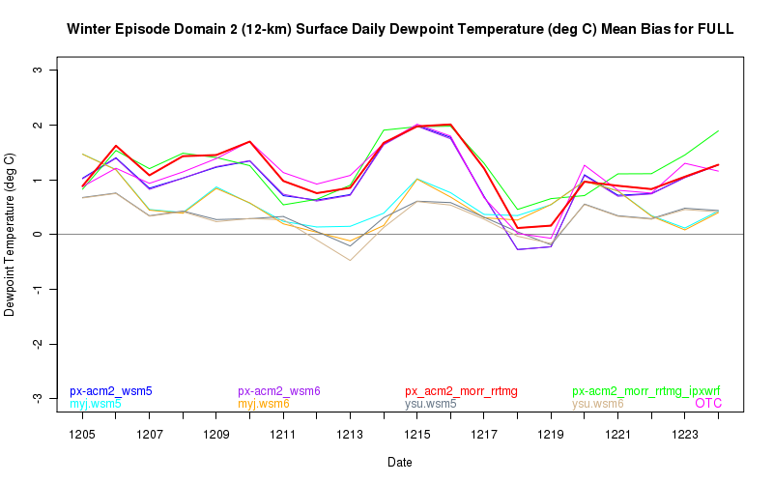
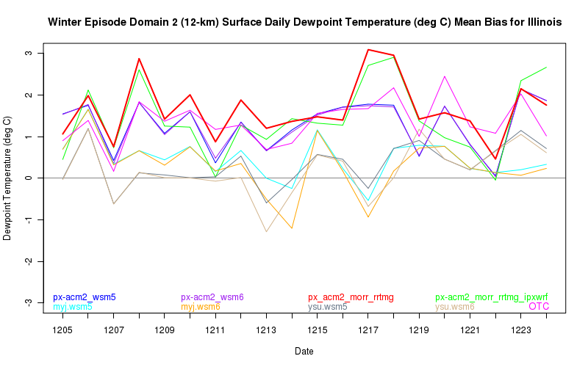

Relative Humidity

The sensitivity runs for relative humidity during the summer episode indicate all of the runs except for one significant outlier track closely to the production run and have a positive mean bias of approximately 2-3%. The ysu.wsm6 sensitivity run consistently shows a negative mean bias of roughly the same 2-3%. In the winter episode, all of the sensitivity runs including the production run generally have a positive bias of about 5%. The myj.wsm6 run has the largest bias of the sensitivity runs reaching upwards of 10% during the 16-20 December period when it diverges from the majority of the runs.
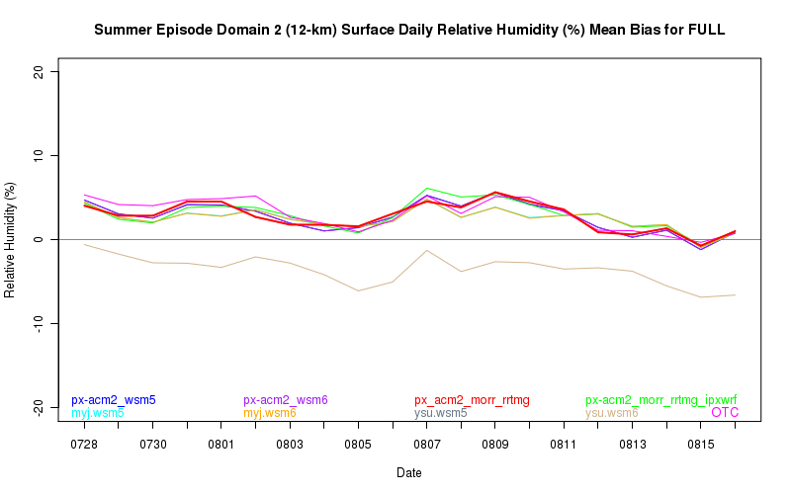
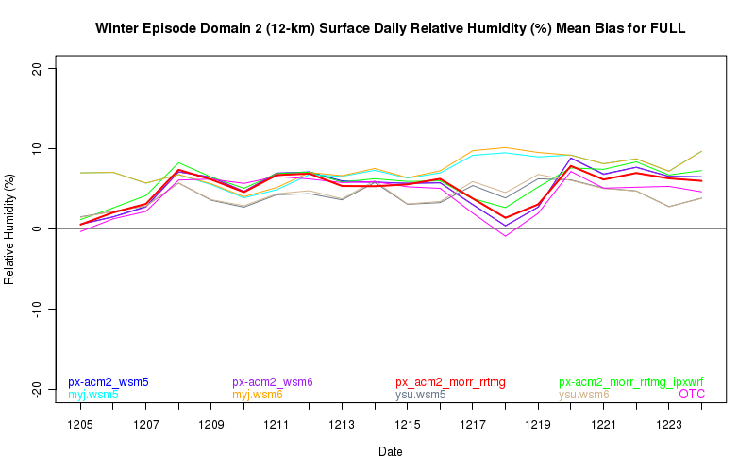

Specific Humidity

The summer episode sensitivity runs for specific humidity look qualitatively very similar to the dew point temperature sensitivity runs. The mean specific humidity value is much lower in winter due to lower absolute moisture levels and this is contributing to a perceived lack of a significant bias during the winter episode. However, it appears that as with the dew point temperature the specific humidity has the most significant and consistent positive bias farther to the north over the Upper Midwest and Ohio Valley states. As with the dew point temperature for the summer episode, the px-acm2_morr_rrtmg_ipxwrf run has a positive bias of about 0.5 g/kg and the ysu.wsm6 has about a 1 g/kg negative bias. The majority of the sensitivity runs, however, track closely to the production run.
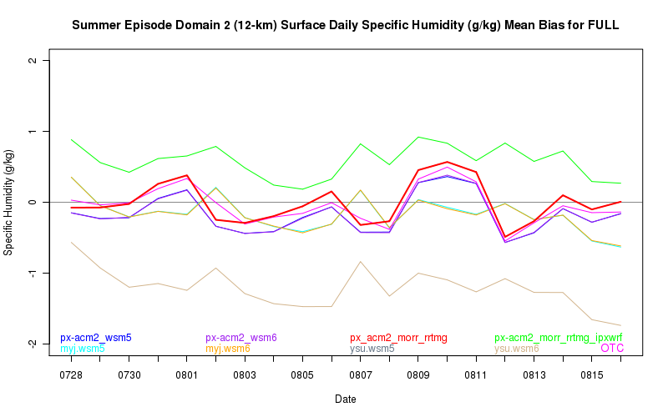
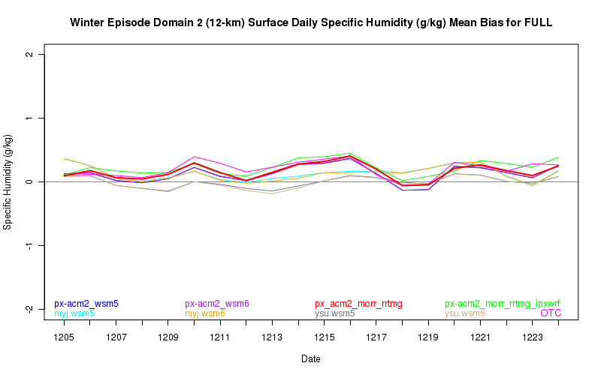

Wind Speed

The production and sensitivity runs for the summer and winter episodes are very similar to one another and exhibit only very slight positive biases. The OTC sensitivity run is the single outlier especially during the winter episode when it runs about a 0.5 m/s negative bias relative to the observed wind speed values. Overall, for both episodes the mean bias is small.
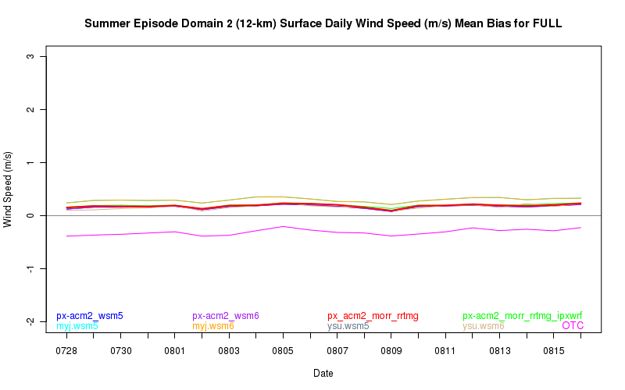
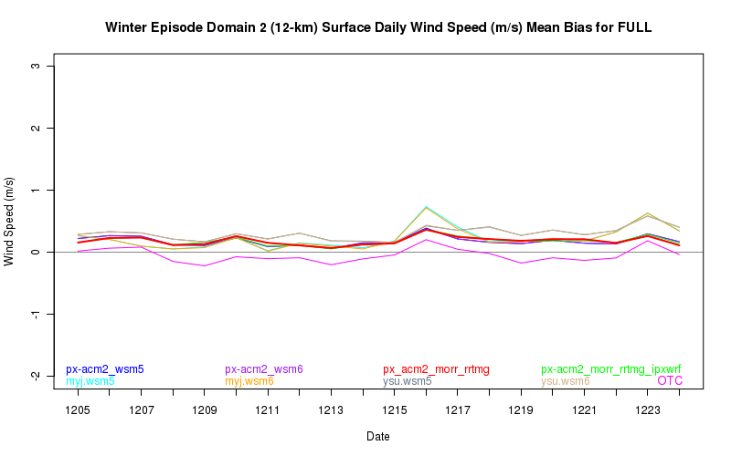

Task 2 H 5: Wind speed plots

The following section shows time series of spatial averages for the surface wind speed from observations (in black) and simulated by the WRF model for 5-day periods for the summer and winter episodes of the sensitivity runs. The production run, px_acm2_morr_rrtmg, is the red curve in the following plots.

The following plot shows the individual 5-day time series for the summer episode of the WRF sensitivity runs. The production run and most of the sensitivity runs have an under representation of the variability in the observed wind speeds with winds that are simulated too low in the daytime hours and too high during the night. The myj.wsm5 and myj.wsm6 sensitivity runs perform well at simulating the peak wind speeds that occur in the daytime hours although perhaps they show a slight positive bias. The OTC run accurately simulates the wind speed minima that occur during the nighttime and early morning hours, but at other times is the poorest of the sensitivity runs when compared with the observed wind speeds as it predicts the lowest wind speed maxima.

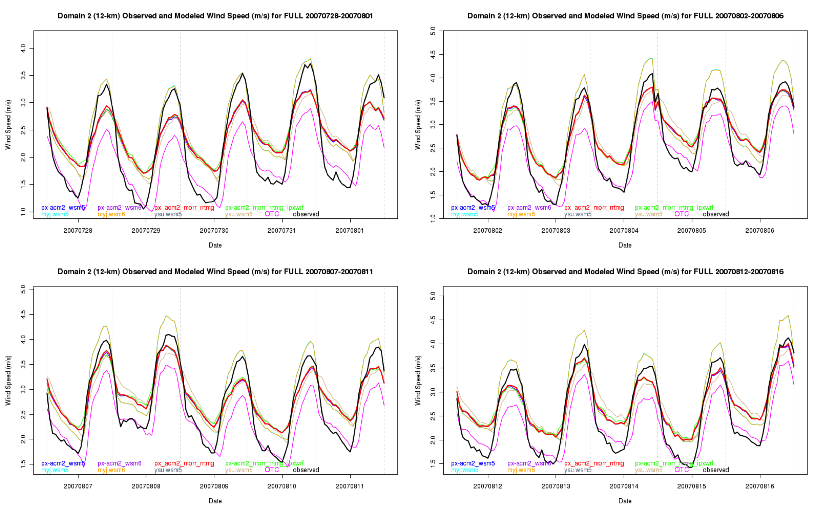

The sensitivity plots for one of the 5-day periods from the summer episode is shown below to highlight one of the regional differences. The plot for Florida is similar to the plot for the entire domain 2, with an under representation of the variability in the observed wind speeds. However, for this the production run and a number of the other sensitivity runs appear to be much better at simulating the wind speed minima (they are within about 0.5 m/s of the observed wind speed minimum).

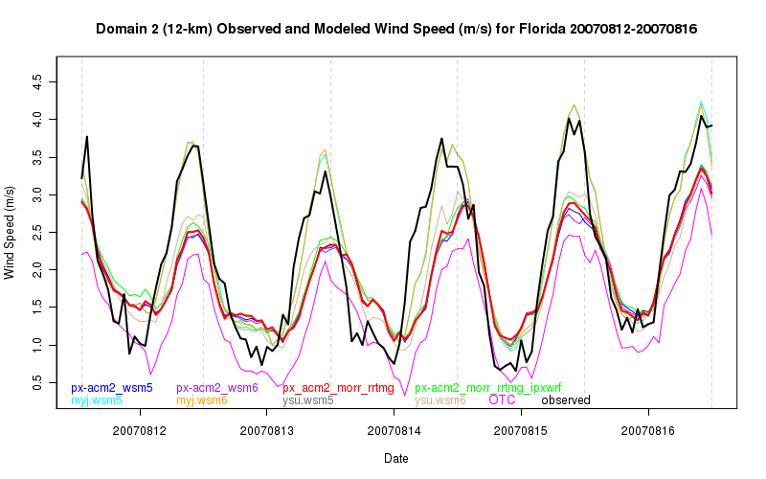

The winter episode shows some considerable differences compared to the summer episode. The observed wind speeds in the winter episode generally have greater variability than during the summer. The production run performs well at simulating the maximum wind speeds, but still appears to overestimate the wind speed during the nighttime and early morning hours when there is a stable boundary layer and the wind speeds are reduced. The ysu.wsm6 has the largest errors of all runs during much of the winter episode and performs the worst during the periods where the boundary layer becomes stable and the observed wind speeds decrease significantly. The OTC sensitivity run consistently has the lowest wind speeds of all the sensitivity runs, similar to what is found for the summer episode.

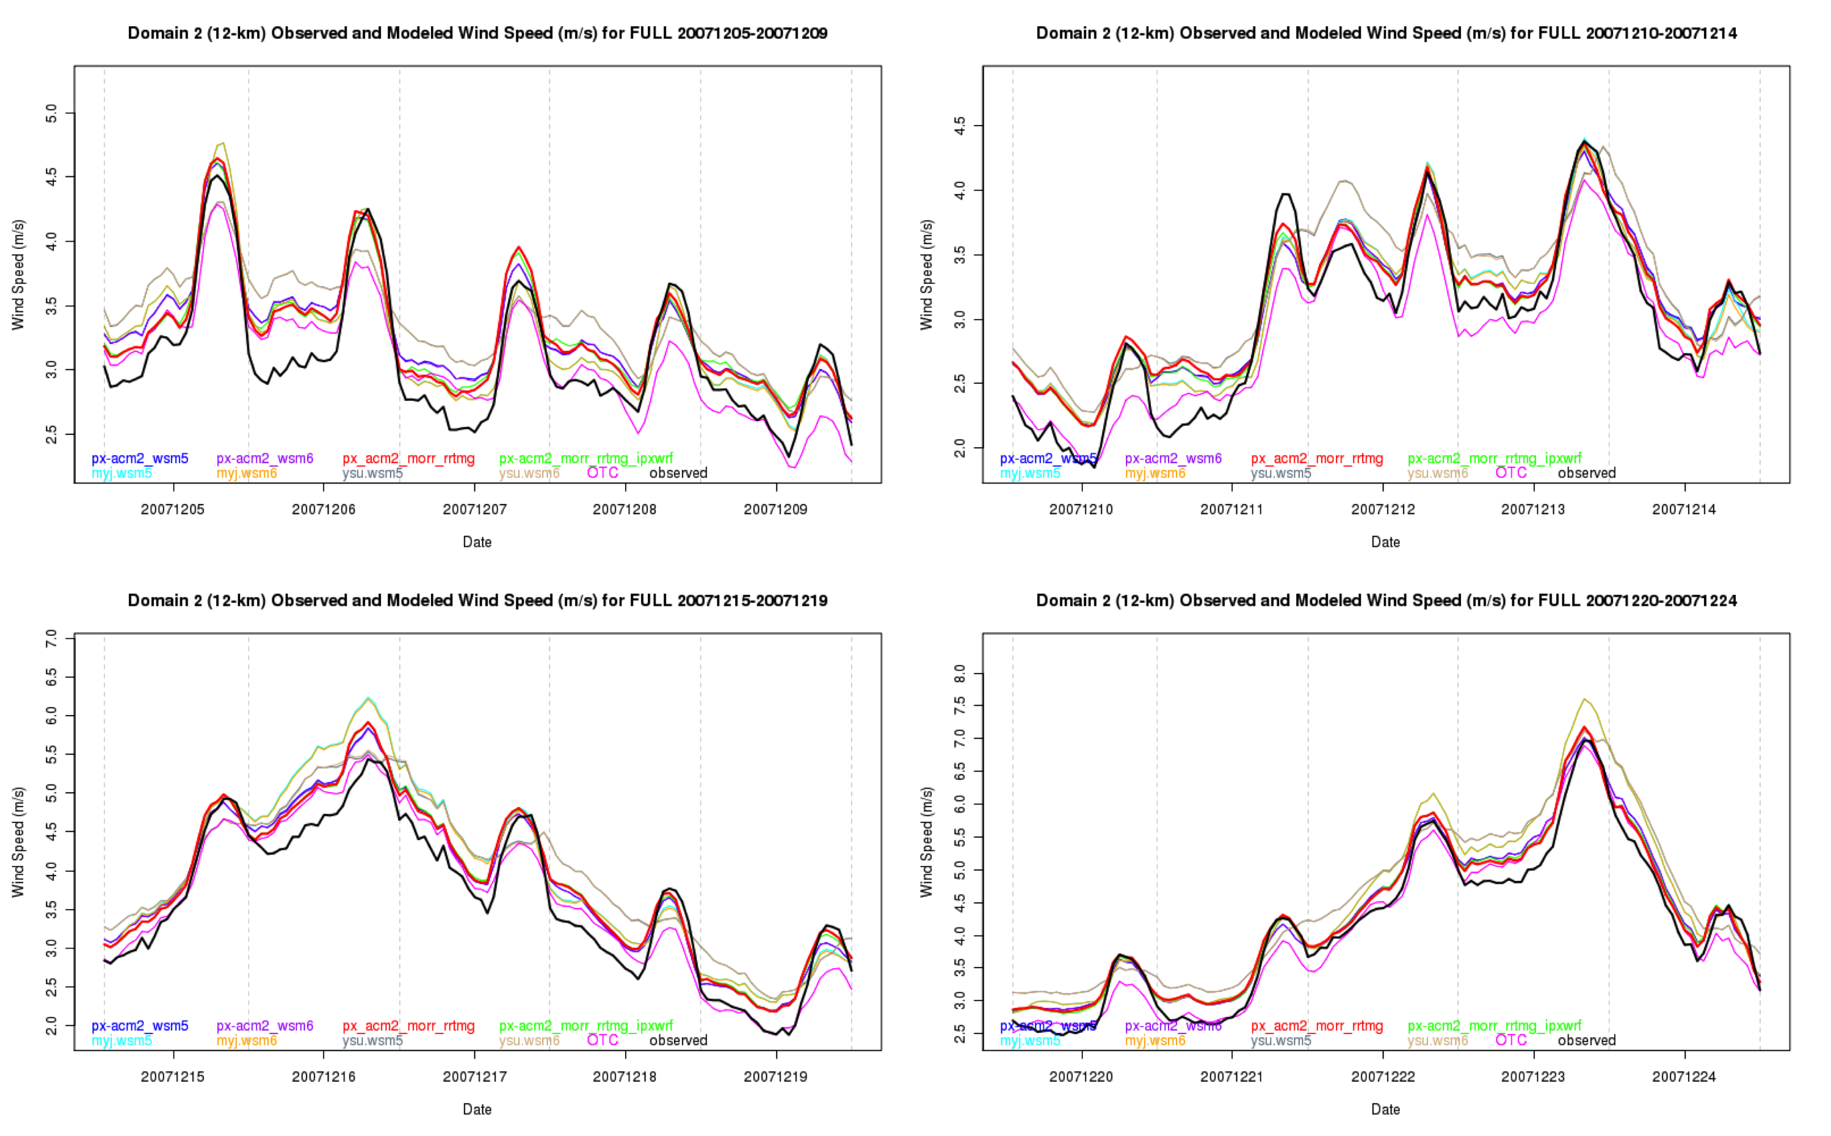
Winter episode plots for separate 5-day periods for Indiana and West Virginia are show below again to highlight some of the regional differences. The production run in the Indiana plot generally tracks the observations well and does not appear to show a systematic bias. A couple of the sensitivity runs (among them myj.wsm5, myj.wsm6, and ysu.wsm6) overpredict the wind speed during maxima in the observed wind speed. In the West Virginia plot there is a tendency for all of the sensitivity runs, including the production run, to overestimate the wind speed. The myj.wsm5 and myj.wsm6 runs had especially strong wind speeds relative to the observed wind speeds. The behavior of the WRF simulation over West Virginia is likely attributable to the higher terrain across much of the state (as was also found for the year-long statistics of the production run).
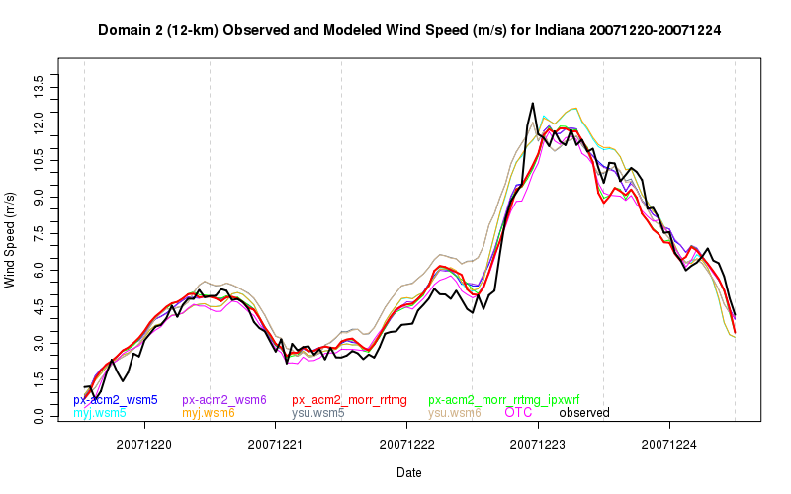
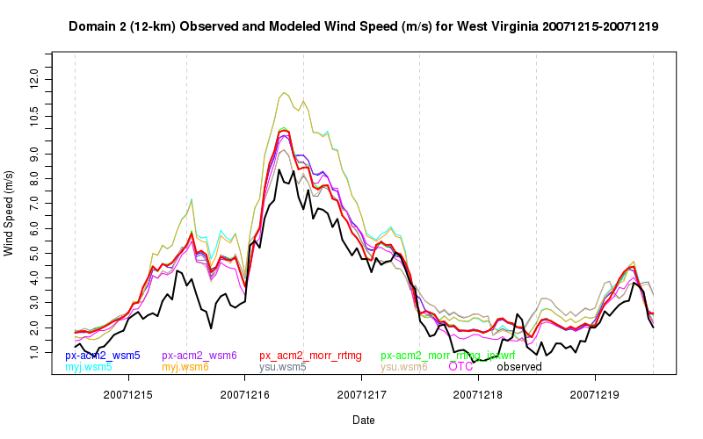

Task 2 H 6: Bubble spatial plots of error statistics

This section discusses the results of the sensitivity runs in terms of the spatial “bubble” plots of bias and MAE. These plots are analogous to those for the production run in Task 2 C.

Temperature

The 2-meter / surface temperature mean absolute errors (MAE) of domain 2 were generally less than 2.5 ⁰C for both winter and summer for all sensitivity runs. However, there were some differences in the biases between the runs. For winter the OTC, px_acm2_morr_rrtmg_ipxwrf, and px_acm2_morr_rrtmg runs exhibited warm biases > 1.0 C over the Great Plains, southern Canada and many locations along East Coast. The px_acm2_morr_rrtmg run, shown below, was the best of the three as the other two featured more locations with larger biases > 2.0 C.

Winter Temperature Mean Bias for Domain 2 for px_acm2_morr_rrtmg
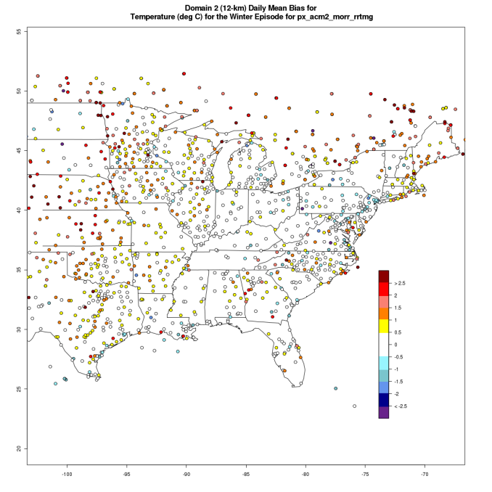

The runs myj_wsm5, myj_wsm6, ysu_wsm5, and ysu_wsm6 featured a cold winter bias of < -2.0 C over Wisconsin and eastern Minnesota as shown below for myj_wsm6. The cold bias was only present on 4 of the 19 days of the winter runs and interestingly was present for those same days, December 13, 16, 17, 19, in all the sensitivity runs. The fact that the cold bias only shows up as a seasonal bias in these four runs was that much larger positive biases (> 2.5 C) on other days for the other runs negated this cold bias. There were no substantial winter temperature biases for the px_acm2_wsm5 and px_acm2_wsm6 runs.

Winter Temperature Mean Bias for Domain 2 for myj_wsm6
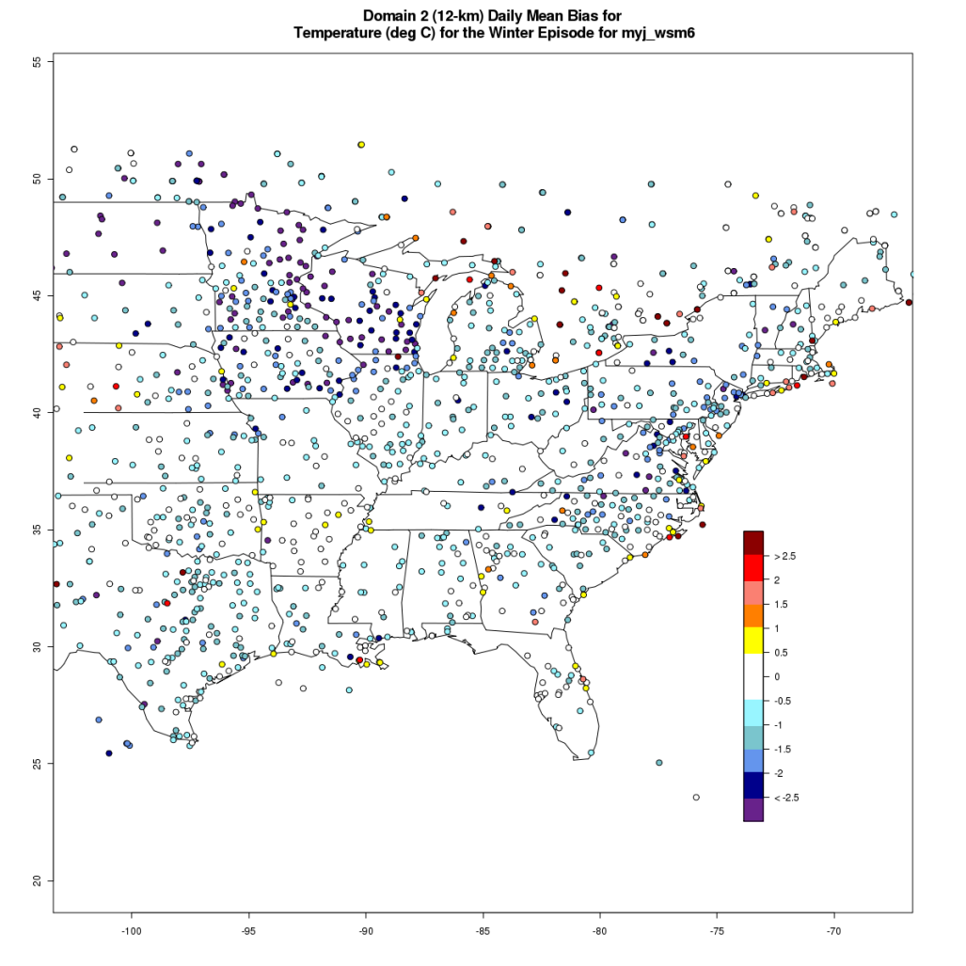

During summer only the px_acm2_morr_rrtmg_ipxwrf run exhibited notable biases. For this run there was a general 0.5 warm bias in the northern half of domain 2 and with an embedded cool bias of < - 2.0 C immediately north of the Great Lakes.

Relative humidity and dew point

The WRF-MET 2-meter / surface relative humidity (RH) MAEs were generally < 10 % during the summer and < 15 % in winter for all runs. During winter all runs exhibited a moist bias of 10 – 15 % from the upper Midwest to New England. The 2-meter dew point errors exhibited greater inter- run variability. During winter runs OTC, px_acm2_morr_rrtmg_ipxwrf, px_acm2_morr_rrtmg featured a moist dew point bias of > 1.5 C over much of the northern half of domain 2, while the other runs featured a moist bias < 1.5 C. During summer the biases in the dew point temperature did not seem to have any discernable pattern in all but two runs. For px_acm2_morr_rrtmg_ipxwrf, there was a notable moist bias > 1.5 C over much of the domain and for ysu_wsm6 there was dry bias of < -2.0 C in many locations as shown below. In neither case was the bias dependent on the time of the day, but the cool bias in the latter run seemed to be more persistent.

Summer Nighttime Dew point Mean Bias for Domain 2 for px_acm2_morr_rrtmg_ipxwrf
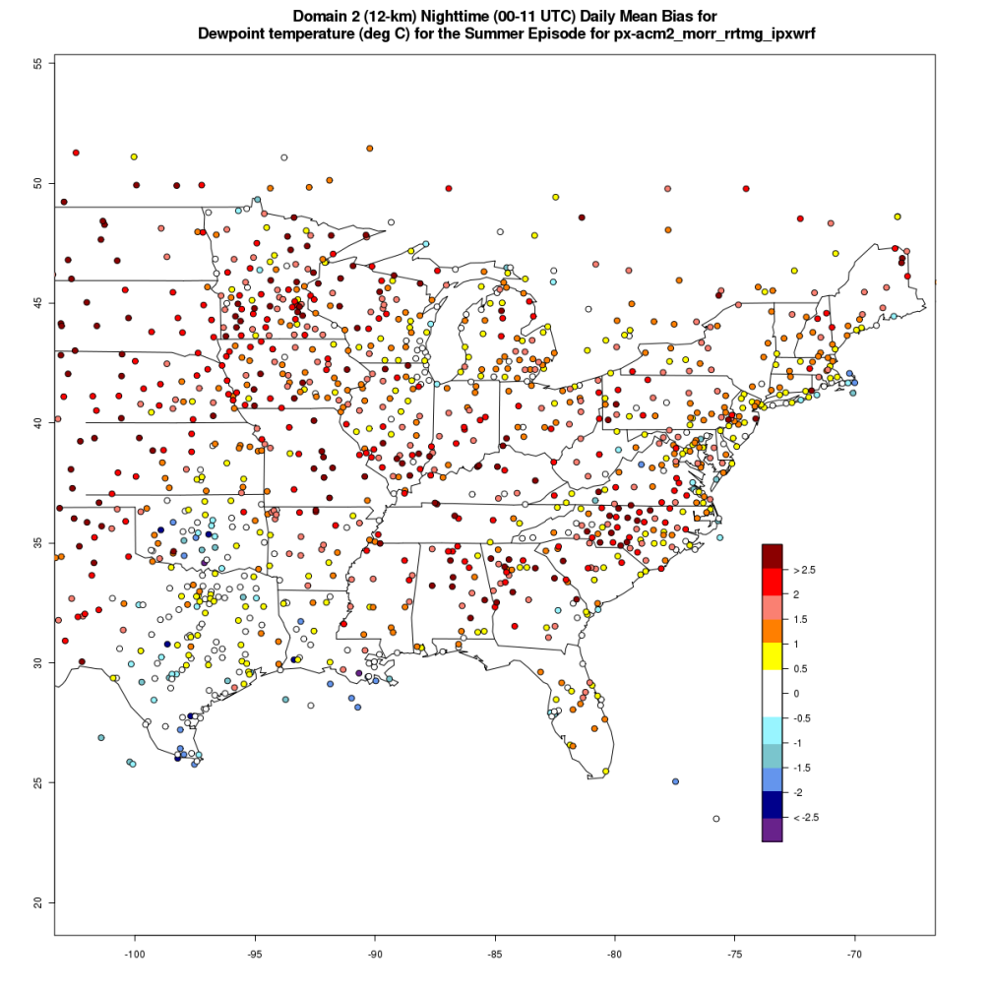

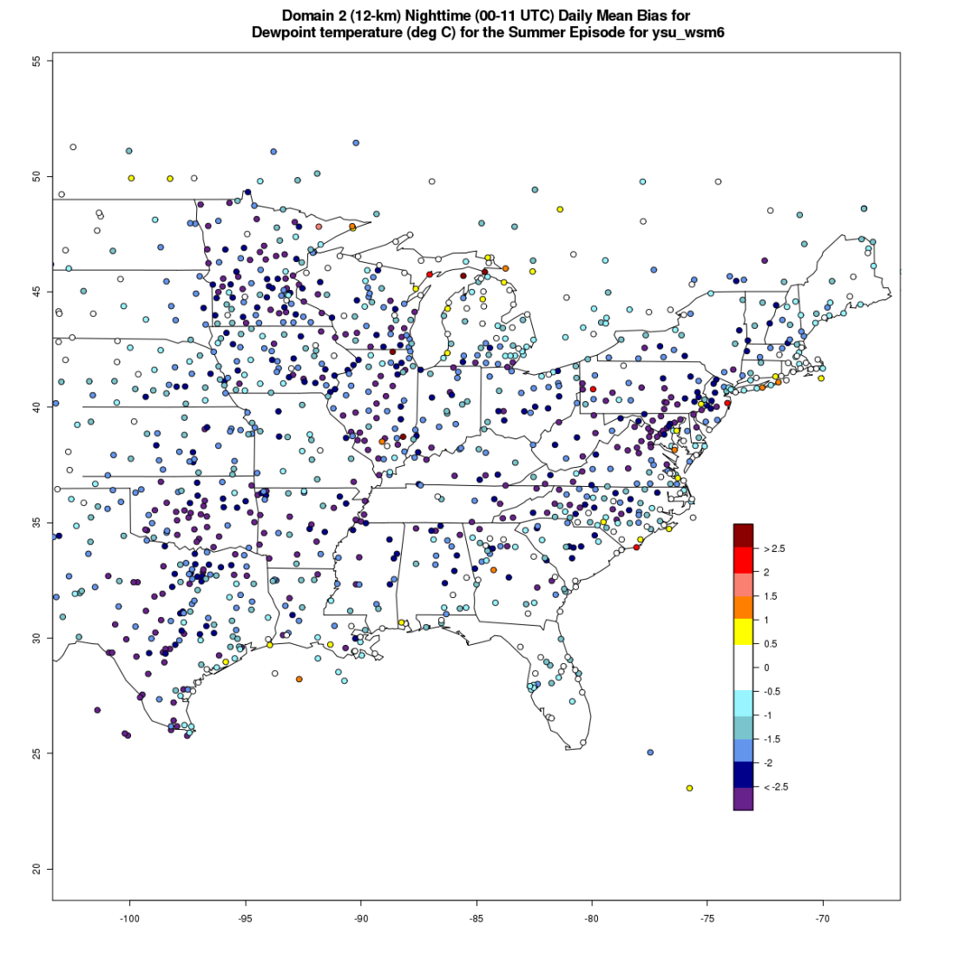

Wind speed

During winter the MAEs for the WRF-MET 10- meter / surface wind speed were generally < 1.5 m/s for all runs over much of domain 2. The exceptions were along the northeastern coast of the U.S. and in southern Canada where the MAEs were > 1.5 m/s with some locations > 2.0 m/s. There did not seem to be any notable differences in the wind errors between the sensitivity runs and biases seemed to be < 0.5 m/s at most locations.

During summer the 10-meter wind MAEs were generally < 1.5 m/s with biases < 0.5 m/s for all runs. There was some inter-run variability in summer as runs OTC, ysu-wsm5 and ysu_wsm6 exhibited MAEs of 1.5 – 2.0 m/s at many locations along coast of the northeastern U.S. and in southern Canada

Wind direction

The wind direction errors exhibited the same characteristics as reported in Task 2 C. There were no distinguishable differences between the sensitivity runs.

Meteorological modeling website and other technical aspects

Website development and documentation

The project web site (http://sesarm.aer.com) serves as the primary means for distributing and evaluating the substantial meteorological modeling results/summaries and communicating the corresponding documentation to SESARM. This web site satisfies the requirements for 'Task 5 Technical Meteorological Modeling Web Site' of contract S-2009-09-01. All content on this web site has been approved by the SESARM Project Officer prior to posting. The website presents objective evaluation results as itemized by Amendment 2 of the project Contract, signed 4 August 2011.

Supplemental Dataset

All WRF-MET point_stat output files (referred to earlier in this document as ‘STAT’ files) have been provided on an external drive to SESARM. These data represent the raw pairs of modeled and observed values, including spatially-averaged values, that are valid at the top of each hour. Data are available for the full calendar year for the production run, and for each hour during each sensitivity period for the sensitivity runs. Data are available for domains 1 and 2 for the production run, and domain 2 for each sensitivity run.

Summary and conclusions

Do the model results fit our conceptual understanding?

Meteorological fields generated during this modeling effort agree with our conceptual understanding of the physical processes of the atmosphere, and, as such, are representative of the observed weather conditions. The WRF-ARW model, when configured in the manner followed by SESARM, ensures that the physical processes of the atmosphere, such as heat and moisture fluxes, interact according to the laws of motion in a manner that is reproducible and verifiable using observations, subject to known, acceptable, model limitations.

Are diurnal features adequately captured?

The WRF model adequately captures the diurnal cycle of temperature, moisture and wind. During periods when the surface flow is forced more strongly by synoptic weather systems, such as during the winter, forecast errors for the wind speeds are minimized. During spring and summer when strong insolation increases the depth of the mixed layer, the model tends to underpredict surface wind speeds during the afternoon. Conversely, the model maintains mixing that is too strong during the overnight hours.

Do the wind fields agree with the observations?

Overall surface wind fields are well represented in the model and provide valuable estimation of the flow fields in the troposphere. Domain-wide wind speed forecasts averaged over full days and for longer timer periods did not exhibit a prolonged or substantial speed bias and wind speed RMSE errors were generally near or slightly exceeded the critical threshold of 2 m/s only for the coarse domain. Values of correlation coefficient are higher than the critical threshold of approximately 0.60. These values do not suggest a systematic problem with the model configuration or performance. Errors values for wind fields above the PBL and removed from the effects of orography were noticeably smaller.

Wind direction forecasts did not exhibit substantial biases, however, mean absolute errors for both domains were at or slightly above the critical threshold of 30 degrees. In combination, these two sets of errors suggest that the direction errors were somewhat random in nature, which is not unexpected when compared with other modeling studies.

Do the temperature and moisture fields generally match the observations?

Overall the temperature and moisture fields generally match the observations. Mean biases in temperature were typically within the critical threshold of 0.5 ºC, with domain 2 values slightly less than those for domain 1. Mean absolute error values during the wintertime were approximately 2 ºC resulting primarily from warm biases. Summertime values were somewhat less. Correlation coefficient values were significantly higher than the critical threshold.

Both mean bias and mean absolute errors for specific humidity were well within acceptable thresholds, even during the summer when levels of moisture in the atmosphere are significantly higher than in the cold winter months. Bias values for all months and both domains were small and positive, with similar characteristics seen in the dew point temperature. A positive bias of moisture may be related to the presence of snow cover in the northern US during the winter and spring, Though a causal relationship is not possible to ascertain, the positive bias of moisture was most pronounced when snow cover was present.

Do the meteorological fields produce acceptable air quality results?

AER recommends the future use of these WRF runs for the following reasons: 1) the fields were generated from the latest version of a state-of-the-art meteorological model, 2) proper configuration of the model was followed, 3) error values are consistent with those in the literature, and 4) there is an absence of obvious, profound, systematic modeling errors. Despite the overall recommendation, it is suggested that future users of subsets of these raw meteorological fields and subsequent air quality fields closely inspect the quality of the individual WRF runs, since the quality of any one run can vary considerably. As well, patterns that seem to emerge from some of the analyses (e.g., time series at METAR sites) are sometimes not representative of broader geographical regions (viz. corresponding bubble spatial plots). The user should make an assessment for their own needs based on the time and region of interest. The individual poor forecasts are often attributed to errors in the initial conditions of the model and may ultimately be linked to failures in the observational network after substantial scientific investigation. Typically these poor model forecasts are limited in space and time.

Appendix A

This appendix lists the location details of all Continental US METAR locations whose data are potentially in the prepBUFR observation dataset that was used in this evaluation study. These are observation locations that are generally available over the GTS communication channel that is the standard transmission channel for NCEP. We know of no source that monitors on a site-by-site basis what is available at any observation time. Observations come and go from this set for a number of reasons, including, but not limited to, communications failures, equipment failures, typographical errors and various attempts at quality control. All observations in the prepBUFR files were ingested and used by WRF-MET. There are no known observations that are never used within CONUS and, while a very small number of observations may change states depending on which modeling domain is used, they are never used in multiple states at once for each domain.

This study used Version 2 of WRF-MET, which does not have the capability to assign station IDs to the latitude/longitude pairs associated with each observation.

CD STATION ICAO IATA SYNOP LAT LONG ELEV (m)
AL ALABASTER KEET EET 33 11N 086 47W 173
AL ALBERTVILLE MUNI K8A0 8A0 34 14N 086 15W 315
AL ALEXANDER/RUSSEL KALX ALX 32 55N 085 58W 209
AL ANDALUSIA/OPP AR K79J 79J 31 19N 086 24W 94
AL ANNISTON KANB ANB 33 35N 085 51W 183
AL AUBURN UNIV. (AM KAUB AUB 32 36N 085 30W 198
AL AUBURN OPELIKA A KAUO AUO 32 37N 085 25W 236
AL BIRMINGHAM KBHM BHM 72228 33 34N 086 45W 197
AL OZARK/CAIRNS AAF KOZR OZR 31 17N 085 43W 93
AL CENTREVILLE WSM K0A8 0A8 72229 32 53N 087 15W 140
AL COURTLAND K9A4 9A4 34 40N 087 21W 179
AL CULLMAN/FOLSOM F K3A1 3A1 34 16N 086 51W 294
AL DECATUR KDCU DCU 34 39N 086 57W 176
AL DOTHAN KDHN DHN 31 19N 085 27W 113
AL EUFAULA KEUF EUF 31 57N 085 08W 87
AL EVERGREEN KGZH GZH 31 25N 087 03W 78
AL FAIRHOPE KCQF CQF 30 28N 087 53W 28
AL FLORALA MUNI K0J4 0J4 31 03N 086 19W 96
AL FT PAYNE/ISBELL K4A9 4A9 34 28N 085 43W 267
AL FT RUCKER/SHELL KSXS SXS 31 22N 085 51W 122
AL FT RUCKER/HANCHE KHEY HEY 31 21N 085 39W 97
AL GADSDEN MUNI KGAD GAD 33 58N 086 04W 173
AL GREENVILLE KPRN PRN 31 51N 086 37W 138
AL GULF SHORES KJKA JKA 30 17N 087 40W 5
AL HALEYVILLE K1M4 1M4 34 17N 087 36W 284
AL HUNTSVILLE KHSV HSV 72323 34 39N 086 47W 191
AL HUNTSVILLE/MADIS KMDQ MDQ 34 52N 086 33W 230
AL JASPER/WALKER KJFX JFX 33 54N 087 19W 148
AL LOWE AHP/FT. RUC KLOR LOR 31 21N 085 45W 74
AL MAXWELL AFB/MGM KMXF MXF 32 22N 086 22W 51
AL MOBILE/BROOKLEY KBFM BFM 30 37N 088 04W 20
AL MOBILE/BATES KMOB MOB 72223 30 41N 088 15W 63
AL MONTGOMERY KMGM MGM 72226 32 18N 086 24W 63
AL MUSCLE SHOAL KMSL MSL 34 45N 087 36W 164
AL PHI OIL PLAT KRAM RAM 29 03N 088 05W 10
AL REDSTONE ARSENAL KHUA HUA 74001 34 41N 086 41W 209
AL SCOTTSBORO K4A6 4A6 34 41N 086 00W 198
AL TROY KTOI TOI 31 51N 086 01W 118
AL TUSCALOOSA KTCL TCL 33 13N 087 37W 49
AL VIOSCA KNOLL768 KVOA VOA 29 14N 087 47W 53
AR ARKADELPHIA KM89 M89 34 06N 093 04W 56
AR BATESVILLE KBVX BVX 35 43N 091 39W 141
AR BENTONVILLE KH00 H00 36 21N 094 13W 395
AR BENTONVILLE KVBT VBT 36 21N 094 13W 395
AR BENTONVILLE (NW) KXNA XNA 36 17N 094 18W 392
AR BLYTHEVILLE KHKA HKA 35 56N 089 50W 78
AR BLYTHEVILLE KBYH BYH 35 58N 089 57W 78
AR CAMDEN KCDH CDH 33 37N 092 46W 35
AR CLINTON MUNI KCCA CCA 35 36N 092 27W 157
AR CORNING K4M9 4M9 36 24N 090 39W 90
AR DE QUEEN KDEQ DEQ 34 03N 094 24W 106
AR EL DORADO KELD ELD 33 13N 092 49W 81
AR FAYETTEVILLE KFYV FYV 36 01N 094 10W 379
AR FLIPPIN (AWOS) KFLP FLP 36 17N 092 35W 219
AR FORT SMITH KFSM FSM 72344 35 20N 094 22W 140
AR HARRISON KHRO HRO 36 16N 093 09W 417
AR HOT SPRINGS KHOT HOT 34 29N 093 06W 162
AR JONESBORO KJBR JBR 35 50N 090 39W 79
AR LITTLE ROCK KLIT LIT 34 44N 092 14W 79
AR LITTLE ROCK AFB KLRF LRF 34 55N 092 09W 95
AR MENA INTERMTN KMEZ MEZ 34 33N 094 12W 329
AR W MEMPHIS MUNI KAWM AWM 35 08N 090 14W 65
AR MONTICELLO KLLQ LLQ 33 38N 091 45W 83
AR MOUNT IDA KMWT MWT 34 33N 093 35W 214
AR MOUNTAIN HOME KBPK BPK 36 22N 092 28W 280
AR N. LITTLE ROCK KLZK LZK 72340 34 50N 092 16W 173
AR NEWPORT KM19 M19 35 38N 091 11W 73
AR PINE BLUFF/GRIDR KPBF PBF 34 11N 091 56W 62
AR ROGERS KROG ROG 36 22N 094 05W 415
AR RUSSELLVILLE KRUE RUE 35 15N 093 06W 115
AR SEARCY KSRC SRC 35 15N 091 44W 80
AR SILOAM SPRING KSLG SLG 36 12N 094 28W 300
AR SPRINGDALE MUNI KASG ASG 36 10N 094 07W 412
AR STUTTGART KSGT SGT 34 36N 091 34W 68
AR TEXARKANA KTXK TXK 33 27N 093 59W 111
AR WALNUT RIDGE KARG ARG 36 07N 090 55W 83
AZ PHOENIX/SKY HRBR KPHX PHX 72278 33 26N 112 03W 336
AZ TUCSON KTUS TUS 32 08N 110 57W 776
AZ BUCKEYE KBXK BXK 33 25N 112 41W 315
AZ BULLHEAD CITY KIFP IFP 35 09N 114 34W 212
AZ CASA GRANDA KCGZ CGZ 32 57N 111 46W 446
AZ CHANDLER/MESA KIWA IWA 33 18N 111 39W 412
AZ CHANDLER KCHD CHD 33 16N 111 49W 379
AZ DAVIS/TUCSON KDMA DMA 32 10N 110 52W 824
AZ DOUGLAS BISBEE KDUG DUG 31 28N 109 35W 1265
AZ FLAGSTAFF KFLG FLG 72375 35 08N 111 40W 2134
AZ FORT HUACHUCA KFHU FHU 72273 31 35N 110 21W 1438
AZ GILA BEND (AAF) KGBN GBN 74724 32 52N 112 43W 262
AZ GLENDALE KGEU GEU 33 32N 112 18W 325
AZ LUKE AFB/GLENDAL KLUF LUF 33 31N 112 22W 332
AZ GOODYEAR MUNICIP KGYR GYR 33 25N 112 22W 295
AZ GRAND CANYON KGCN GCN 72378 35 57N 112 09W 2016
AZ GRAND CANYON/VAL K40G 40G 35 38N 112 09W 1830
AZ KINGMAN KIGM IGM 72370 35 15N 113 56W 1032
AZ LAKE HAVASU CITY KHII HII 34 34N 114 22W 238
AZ MESA/FALCON FLD KFFZ FFZ 33 28N 111 43W 424
AZ NOGALES KOLS OLS 31 25N 110 51W 1184
AZ PAGE KPGA PGA 72371 36 55N 111 27W 1307
AZ PAYSON KPAN PAN 34 15N 111 20W 1572
AZ PHOENIX/DEER VLY KDVT DVT 33 41N 112 04W 443
AZ PIONEER AIRFIELD KALK ALK 31 36N 110 26W 1453
AZ PRESCOTT KPRC PRC 34 39N 112 25W 1524
AZ SAFFORD KSAD SAD 32 51N 109 38W 962
AZ SCOTTSDALE KSDL SDL 33 37N 111 55W 447
AZ SEDONA KSEZ SEZ 34 51N 111 47W 1473
AZ SHOW LOW MUNICIP KSOW SOW 34 16N 110 00W 1954
AZ ST. JOHNS KSJN SJN 34 31N 109 23W 1745
AZ TUCSON/RYAN FLD KRYN RYN 32 09N 111 10W 737
AZ WILLIAMS CLARK KCMR CMR 35 18N 112 12W 2036
AZ WINDOW ROCK KRQE RQE 35 39N 109 04W 2055
AZ WINSLOW KINW INW 72374 35 02N 110 43W 1490
AZ YUMA INTL KYUM YUM 72280 32 38N 114 35W 63
AZ YUMA MCAS KNYL NYL 69960 32 38N 114 37W 65
CA ALAMEDA NAS KNGZ NGZ 74506 37 46N 122 19W 4
CA ALTURAS KAAT AAT 41 29N 120 34W 1331
CA APPLE VALLEY KAPV APV 34 34N 117 11W 934
CA ARCATA/EUREKA KACV ACV 40 59N 124 06W 67
CA AUBURN MUNI KAUN AUN 38 57N 121 05W 467
CA AVALON KAVX AVX 72292 33 24N 118 25W 482
CA BAKERSFIELD KBFL BFL 72384 35 26N 119 03W 151
CA BEALE AFB/MARYSV KBAB BAB 39 07N 121 25W 34
CA BEAUMONT KBUO BUO 33 55N 116 58W 692
CA BIG BEAR CITY KL35 L35 34 16N 116 51W 2059
CA BICYCLE LAKE KBYS BYS 74611 35 17N 116 37W 716
CA BISHOP KBIH BIH 72480 37 22N 118 21W 1253
CA BLYTHE KBLH BLH 33 37N 114 43W 119
CA BURBANK KBUR BUR 72288 34 12N 118 22W 217
CA BURNEY KBNY BNY 40 52N 121 40W 957
CA CALEXICO INTL KCXL CXL 32 40N 115 30W 1
CA CAMARILLO KCMA CMA 34 13N 119 04W 23
CA CAMP PENDLETON KNFG NFG 33 17N 117 20W 24
CA CAMPO KCZZ CZZ 32 38N 116 28W 807
CA CARLSBAD KCRQ CRQ 33 08N 117 17W 99
CA CHICO MUNICIPAL KCIC CIC 72497 39 47N 121 50W 73
CA CHINA LAKE (NAF) KNID NID 74612 35 40N 117 40W 696
CA CHINO KCNO CNO 33 59N 117 37W 207
CA COLUMBIA KO22 O22 38 02N 120 25W 646
CA CONCORD KCCR CCR 38 00N 122 03W 11
CA CORONA MUNI KAJO AJO 33 54N 117 36W 163
CA CRESCENT CITY KCEC CEC 41 46N 124 13W 17
CA DAGGETT KDAG DAG 34 51N 116 47W 587
CA DAVIS KEDU EDU 38 32N 121 47W 21
CA EDWARDS AFB KEDW EDW 72381 34 53N 117 52W 702
CA EDWARDS N-AUX K9L2 9L2 34 58N 117 52W 701
CA EL CENTRO NAF KNJK NJK 72281 32 49N 115 40W -13
CA EL MONTE KEMT EMT 74704 34 04N 118 01W 90
CA EMIGRANT GAP KBLU BLU 39 17N 120 42W 1609
CA EUREKA/MURRAY KEKA EKA 72594 40 48N 124 10W 18
CA FRESNO KFAT FAT 72389 36 47N 119 43W 104
CA FRESNO CHANDLER KFCH FCH 36 43N 119 49W 85
CA FULLERTON KFUL FUL 33 52N 117 59W 35
CA HALF MOON BAY KHAF HAF 37 31N 122 30W 21
CA HANFORD KHJO HJO 36 19N 119 37W 74
CA HANFORD KO18 O18 36 19N 119 38W 74
CA HAWTHORNE KHHR HHR 33 55N 118 20W 18
CA HAYWARD KHWD HWD 37 40N 122 07W 21
CA HOLLISTER MUNI KCVH CVH 36 54N 121 25W 70
CA HUNTER LIGGET KHGT HGT 69002 36 00N 121 13W 310
CA IMPERIAL KIPL IPL 32 50N 115 35W -17
CA IMPERIAL BEACH KNRS NRS 32 34N 117 07W 7
CA INYOKERN KIYK IYK 35 40N 117 49W 749
CA LA VERNE/BRACKET KPOC POC 34 06N 117 46W 308
CA LANCASTER/FOX KWJF WJF 34 43N 118 13W 715
CA LEMOORE NAS/REEV KNLC NLC 74702 36 19N 119 57W 72
CA LINCOLN KLHM LHM 38 55N 121 21W 37
CA LIVERMORE KLVK LVK 37 42N 121 49W 117
CA LOMPOC KLPC LPC 74606 34 40N 120 28W 27
CA LONG BEACH KLGB LGB 72297 33 49N 118 09W 10
CA LOS ALAMITOS AAF KSLI SLI 33 46N 118 02W 11
CA LOS ANGELES KLAX LAX 72295 33 56N 118 23W 46
CA LOS ANGELES KCQT CQT 34 01N 118 17W 56
CA LA / WHITEMAN KWHP 34 15N 118 25W 306
CA MADERA KMAE MAE 36 59N 120 07W 77
CA MAMMOTH/JUNE LAK KMMH MMH 37 37N 118 49W 2173
CA MARYSVILLE KMYV MYV 39 06N 121 34W 21
CA MATHER FIELD KMHR MHR 38 32N 121 17W 29
CA MCCLELLAN AFB KMCC MCC 38 40N 121 24W 23
CA MERCED KMCE MCE 37 17N 120 30W 47
CA MERCED/CASTLE AF KMER MER 72481 37 23N 120 34W 57
CA MIRAMAR NAS/SAN KNKX NKX 72293 32 52N 117 08W 146
CA MODESTO KMOD MOD 37 37N 120 57W 29
CA MOFFETT NAS/MTN KNUQ NUQ 74509 37 24N 122 03W 12
CA MOJAVE KMHV MHV 35 04N 118 09W 849
CA MONTAGUE/SISKIYO KSIY SIY 41 46N 122 28W 807
CA MONTEREY KMRY MRY 36 35N 121 51W 66
CA MOUNT SHASTA KMHS MHS 72595 41 19N 122 19W 1078
CA MOUNT WILSON KMWS MWS 72289 34 13N 118 04W 1739
CA NAPA KAPC APC 38 12N 122 17W 13
CA NEEDLES KEED EED 72380 34 46N 114 37W 302
CA NEWHALL K3A6 3A6 34 22N 118 34W 427
CA NORTH ISLAND NAS KNZY NZY 32 42N 117 13W 8
CA NOVATO/GNOSS FLD KDVO DVO 38 09N 122 33W 1
CA OAKLAND KOAK OAK 72493 37 42N 122 13W 26
CA OCEANSIDE KOKB OKB 33 13N 117 21W 8
CA OCEANSIDE/RED-B KNXF NXF 33 17N 117 27W 27
CA ONTARIO KONT ONT 34 03N 117 35W 274
CA OROVILLE KOVE OVE 39 30N 121 37W 58
CA OXNARD KOXR OXR 34 12N 119 12W 20
CA PALM SPRINGS KPSP PSP 33 49N 116 30W 135
CA PALMDALE KPMD PMD 72382 34 38N 118 05W 780
CA PALO ALTO KPAO PAO 37 28N 122 07W 2
CA PASO ROBLES KPRB PRB 35 40N 120 38W 245
CA PETALUMA KO69 O69 38 15N 122 36W 28
CA PLACERVILLE KPVF PVF 38 43N 120 45W 789
CA POINT MUGU NAS KNTD NTD 72391 34 07N 119 07W 4
CA PORTERVILLE KPTV PTV 36 01N 119 04W 135
CA PT. PIEDRAS BLAN K87Q 87Q 72390 35 40N 121 17W 27
CA RED BLUFF KRBL RBL 72591 40 09N 122 15W 104
CA REDDING KRDD RDD 72592 40 31N 122 18W 155
CA RIVERSIDE KRAL RAL 33 57N 117 27W 252
CA RIVERSIDE/MARCH KRIV RIV 72286 33 52N 117 16W 469
CA RAMONA KRNM RNM 33 02N 116 55W 427
CA SACRAMENTO KSAC SAC 38 30N 121 30W 11
CA SACRAMENTO/METRO KSMF SMF 38 42N 121 36W 6
CA SALINAS KSNS SNS 36 40N 121 36W 30
CA SAN BERNARDINO KSBD SBD 34 06N 117 14W 353
CA SAN CARLOS AIRPO KSQL SQL 37 31N 122 15W 1
CA SAN CLEMENTE IS. KNUC NUC 33 01N 118 34W 55
CA SAN DIEGO KSAN SAN 72290 32 44N 117 11W 12
CA SAN DIEGO/MNTGMY KMYF MYF 32 49N 117 08W 136
CA SAN DIEGO/BROWN KSDM SDM 32 35N 117 00W 159
CA SAN DIEGO/SANTEE KSEE SEE 32 49N 116 58W 117
CA SAN FRANCISCO KSFO SFO 72494 37 37N 122 22W 3
CA SAN JOSE KSJC SJC 74505 37 22N 121 55W 24
CA SAN JOSE/REID KRHV RHV 37 19N 121 49W 41
CA SAN LUIS OBISPO KSBP SBP 35 14N 120 38W 59
CA SAN NICOLAS ISLA KNSI NSI 72291 33 13N 119 27W 154
CA SANDBERG KSDB SDB 72383 34 45N 118 43W 1377
CA COSTA MESA KSNA SNA 33 40N 117 52W 16
CA SANTA BARBARA KSBA SBA 34 26N 119 51W 3
CA SANTA MARIA KSMX SMX 72394 34 54N 120 27W 74
CA SANTA MONICA KSMO SMO 34 01N 118 27W 57
CA SANTA ROSA KSTS STS 38 30N 122 49W 39
CA SANTA YNEZ KIZA IZA 34 36N 120 04W 205
CA SHELTER COVE KO87 O87 40 01N 124 04W 21
CA SOUTH LAKE TAHOE KTVL TVL 38 54N 120 00W 1924
CA STOCKTON KSCK SCK 72492 37 53N 121 13W 10
CA SUSANVILLE MUNI KSVE SVE 72584 40 22N 120 34W 1263
CA THERMAL/PALM SPG KTRM TRM 33 38N 116 10W -35
CA TORRANCE MUNICIP KTOA TOA 33 47N 118 19W 31
CA TRAVIS AFB/FAIRF KSUU SUU 74516 38 16N 121 55W 19
CA TRUCKEE TAHOE KTRK TRK 39 19N 120 07W 1798
CA TEHACHAPI KTSP TSP 35 08N 118 26W 1220
CA TWENTYNINE PALMS KNXP NXP 69015 34 17N 116 10W 626
CA UKIAH KUKI UKI 39 07N 123 12W 187
CA VACAVILLE KVCB VCB 38 23N 121 57W 33
CA VAN NUYS KVNY VNY 34 13N 118 29W 245
CA VANDENBERG AFB KVBG VBG 72393 34 44N 120 35W 112
CA VANDENBERG RANGE KXVW XVW 34 43N 120 34W 100
CA VICTORVILLE KVCV VCV 34 35N 117 23W 876
CA VISALIA MUNI KVIS VIS 36 19N 119 24W 89
CA WATSONVILLE KWVI WVI 36 56N 121 47W 43
CA WEAVERVILLE KO54 O54 40 45N 122 55W 717
CO DENVER (DIA) KDEN DEN 72565 39 50N 104 39W 1640
CO AKRON KAKO AKO 40 10N 103 13W 1421
CO ALAMOSA KALS ALS 72462 37 26N 105 52W 2299
CO ASPEN KASE ASE 39 14N 106 52W 2354
CO BERTHOUD PASS K0CO 0CO 39 48N 105 46W 4113
CO BROOMFIELD/JEFFC KBJC BJC 39 55N 105 07W 1724
CO BUCKLEY ANGB/DEN KBKF BKF 39 43N 104 45W 1726
CO BURLINGTON KITR ITR 39 15N 102 17W 1279
CO CANON CITY K1V6 1V6 38 26N 105 06W 1658
CO COLORADO SPRINGS KCOS COS 72466 38 49N 104 43W 1856
CO CO SPNGS MEADOW KFLY FLY 38 57N 104 34W 2096
CO CORTEZ KCEZ CEZ 37 18N 108 38W 1797
CO CRAIG KCAG CAG 72570 40 30N 107 31W 1887
CO DENVER/ARAPAHOE KAPA APA 39 34N 104 51W 1775
CO DENVER F. RANGE KFTG FTG 39 47N 104 33W 1675
CO DURANGO KDRO DRO 37 09N 107 46W 2035
CO EAGLE CO. REGION KEGE EGE 39 38N 106 55W 1993
CO FORT CARSON KFCS FCS 72468 38 40N 104 46W 1789
CO FT COLLINS/LOVEL KFNL FNL 40 27N 105 01W 1529
CO GRAND JUNCTION KGJT GJT 72476 39 07N 108 31W 1475
CO GREELEY/WELD KGXY GXY 40 25N 104 37W 1420
CO GUNNISON KGUC GUC 38 31N 106 55W 2339
CO HAYDEN/YAMPA KHDN HDN 72571 40 28N 107 13W 2012
CO LA JUNTA KLHX LHX 38 03N 103 31W 1277
CO LAMAR KLAA LAA 72463 38 04N 102 41W 1119
CO LEADVILLE KLXV LXV 72467 39 14N 106 19W 3028
CO LIMON KLIC LIC 39 16N 103 40W 1630
CO MEEKER KEEO EEO 40 03N 107 53W 1930
CO MONTROSE KMTJ MTJ 38 30N 107 54W 1750
CO NUCLA/HOPKINS F KAIB AIB 38 14N 108 34W 1811
CO PUEBLO KPUB PUB 72464 38 17N 104 30W 1420
CO RIFLE KRIL RIL 39 32N 107 44W 1678
CO SAGUACHE MUNI K04V 04V 38 06N 106 10W 2385
CO SPRINGFIELD KSPD SPD 37 17N 102 37W 1335
CO STEAMBOAT SPRING KSBS SBS 40 31N 106 52W 2096
CO MT WERNER SBS K3MW 3MW 40 27N 106 45W 3241
CO TELLURIDE REGION KTEX TEX 37 57N 107 54W 2769
CO TRINIDAD/ANIMAS KTAD TAD 37 16N 104 19W 1756
CO USAF ACADEMY/COS KAFF AFF 74531 38 58N 104 49W 2003
CO YUMA KYMA 40 06N 102 43W 1261
CO FLAGLER KFLA 39 17N 103 04W 1507
CO IDALIA KIDL 39 42N 102 17W 1209
CO KIRK K72C 39 36N 102 34W 1280
CO STERLING KSTK 40 37N 103 16W 1231
CO STRATTON KSTR 39 18N 102 36W 1345
CO RED CLIFF PASS KCCU 39 28N 106 09W 3680
CO RANGELY K4V0 40 06N 108 46W 1608
CO BUENA VISTA KAEJ 38 49N 106 07W 2422
CO DELTA/BLAKE FLD KAJZ 38 47N 108 04W 1583
CO SALIDA KANK 38 32N 106 03W 2293
CO BOULDER MUNI KBDU 40 02N 105 14W 1612
CO ELLICOTT-B AFA KABH 38 45N 104 18W 1840
CO ERIE MUNI KEIK 40 01N 105 03W 1564
CO FORT MORGAN KFMM 40 20N 103 48W 1393
CO GRANBY/GRAND CO KGNB 40 05N 105 55W 2500
CO HOLYOKE KHEQ 40 34N 102 16W 1137
CO LONGMONT/VBRAND KLMO 40 10N 105 10W 1541
CO PAGOSA SPRINGS KPSO 37 17N 107 03W 2334
CO WOLF CREEK PASS KCPW 37 27N 106 48W 3584
CO CORONA PASS KCRV 40 03N 105 35W 3538
CO MONUMENT/ELBERT KMNH 39 13N 104 39W 2152
CO MONARCH PASS KMYP 38 29N 106 19W 3667
CO LA VETA PASS KVTP 37 30N 105 10W 3114
CO WALDEN K33V 40 45N 106 16W 2484
CO KREMMLING AWOS K20V 40 03N 106 22W 2259
CO WILKERSON PASS K4BM 39 03N 105 31W 3438
CO SUNLIGHT K5SM 39 26N 107 23W 3232
CO COTTONWOOD PASS K7BM 38 47N 106 13W 2995
CO WRAY K2V5 40 06N 102 14W 1118
CT BRIDGEPORT KBDR BDR 72504 41 10N 073 08W 7
CT CHESTER KSNC SNC 41 23N 072 30W 127
CT DANBURY KDXR DXR 41 22N 073 29W 139
CT GROTON/NEW LONDO KGON GON 41 20N 072 03W 3
CT HARTFORD/BRAINAR KHFD HFD 41 44N 072 39W 4
CT MERIDEN KMMK MMK 41 31N 072 50W 31
CT NEW HAVEN/TWEED KHVN HVN 41 16N 072 52W 4
CT OXFORD/WATERBURY KOXC OXC 41 28N 073 08W 222
CT WILLIMANTIC KIJD IJD 41 45N 072 11W 75
CT WINDSOR LOCKS KBDL BDL 72508 41 56N 072 41W 60
DE DOVER AFB KDOV DOV 39 07N 075 28W 9
DE GEORGETOWN KGED GED 38 41N 075 22W 19
DE WILMINGTON KILG ILG 39 40N 075 36W 28
FL APALACHICOLA KAAF AAF 72220 29 44N 085 02W 5
FL BARTOW MUNICIPAL KBOW BOW 27 56N 081 46W 39
FL BOCA RATON KBCT BCT 26 23N 080 06W 4
FL BONIFAY TRI-CTY K1J0 1J0 30 51N 085 36W 26
FL BROOKSVILLE KBKV BKV 28 28N 082 27W 20
FL CAPE CANAVERAL KXMR XMR 74794 28 28N 080 32W 3
FL CECIL FIELD NAS KNZC NZC 30 13N 081 52W 25
FL CRESTVIEW KCEW CEW 30 47N 086 31W 55
FL CROSS CITY KCTY CTY 72212 29 38N 083 06W 13
FL CRYSTAL RIVER KCGC CGC 28 52N 082 34W 3
FL DAYTONA BEACH KDAB DAB 29 11N 081 04W 9
FL DESTIN KDTS DTS 30 24N 086 28W 5
FL DUKE FLD/EGLIN KEGI EGI 74778 30 38N 086 31W 59
FL EGLIN AFB/VALPAR KVPS VPS 72221 30 28N 086 31W 26
FL EVERGLADES CITY KEGC EGC 25 51N 081 23W 2
FL FERNANDINA BEACH KFHB FHB 30 37N 081 28W 5
FL FLAMINGO/MONROE KFLM FLM 25 08N 080 55W 2
FL FT LAUDERD/HOLLY KFLL FLL 26 04N 080 09W 3
FL FT LAUDERD/EXEC KFXE FXE 26 12N 080 11W 6
FL FORT MYERS KRSW RSW 26 32N 081 45W 10
FL FORT MYERS KFMY FMY 26 35N 081 52W 4
FL FORT PIERCE KFPR FPR 27 30N 080 23W 13
FL GAINESVILLE KGNV GNV 29 42N 082 17W 45
FL HOLLYWOOD KHWO HWO 26 00N 080 14W 2
FL HOMESTEAD AFB KHST HST 25 28N 080 22W 2
FL HURLBURT FIELD KHRT HRT 74777 30 25N 086 40W 12
FL INVERNESS KX40 X40 28 48N 082 19W 15
FL JACKSONVIL/CRAIG KCRG CRG 30 20N 081 31W 13
FL JACKSONVILLE NAS KNIP NIP 30 13N 081 40W 7
FL JACKSONVILLE KJAX JAX 72206 30 30N 081 41W 10
FL JACKSONVIL/CECIL KVQQ VQQ 30 13N 081 53W 25
FL JACKSONVIL/NAVAL KNEN NEN 30 21N 081 53W 30
FL KEYSTONE HEIGHTS K42J 42J 29 51N 082 03W 60
FL KEY WEST NAS KNQX NQX 24 34N 081 40W 2
FL KEY WEST KEYW EYW 72201 24 33N 081 45W 5
FL KISSIMMEE/ORLAND KISM ISM 28 17N 081 26W 25
FL LAKELAND REGIONA KLAL LAL 27 58N 082 01W 43
FL LEESBURG KLEE LEE 28 49N 081 49W 23
FL MACDILL AFB/TAMP KMCF MCF 74788 27 51N 082 31W 4
FL MARATHON KMTH MTH 24 44N 081 03W 2
FL MARIANNA KMAI MAI 30 50N 085 11W 32
FL MAYPORT NAS KNRB NRB 30 23N 081 25W 5
FL MELBOURNE KMLB MLB 72204 28 06N 080 39W 11
FL MERRITT ISLAND KCOI COI 28 20N 080 41W 2
FL MIAMI/TAMIAMI KTMB TMB 25 39N 080 26W 2
FL MIAMI KMIA MIA 25 48N 080 17W 3
FL MIAMI/OPA LOCKA KOPF OPF 25 55N 080 17W 16
FL MIAMI BEACH KMBF MBF 25 46N 080 08W 1
FL MILTON/WHITING S KNDZ NDZ 30 42N 087 01W 54
FL NAPLES MUNICIPAL KAPF APF 26 09N 081 46W 3
FL NASA SHUTTLE FCL KTTS TTS 28 37N 080 43W 3
FL NEW PORT RICHEY KRRF RRF 28 11N 082 38W 12
FL NEW SMYRNA BEACH KEVB EVB 29 03N 080 57W 3
FL OCALA MUNI KOCF OCF 29 10N 082 13W 27
FL OCEAN REEF KOCR OCR 25 18N 080 16W 2
FL OKEECHOBEE CTY KOBE OBE 27 16N 080 51W 11
FL ORLANDO KMCO MCO 72205 28 25N 081 20W 29
FL ORLANDO KORL ORL 28 33N 081 20W 37
FL ORMOND BEACH VOR KOMN OMN 29 18N 081 07W 9
FL PALM COAST KXFL XFL 29 28N 081 12W 10
FL PANAMA CITY KECP ECP 30 21N 085 48W 21
FL PATRICK AFB/COCO KCOF COF 74795 28 13N 080 35W 3
FL PENSACOLA KPNS PNS 72222 30 29N 087 11W 38
FL PENSACOLA NAS KNPA NPA 30 21N 087 19W 9
FL PERRY FOLEY K40J 40J 30 04N 083 34W 13
FL PLANT CITY MUNI KPCM PCM 28 00N 082 10W 47
FL POMPANO BEACH KPMP PMP 26 15N 080 07W 6
FL PORT RICHEY KX41 X41 28 21N 082 37W 12
FL PUNTA GORDA KPGD PGD 26 55N 082 00W 7
FL QUINCY K2J9 2J9 30 36N 084 33W 69
FL SANFORD/ORLANDO KSFB SFB 28 46N 081 13W 17
FL SARASOTA/BRADENT KSRQ SRQ 27 24N 082 34W 18
FL ST AUGUSTINE KSGJ SGJ 99441 29 58N 081 19W 3
FL ST PETERSBURG KPIE PIE 27 55N 082 41W 4
FL ST PETERS/ALBERT KSPG SPG 27 46N 082 38W 2
FL STUART/WITHAM KSUA SUA 27 11N 080 13W 6
FL TALLAHASSEE KTLH TLH 72214 30 24N 084 21W 19
FL TAMPA KTPA TPA 72211 27 58N 082 32W 11
FL TAMPA/O KNIGHT KTPF TPF 27 55N 082 27W 3
FL TAMPA/VANDENBURG KVDF VDF 28 01N 082 21W 7
FL TITUSVILLE KTIX TIX 28 30N 080 48W 11
FL TYNDALL AFB KPAM PAM 74775 30 04N 085 34W 5
FL VENICE KVNC VNC 27 04N 082 26W 6
FL VERO BEACH KVRB VRB 27 39N 080 25W 10
FL THE VILLAGES KVVG VVG 28 57N 081 58W 27
FL WEST PALM BEACH KPBI PBI 72203 26 41N 080 06W 6
FL WHITING FLD NAS KNSE NSE 30 43N 087 01W 61
FL WINTER HAVEN KGIF GIF 28 04N 081 45W 43
FL HURLBERT KQHY 30 24N 086 39W 8
GA ALBANY KABY ABY 72216 31 32N 084 12W 58
GA AMERICUS KACJ ACJ 32 07N 084 11W 143
GA ALMA KAMG AMG 31 32N 082 30W 59
GA ATHENS KAHN AHN 72311 33 57N 083 20W 244
GA ATLANTA KATL ATL 72219 33 38N 084 27W 296
GA ATLANTA/FULTON KFTY FTY 33 47N 084 31W 263
GA ATLANTA/PAULDING KPUJ PUJ 33 55N 084 56W 393
GA AUGUSTA/DANIEL KDNL DNL 33 28N 082 02W 130
GA AUGUSTA/BUSH KAGS AGS 72218 33 22N 081 58W 44
GA BAINBRIDGE KBGE BGE 30 58N 084 38W 43
GA BLAIRSVILLE KDZJ DZJ 34 51N 084 00W 582
GA BLAKELY EARLY C KBIJ BIJ 31 24N 084 54W 65
GA BRUNSWICK KSSI SSI 31 09N 081 23W 6
GA BRUNSWICK/GLYNCO KBQK BQK 31 15N 081 28W 8
GA CANTON/CHEROKEE K47A 47A 34 19N 084 25W 372
GA CARROLLTON/GRAY KCTJ CTJ 33 38N 085 09W 354
GA CARTERSVILLE KVPC VPC 34 08N 084 51W 222
GA CLAXTON/EVANS CO KCWV CWV 32 12N 081 52W 33
GA COLUMBUS KCSG CSG 32 31N 084 57W 135
GA COVINGTON K9A1 9A1 33 38N 083 51W 247
GA DALTON KDNN DNN 34 43N 084 52W 216
GA DOBBINS AFB/MARI KMGE MGE 72227 33 55N 084 31W 326
GA DOUGLAS MUNI KDQH DQH 31 29N 082 52W 78
GA DUBLIN KDBN DBN 32 34N 082 59W 94
GA ELBERTON PATZ F K27A 27A 34 06N 082 49W 184
GA FT BENNING/COLUM KLSF LSF 72225 32 19N 085 00W 71
GA FT STEWART/WRIGH KLHW LHW 72209 31 52N 081 34W 14
GA GAINESVILLE KGVL GVL 34 16N 083 50W 386
GA GREENSBORO K3J7 3J7 33 36N 083 08W 206
GA HOMERVILLE KHOE HOE 31 03N 082 47W 57
GA JESUP/WAYNE CTY KJES JES 31 33N 081 53W 33
GA LA GRANGE KLGC LGC 33 00N 085 04W 211
GA LAWRENCEVILLE KLZU LZU 33 59N 083 58W 323
GA MACON KMCN MCN 72217 32 41N 083 39W 109
GA MARIETTA MCCOLUM KRYY RYY 34 01N 084 36W 317
GA MCDUFFIE/THOMSON KHQU HQU 33 32N 082 31W 152
GA MILLEDGEVILLE KMLJ MLJ 33 09N 083 14W 117
GA MOODY AFB/VALDOS KVAD VAD 74781 30 58N 083 12W 71
GA MOULTRIE MUNI KMGR MGR 31 05N 083 48W 90
GA MOULTRIE/SPENCE KMUL MUL 31 08N 083 42W 89
GA NEWNAN KCCO CCO 33 19N 084 46W 296
GA PEACHTREE/DEKALB KPDK PDK 33 53N 084 18W 302
GA PEACHTREE CITY KFFC FFC 72215 33 21N 084 34W 262
GA ROME KRMG RMG 72320 34 21N 085 10W 193
GA SAVANNAH KSAV SAV 72207 32 07N 081 12W 14
GA SAVANNAH/HUNTER KSVN SVN 74780 32 01N 081 09W 13
GA STATESBORO KTBR TBR 32 29N 081 44W 57
GA SWAINSBORO KSBO SBO 32 37N 082 22W 100
GA SYLVANIA KJYL JYL 32 39N 081 36W 57
GA TIFTON KTMA TMA 31 26N 083 29W 109
GA THOMASTON UPSON KOPN OPN 32 57N 084 16W 243
GA THOMASVILLE KTVI TVI 30 54N 083 53W 80
GA VALDOSTA REGIONA KVLD VLD 30 46N 083 16W 62
GA VIDALIA MUNI KVDI VDI 32 12N 082 22W 84
GA WARNER ROBINS AF KWRB WRB 32 37N 083 35W 90
GA WASHINGTON KIIY IIY 33 47N 082 49W 197
GA WAYCROSS/WARE CO KAYS AYS 72213 31 15N 082 24W 46
GA WINDER/BARROW KWDR WDR 33 59N 083 40W 287
IA ALGONA KAXA AXA 43 04N 094 16W 372
IA AMES KAMW AMW 41 59N 093 37W 279
IA ANKENY KIKV IKV 41 41N 093 34W 275
IA ATLANTIC KAIO AIO 41 23N 095 02W 360
IA AUDUBON KADU ADU 41 42N 094 55W 392
IA BOONE MUNI KBNW BNW 42 02N 093 50W 354
IA BURLINGTON KBRL BRL 40 46N 091 08W 211
IA CARROLL KCIN CIN 42 02N 094 46W 375
IA CEDAR RAPIDS KCID CID 72545 41 53N 091 43W 264
IA CENTERVILLE MUNI KTVK TVK 40 41N 092 54W 314
IA CHARITON KCNC CNC 41 01N 093 22W 320
IA CHARLES CITY KCCY CCY 43 04N 092 37W 343
IA CHEROKEE KCKP CKP 42 44N 095 33W 374
IA CLARINDA KICL ICL 40 43N 095 01W 303
IA CLARION KCAV CAV 42 45N 093 46W 354
IA CLINTON MUNI KCWI CWI 41 49N 090 19W 216
IA COUNCIL BLUFFS KCBF CBF 41 16N 095 46W 382
IA CRESTON KCSQ CSQ 41 01N 094 22W 394
IA DAVENPORT/QUAD C KDVN DVN 74455 41 37N 090 35W 230
IA DECORAH KDEH DEH 43 16N 091 43W 353
IA DENISON KDNS DNS 41 58N 095 22W 388
IA DES MOINES KDSM DSM 72546 41 32N 093 40W 295
IA DUBUQUE KDBQ DBQ 72547 42 24N 090 42W 326
IA ESTHERVILLE KEST EST 43 24N 094 45W 401
IA FAIRFIELD KFFL FFL 41 02N 091 58W 244
IA FOREST CITY KFXY FXY 43 14N 093 37W 375
IA FORT DODGE KFOD FOD 72549 42 32N 094 10W 355
IA FORT MADISON KFSW FSW 40 40N 091 19W 221
IA GRINNELL REG KGGI GGI 41 43N 092 44W 307
IA HARLAN MUNI KHNR HNR 41 35N 095 20W 375
IA INDEPENDENCE KIIB IIB 42 27N 091 57W 298
IA IOWA CITY KIOW IOW 41 38N 091 33W 198
IA IOWA FALLS MUNI KIFA IFA 42 28N 093 16W 347
IA KEOKUK MUNI KEOK EOK 40 28N 091 25W 205
IA KNOXVILLE KOXV OXV 41 17N 093 07W 283
IA LAMONI KLWD LWD 40 38N 093 54W 346
IA LE MARS KLRJ LRJ 42 46N 096 12W 365
IA MARSHALLTOWN KMIW MIW 42 07N 092 55W 296
IA MASON CITY KMCW MCW 43 09N 093 20W 369
IA MONTICELLO MUNI KMXO MXO 42 13N 091 10W 259
IA MT PLEASANT KMPZ MPZ 40 57N 091 31W 224
IA MUSCATINE KMUT MUT 41 22N 091 09W 167
IA NEWTON MUNI KTNU TNU 41 40N 093 01W 290
IA OELWEN KOLZ OLZ 42 40N 091 58W 328
IA ORANGE CITY KORC ORC 42 58N 096 04W 431
IA OSCEOLA MUNI KI75 I75 41 03N 093 41W 339
IA OSKALOOSA MUNI KOOA OOA 41 14N 092 30W 256
IA OTTUMWA KOTM OTM 41 06N 092 27W 256
IA PELLA KPEA PEA 41 24N 092 57W 270
IA PERRY MUNI KPRO PRO 41 50N 094 10W 308
IA RED OAK KRDK RDK 41 01N 095 16W 318
IA SHELDON KSHL SHL 43 13N 095 49W 432
IA SHENANDOAH MUNI KSDA SDA 40 45N 095 25W 296
IA SIOUX CITY KSUX SUX 72557 42 23N 096 23W 338
IA SPENCER KSPW SPW 72650 43 10N 095 13W 403
IA STORM LAKE KSLB SLB 42 36N 095 13W 454
IA VINTON KVTI VTI 42 13N 092 01W 255
IA WASHINGTON KAWG AWG 41 16N 091 40W 230
IA WATERLOO KALO ALO 72548 42 33N 092 24W 264
IA WEBSTER CITY KEBS EBS 42 25N 093 52W 342
IA ADAIR I80 XADA 41 29N 094 43W 450
IA ALGONA US18 XALG 43 05N 094 23W 337
IA ALTON IA10 XATN 42 49N 096 05W 430
IA ALTOONA I80/US65 XALT 41 40N 093 31W 262
IA AMES I35 XAME 42 02N 093 34W 313
IA ANKENY I35 XANK 41 46N 093 34W 264
IA AVOCA I80 XAVO 41 29N 095 17W 377
IA BURLINGTON US34 XBUR 40 49N 091 05W 218
IA CARROLL US30 XCAR 42 05N 094 53W 389
IA CEDAR RAPIDS 380 XCDR 41 49N 091 40W 236
IA CEDAR RAPID US30 XCID 41 56N 091 41W 246
IA CENTERVILLE IA2 XCEN 40 44N 093 00W 295
IA COUNCIL BLUFF 80 XCOU 41 14N 095 52W 268
IA CRESTON US34 XCRE 41 04N 094 18W 388
IA DAVENPORT 80/280 XDAV 41 36N 090 41W 206
IA DECORAH IA9 XDEC 43 14N 091 41W 310
IA DES MOINES I35 XDSM 41 32N 093 46W 224
IA DES MOINES I235 XDES 41 35N 093 37W 281
IA DE SOTO 80/US169 XDST 41 32N 094 06W 291
IA DE WITT US30/61 XDEW 41 50N 090 34W 240
IA DUBUQUE US20 XDUB 42 29N 090 44W 250
IA FORT DODGE US20 XFOD 42 26N 094 11W 286
IA GRINNELL I80 XGRI 41 41N 092 44W 281
IA IOWA CITY US218 XIAC 41 38N 091 35W 254
IA IOWA CITY I80 XIOW 41 41N 091 35W 250
IA JEFFERSON IA4 XJEF 42 03N 094 23W 310
IA LEON I35/IA2 XLEO 40 44N 093 50W 349
IA MANCHESTER US20 XMAN 42 26N 091 26W 309
IA MAQUOKETA 61/64 XMAQ 42 04N 090 41W 251
IA MARSHALTOWN US30 XMAR 42 01N 092 58W 291
IA MASON CITY I35 XMCW 43 02N 093 20W 376
IA MISSOURI VAL I29 XMIS 41 32N 095 55W 309
IA MT PLEASANT U218 XMOU 40 53N 091 33W 133
IA NEW HAMPTON US18 XNEW 43 02N 092 28W 327
IA ONAWA I29 XONA 41 52N 096 01W 303
IA OSCEOLA I35 XOSC 41 02N 093 47W 334
IA OTTUMWA US63 XOTT 41 01N 092 25W 196
IA PELLA IA163 XPEL 41 23N 092 52W 271
IA RED OAK US34/71 XRED 40 59N 094 59W 290
IA SIDNEY I29/IA2 XSID 40 41N 095 47W 287
IA SIGOURNEY IA92 XSIG 41 20N 092 19W 202
IA SIOUX CITY I29 XSIO 42 29N 096 23W 364
IA SPENCER US18 XSPE 43 08N 095 05W 452
IA STORM LAKE 71/3 XSTO 42 44N 095 09W 405
IA TIPTON I80 XTIP 41 38N 091 08W 236
IA URBANA I380 XURB 42 19N 091 59W 302
IA WATERLOO US20 XWAT 42 27N 092 19W 269
IA WILLIAMS I35 XWIL 42 32N 093 34W 325
IA WILLAIMSBURG I80 XWBG 41 41N 092 01W 260
IA HANLONTOWN I35 XHAN 43 23N 093 20W 333
IA STEAMBOAT R US20 XSBI 42 27N 093 03W 348
IA IDA GROVE US59 XIGI 42 21N 095 29W 376
IA CEDAR RAPIDS U30 XCRI 41 56N 091 33W 232
IA BEDFORD XBFI 40 41N 094 43W 357
IA COLFAX XCFI 41 41N 093 16W 247
IA EDDYVILLE XDYI 41 09N 092 39W 244
IA SIBLEY XSYI 43 26N 095 43W 480
IA TAMA XTMI 41 58N 092 18W 250
IA CANTRIL XCTI 40 40N 092 04W 211
IA DENISON XDNI 41 55N 095 20W 426
IA PLAINFIELD XPFI 42 50N 092 32W 294
IA QUAD CITIES XQCI 41 31N 090 31W 177
IA STATE FAIR Q03I 41 36N 093 34W 333
IA ADAIR QADI 41 31N 094 35W 417
IA ADEL QAEI 41 37N 094 01W 292
IA AFTON QAFI 41 02N 094 11W 387
IA ALGONA QAGI 43 04N 094 14W 341
IA ANKENY QAKI 41 44N 093 37W 310
IA ALBIA QALI 41 02N 092 49W 312
IA AMES QAMI 42 03N 093 38W 309
IA ANITA QATI 41 27N 094 46W 387
IA AUDUBON QAUI 41 43N 094 55W 426
IA BEDFORD QBDI 40 40N 094 43W 350
IA BELMOND QBKI 42 51N 093 36W 372
IA BLOOMFIELD QBMI 40 45N 092 25W 260
IA BOONE QBOI 42 02N 093 47W 353
IA BROOKLYN QBRI 41 44N 092 27W 280
IA BUSSEY QBSI 41 13N 092 53W 265
IA BAXTER QBXI 41 50N 093 09W 304
IA BLANK PARK ZOO QBZI 41 32N 093 37W 294
IA CARROLL QCAI 42 04N 094 52W 423
IA COON RAPIDS QCBI 41 53N 094 41W 386
IA CHARLES CITY QCCI 43 04N 092 40W 304
IA CORYDON QCDI 40 45N 093 19W 331
IA CENTERVILLE QCEI 40 44N 092 52W 299
IA CLARION QCGI 42 44N 093 44W 377
IA CHARITON QCHI 41 01N 093 19W 332
IA CLEAR LAKE QCKI 43 08N 093 22W 368
IA CRESCO QCQI 43 23N 092 06W 390
IA CORNING QCNI 40 59N 094 44W 390
IA COLO QCOI 42 01N 093 19W 315
IA CRESTON QCRI 41 04N 094 22W 417
IA INWOOD QCSI 43 19N 096 26W 449
IA DSM CHRISTIAN QDCI 41 38N 093 48W 279
IA SHELDON QDNI 43 11N 095 50W 433
IA RIVER WOODS QDRI 41 34N 093 35W 304
IA EAGLE GROVE QEGI 42 40N 093 55W 339
IA FARNHAMVILLE QFAI 42 20N 094 25W 374
IA FOREST CITY QFCI 43 16N 093 39W 384
IA FORT DODGE QFDI 42 31N 094 11W 353
IA FONTANELLE QFOI 41 17N 094 34W 423
IA GLIDDEN QGLI 42 04N 094 44W 387
IA GARNER QGNI 43 05N 093 37W 373
IA GRIMES QGRI 41 41N 093 48W 310
IA HULL QHII 43 11N 096 08W 436
IA HAMPTON QHPI 42 45N 093 11W 328
IA HUMBOLDT QHUI 42 43N 094 14W 379
IA ICA QIAI 41 35N 093 44W 285
IA IOWA FALLS QIFI 42 32N 093 16W 376
IA INDIANOLA QINI 41 22N 093 33W 310
IA JORDAN CREEK QJCI 41 34N 093 46W 283
IA JEFFERSON QJEI 42 00N 094 23W 338
IA SOUTH HAMILTON QJWI 42 18N 093 39W 340
IA KCCI QKCI 41 35N 093 38W 274
IA KNOXVILLE QKNI 41 19N 093 07W 301
IA KANAWHA QKWI 42 56N 093 47W 369
IA LEON QLEI 40 45N 093 44W 365
IA LATIMER QLMI 42 45N 093 22W 398
IA LAMONI QLOI 40 38N 093 56W 359
IA LUVERNE QLUI 42 55N 094 05W 360
IA ROCK RAPIDS QLYI 43 25N 096 10W 410
IA MARSHALLTOWN QMAI 42 01N 092 55W 314
IA MADRID QMDI 41 53N 093 49W 310
IA LAKE MILLS QMII 43 25N 093 32W 393
IA MALLARD QMLI 42 56N 094 41W 387
IA MONTEZUMA QMNI 41 35N 092 31W 309
IA MOUNT AYR QMOI 40 43N 094 14W 396
IA MANSON-NW QMSI 42 30N 094 22W 368
IA MURRAY QMUI 41 02N 093 57W 365
IA MASON CITY QMWI 43 08N 093 14W 357
IA MASON CITY QMYI 43 09N 093 10W 335
IA NEWTON QNEI 41 42N 093 02W 305
IA THOMPSON QNII 43 22N 093 42W 384
IA NORTHWOOD QNKI 43 27N 093 12W 371
IA NORA SPRINGS QNSI 43 09N 093 00W 332
IA NEVADA QNVI 42 01N 093 26W 313
IA OSAGE QOAI 43 17N 092 49W 353
IA OSKALOOSA QOCI 41 18N 092 39W 245
IA OGDEN QOGI 42 02N 094 02W 332
IA OSCEOLA QOSI 41 02N 093 46W 353
IA PANORA QPAI 41 42N 094 22W 356
IA PELLA QPEI 41 25N 092 54W 289
IA NORTH POLK QPKI 41 47N 093 43W 286
IA PERRY QPYI 41 50N 094 05W 312
IA MASON CITY QRMI 43 08N 093 06W 328
IA ROCKWELL CITY QROI 42 23N 094 38W 384
IA ROCKFORD QRRI 43 03N 092 56W 316
IA ROCKWELL QRSI 42 59N 093 06W 351
IA RUSSELL QRUM 44 19N 095 57W 466
IA RICEVILLE QRVI 43 21N 092 30W 382
IA ST ANSGAR QSAI 43 22N 092 55W 358
IA SIBLEY QSBI 43 24N 095 45W 462
IA STUART QSTI 41 30N 094 19W 367
IA SULLY QSUI 41 34N 092 50W 289
IA TITONKA QTKI 43 14N 094 02W 348
IA MESKWAKI SS TAMA QTQI 41 59N 092 39W 256
IA UNION QUNI 42 14N 093 04W 301
IA VENTURA QVTI 43 08N 093 29W 386
IA WALL LAKE QWAI 42 16N 095 06W 426
IA WEBSTER CITY QWBI 42 28N 093 49W 345
IA WOODWARD QWGI 41 52N 093 55W 291
IA WINTERSET QWII 41 20N 094 01W 356
ID BOISE KBOI BOI 72681 43 34N 116 14W 875
ID BURLEY KBYI BYI 42 33N 113 46W 1264
ID BONNERS FERRY K65S 65S 48 44N 116 18W 713
ID CALDWELL KEUL EUL 43 37N 116 37W 740
ID CHALLIS KLLJ LLJ 44 31N 114 13W 1536
ID COEUR D'ALENE KCOE COE 47 46N 116 49W 707
ID DRIGGS REED MEM KDIJ DIJ 43 45N 111 06W 1899
ID GRANGEVILLE KGIC GIC 72687 45 57N 116 07W 1009
ID HAILEY/FRIEDMAN KSUN SUN 43 30N 114 17W 1620
ID IDAHO FALLS KIDA IDA 43 31N 112 04W 1453
ID JEROME COUNTY KJER JER 42 43N 114 27W 1222
ID LEWISTON KLWS LWS 72783 46 22N 117 01W 438
ID LOWELL/ELK CITY KP69 P69 46 09N 115 36W 480
ID MALAD CITY KMLD MLD 42 10N 112 17W 1373
ID MALTA (AWRS) K77M 77M 42 19N 113 19W 1375
ID MCCALL KMYL MYL 44 53N 116 06W 1533
ID MOUNTAIN HOME KMUO MUO 43 02N 115 52W 913
ID MULLAN PASS KMLP MLP 47 27N 115 40W 1837
ID NAMPA KMAN MAN 43 35N 116 31W 774
ID POCATELLO KPIH PIH 72578 42 55N 112 34W 1359
ID REXBURG KRXE RXE 43 50N 111 48W 1480
ID SALMON/LEMHI KSMN SMN 72686 45 07N 113 52W 1233
ID SODA SPRINGS KU78 U78 42 38N 111 34W 1780
ID SPENCER KS14 S14 44 21N 112 10W 1800
ID STANLEY KSNT SNT 44 10N 114 56W 1980
ID TWIN FALLS KTWF TWF 42 29N 114 29W 1266
ID WALL/SANDPOINT KSZT SZT 48 18N 116 34W 648
IL ALTON/ST LOUIS R KALN ALN 38 53N 090 02W 166
IL BLOOMINGTON/NORM KBMI BMI 40 28N 088 55W 267
IL CAHOKIA/ST LOUIS KCPS CPS 38 34N 090 09W 126
IL CAIRO KCIR CIR 37 04N 089 13W 98
IL CARBONDALE/MURPH KMDH MDH 37 47N 089 15W 130
IL CARMI MUNI KCUL 38 05N 088 07W 118
IL CENTRALIA KENL ENL 38 31N 089 06W 163
IL CHAMPAIGN/URBANA KCMI CMI 40 02N 088 16W 228
IL CHICAGO KMDW MDW 72534 41 47N 087 45W 188
IL CHICAGO O'HARE KORD ORD 72530 41 59N 087 56W 200
IL CHICAGO/AURORA KARR ARR 74465 41 46N 088 29W 215
IL CHICAGO/DUPAGE KDPA DPA 41 55N 088 15W 231
IL CHICAGO/MEIGS KCGX CGX 41 52N 087 35W 181
IL CHICAGO/LANSING KIGQ IGQ 41 32N 087 32W 188
IL DANVILLE KDNV DNV 40 12N 087 36W 212
IL DECATUR KDEC DEC 39 50N 088 51W 207
IL DE KALB KDKB DKB 41 56N 088 42W 279
IL EFFINGHAM K1H2 1H2 39 04N 088 32W 179
IL FAIRFIELD KFWC FWC 38 23N 088 25W 133
IL FREEPORT KFEP FEP 42 15N 089 35W 262
IL FLORA KFOA FOA 38 40N 088 27W 144
IL GALESBURG KGBG GBG 40 56N 090 26W 233
IL HARRISBURG KHSB HSB 37 49N 088 33W 121
IL JACKSONVILLE KIJX IJX 39 46N 090 14W 190
IL JOLIET KJOT JOT 41 31N 088 10W 177
IL KANKAKEE KIKK IKK 41 04N 087 51W 192
IL LACON KC75 C75 41 01N 089 23W 173
IL LAWRENCEVILLE KLWV LWV 38 46N 087 36W 131
IL LINCOLN KAAA AAA 40 10N 089 20W 182
IL LITCHFIELD MUNI K3LF 3LF 39 10N 089 40W 210
IL MACOMB MUNI KMQB MQB 40 31N 090 39W 215
IL MARION REGIONAL KMWA MWA 37 45N 089 01W 144
IL MARSEILLES KMMO MMO 74460 41 22N 088 40W 225
IL MATTOON/CHARLEST KMTO MTO 39 28N 088 16W 214
IL METROPOLIS KM30 M30 37 11N 088 45W 117
IL MOLINE/QUAD CITY KMLI MLI 72544 41 27N 090 31W 184
IL MORRIS-WASHBURN KC09 C09 41 26N 088 25W 178
IL MOUNT CARMEL KAJG AJG 38 36N 087 44W 131
IL MOUNT VERNON KMVN MVN 38 19N 088 52W 146
IL OLNEY-NOBLE KOLY OLY 38 43N 088 11W 147
IL PALWAUKEE KPWK PWK 42 07N 087 54W 203
IL PEORIA KPIA PIA 72532 40 40N 089 41W 205
IL PARIS KPRG PRG 39 42N 087 40W 199
IL PERU KVYS VYS 41 21N 089 09W 199
IL PITTSFIELD KPPQ PPQ 39 38N 090 47W 216
IL PONTIAC KPNT PNT 40 55N 088 38W 201
IL QUINCY MUNI/BALD KUIN UIN 39 57N 091 12W 234
IL RANTOUL KTIP TIP 40 18N 088 09W 225
IL ROBINSON MUNI KRSV RSV 39 01N 087 39W 141
IL ROCKFORD KRFD RFD 72543 42 12N 089 06W 221
IL ROCHELLE/KORITZ KRPJ RPJ 41 53N 089 05W 238
IL ROMEOVILLE/CHI KLOT LOT 41 37N 088 06W 205
IL SALEM/LECKRONE KSLO SLO 38 39N 088 58W 175
IL SAVANNA/TRITOWN KSFY SFY 42 03N 090 07W 188
IL SCOTT AFB/BELLEV KBLV BLV 38 32N 089 50W 138
IL SPARTA KSAR SAR 38 09N 089 42W 164
IL SPRINGFIELD KSPI SPI 72439 39 51N 089 41W 181
IL STERLING ROCKFAL KSQI SQI 41 45N 089 40W 197
IL TAYLORVILLE KTAZ TAZ 39 32N 089 20W 190
IL WAUKEGAN KUGN UGN 42 25N 087 52W 222
IN ANDERSON MUNICIP KAID AID 40 07N 085 37W 280
IN AUBURN DEKALB C KGWB GWB 41 18N 085 04W 269
IN BLOOMINGTON KBMG BMG 39 09N 086 37W 257
IN COLUMBUS/BALKALA KBAK BAK 39 16N 085 54W 200
IN ELKHART MUNICIPA KEKM EKM 41 43N 086 00W 237
IN EVANSVILLE KEVV EVV 72432 38 03N 087 31W 117
IN FORT WAYNE KFWA FWA 72533 40 59N 085 11W 248
IN GARY REGIONAL KGYY GYY 41 37N 087 25W 180
IN GOSHEN KGSH GSH 41 32N 085 47W 252
IN GRISSOM AFB/PERU KGUS GUS 40 38N 086 09W 247
IN HUNTINGBURG KHNB HNB 38 15N 086 57W 161
IN INDIANAPOLIS KEYE EYE 39 50N 086 18W 248
IN INDIANAPOLIS KIND IND 72438 39 43N 086 18W 241
IN INDIANAPOLIS EXC KTYQ TYQ 40 02N 086 15W 281
IN KNOX STARKE CTY KOXI OXI 41 20N 086 40W 209
IN KOKOMO KOKK OKK 40 32N 086 04W 253
IN LAFAYETTE KLAF LAF 40 25N 086 56W 182
IN MARION MUNI KMZZ MZZ 40 29N 085 41W 262
IN MUNCIE KMIE MIE 40 14N 085 24W 285
IN RENSSELAER KRZL RZL 40 57N 087 11W 213
IN ROCHESTER KRCR RCR 41 04N 086 11W 241
IN SHELBYVILLE KGEZ GEZ 39 35N 085 48W 245
IN SOUTH BEND KSBN SBN 72535 41 42N 086 19W 237
IN TERRE HAUTE KHUF HUF 72437 39 27N 087 20W 179
IN VALPARAISO KVPZ VPZ 41 27N 087 00W 231
IN WARSAW MUNI KASW ASW 41 16N 085 50W 259
KS BURLINGTON KUKL UKL 38 18N 095 44W 358
KS CHANUTE KCNU CNU 37 40N 095 29W 297
KS COFFEYVILLE KCFV CFV 37 05N 095 34W 225
KS CONCORDIA KCNK CNK 72458 39 33N 097 39W 447
KS DODGE CITY KDDC DDC 72451 37 46N 099 58W 789
KS ELKHART KEHA EHA 72460 37 00N 101 54W 1099
KS EMPORIA KEMP EMP 38 20N 096 12W 367
KS FORT LEAVENWORTH KFLV FLV 39 22N 094 55W 235
KS FT RILEY/MARSHAL KFRI FRI 72455 39 02N 096 46W 325
KS GARDEN CITY KGCK GCK 37 55N 100 43W 877
KS GOODLAND KGLD GLD 72465 39 22N 101 42W 1113
KS GREAT BEND KGBD GBD 38 21N 098 52W 575
KS HAYS MUNI KHYS HYS 38 51N 099 16W 609
KS HILL CITY KHLC HLC 39 22N 099 50W 669
KS HUTCHINSON KHUT HUT 38 04N 097 52W 467
KS INDEPENDENCE KIDP IDP 37 10N 095 47W 251
KS JENNINGS KJN8 JN8 39 41N 100 18W 762
KS LAWRENCE KLWC LWC 39 01N 095 13W 253
KS LEOTI/HOARD MEML K3K7 3K7 38 27N 101 21W 1007
KS LIBERAL KLBL LBL 37 02N 100 58W 879
KS MANHATTAN KMHK MHK 39 08N 096 41W 317
KS MCCONNELL AFB KIAB IAB 37 37N 097 16W 418
KS MEDICINE LODGE KP28 P28 72452 37 17N 098 33W 469
KS NEW ALMELO KAL8 AL8 39 36N 100 07W 734
KS NEWTON KEWK EWK 38 02N 097 16W 467
KS OLATHE/INDUSTRIA KIXD IXD 38 49N 094 53W 342
KS OLATHE/EXECUTIVE KOJC OJC 38 51N 094 44W 326
KS PARSONS KPPF PPF 37 20N 095 30W 274
KS PITTSBURG KPTS PTS 37 27N 094 44W 290
KS PRATT INDUST KPTT PTT 37 42N 098 45W 595
KS RUSSELL KRSL RSL 38 52N 098 49W 567
KS SALINA KSLN SLN 38 47N 097 39W 385
KS TOPEKA/FORBES KFOE FOE 38 56N 095 39W 320
KS TOPEKA KTOP TOP 72456 39 04N 095 38W 268
KS WAKEENEY KWK6 WK6 39 02N 099 53W 752
KS WICHITA KICT ICT 72450 37 39N 097 26W 407
KS WICHITA/JABARA KAAO AAO 37 45N 097 13W 434
KS WINFIELD/ARKANSA KWLD WLD 37 10N 097 02W 350
KS OBERLIN KOIN OIN 39 50N 100 32W 824
KS SYRACUSE K3K3 3K3 38 00N 101 45W 1013
KS NORTON KNRN NRN 39 51N 099 54W 727
KS TRIBUNE KTRB TRB 38 27N 101 45W 1103
KS COLBY KCBK CBK 39 26N 101 03W 971
KS GRINNELL KGNL GNL 39 08N 100 37W 887
KS HOXIE KHOX HOX 39 22N 100 26W 833
KS PHILLIPSBURG KPHG PHG 39 44N 099 19W 582
KS HERNDON KHD7 HD7 39 55N 100 50W 814
KS LOGAN KLG5 LG5 39 40N 099 34W 597
KS ST FRANCIS KSYF SYF 39 46N 101 48W 1025
KS ABILENE KK78 K78 38 54N 097 14W 352
KS ELLSWORTH K9K7 9K7 38 45N 098 14W 492
KS EUREKA K13K 13K 37 51N 096 18W 369
KS FORT SCOTT KFSK FSK 37 48N 094 46W 280
KS HUGOTON KHQG HQG 37 10N 101 22W 956
KS JOHNSON K2K3 2K3 37 35N 101 44W 1013
KS KINGMAN K9K8 9K8 37 40N 098 07W 490
KS MCPHERSON KMPR MPR 38 21N 097 41W 457
KS OAKLEY KOEL OEL 39 07N 100 49W 929
KS SCOTT CITY KTQK TQK 38 28N 100 53W 904
KS SMITH CENTER KK82 K82 39 46N 098 48W 549
KS ULYSSES KULS ULS 37 36N 101 22W 936
KS WELLINGTON KEGT EGT 37 19N 097 23W 390
KY BOWLING GREE KBWG BWG 36 58N 086 25W 168
KY COVINGTON KCVG CVG 72421 39 03N 084 40W 269
KY DANVILLE KDVK DVK 37 35N 084 46W 312
KY HOPKINSVILLE KHOP HOP 74671 36 40N 087 30W 174
KY FORT KNOX/GODMAN KFTK FTK 72424 37 53N 085 58W 230
KY FRANKFORT KFFT FFT 38 11N 084 54W 236
KY GLASGOW KGLW GLW 37 02N 085 57W 218
KY HENDERSON CITY KEHR EHR 37 49N 087 40W 117
KY LEXINGTON KLEX LEX 72422 38 02N 084 36W 300
KY LONDON KLOZ LOZ 72329 37 05N 084 04W 362
KY LOUISVILLE KSDF SDF 72423 38 11N 085 44W 146
KY LOUISVILLE/BOWMN KLOU LOU 38 13N 085 40W 164
KY LOUISVILLE/WFO KLMK LMK 38 14N 085 40W 166
KY MIDDLESBORO-BELL K1A6 1A6 36 37N 083 44W 352
KY MONTICELLO/WAYNE KEKQ EKQ 36 51N 084 51W 294
KY MURRAY KYLE-OAK KCEY CEY 36 40N 088 22W 176
KY NOCTOR/JACKSON KJKL JKL 37 36N 083 19W 416
KY OWENSBORO/DAVIES KOWB OWB 37 43N 087 10W 124
KY PADUCAH KPAH PAH 72435 37 04N 088 46W 119
KY RICHMOND/MADISON KI39 I39 37 38N 084 20W 306
KY SOMERSET KSME SME 37 03N 084 37W 283
LA ABBEVILLE CC MEM K0R3 0R3 29 59N 092 05W 5
LA ALEXANDRIA KAEX AEX 74754 31 20N 092 34W 27
LA ALEXANDRIA KESF ESF 31 24N 092 17W 28
LA AMELIA/LAKE PALO K7R3 7R3 29 41N 091 05W 2
LA AUDUBON PARK KAUD AUD 29 56N 090 08W 2
LA BARKSDALE AFB KBAD BAD 32 30N 093 40W 51
LA BASTROP MOREHOUS KBQP BQP 32 45N 091 53W 51
LA BATON ROUGE KBTR BTR 30 32N 091 09W 21
LA BOGALUSA CARR F KBXA BXA 30 49N 089 52W 36
LA BOOTHVILLE KBVE BVE 72232 29 19N 089 24W 1
LA CAMERON HELIPORT K7R5 7R5 29 46N 093 17W 1
LA CHENAULT/LK CHAS KCWF CWF 30 13N 093 09W 4
LA DERIDDER/FSS KDRI DRI 30 50N 093 20W 63
LA EUGENE IS 330 K3B6 3B6 28 14N 091 41W 1
LA FORT POLK FR KPOE POE 72239 31 03N 093 12W 101
LA PEASON RIDG/POLK KAQV AQV 31 24N 093 18W 111
LA FULLERTON/POLK KBKB BKB 31 00N 092 58W 94
LA SELF STRIP/POLK KDNK DNK 31 07N 092 58W 114
LA FOURCHON (SAWRS) K9F2 9F2 29 06N 090 12W 2
LA PORT FOURCHON KXPY XPY 29 07N 090 12W 2
LA GALLIANO KGAO GAO 29 27N 090 16W 1
LA GALLIANO HELIPRT K2GL 2GL 29 25N 090 18W 3
LA GRAND ISLE (SAWR KAXO AXO 99429 29 15N 089 58W 2
LA GREEN CANYON 184 KXCN XCN 27 46N 091 31W 1
LA GREEN CANYON 52 K28K 28K 27 53N 091 30W 1
LA HAMMOND KHDC HDC 30 31N 090 25W 13
LA HIGH ISLAND 334A KH02 H02 28 06N 093 24W 30
LA HIGH IS. 264C KH08 H08 28 28N 093 44W 30
LA OFFSHORE KH78 H78 28 11N 088 29W 43
LA HOUMA TERREBONNE KHUM HUM 29 34N 090 40W 3
LA INTRACOASTAL CIT K7R4 7R4 29 46N 092 07W 5
LA LAFAYETTE KLFT LFT 30 12N 092 00W 11
LA LAKE CHARLES KLCH LCH 72240 30 08N 093 13W 4
LA MINDEN KMNE MNE 32 39N 093 18W 85
LA MONROE KMLU MLU 32 31N 092 02W 29
LA NATCHITOCHES KIER IER 31 44N 093 06W 37
LA NEW IBERIA KARA ARA 30 02N 091 53W 18
LA NEW ORLEANS/LAKE KNEW NEW 30 03N 090 02W 3
LA NEW ORLEANS NAS KNBG NBG 29 49N 090 01W 1
LA NEW ORLEANS/INTL KMSY MSY 72231 30 00N 090 15W 5
LA OAKDALE ALLEN P KACP ACP 30 45N 092 41W 33
LA RUSTON REGIONAL KRSN RSN 32 31N 092 35W 95
LA PATTERSON MEMORI KPTN PTN 29 43N 091 19W 3
LA SALT POINT KP92 P92 29 34N 091 32W 1
LA SHIP SHOAL 207 KGSM GSM 28 32N 090 59W 1
LA SHREVEPORT/DWNTN KDTN DTN 32 33N 093 45W 53
LA SHREVEPORT KSHV SHV 72248 32 27N 093 50W 83
LA SLIDELL 22 KASD ASD 30 21N 089 49W 9
LA S MARSH ISL 268 KSRN SRN 29 07N 091 52W 1
LA S MARSH ISLAND K7R8 7R8 28 18N 091 58W 1
LA SOUTH TIMBALIER KS58 S58 28 31N 090 34W 1
LA SULPHUR KUXL UXL 30 08N 093 23W 4
LA TALLULAH/VICKSBU KTVR TVR 32 21N 091 02W 26
LA VENICE HELIPORT K1B7 1B7 29 21N 089 26W 1
LA E. CAMERON 346 KE12 E12 28 04N 092 42W 1
LA W. CAMERON 560 KW60 W60 28 09N 093 21W 1
LA PHI OIL PLATF KQT8 QT8 27 32N 092 26W 1
LA PHI OIL PLATF KQT9 QT9 27 47N 090 38W 1
LA PHI OIL PLATF K4CO 4CO 29 47N 093 11W 1
LA PHI OIL PLATF K4C0 4C0 29 47N 093 11W 1
LA GARDEN BANKS172 KGHB GHB 27 50N 091 59W 30
LA MISS CANYAN 807 KCYD CYD 28 10N 089 13W 1
LA INDEPEDENCE 920 KIPN IPN 28 05N 087 59W 41
LA MAGNOLIA OILP KGBK GBK 27 12N 092 12W 59
LA SHIP SHOAL178 KSPR SPR 28 36N 091 12W 31
LA MISS CANYON 311A KMDJ MDJ 28 39N 089 48W 31
LA E CAMERON278OILP KEHC EHC 28 26N 092 53W 31
LA SABINE 13B OILP KVBS VBS 29 29N 093 38W 31
LA S MARSH268 OILP KSCF SCF 29 07N 091 52W 8
LA VERMILLION26OILP KVNP VNP 29 28N 092 22W 28
LA EUGENE I 215OILP KEIR EIR 28 38N 091 29W 28
LA ATLANTIS OILP KATP ATP 27 12N 090 02W 62
LA E CAMERON 47JP KCMB CMB 29 26N 092 59W 29
LA GREEN CANYON 338 KGRY GRY 27 38N 090 27W 58
LA HIGH IS. 179A KXIH XIH 29 11N 094 31W 75
LA MAIN PASS 289C KVKY VKY 29 15N 088 26W 32
LA MAIN PASS 140B KMIS MIS 29 18N 088 51W 32
LA S TIMBALIER 301B KSTZ STZ 28 10N 090 40W 25
LA VERMILION 331 KVQT VQT 28 16N 092 16W 25
LA MISS CANYON 474 KIKT IKT 28 31N 088 17W 25
MA BEDFORD KBED BED 74490 42 28N 071 18W 50
MA BEVERLY KBVY BVY 42 35N 070 55W 28
MA BOSTON KBOS BOS 72509 42 22N 071 01W 6
MA CHATHAM KCHH CHH 74494 41 40N 069 58W 16
MA CHATHAM KCQX CQX 41 41N 070 00W 19
MA CHICOPEE/WESTOVE KCEF CEF 74491 42 12N 072 31W 75
MA CHICOPEE/WESTOVE 72491 42 12N 072 31W 75
MA EAST MILTON KMQE MQE 42 13N 071 07W 199
MA FALMOUTH/OTIS AB KFMH FMH 41 38N 070 31W 40
MA FITCHBURG KFIT FIT 42 33N 071 45W 103
MA HYANNIS KHYA HYA 41 40N 070 16W 22
MA LAWRENCE KLWM LWM 42 43N 071 08W 54
MA MARSHFIELD KGHG GHG 42 06N 070 40W 4
MA MARTHAS VINEYARD KMVY MVY 41 24N 070 37W 16
MA NANTUCKET KACK ACK 72506 41 15N 070 04W 16
MA NEW BEDFORD KEWB EWB 41 41N 070 57W 23
MA NORTH ADAMS KAQW AQW 42 42N 073 10W 199
MA NORWOOD KOWD OWD 42 11N 071 10W 19
MA ORANGE KORE ORE 42 34N 072 17W 164
MA PITTSFIELD KPSF PSF 42 26N 073 17W 355
MA PLYMOUTH KPYM PYM 41 55N 070 44W 43
MA PROVINCETOWN KPVC PVC 42 04N 070 13W 2
MA SOUTH WEYMOUTH KNZW NZW 42 08N 070 55W 49
MA TAUNTON KTAN TAN 41 53N 071 01W 7
MA WESTFIELD KBAF BAF 42 10N 072 43W 83
MA WORCESTER KORH ORH 42 16N 071 52W 304
MD ABERDEEN/PHILLIP KAPG APG 74002 39 28N 076 10W 18
MD ANNAPOLIS/NAVAL KNAK 38 59N 076 29W 2
MD ANDREWS AFB KADW ADW 74594 38 49N 076 52W 86
MD BALTO/WASH INTL KBWI BWI 72406 39 10N 076 41W 59
MD BALTIMORE/MARTIN KMTN MTN 39 19N 076 25W 7
MD BALTIMORE/DWNTWN KDMH DMH 39 17N 076 37W 5
MD CAMBRIDGE-DORCH KCGE CGE 38 32N 076 02W 6
MD CAMP DAVID KRSP 39 39N 077 28W 561
MD CARROLL CNTY KDMW DMW 39 36N 077 00W 241
MD COLLEGE PARK KCGS CGS 38 59N 076 55W 15
MD CUMBERLAND REG KCBE CBE 39 37N 078 46W 236
MD EASTON/NEWNAM KESN ESN 38 48N 076 04W 22
MD FORT MEADE KFME FME 39 05N 076 46W 46
MD FORT RITCHIE KJWX JWX 39 43N 077 25W 84
MD FREDERICK KFDK FDK 39 25N 077 22W 92
MD GARRETT CO K2G4 2G4 39 35N 079 20W 894
MD GAITHERSBURG KGAI GAI 39 10N 077 10W 165
MD HAGERSTOWN KHGR HGR 39 42N 077 44W 224
MD OCEAN CITY KOXB OXB 38 19N 075 07W 3
MD PATUXENT RIVER KNHK NHK 72404 38 16N 076 24W 12
MD RIDGELY KRJD RJD 38 58N 075 52W 20
MD SALISBURY KSBY SBY 38 20N 075 30W 19
MD STEVENSVILLE KW29 W29 38 59N 076 20W 15
MD ST MARYS (DUKE) K2W6 2W6 38 19N 076 33W 44
MD WEBSTER NAVAL KNUI NUI 38 09N 076 26W 7
ME AUBURN/LEWISTON KLEW LEW 44 02N 070 16W 88
ME AUGUSTA KAUG AUG 44 19N 069 48W 109
ME BANGOR KBGR BGR 72607 44 48N 068 49W 57
ME BAR HARBOR KBHB BHB 44 27N 068 22W 26
ME BRUNSWICK NAS KNHZ NHZ 74392 43 52N 069 55W 23
ME CARIBOU KCAR CAR 72712 46 52N 068 01W 191
ME CLAYTON LAKE K40B 40B 46 37N 069 31W 314
ME EASTPORT KEPM EPM 72608 44 55N 067 01W 14
ME FRENCHVILLE KFVE FVE 47 17N 068 18W 301
ME FRYEBURG KIZG IZG 43 59N 070 57W 135
ME GREENVILLE KGNR GNR 72619 45 28N 069 33W 427
ME HOULTON KHUL HUL 46 07N 067 48W 150
ME MILLINOCKET KMLT MLT 45 39N 068 42W 123
ME OLD TOWN/DEWITT KOLD OLD 44 57N 068 40W 39
ME PORTLAND KPWM PWM 72606 43 39N 070 18W 15
ME PRESQUE ISLE KPQI PQI 72713 46 40N 068 02W 146
ME ROCKLAND/KNOX KRKD RKD 44 04N 069 05W 17
ME SANFORD MUNI KSFM SFM 43 23N 070 43W 74
ME WATERVILLE KWVL WVL 44 31N 069 40W 101
ME WISCASSET KIWI IWI 43 58N 069 43W 20
MI ADRIAN KADG ADG 41 52N 084 05W 241
MI ALMA KAMN AMN 43 19N 084 41W 230
MI ALPENA KAPN APN 72639 45 04N 083 34W 210
MI ANN ARBOR KARB ARB 42 13N 083 44W 251
MI BAD AXE KBAX BAX 43 47N 082 59W 234
MI BATTLE CREEK KBTL BTL 42 19N 085 14W 290
MI BELLAIRE KACB ACB 44 59N 085 12W 190
MI BEAVER ISLAND KSJX SJX 45 42N 085 34W 204
MI BENTON HARBOR KBEH BEH 42 08N 086 25W 191
MI BIG RAPIDS KRQB RQB 43 43N 085 30W 302
MI CADILLAC/WEXFORD KCAD CAD 44 16N 085 25W 398
MI CARO/TUSCOLA KCFS CFS 43 28N 083 27W 214
MI CHARLEVOIX KCVX CVX 45 18N 085 16W 204
MI CHARLOTTE KFPK FPK 42 34N 084 49W 272
MI CHEBOYGAN KSLH SLH 45 39N 084 31W 195
MI CHIPPEWA INTL KCIU CIU 46 15N 084 28W 244
MI COLDWATER KOEB OEB 41 55N 085 02W 292
MI COPPER HARBOR KP59 P59 47 28N 087 53W 190
MI DETROIT/CITY AIR KDET DET 42 24N 083 01W 190
MI DETROIT/WILLOW KYIP YIP 42 14N 083 32W 215
MI DETROIT/WAYNE KDTW DTW 72537 42 14N 083 20W 195
MI DETROIT/GROSSE I KONZ ONZ 42 06N 083 09W 180
MI DRUMMOND IS KDRM DRM 46 00N 083 45W 204
MI ESCANABA KESC ESC 72648 45 45N 087 01W 187
MI FLINT KFNT FNT 72637 42 58N 083 45W 233
MI FRANKFORT KFKS FKS 44 38N 086 12W 193
MI FREMONT KFFX FFX 43 26N 086 00W 236
MI GAYLORD KGLR GLR 45 01N 084 41W 407
MI GRAND RAPIDS KGRR GRR 72635 42 53N 085 31W 237
MI GRAYLING AF KGOV GOV 44 41N 084 44W 353
MI GWINN/SAWYER KSAW SAW 46 21N 087 24W 372
MI HANCOCK KCMX CMX 72744 47 10N 088 29W 326
MI HARBOR SPRINGS KMGN MGN 45 26N 084 55W 209
MI HILLSDALE KJYM JYM 41 55N 084 35W 360
MI HOLLAND KBIV BIV 42 45N 086 06W 208
MI HOUGHTON LAKE KHTL HTL 72638 44 21N 084 40W 351
MI HOWELL KOZW OZW 42 37N 083 58W 293
MI IONIA KY70 Y70 42 56N 085 04W 250
MI IRON MOUNTAIN KIMT IMT 45 49N 088 07W 349
MI IRONWOOD KIWD IWD 46 31N 090 07W 375
MI JACKSON/REYNOLDS KJXN JXN 42 16N 084 28W 305
MI KALAMAZOO KAZO AZO 42 14N 085 33W 272
MI LAMBERTVILLE KDUH DUH 41 44N 083 39W 204
MI LANSING KLAN LAN 72539 42 47N 084 35W 264
MI LUDINGTON/MASON KLDM LDM 43 58N 086 24W 197
MI MACKINAC ISLAND KMCD MCD 45 51N 084 38W 226
MI MANISTEE KMBL MBL 44 16N 086 15W 189
MI MANISTIQUE KISQ ISQ 45 58N 086 10W 209
MI MANISTIQUE KP75 P75 45 57N 086 14W 178
MI MARSHALL KRMY RMY 42 14N 084 57W 287
MI MASON KTEW TEW 42 34N 084 25W 280
MI MENOMINEE KMNM MNM 45 07N 087 37W 191
MI MIDLAND BARSTOW KIKW IKW 43 40N 084 16W 194
MI MONROE KTTF TTF 41 56N 083 25W 188
MI MOUNT PLEASANT KMOP MOP 43 37N 084 44W 230
MI MUNISING LAKESH KP53 P53 46 25N 086 39W 187
MI MUSKEGON KMKG MKG 72636 43 10N 086 14W 191
MI NEWBERRY KERY ERY 46 18N 085 27W 265
MI OSCODA/WURTSMITH KOSC OSC 44 27N 083 24W 193
MI OWOSSO KRNP RNP 43 00N 084 08W 224
MI PELLSTON KPLN PLN 45 34N 084 48W 217
MI PONTIAC KPTK PTK 42 40N 083 25W 299
MI PORT HOPE KP58 P58 44 01N 082 48W 179
MI PORT HURON KPHN PHN 42 55N 082 31W 198
MI ROGERS CITY KPZQ PZQ 45 24N 083 49W 204
MI SAGINAW KMBS MBS 43 32N 084 05W 202
MI SAGINAW/BROWNE KHYX HYX 43 26N 083 52W 183
MI SALEM (LANSING) KSVM SVM 42 25N 083 36W 290
MI SAULT STE MARIE KSSM SSM 46 28N 084 22W 221
MI SAULT STE MARIE KANJ ANJ 72734 46 28N 084 22W 218
MI SELFRIDGE ANGB KMTC MTC 42 37N 082 49W 177
MI SOUTH HAVEN KLWA LWA 42 21N 086 15W 203
MI STURGIS/KIRSCH KIRS IRS 41 48N 085 26W 282
MI THREE RIVERS KHAI HAI 41 58N 085 36W 251
MI TRAVERSE CIT KTVC TVC 44 44N 085 34W 190
MI TROY/OAKLAND KVLL VLL 42 33N 083 11W 222
MN AITKIN NDB KAIT AIT 46 32N 093 40W 367
MN ALBERT LEA KAEL AEL 43 40N 093 22W 383
MN ALEXANDRIA KAXN AXN 45 52N 095 24W 433
MN APPLETON MUNICIP KAQP AQP 45 13N 096 00W 311
MN AUSTIN MUNI KAUM AUM 43 40N 092 55W 375
MN BAUDETTE KBDE BDE 48 44N 094 37W 329
MN BEMIDJI KBJI BJI 72755 47 30N 094 55W 420
MN BENSON MUNI KBBB BBB 45 19N 095 39W 317
MN BIGFORK KFOZ FOZ 47 46N 093 39W 411
MN BRAINERD KBRD BRD 46 24N 094 08W 372
MN BUFFALO MUNI KCFE CFE 45 10N 093 51W 295
MN CAMBRIDGE MUNI KCBG CBG 45 34N 093 16W 287
MN CANBY/MYERS FLD KCNB CNB 44 44N 096 16W 364
MN CLOQUET KCOQ COQ 46 42N 092 30W 390
MN COOK MUNI AIRPOR KCQM CQM 47 49N 092 41W 404
MN CRANE LAKE KCDD CDD 48 16N 092 29W 341
MN CROOKSTON MUNI KCKN CKN 47 51N 096 37W 273
MN DETROIT LAKES KDTL DTL 46 49N 095 52W 426
MN DODGE CENTER KTOB TOB 44 01N 092 49W 398
MN DULUTH (SKY HARB KDYT DYT 46 43N 092 02W 186
MN DULUTH KDLH DLH 72745 46 51N 092 12W 435
MN ELBOW LAKE MUNI KY63 Y63 45 59N 096 00W 367
MN ELY MUNI KELO ELO 47 49N 091 49W 443
MN EVELETH MUNI KEVM EVM 47 23N 092 30W 421
MN FAIRMONT MUNI KFRM FRM 43 38N 094 25W 354
MN FARIBAULT MUNI KFBL FBL 44 19N 093 19W 322
MN FERGUS FALLS KFFM FFM 72656 46 16N 096 09W 361
MN FLAG ISLAND KFGN FGN 49 19N 094 52W 328
MN FOSSTON KFSE FSE 47 35N 095 46W 389
MN GLENCOE KGYL GYL 44 45N 094 05W 302
MN GLENWOOD KGHW GHW 45 38N 095 19W 425
MN GRAND MARAIS KGNA 47 45N 090 21W 185
MN GRAND MARAIS KGRM GRM 47 50N 090 23W 505
MN GRAND MARAIS/COO KCKC 47 50N 090 22W 548
MN GRAND RAPIDS KGPZ GPZ 47 13N 093 31W 413
MN GRANITE FALLS KGDB GDB 44 45N 095 33W 319
MN HALLOCK KHCO HCO 48 45N 096 56W 250
MN HIBBING KHIB HIB 47 23N 092 50W 412
MN HINCKLEY K04W 04W 46 01N 092 54W 311
MN HUTCHINSON KHCD HCD 44 52N 094 22W 323
MN INTERNTNL FALLS KINL INL 72747 48 34N 093 24W 360
MN JACKSON MUNI KMJQ MJQ 43 38N 094 58W 441
MN LAKE ELMO K21D 21D 45 00N 092 51W 285
MN LITCHFIELD KLJF LJF 45 06N 094 30W 348
MN LITTLE FALLS KLXL LXL 45 57N 094 20W 342
MN LONG PRAIRIE K14Y 14Y 45 54N 094 52W 406
MN LONGVILLE KXVG XVG 46 59N 094 12W 407
MN LUVERNE KLYV LYV 43 37N 096 13W 436
MN MADISON KDXX DXX 44 59N 096 10W 330
MN MANKATO KMKT MKT 44 13N 093 55W 311
MN MARSHALL/RYAN KMML MML 44 27N 095 49W 359
MN MAPLE LAKE KMGG MGG 45 14N 093 59W 313
MN MCGREGOR/IVERSON KHZX HZX 46 37N 093 19W 374
MN MINNEAPOLIS KMSP MSP 72658 44 53N 093 14W 265
MN MINNEAPLS/BLAINE KANE ANE 45 08N 093 13W 278
MN MNPLS/FLYING CLD KFCM FCM 44 50N 093 28W 280
MN MNPLS/CRYSTAL KMIC MIC 45 04N 093 21W 265
MN MNPLS/AIRLAKE KLVN LVN 44 38N 093 14W 293
MN MONTEVIDEO KMVE MVE 44 58N 095 43W 315
MN MOORHEAD MUNI KJKJ JKJ 46 50N 096 40W 280
MN MOOSE LAKE KMZH MZH 46 25N 092 48W 328
MN MORA KJMR JMR 45 53N 093 16W 309
MN MORRIS MUNI KMOX MOX 45 34N 095 58W 344
MN CANBY/MYERS FLD K27D 27D 44 44N 096 16W 363
MN NEW ULM MUNI KULM ULM 44 19N 094 30W 308
MN OLIVIA KOVL OVL 44 47N 095 02W 328
MN ORR KORB ORB 48 01N 092 52W 397
MN ORTONVILLE KVVV VVV 45 18N 096 25W 335
MN OWATONNA KOWA OWA 44 07N 093 15W 350
MN PARK RAPIDS KPKD PKD 46 54N 095 04W 442
MN PAYNESVILLE KPEX PEX 45 22N 094 45W 360
MN PINE RIVER REGIO KPWC PWC 46 43N 094 22W 395
MN PIPESTONE KPQN PQN 43 58N 096 19W 529
MN PRESTON KFKA FKA 43 41N 092 11W 389
MN PRINCETON MUNI KPNM PNM 45 33N 093 36W 298
MN RED WING KRGK RGK 44 35N 092 29W 239
MN REDWOOD FALL KRWF RWF 44 33N 095 05W 311
MN ROCHESTER KRST RST 72644 43 54N 092 30W 403
MN ST MARY HOSPITAL K9MN 9MN 44 01N 092 29W 355
MN ROSEAU MUNI KROX ROX 48 51N 095 42W 323
MN RUSH CITY KROS ROS 45 42N 092 57W 281
MN SAUK CENTRE KD39 D39 45 42N 094 56W 380
MN SILVER BAY KBFW BFW 47 12N 091 24W 331
MN SLAYTON KDVP DVP 43 59N 095 47W 495
MN SOUTH ST PAUL KSGS SGS 44 51N 093 02W 250
MN ST. CLOUD KSTC STC 72655 45 33N 094 03W 314
MN ST. JAMES KJYG JYG 43 59N 094 33W 325
MN ST. PAUL KSTP STP 44 56N 093 03W 219
MN STANTON KSYN SYN 44 29N 093 01W 280
MN STAPLES KSAZ SAZ 46 22N 094 48W 392
MN THIEF RIVER KTVF TVF 48 04N 096 10W 340
MN TOFTE (RAMOS) KP61 P61 47 34N 090 49W 241
MN TRACY KTKC TKC 44 15N 095 37W 408
MN TWO HARBORS KTWM TWM 47 02N 091 45W 328
MN WADENA MUNI KADC ADC 46 27N 095 13W 418
MN WARROAD KRRT RRT 72756 48 56N 095 20W 327
MN WASECA KACQ ACQ 44 04N 093 33W 343
MN WASKISH MUNI KVWU VWU 48 09N 094 31W 360
MN WHEATON NDB KETH ETH 45 47N 096 33W 313
MN WILLMAR/RICE KILL ILL 45 07N 095 04W 344
MN WILLMAR MUNI KBDH BDH 45 07N 095 08W 247
MN WINDOM MUNI AIRP KMWM MWM 43 54N 095 06W 430
MN WINONA MUNI KONA ONA 44 04N 091 42W 200
MN WORTHINGTON KOTG OTG 43 38N 095 34W 480
MN AUSTIN QASM 43 40N 092 57W 365
MN ALBERT LEA QBLM 43 38N 093 23W 383
MN PRESTON QFCM 43 40N 092 00W 318
MN ROCHESTER QFMM 44 01N 092 28W 304
MN GRAND MEADOW QGMM 43 43N 092 30W 403
MN HILLS QHIM 43 31N 096 22W 342
MN ROCHESTER QJAM 44 04N 092 29W 317
MN ROCHESTER QKGM 44 02N 092 28W 319
MN LEROY QLEM 43 31N 092 31W 393
MN MADISON QMAM 45 01N 096 11W 340
MN WORTHINGTON QMOM 43 38N 095 38W 483
MN LUVERNE QMSM 43 40N 096 13W 443
MN LAMBERTON QRCM 44 14N 095 16W 349
MN WEST CONCORD QTMM 44 08N 092 54W 387
MN ROCHESTER QWLM 43 59N 092 26W 312
MO BOONVILLE KVER VER 38 57N 092 41W 218
MO BRANSON KBBG BBG 36 32N 093 12W 397
MO CAMDENTON KH21 H21 37 58N 092 41W 324
MO CAPE GIRARDEAU KCGI CGI 37 14N 089 35W 102
MO CHILLICOTHE KCDJ CDJ 39 49N 093 35W 234
MO CLINTON KGLY GLY 38 21N 093 41W 251
MO COLUMBIA KCOU COU 72445 38 49N 092 13W 271
MO FARMINGTON KFAM FAM 37 46N 090 25W 288
MO FORT LEONARD WOO KTBN TBN 37 43N 092 07W 353
MO GRANDVIEW KGVW GVW 38 50N 094 34W 337
MO JEFFERSON CITY KJEF JEF 38 36N 092 09W 168
MO JOPLIN KJLN JLN 37 09N 094 30W 299
MO KAISER MEM KAIZ AIZ 38 06N 092 32W 265
MO KANSAS CITY/INTL KMCI MCI 72446 39 18N 094 44W 320
MO KANSAS CITY/DNTN KMKC MKC 39 07N 094 36W 227
MO KIRKSVILLE KIRK IRK 40 06N 092 33W 293
MO LEES SUMMIT MUNI KLXT LXT 38 58N 094 22W 306
MO MALDEN KMAW MAW 36 36N 090 00W 90
MO MONETT KHFJ HFJ 36 54N 094 01W 401
MO POPULAR BLUFF KPOF POF 36 46N 090 19W 99
MO SEDALIA KDMO DMO 38 43N 093 10W 274
MO SPICKARD KP35 P35 72540 40 15N 093 43W 270
MO SPRINGFIELD KSGF SGF 72440 37 14N 093 23W 390
MO ST. CHARLES KSET SET 38 56N 090 26W 134
MO ST. JOSEPH KSTJ STJ 72449 39 46N 094 55W 247
MO ST. LOUIS/SPIRIT KSUS SUS 38 39N 090 39W 141
MO ST. LOUIS KSTL STL 72434 38 45N 090 22W 171
MO VICHY/ROLLA KVIH VIH 38 08N 091 46W 333
MO WARRENSBURG SKYH KRCM RCM 38 47N 093 48W 244
MO WEST PLAINS KUNO UNO 72348 36 53N 091 54W 372
MO WHITEMAN AFB KSZL SZL 38 43N 093 32W 265
MS BAY ST LOUIS KHSA HSA 30 22N 089 27W 7
MS BILOXI/KEESLER KBIX BIX 30 25N 088 55W 10
MS BROOKHAVEN K1R7 1R7 31 36N 090 25W 149
MS CLARKSDALE KCKM CKM 34 18N 090 31W 53
MS COLUMBUS AFB KCBM CBM 33 38N 088 27W 67
MS CORINTH/R TURNER KCRX CRX 34 55N 088 36W 130
MS GOLDEN/COLUMBUS KGTR GTR 33 27N 088 34W 80
MS GREENVILLE KGLH GLH 33 30N 090 59W 45
MS GREENWOOD KGWO GWO 33 30N 090 05W 44
MS GULFPORT KGPT GPT 30 25N 089 05W 14
MS HATTIESBURG KHBG HBG 31 16N 089 15W 44
MS JACKSON/HAWKINS KHKS HKS 32 20N 090 13W 108
MS JACKSON KJAN JAN 72235 32 19N 090 05W 91
MS MCCOMB KMCB MCB 31 11N 090 28W 124
MS MERIDIAN NAS KNMM NMM 32 32N 088 34W 97
MS MERIDIAN/KEY FLD KMEI MEI 72234 32 20N 088 45W 89
MS NATCHEZ/HARDY KHEZ HEZ 31 37N 091 17W 83
MS OLIVE BRANCH KOLV OLV 34 59N 089 47W 122
MS OXFORD KUOX UOX 34 23N 089 32W 137
MS PASCAGOULA KPQL PQL 30 28N 088 32W 6
MS PASCAGOULA KPGL PGL 30 24N 088 29W 3
MS PINE BELT RGNL KPIB PIB 31 28N 089 19W 91
MS RAYMOND KM16 M16 32 18N 090 25W 76
MS STARKVILLE KSTF STF 33 26N 088 51W 102
MS TUNICA KUTA UTA 34 41N 090 21W 59
MS TUPELO KTUP TUP 72332 34 16N 088 46W 105
MS INNOVATOR OILP KMYT MYT 28 13N 089 37W 23
MS WEST DELTA 27A KDLP DLP 29 07N 089 33W 36
MT BAKER KBHK 46 21N 104 15W 902
MT ENNIS BIG SKY KEKS EKS 45 16N 111 39W 1641
MT BILLINGS KBIL BIL 72677 45 48N 108 33W 1091
MT BOZEMAN KBZN BZN 45 47N 111 10W 1361
MT BROWNING K8S0 8S0 48 36N 113 07W 1419
MT BUTTE KBTM BTM 45 58N 112 30W 1688
MT COLSTRIP KM46 M46 45 51N 106 43W 1044
MT CUT BANK KCTB CTB 48 36N 112 22W 1175
MT DILLON KDLN DLN 45 15N 112 33W 1591
MT DRUMMOND K3DU 3DU 46 40N 113 09W 1202
MT EKALAKA K97M 97M 45 53N 104 32W 1068
MT GLASGOW KGGW GGW 72768 48 13N 106 37W 694
MT GLENDIVE KGDV GDV 47 07N 104 47W 749
MT GREAT FALLS KGTF GTF 72775 47 28N 111 23W 1119
MT HAMILTON/RAVALLI KHMM HMM 46 15N 114 09W 1110
MT HARLOWTON K3HT 3HT 46 25N 109 49W 1268
MT HAVRE KHVR HVR 72777 48 33N 109 46W 787
MT HELENA KHLN HLN 72772 46 36N 111 58W 1182
MT JORDAN KJDN JDN 47 20N 106 57W 801
MT KALISPELL KGPI GPI 48 19N 114 15W 908
MT LAUREL K6S8 6S8 45 42N 108 46W 1072
MT LEWISTOWN KLWT LWT 47 02N 109 28W 1270
MT LIVINGSTON KLVM LVM 45 42N 110 26W 1418
MT MALMSTROM AFB KGFA GFA 47 30N 111 10W 1075
MT MALTA KM75 M75 48 22N 107 55W 687
MT MILES CITY KMLS MLS 74230 46 26N 105 53W 801
MT MISSOULA KMSO MSO 72773 46 55N 114 06W 975
MT PLAINS KS34 S34 47 28N 114 54W 752
MT ROUNDUP KRPX RPX 46 28N 108 33W 1065
MT SCOBEY K9S2 9S2 48 48N 105 26W 742
MT SIDNEY RICHLAND KSDY SDY 47 42N 104 12W 605
MT THOMPSON FALLS K3TH 3TH 47 36N 115 22W 725
MT TWIN BRIDGES K7S1 7S1 45 32N 112 18W 1456
MT WEST YELLOWSTONE KWEY WEY 72676 44 38N 111 05W 2031
MT WOLF POINT KOLF OLF 48 06N 105 35W 604
MT WEST YELLOWSTONE KWYS WYS 44 40N 111 07W 2025
NC AHOSKIE/TRI COUN KASJ ASJ 36 17N 077 10W 21
NC ALBEMARLE STANLY KVUJ VUJ 35 25N 080 09W 186
NC ANDREWS KRHP RHP 35 11N 083 51W 518
NC WADESBORO/ANSON KAFP AFP 35 01N 080 05W 92
NC ASHEBORO MUNI KHBI HBI 35 39N 079 54W 205
NC ASHEVILLE KAVL AVL 72315 35 26N 082 32W 670
NC BEAUFORT KMRH MRH 34 44N 076 39W 3
NC BOGUE/SWANSBORO KNJM NJM 34 40N 077 01W 7
NC BOONE WATAUGA CT KTNB TNB 36 12N 081 39W 911
NC BURLINGTON KBUY BUY 36 03N 079 28W 180
NC CAPE HATTERAS KHAT HAT 72302 35 16N 075 32W 3
NC CHAPEL HILL KIGX IGX 35 56N 079 04W 155
NC CHARLOTTE KCLT CLT 72314 35 13N 080 57W 220
NC CHERRY POINT KNKT NKT 72309 34 53N 076 52W 9
NC CLINTON KCTZ CTZ 34 59N 078 22W 45
NC CONCORD REG ARPT KJQF JQF 35 23N 080 43W 210
NC CURRITUCK KONX ONX 36 24N 076 01W 5
NC DAVIDSON CTY AP KEXX EXX 35 47N 080 18W 223
NC EDENTON KEDE EDE 36 01N 076 34W 6
NC ELIZABETH CITY KECG ECG 36 16N 076 11W 11
NC ELIZABETHTOWN KEYF EYF 34 36N 078 35W 41
NC ERWIN/HARNETT CO KHRJ HRJ 35 23N 078 44W 60
NC FAYETTEVILLE KFAY FAY 34 59N 078 53W 55
NC FORT BRAGG/SIMMO KFBG FBG 74693 35 07N 078 55W 74
NC GASTONIA KAKH AKH 35 12N 081 09W 243
NC GOLDSBORO/S. J. KGSB GSB 35 19N 077 58W 33
NC GOLDSBORO/WAYNE KGWW GWW 35 28N 077 58W 41
NC GREENSBORO KGSO GSO 72317 36 06N 079 57W 275
NC HATTERAS/MITCHEL KHSE HSE 35 14N 075 37W 3
NC HENDERSON/OXFORD KHNZ HNZ 36 22N 078 32W 161
NC HICKORY KHKY HKY 35 45N 081 23W 354
NC HOFFMAN/MACKALL KHFF HFF 35 01N 079 30W 115
NC JACKSONVILLE KOAJ OAJ 34 49N 077 37W 29
NC JEFFERSON KGEV GEV 36 26N 081 25W 969
NC KENANSVILLE/DUPL KDPL DPL 35 00N 077 58W 42
NC KILL DEVIL HILLS KFFA FFA 36 01N 075 40W 4
NC KINSTON/STALLING KISO ISO 35 19N 077 37W 29
NC LINCOLNTON KIPJ IPJ 35 29N 081 10W 267
NC LOUISBURG/FRANKL KLHZ LHZ 36 01N 078 20W 113
NC LUMBERTON KLBT LBT 34 36N 079 04W 37
NC MACON/FRANKLIN K1A5 1A5 35 13N 083 25W 616
NC MANTEO/DARE CO KMQI MQI 35 55N 075 42W 4
NC MAXTON KMEB MEB 34 47N 079 22W 67
NC MONROE KEQY EQY 35 01N 080 37W 212
NC MORGANTON/LENOIR KMRN MRN 35 49N 081 37W 387
NC MOUNT AIRY/SURRY KMWK MWK 36 28N 080 33W 380
NC NEW BERN KEWN EWN 35 04N 077 03W 3
NC NEW RIVER MCAS KNCA NCA 34 43N 077 27W 8
NC PINEY ISLAND KNBT NBT 35 01N 076 28W 5
NC PITT GREENVILLE KPGV PGV 35 37N 077 24W 8
NC POPE AFB KPOB POB 72303 35 10N 079 01W 66
NC RALEIGH/DURHAM KRDU RDU 72306 35 52N 078 47W 130
NC REIDSVILLE KSIF SIF 36 26N 079 51W 211
NC ROANOKE RAPIDS KRZZ RZZ 36 26N 077 43W 75
NC ROANOKE RAPIDS KIXA IXA 36 20N 077 38W 44
NC ROCKINGHAM KRCZ RCZ 34 53N 079 46W 109
NC ROCKY MOUNT KRWI RWI 35 51N 077 54W 47
NC ROXBORO PERSON KTDF TDF 36 17N 078 59W 186
NC RUTHERFORDTON KFQD FQD 35 25N 081 56W 329
NC SALISBURY ROWAN KRUQ RUQ 35 39N 080 31W 236
NC SANFORD KTTA TTA 35 35N 079 06W 75
NC SHELBY MUNI KEHO EHO 35 15N 081 36W 258
NC SOUTHERN PINES KSOP SOP 35 13N 079 24W 141
NC SMITHFIELD JOHNS KJNX JNX 35 32N 078 23W 50
NC STATESVILLE KSVH SVH 35 45N 080 57W 294
NC SOUTHPORT KSUT SUT 33 56N 078 05W 8
NC TARBORO KETC ETC 35 56N 077 33W 17
NC WASHINGTON KOCW OCW 35 34N 077 03W 12
NC WHITEVILLE KCPC CPC 34 17N 078 43W 29
NC WILKESBORO KUKF UKF 36 13N 081 06W 396
NC WILMINGTON KILM ILM 34 16N 077 54W 9
NC WINSTON SALEM KINT INT 72319 36 08N 080 13W 291
ND BEACH K20U 20U 46 56N 103 59W 840
ND BISMARCK KBIS BIS 72764 46 46N 100 45W 505
ND BOWMAN MUNI KBPP BPP 46 11N 103 26W 902
ND CANDO K9D7 9D7 48 29N 099 14W 452
ND CARRINGTON K46D 46D 47 27N 099 09W 490
ND CAVALIER K2C8 2C8 48 47N 097 38W 272
ND COOPERSTOWN KS32 S32 47 25N 098 06W 684
ND CROSBY KD50 D50 48 56N 103 18W 595
ND DEVILS LAKE KDVL DVL 72757 48 07N 098 55W 443
ND DEVILS LAKE KP11 P11 72758 48 07N 098 55W 443
ND DICKINSON KDIK DIK 46 48N 102 48W 788
ND FARGO KFAR FAR 72753 46 56N 096 49W 277
ND GARRISON KN60 N60 47 39N 101 26W 582
ND GRAFTON KGAF GAF 48 24N 097 22W 252
ND GRAND FORKS AFB KRDR RDR 47 58N 097 24W 278
ND GRAND FORKS KGFK GFK 47 57N 097 11W 190
ND GWINNER KGWR GWR 46 13N 097 39W 386
ND HARVEY K5H4 5H4 47 47N 099 56W 490
ND HAZEN KHZE HZE 47 17N 101 35W 553
ND HETTINGER KHEI HEI 46 01N 102 39W 828
ND JAMESTOWN KJMS JMS 46 56N 098 40W 455
ND LANGDON/ROBERTSN KD55 D55 48 45N 098 24W 491
ND LIDGERWOOD (RAMO KP67 P67 46 06N 097 09W 351
ND LINTON K7L2 7L2 46 13N 100 15W 543
ND MANDAN KY19 Y19 46 46N 100 54W 593
ND MINOT AFB KMIB MIB 48 25N 101 20W 508
ND MINOT KMOT MOT 48 15N 101 16W 519
ND OAKES K2D5 2D5 46 10N 098 05W 407
ND ROLLA K06D 06D 48 53N 099 37W 556
ND RUGBY KRUG RUG 48 23N 100 01W 472
ND STANLEY K08D 08D 48 18N 102 24W 684
ND TIOGA KD60 D60 48 23N 102 54W 693
ND VALLEY CITY KBAC BAC 46 56N 098 01W 684
ND WALHALLA K96D 96D 48 56N 097 54W 290
ND WATFORD CITY KS25 S25 47 48N 103 15W 644
ND WILLISTON KISN ISN 72767 48 10N 103 38W 579
ND WAHPETON KBWP BWP 46 15N 096 37W 295
NE AINSWORTH MUNICI KANW ANW 42 34N 100 00W 789
NE ALBION MUNI KBVN BVN 41 44N 098 03W 551
NE ALLIANCE KAIA AIA 42 03N 102 48W 1196
NE AURORA KAUH AUH 40 53N 098 00W 550
NE BEATRICE MUNICIP KBIE BIE 40 17N 096 45W 403
NE BLAIR MUNI KBTA BTA 41 25N 096 07W 396
NE BROKEN BOW MUNI KBBW BBW 41 26N 099 38W 776
NE CHADRON KCDR CDR 42 50N 103 06W 1010
NE COLUMBUS MUNI KOLU OLU 41 27N 097 19W 440
NE FALLS CITY/BRENN KFNB FNB 40 04N 095 35W 300
NE FREMONT MUNI ARP KFET FET 41 27N 096 31W 367
NE GRAND ISLAND KGRI GRI 72552 40 58N 098 19W 561
NE HASTINGS KHSI HSI 40 36N 098 26W 591
NE HEBRON MUNI KHJH HJH 40 09N 097 35W 447
NE HOLDREGE/BREWSTR KHDE HDE 40 27N 099 19W 705
NE IMPERIAL MUNICIP KIML IML 40 31N 101 37W 998
NE KEARNEY MUNI KEAR EAR 40 43N 099 00W 649
NE KIMBALL MUNI KIBM IBM 41 11N 103 41W 1501
NE LEXINGTON KLXN LXN 40 47N 099 46W 734
NE LINCOLN KLNK LNK 72551 40 51N 096 46W 364
NE MCCOOK KMCK MCK 40 12N 100 35W 782
NE NEBRASKA CITY KAFK AFK 40 36N 095 51W 354
NE NORFOLK KOFK OFK 72556 41 59N 097 26W 470
NE NORTH OMAHA KOVN OVN 72553 41 22N 096 01W 406
NE NORTH PLATTE KLBF LBF 72562 41 07N 100 40W 847
NE O'NEILL KONL ONL 42 28N 098 40W 619
NE OFFUTT AFB/BELLE KOFF OFF 72554 41 07N 095 55W 319
NE OGALLALA KOGA OGA 41 07N 101 46W 999
NE OMAHA/EPPLEY KOMA OMA 72550 41 19N 095 54W 312
NE OMAHA/MILLARD KMLE MLE 41 12N 096 07W 320
NE ORD/SHARP FIELD KODX ODX 41 37N 098 57W 631
NE PLATTSMOUTH MUNI KPMV PMV 40 57N 095 55W 367
NE SCOTTSBLUFF KBFF BFF 72566 41 52N 103 35W 1203
NE SIDNEY KSNY SNY 72561 41 06N 102 59W 1307
NE TEKAMAH KTQE TQE 41 46N 096 11W 312
NE THEDFORD/THOMAS KTIF TIF 41 58N 100 34W 892
NE VALENTINE KVTN VTN 72567 42 52N 100 33W 788
NE WAHOO KAHQ AHQ 41 14N 096 36W 374
NE WAYNE MUNI KLCG LCG 42 15N 096 59W 436
NE YORK KJYR JYR 40 54N 097 37W 509
NE BENKELMAN-JONES K42V 42V 40 03N 101 32W 953
NE CHAMPION KCHM CHM 40 23N 101 43W 1029
NH BERLIN KBML BML 72616 44 35N 071 11W 345
NH CONCORD KCON CON 72605 43 12N 071 30W 103
NH JAFFREY KAFN AFN 42 48N 072 00W 313
NH KEENE/DILLANT KEEN EEN 42 53N 072 16W 149
NH LACONIA MUNI KLCI LCI 43 34N 071 25W 166
NH LEBANON KLEB LEB 72611 43 38N 072 18W 171
NH MANCHESTER KMHT MHT 42 56N 071 26W 81
NH MOUNT WASHINGTON KMWN MWN 72613 44 16N 071 17W 1910
NH NASHUA/BOIRE FLD KASH ASH 42 47N 071 31W 61
NH PLYMOUTH K1P1 1P1 43 47N 071 45W 154
NH PORTSMOUTH/PEASE KPSM PSM 43 04N 070 49W 31
NH ROCHESTER KDAW DAW 43 17N 070 55W 100
NH WHITEFIELD KHIE HIE 44 22N 071 33W 318
NJ ANDOVER K12N 12N 41 01N 074 44W 177
NJ ATLANTIC CITY KACY ACY 72407 39 28N 074 35W 23
NJ BELMAR/FARMDALE KBLM BLM 40 10N 074 07W 48
NJ CALDWELL KCDW CDW 40 53N 074 17W 64
NJ LAKEHURST NAS KNEL NEL 72409 40 01N 074 20W 31
NJ LINDEN KLDJ LDJ 40 37N 074 15W 7
NJ MILLVILLE KMIV MIV 39 22N 075 05W 23
NJ MORRISTOWN MUNI KMMU MMU 40 47N 074 25W 57
NJ MOUNT HOLLY KVAY VAY 39 56N 074 50W 15
NJ NEWARK KEWR EWR 72502 40 41N 074 10W 7
NJ SOMERVILLE KSMQ SMQ 40 37N 074 40W 30
NJ SUSSEX KFWN FWN 41 12N 074 38W 133
NJ TETERBORO KTEB TEB 40 52N 074 03W 7
NJ TOMS RIVER KMJX MJX 39 56N 074 18W 25
NJ TRENTON KTTN TTN 40 17N 074 49W 59
NJ WILDWOOD KWWD WWD 39 01N 074 55W 7
NJ WOODBINE MUNI KOBI OBI 39 13N 074 48W 13
NJ WRIGHTST/MCGUIRE KWRI WRI 40 01N 074 35W 41
NM GALLUP KGUP GUP 35 31N 108 48W 1971
NM ALAMOGORDO WHITE KALM ALM 72269 32 49N 105 58W 1279
NM ALBUQUERQUE KABQ ABQ 72365 35 03N 106 37W 1618
NM ANGEL FIRE KAXX AXX 36 25N 105 17W 2548
NM ARTESIA KATS ATS 32 51N 104 28W 1081
NM BELEN KE80 E80 34 39N 106 50W 1582
NM CANNON AFB/CLOVI KCVS CVS 34 22N 103 19W 1309
NM CARLSBAD KCNM CNM 32 20N 104 15W 985
NM CHAMA (AWRS) KE33 E33 36 53N 106 34W 2393
NM CLAYTON KCAO CAO 72360 36 27N 103 09W 1514
NM CLINES CORNERS KCQC CQC 35 00N 105 40W 2160
NM CLOVIS MUNI KCVN CVN 34 25N 103 04W 1284
NM CORONA/LINCOLN K4CR 4CR 34 06N 105 40W 1981
NM DEMING KDMN DMN 32 16N 107 43W 1311
NM DOUBLE EAGLE II KAEG AEG 35 08N 106 48W 1779
NM FARMINGTON KFMN FMN 36 45N 108 14W 1685
NM GRANTS KGNT GNT 35 10N 107 54W 1987
NM HOBBS/LEA CO. KHOB HOB 32 40N 103 13W 1115
NM HOLLOMAN AFB KHMN HMN 74732 32 51N 106 05W 1248
NM LAS CRUCES INTL KLRU LRU 32 16N 106 55W 1358
NM LAS VEGAS KLVS LVS 35 39N 105 08W 2091
NM LOS ALAMOS KLAM LAM 35 52N 106 16W 2179
NM MORIARTY K4MY 4MY 34 59N 106 00W 1890
NM MORIARTY K0E0 0E0 34 59N 106 00W 1890
NM RATON KRTN RTN 36 44N 104 30W 1936
NM ROSWELL KROW ROW 72268 33 18N 104 30W 1112
NM SIERRA B/RUIDOSO KSRR SRR 33 28N 105 31W 2076
NM SANTA FE KSAF SAF 35 37N 106 06W 1930
NM SANTA TERESA K5T6 5T6 31 53N 106 42W 1253
NM SILVER CITY KSVC SVC 72272 32 38N 108 09W 1659
NM SOCORRO KONM ONM 72362 34 01N 106 54W 1410
NM TAOS MUNI APT KSKX SKX 36 27N 105 40W 2161
NM TORREON/CUBA K4SL 4SL 35 47N 107 10W 2106
NM TRUTH OR CONSEQ. KTCS TCS 72271 33 14N 107 16W 1469
NM TUCUMCARI KTCC TCC 35 11N 103 36W 1235
NM WHITE SANDS TEST K2C2 2C2 74734 32 22N 106 28W 1244
NM MCGREGOR RANGE KQMG 32 03N 106 09W 1283
NV AUSTIN KU31 U31 39 30N 117 04W 2014
NV BATTLE MOUNTAIN KB23 B23 40 36N 116 52W 1381
NV BOULDER CITY KBVU BVU 35 57N 114 52W 671
NV CARSON CITY KCXP CXP 39 11N 119 43W 1435
NV DESERT R/MERCURY KDRA DRA 72387 36 37N 116 02W 1006
NV ELKO KEKO EKO 40 50N 115 47W 1547
NV ELY KELY ELY 72486 39 18N 114 51W 1906
NV EUREKA KP68 P68 39 36N 116 00W 1809
NV FALLON NAS KNFL NFL 39 25N 118 42W 1199
NV INDIAN SPRINGS KINS INS 36 35N 115 40W 955
NV IND SPRNG RANGE KL63 L63 69017 36 31N 115 34W 972
NV LAS VEGAS KLAS LAS 72386 36 05N 115 09W 636
NV LAS VEGAS/NELLIS KLSV LSV 36 13N 115 01W 570
NV VEGAS/HENDERSON KHND HND 35 59N 115 08W 749
NV LOVELOCK KLOL LOL 72580 40 04N 118 34W 1189
NV NORTH LAS VEGAS KVGT VGT 36 12N 115 12W 671
NV RENO KRNO RNO 72488 39 29N 119 46W 1342
NV TONOPAH KTPH TPH 72485 38 03N 117 05W 1652
NV TONOPAH RANGE74 KBJN BJN 72282 37 37N 116 16W 1756
NV WELLS K9BB 9BB 41 06N 114 58W 1723
NV WILDHORSE RES/EL KAWH AWH 41 40N 115 46W 1902
NV WINNEMUCCA KWMC WMC 72583 40 54N 117 48W 1310
NY ALBANY KALB ALB 72518 42 45N 073 48W 92
NY BINGHAMTON KBGM BGM 72515 42 13N 075 59W 490
NY BUFFALO/CHEEKTOW KBUF BUF 72528 42 56N 078 44W 211
NY CANANDAIGUA KD38 D38 42 54N 077 19W 248
NY DANSVILLE KDSV DSV 72523 42 34N 077 43W 198
NY DUNKIRK KDKK DKK 99425 42 30N 079 17W 202
NY EAST HAMPTON KHTO HTO 40 57N 072 15W 17
NY ELMIRA KELM ELM 42 09N 076 54W 302
NY ENDICOTT/TRI-CIT KCZG CZG 42 05N 076 06W 254
NY FARMINGDALE KFRG FRG 40 44N 073 25W 21
NY FORT DRUM/WHEELE KGTB GTB 74370 44 02N 075 43W 207
NY FULTON KFZY FZY 43 21N 076 23W 138
NY GLENS FALLS KGFL GFL 43 20N 073 37W 103
NY HAMILTON MUNICIP KVGC VGC 42 51N 075 34W 347
NY HORNELL K4G6 4G6 42 23N 077 41W 372
NY HUDSON/COLUMBIA K1B1 1B1 42 17N 073 43W 60
NY ISLIP KISP ISP 40 48N 073 06W 43
NY ITHACA/TOMPKINS KITH ITH 42 28N 076 27W 335
NY JAMESTOWN KJHW JHW 42 08N 079 16W 525
NY MASSENA KMSS MSS 44 56N 074 51W 66
NY MONTAUK KMTP MTP 41 04N 071 55W 2
NY MONTGOMERY KMGJ MGJ 41 31N 074 16W 108
NY MONTICELLO KMSV MSV 41 42N 074 47W 428
NY NEWBURGH/STEWART KSWF SWF 41 30N 074 05W 150
NY NIAGARA FALLS KIAG IAG 43 07N 078 56W 182
NY NORWICH KOIC OIC 42 34N 075 31W 312
NY NYC/JFK ARPT KJFK JFK 74486 40 38N 073 46W 9
NY NYC/LA GUARDIA KLGA LGA 72503 40 47N 073 53W 11
NY NYC/CENTRAL PARK KNYC NYC 40 47N 073 58W 11
NY OGDENSBURG INTL KOGS OGS 44 40N 075 28W 91
NY OLEAN KOLE OLE 42 14N 078 22W 651
NY PENN YAN KPEO PEO 42 39N 077 03W 256
NY PLATTSBURGH KPLB PLB 44 41N 073 32W 106
NY PLATTSBURGH AFB KPBG PBG 44 39N 073 28W 72
NY POTSDAM KPTD PTD 44 41N 074 57W 144
NY POUGHKEEPSIE KPOU POU 41 38N 073 53W 46
NY ROCHESTER KROC ROC 72529 43 07N 077 41W 178
NY ROME/GRIFFISS AF KRME RME 43 13N 075 24W 154
NY SARANAC LAKE KSLK SLK 44 24N 074 12W 498
NY SARATOGA SPRINGS K5B2 5B2 43 03N 073 52W 132
NY SCHENECTADY AIRP KSCH SCH 42 51N 073 55W 115
NY SHIRLEY KHWV HWV 40 49N 072 52W 21
NY SIDNEY KN23 N23 42 18N 075 25W 313
NY SYRACUSE KSYR SYR 72519 43 07N 076 06W 127
NY UTICA KUCA UCA 43 09N 075 23W 228
NY WATERTOWN KART ART 43 59N 076 02W 100
NY WELLSVILLE KELZ ELZ 42 06N 077 59W 646
NY WESTHAMPTON BEAC KFOK FOK 40 51N 072 37W 33
NY WHITE PLAINS KHPN HPN 41 04N 073 42W 121
NY WILLIAMSON/SODUS KSDC SDC 43 14N 077 07W 129
OH AKRON (FULTON) KAKR AKR 41 02N 081 28W 363
OH AKRON KCAK CAK 72521 40 55N 081 27W 377
OH ASHTABULA KHZY HZY 41 47N 080 42W 276
OH ATHENS KUNI UNI 39 13N 082 14W 193
OH BELLEFONTAINE KEDJ EDJ 40 22N 083 49W 342
OH CINCINNAT/LUNKEN KLUK LUK 39 06N 084 25W 155
OH CLEVELAND KBKL BKL 41 32N 081 40W 184
OH CLEVELAND KCLE CLE 72524 41 25N 081 51W 233
OH CLEVLND/CUYAHOGA KCGF CGF 41 34N 081 28W 268
OH COLUMBUS KCMH CMH 72428 40 00N 082 53W 247
OH COLUMBUS/ST UNIV KOSU OSU 40 05N 083 05W 280
OH COLUMBUS/BOLTON KTZR TZR 39 54N 083 08W 276
OH DAYTON KDAY DAY 72429 39 54N 084 13W 305
OH DAYTON KMGY MGY 39 36N 084 14W 289
OH DEFIANCE KDFI DFI 41 20N 084 26W 219
OH DELAWARE KDLZ DLZ 40 17N 083 07W 289
OH FINDLAY KFDY FDY 41 01N 083 40W 247
OH FLAG CITY KFBC FBC 41 01N 083 40W 247
OH HAMILTON KHAO HAO 39 22N 084 31W 188
OH LANCASTER KLHQ LHQ 39 45N 082 40W 260
OH LIMA KAOH AOH 40 42N 084 01W 296
OH LORAIN/ELYRIA KLPR LPR 41 21N 082 11W 241
OH MANSFIELD KMFD MFD 40 49N 082 31W 395
OH MARION KMNN MNN 40 37N 083 04W 301
OH MARYSVILLE KMRT MRT 40 13N 083 21W 312
OH MIDDLETOWN/HOOK KMWO MWO 39 32N 084 24W 198
OH MT VERNON/KNOX K4I3 4I3 40 20N 082 32W 363
OH NEW PHILADELPHIA KPHD PHD 40 28N 081 25W 272
OH NEWARK KVTA VTA 40 01N 082 28W 268
OH RAVENA/PORTAGE KPOV POV 41 13N 081 15W 365
OH RICKENBACKER ANG KLCK LCK 39 49N 082 55W 227
OH SPRINGFIELD MUNI KSGH SGH 39 50N 083 50W 321
OH TOLEDO KTDZ TDZ 41 34N 083 29W 189
OH TOLEDO KTOL TOL 72536 41 35N 083 48W 210
OH VERSAILLES KVES VES 40 12N 084 32W 307
OH WILLOUGHBY KLNN LNN 41 40N 081 22W 191
OH WILMINGTON KILN ILN 72426 39 26N 083 48W 322
OH WOOSTER KBJJ BJJ 40 52N 081 53W 343
OH WRIGHT PATERSON KFFO FFO 74570 39 49N 084 02W 251
OH YOUNGSTOWN KYNG YNG 72525 41 15N 080 40W 360
OH ZANESVILLE KZZV ZZV 39 57N 081 54W 268
OK ADA KADH ADH 34 48N 096 40W 308
OK ARDMORE KADM ADM 34 17N 097 01W 232
OK ARDMORE/EXEC K1F0 1F0 34 09N 097 07W 257
OK ALTUS AFB KLTS LTS 72352 34 40N 099 16W 420
OK ALTUS/QUARTZ MTN KAXS AXS 34 42N 099 20W 437
OK ALVA KAVK AVK 36 46N 098 40W 449
OK ATOKA KAQR AQR 34 24N 096 09W 189
OK BARTLESVILLE KBVO BVO 36 46N 096 01W 210
OK BLACKWELL KBKN BKN 36 45N 097 21W 314
OK CLAREMORE KGCM GCM 36 18N 095 29W 221
OK CHANDLER KCQB CQB 35 43N 096 49W 300
OK CHICKASHA KCHK CHK 35 06N 097 58W 351
OK CLINTON KCSM CSM 35 21N 099 12W 588
OK CLINTON KCLK CLK 35 32N 098 56W 492
OK CUSHING KCUH CUH 35 57N 096 46W 279
OK DUNCAN KDUC DUC 34 28N 097 58W 339
OK DURANT KDUA DUA 33 57N 096 24W 213
OK EL RENO MUNI KRQO RQO 35 28N 098 00W 432
OK ENID/VANCE AFB KEND END 36 19N 097 55W 398
OK ENID/WOODRING KWDG WDG 36 22N 097 46W 356
OK FORT SILL KFSI FSI 72355 34 39N 098 24W 362
OK FREDERICK/ALTUS KFDR FDR 34 21N 098 59W 386
OK GAGE KGAG GAG 36 18N 099 46W 668
OK GROVE KGMJ GMJ 36 36N 094 44W 254
OK GUTHRIE KGOK GOK 35 51N 097 24W 324
OK GUYMON KGUY GUY 36 41N 101 30W 948
OK HOBART KHBR HBR 34 59N 099 03W 473
OK IDABEL K4O4 4O4 33 55N 094 52W 144
OK LAWTON KLAW LAW 34 33N 098 25W 337
OK MCALESTER KMLC MLC 34 53N 095 47W 232
OK MUSKOGEE KMKO MKO 35 39N 095 22W 185
OK NORMAN/WESTHEIME KOUN OUN 72357 35 15N 097 28W 357
OK OKLAHOMA CITY KOKC OKC 72353 35 23N 097 36W 390
OK OKLA CITY/WILEY KPWA PWA 35 32N 097 39W 397
OK OKLA CITY/PAGE KRCE RCE 35 29N 097 49W 413
OK OKMULGEE KOKM OKM 35 40N 095 57W 220
OK PAULS VALLEY KPVJ PVJ 34 43N 097 13W 295
OK PONCA CITY KPNC PNC 36 44N 097 06W 308
OK POTEAU (R KERR) KRKR RKR 35 01N 094 37W 138
OK SALLISAW KJSV JSV 35 26N 094 48W 161
OK SEMINOLE KSRE SRE 35 16N 096 41W 312
OK SHAWNEE KSNL SNL 35 21N 096 57W 327
OK STIGLER KGZL GZL 35 17N 095 06W 183
OK STILLWATER KSWO SWO 36 10N 097 05W 290
OK TAHLEQUAH KTQH TQH 35 56N 095 00W 266
OK TINKER AFB KTIK TIK 72354 35 25N 097 22W 394
OK TULSA KTUL TUL 72356 36 12N 095 53W 207
OK TULSA KRVS RVS 36 03N 095 59W 200
OK WATONGA KJWG JWG 35 52N 098 25W 472
OK WEATHERFORD KOJA OJA 35 33N 098 40W 490
OK WOODWARD KWWR WWR 36 27N 099 31W 667
OR PORTLAND KPDX PDX 72698 45 35N 122 36W 7
OR HILLSBORO/PORTLD KHIO HIO 45 33N 122 57W 68
OR ASTORIA KAST AST 72791 46 09N 123 53W 3
OR AURORA KUAO UAO 45 15N 122 46W 59
OR BAKER KBKE BKE 44 51N 117 49W 1024
OR BEND KBDN BDN 44 06N 121 12W 1055
OR BROOKINGS KBOK BOK 72598 42 04N 124 17W 140
OR BURNS KBNO BNO 72683 43 36N 118 57W 1264
OR CAPE BLANCO (CGS K92S 92S 72599 42 50N 124 34W 57
OR CASCADE LOCKS ST KCZK CZK 45 40N 121 52W 46
OR CLATSOP SPIT K3CL 3CL 46 14N 124 01W 9
OR CORVALLIS MUNI A KCVO CVO 44 30N 123 16W 75
OR EUGENE KEUG EUG 72693 44 08N 123 13W 114
OR FLORENCE MUNI K6S2 6S2 43 59N 124 07W 16
OR GOLD BEACH K4S1 4S1 42 25N 124 25W 5
OR HERMISTON KHRI HRI 45 50N 119 16W 195
OR JOHN DAY STATE KGCD GCD 44 23N 118 58W 1127
OR KLAMATH FALLS KLMT LMT 42 09N 121 43W 1246
OR LA GRANDE KLGD LGD 45 16N 118 00W 827
OR LAKEVIEW KLKV LKV 42 10N 120 24W 1441
OR MCMINNVILLE KMMV MMV 45 12N 123 08W 48
OR MEACHAM KMEH MEH 45 31N 118 25W 1136
OR MEDFORD KMFR MFR 72597 42 23N 122 52W 396
OR NEWPORT KJNW JNW 44 34N 124 04W 48
OR NEWPORT KONP ONP 72695 44 34N 124 02W 48
OR NORTH BEND KOTH OTH 72691 43 25N 124 15W 4
OR ONTARIO KONO ONO 44 01N 117 01W 667
OR PENDLETON KPDT PDT 72688 45 42N 118 50W 462
OR REDMOND KRDM RDM 44 15N 121 09W 938
OR ROME KP88 P88 42 53N 117 39W 1162
OR ROME KREO REO 42 35N 117 52W 1235
OR ROOSTER ROCK KRRK RRK 45 33N 122 58W 50
OR ROSEBURG KRBG RBG 72690 43 14N 123 21W 154
OR SALEM KSLE SLE 72694 44 54N 123 00W 59
OR SCAPPOOSE KSPB SPB 45 46N 122 52W 14
OR SEA LION CAVES K2SL 2SL 44 07N 124 08W 121
OR SEXTON SUMMIT KSXT SXT 42 36N 123 22W 1170
OR THE DALLES KDLS DLS 45 37N 121 10W 71
OR TILLAMOOK KTMK TMK 45 25N 123 49W 11
OR TROUTDALE KTTD TTD 45 33N 122 25W 14
PA ALLENTOWN KABE ABE 72517 40 39N 075 27W 114
PA ALLENTOWN QUEEN KXLL XLL 40 34N 075 29W 122
PA ALTOONA KAOO AOO 40 18N 078 19W 455
PA AVOCA/WILKES B. KAVP AVP 72513 41 20N 075 43W 291
PA BEAVER FALLS ARP KBVI BVI 40 46N 080 24W 382
PA BRADFORD KBFD BFD 41 48N 078 38W 647
PA BUTLER CO. KBTP BTP 40 46N 079 57W 380
PA CLEARFIELD KFIG FIG 41 03N 078 25W 462
PA COATESVILLE KMQS MQS 39 59N 075 52W 201
PA DOYLESTOWN KDYL DYL 40 20N 075 07W 117
PA DU BOIS KDUJ DUJ 41 10N 078 54W 554
PA ERIE KERI ERI 72526 42 05N 080 11W 222
PA FOUNTAIN DALE KRYT 39 44N 077 26W 274
PA FRANKLIN KFKL FKL 41 22N 079 52W 469
PA HARRISBURG KCXY CXY 40 13N 076 51W 106
PA INDIANA/STEWART KIDI IDI 40 37N 079 05W 429
PA JOHNSTOWN KJST JST 40 19N 078 50W 694
PA LANCASTER KLNS LNS 40 07N 076 18W 125
PA LATROBE/WESTMORL KLBE LBE 40 16N 079 24W 361
PA MEADVILLE KGKJ GKJ 41 38N 080 13W 428
PA MIDDLETOWN KMDT MDT 40 12N 076 46W 95
PA MT. POCONO KMPO MPO 41 08N 075 23W 577
PA MUIR AAF/INDIANT KMUI MUI 40 25N 076 34W 149
PA NEW CASTLE MUNI KUCP UCP 41 02N 080 25W 327
PA PHILADELPHIA KPHL PHL 72408 39 52N 075 14W 18
PA PHILADELPHIA/NE KPNE PNE 40 05N 075 01W 28
PA PHILLY WINGS F KLOM LOM 40 08N 075 16W 92
PA PHILIPSBURG/MID KPSB PSB 72512 40 52N 078 04W 594
PA PITTSBURGH/ALLEG KAGC AGC 40 21N 079 55W 389
PA PITTSBURGH KPIT PIT 72520 40 30N 080 16W 357
PA POTTSTOWN KPTW PTW 40 14N 075 33W 92
PA QUAKERTOWN ARP KUKT UKT 40 26N 075 23W 160
PA READING KRDG RDG 40 22N 075 58W 109
PA SELINSGROVE KSEG SEG 40 49N 076 52W 134
PA STATE COLLEGE KUNV UNV 40 51N 077 50W 378
PA WASHINGTON KAFJ AFJ 40 07N 080 16W 361
PA WILLIAMSPORT KIPT IPT 72514 41 15N 076 55W 164
PA YORK KTHV THV 39 55N 076 53W 144
RI BLOCK ISLAND KBID BID 41 10N 071 34W 33
RI N. KINGSTON/QUON KOQU OQU 41 36N 071 25W 6
RI NEWPORT KUUU UUU 41 32N 071 17W 51
RI PAWTUCKET KSFZ SFZ 41 55N 071 30W 134
RI PROVIDENCE/GREEN KPVD PVD 72507 41 43N 071 26W 16
RI WESTERLY KWST WST 41 21N 071 48W 21
SC AIKEN KAIK AIK 33 39N 081 41W 161
SC ANDERSON KAND AND 34 30N 082 43W 239
SC BARNWELL KBNL BNL 33 15N 081 23W 75
SC BEAUFORT MCAS KNBC NBC 32 28N 080 43W 12
SC BEAUFORT CNTY KARW ARW 32 25N 080 38W 4
SC BERKELEY MONCKS KMKS MKS 33 11N 080 02W 23
SC CAMDEN WOODWARD KCDN CDN 34 17N 080 34W 92
SC CHARLESTON KCHS CHS 72208 32 54N 080 02W 13
SC CHARLESTON/EXEC KJZI JZI 32 42N 080 00W 6
SC CHERAW KCQW CQW 34 43N 079 57W 73
SC CHESTER CATAWBA KDCM DCM 34 47N 081 12W 200
SC CLEMSON KCEU CEU 34 40N 082 53W 268
SC COLUMBIA KCAE CAE 72310 33 56N 081 07W 70
SC COLUMBIA-OWENS KCUB CUB 33 58N 081 00W 56
SC CONWAY-HORRY CTY KHYW HYW 33 50N 079 07W 11
SC DARLINGTON CNTY KUDG UDG 34 27N 079 53W 59
SC FLORENCE KFLO FLO 34 11N 079 44W 44
SC GEORGETOWN KGGE GGE 33 19N 079 19W 12
SC GREENWOOD KGRD GRD 34 15N 082 09W 185
SC GREER/SPARTANSBG KGSP GSP 72312 34 54N 082 13W 287
SC GREENVILLE KGMU GMU 34 51N 082 21W 315
SC GREENVILLE KGYH GYH 34 45N 082 23W 292
SC HARTSVILLE KHVS HVS 34 24N 080 07W 111
SC HILTON HEAD KHXD HXD 32 13N 080 42W 6
SC KINGSTREE KCKI CKI 33 43N 079 51W 21
SC LANCASTER KLKR LKR 34 43N 080 51W 149
SC LAURENS KLUX LUX 34 30N 081 57W 213
SC MANNING KMNI MNI 33 35N 080 13W 32
SC MARION KMAO MAO 34 11N 079 20W 28
SC MARLBORO CNTY KBBP BBP 34 37N 079 44W 45
SC MCENTIRE ANG BAS KMMT MMT 33 55N 080 47W 77
SC MOUNT PLEASANT KLRO LRO 32 54N 079 47W 4
SC MYRTLE BEACH KMYR MYR 74791 33 40N 078 55W 8
SC NORTH MYRTLE BEA KCRE CRE 33 49N 078 43W 10
SC NEWBERRY KEOE EOE 34 19N 081 38W 174
SC ORANGEBURG KOGB OGB 33 28N 080 51W 59
SC PICKENS KLQK LQK 34 49N 082 42W 309
SC ROCK HILL KUZA UZA 34 59N 081 03W 202
SC SHAW AFB/SUMTER KSSC SSC 74790 33 58N 080 28W 74
SC SPARTANBURG VOR KSPA SPA 35 02N 081 56W 303
SC SUMMERVILLE KDYB DYB 33 04N 080 17W 18
SC SUMTER KSMS SMS 34 00N 080 22W 56
SC WALTERBORO KRBW RBW 32 55N 080 38W 31
SC WINNSBORO KFDW FDW 34 19N 081 07W 176
SD ABERDEEN KABR ABR 72659 45 27N 098 25W 397
SD BELLE FOURCHE KEFC EFC 44 43N 103 52W 982
SD BROOKINGS KBKX BKX 44 17N 096 49W 502
SD BUFFALO K2WX 2WX 45 36N 103 33W 915
SD CHAMBERLAIN K9V9 9V9 72653 43 46N 099 19W 519
SD CUSTER KCUT CUT 43 44N 103 37W 1725
SD ELLSWORTH AFB KRCA RCA 44 08N 103 05W 999
SD FAITH KD07 D07 45 02N 102 01W 784
SD HURON KHON HON 72654 44 23N 098 14W 390
SD LEMMON KY22 Y22 72669 45 55N 102 10W 781
SD MADISON KMDS MDS 44 01N 097 05W 524
SD MITCHELL KMHE MHE 43 46N 098 01W 397
SD MOBRIDGE KMBG MBG 72668 45 33N 100 25W 510
SD PHILIP KPHP PHP 44 03N 101 36W 672
SD PIERRE KPIR PIR 44 23N 100 17W 526
SD PINE RIDGE KIEN IEN 43 02N 102 31W 998
SD RAPID CITY/WFO KUNR UNR 72662 44 04N 103 12W 1027
SD RAPID CITY KRAP RAP 44 03N 103 03W 965
SD SIOUX FALLS KFSD FSD 72651 43 35N 096 45W 436
SD SISSETON K8D3 8D3 45 40N 096 59W 354
SD SPEARFISH/CLYDE KSPF SPF 44 28N 103 46W 1188
SD WATERTOWN KATY ATY 44 54N 097 09W 532
SD WINNER KICR ICR 43 23N 099 51W 621
SD YANKTON KYKN YKN 42 55N 097 22W 398
SD BELLE FOURCHE KBEL BEL 44 48N 104 03W 971
SD JCT SD44 US385 KPAC PAC 44 06N 103 31W 1494
SD ELLSWORTH I90 KEL0 EL0 44 07N 103 05W 939
SD WASTA I90 KWTA 44 05N 102 29W 810
SD SHERIDAN LAKE RD KSL0 SL0 44 02N 103 26W 1478
SD EDGEMONT US18 KED0 ED0 43 17N 103 53W 1136
SD SD-WY BORDR US85 KNE0 NE0 44 11N 104 03W 1940
SD GLAD VLY SD20 KGLV 45 24N 101 47W 753
SD BATESLAND US18 KBAT BAT 43 08N 102 06W 1042
SD LEMMON US12 KLEM LEM 45 56N 102 11W 783
SD ANDOVER KADR ADR 45 26N 097 56W 453
SD BELVIDERE KBVD BVD 43 54N 101 08W 728
SD BRANDT KBRA BRA 44 41N 096 51W 564
SD CACTUS FLATS KCAC CAC 43 50N 101 46W 751
SD KADOKA KKAD KAD 43 52N 101 50W 765
SD FREDERICK KFED FED 45 56N 098 34W 427
SD HARROLD KHRD HRD 44 32N 099 42W 547
SD HERRIED KHER HER 45 51N 100 06W 513
SD RELIANCE KREL REL 43 52N 099 34W 542
SD SUMMIT KSUM SUM 45 20N 097 05W 607
SD TOLSTOY KTLS TLS 45 13N 099 40W 596
SD VICTOR KVIC VIC 45 54N 096 52W 329
SD VIVIAN KVIV VIV 44 14N 100 22W 588
SD ABERDEEN QABS 45 29N 098 28W 395
SD ALCESTER QALS 43 01N 096 38W 342
SD BALTIC QBAS 43 46N 096 44W 342
SD BRANDON QBRS 43 36N 096 35W 342
SD FT THOMPSON QCES 44 04N 099 26W 440
SD CLARK QCLS 44 53N 097 44W 342
SD REDFIELD QDPS 44 53N 098 31W 397
SD LEAD QDSS 44 21N 103 47W 1560
SD ELKTON QEKS 44 14N 096 29W 342
SD PARKSTON QESS 43 24N 097 59W 426
SD GETTYSBURG QETS 45 01N 099 58W 628
SD GARRETSON QGAS 43 43N 096 30W 342
SD CHAMBERLAIN QHAS 43 48N 099 20W 447
SD BRITTON QHHS 45 47N 097 45W 414
SD HOWARD QHOS 44 01N 097 32W 342
SD WINNER QHSS 43 23N 099 52W 622
SD HURON QHUS 44 21N 098 14W 388
SD KADOKA QKAS 43 50N 101 31W 749
SD BROOKINGS QKGS 44 17N 096 47W 495
SD MILLER QLES 44 31N 098 59W 484
SD CLEAR LAKE QLKS 44 45N 096 41W 342
SD COLTON QLTS 43 44N 096 55W 478
SD MADISON QMMS 44 01N 097 06W 510
SD MILBANK QMIS 45 12N 096 38W 354
SD MISSION QMSS 43 18N 100 40W 784
SD MOBRIDGE QOBS 45 32N 100 26W 511
SD PIERRE QPIS 44 22N 100 21W 493
SD ELK POINT QPJS 42 41N 096 41W 342
SD RAPID CITY QRAS 44 04N 103 13W 998
SD RAMONA QRMS 44 07N 097 13W 342
SD FSD PH QSAS 43 32N 096 43W 440
SD FSD PAV QSBS 43 32N 096 44W 449
SD EUREKA QSDS 45 46N 099 37W 576
SD FLANDREAU QSNS 44 03N 096 36W 478
SD MITCHELL QTMS 43 43N 098 02W 395
SD MARTY QTYS 43 00N 098 09W 441
SD VERMILLION QVMS 42 47N 096 56W 373
SD WALL QWAS 43 59N 102 14W 854
SD WEBSTER QWES 45 20N 097 31W 342
SD WATERTOWN QWTS 44 55N 097 06W 544
SD YANKTON QYAS 42 53N 097 23W 382
TN BOLIVAR/WHITEHST KM08 M08 35 13N 089 03W 152
TN BRISTOL KTRI TRI 36 29N 082 24W 474
TN CHATTANOOGA KCHA CHA 72324 35 02N 085 12W 210
TN CLARKSVILLE KCKV CKV 36 37N 087 25W 165
TN COLUMBIA KMRC MRC 35 33N 087 11W 208
TN COVINGTON MUNI KM04 M04 35 35N 089 35W 85
TN CROSSVILLE KCSV CSV 35 57N 085 05W 570
TN DICKSON KM02 M02 36 08N 087 26W 272
TN DYERSBURG KDYR DYR 36 00N 089 24W 103
TN ELIZABETHTON K0A9 0A9 36 22N 082 10W 486
TN FAYETTEVILLE KFYM FYM 35 04N 086 34W 300
TN FRANKLIN WILKINS KM52 M52 35 39N 088 23W 157
TN GALLATIN KM33 M33 36 23N 086 25W 178
TN HUNTINGDON KHZD HZD 36 05N 088 28W 151
TN JACKSON KMKL MKL 35 36N 088 55W 128
TN KNOXVILLE KTYS TYS 72326 35 49N 083 59W 302
TN LAWRENCEBURG K2M2 2M2 35 14N 087 15W 286
TN LEBANON KM54 M54 36 11N 086 19W 180
TN LEWISBURG KLUG LUG 35 30N 086 48W 219
TN LIVINGSTON K8A3 8A3 36 25N 085 19W 419
TN MCMINNVILLE KRNC RNC 35 42N 085 51W 315
TN MEMPHIS KMEM MEM 72334 35 04N 089 59W 86
TN MILLINGTON/88D KNQA NQA 35 21N 089 52W 86
TN MURFREESBORO KMBT MBT 35 53N 086 23W 188
TN NASHVILLE KBNA BNA 72327 36 07N 086 41W 210
TN NASHV/JC TUNE KJWN JWN 36 11N 086 53W 151
TN OAK RIDGE KOQT OQT 36 01N 084 14W 277
TN PARIS HENRY CTY KPHT PHT 36 20N 088 23W 177
TN PORTLAND K1M5 1M5 36 36N 086 29W 250
TN ROCKWOOD KRKW RKW 35 55N 084 41W 508
TN SAVANNAH HARDIN KSNH SNH 35 10N 088 13W 144
TN SHELBYVILLE KSYI SYI 35 34N 086 27W 245
TN SMYRNA KMQY MQY 36 01N 086 31W 166
TN SPARTA KSRB SRB 36 03N 085 32W 313
TN TULLAHOMA KTHA THA 35 23N 086 15W 331
TN UNION CITY KUCY UCY 36 23N 088 59W 104
TN WINCHESTER KBGF BGF 35 11N 086 04W 299
TX DALLAS/FT WORTH KDFW DFW 72259 32 54N 097 01W 174
TX ABILENE KABI ABI 72266 32 25N 099 41W 548
TX ALICE KALI ALI 27 44N 098 01W 53
TX ALPINE-CASPARIS KE38 E38 30 23N 103 41W 1376
TX AMARILLO KAMA AMA 72363 35 13N 101 42W 1093
TX ANGLETON KLBX LBX 29 07N 095 28W 6
TX ARLINGTON KGKY GKY 32 40N 097 06W 192
TX AUSTIN KAUS AUS 72254 30 11N 097 41W 166
TX AUSTIN EXEC KEDC EDC 30 24N 097 34W 189
TX AUSTIN/MABRY KATT ATT 30 19N 097 46W 201
TX BAY CITY KBYY BYY 28 58N 095 52W 14
TX BEAUMONT/PORT AR KBPT BPT 72241 29 57N 094 02W 5
TX BEAUMONT KBMT BMT 30 04N 094 13W 10
TX BEEVILLE MUNI KBEA BEA 28 22N 097 47W 82
TX BIG SPRING KBPG BPG 32 13N 101 31W 784
TX BORGER KBGD BGD 35 42N 101 24W 927
TX BOWIE K0F2 0F2 33 36N 097 47W 336
TX BRADY KBBD BBD 31 11N 099 19W 557
TX BRECKENRIDGE KBKD BKD 32 43N 098 53W 392
TX BRENHAM K11R 11R 30 13N 096 22W 94
TX BRIDGEPORT KXBP 33 11N 097 50W 260
TX BROWNSVILLE KBRO BRO 72250 25 55N 097 25W 7
TX BROWNWOOD KBWD BWD 31 48N 098 57W 423
TX BURNET KBMQ BMQ 30 44N 098 14W 389
TX CALDWELL KRWV RWV 30 31N 096 42W 119
TX CANADIAN KHHF HHF 35 54N 100 24W 712
TX DIMMIT KFTN FTN 28 13N 100 01W 236
TX CASTROVILLE MUNI KCVB CVB 29 21N 098 51W 235
TX CHILDRESS KCDS CDS 34 26N 100 17W 594
TX CLARKSVILLE KLBR LBR 33 36N 095 04W 134
TX CLEBURNE KCPT CPT 32 21N 097 26W 260
TX CLEVELAND MUNI K6R3 6R3 30 21N 095 00W 46
TX COLEMAN MUNI KCOM COM 31 50N 099 24W 517
TX COLLEGE STATION KCLL CLL 30 35N 096 22W 96
TX COMANCHE KMKN MKN 31 55N 098 36W 423
TX CONROE KCXO CXO 30 21N 095 25W 75
TX CORPUS CHRISTI KCRP CRP 72251 27 46N 097 30W 14
TX C. CHRISTI NAS KNGP NGP 27 41N 097 16W 6
TX CORSICANA KCRS CRS 32 02N 096 24W 133
TX COTULLA KCOT COT 28 27N 099 13W 140
TX CROCKETT KDKR DKR 31 18N 095 24W 106
TX DALHART KDHT DHT 36 01N 102 33W 1217
TX DALLAS/LOVE FLD KDAL DAL 72258 32 51N 096 51W 158
TX DALLAS/REDBIRD KRBD RBD 32 41N 096 52W 203
TX DALLAS NAS/HENSL KNBE NBE 32 43N 096 58W 150
TX DALLAS/ADDISON KADS ADS 32 58N 096 49W 196
TX DECATUR KLUD LUD 33 15N 097 35W 319
TX DEL RIO KDRT DRT 72261 29 22N 100 55W 313
TX DENTON KDTO DTO 33 12N 097 12W 196
TX DRYDEN K6R6 6R6 30 03N 102 13W 701
TX DUMAS/MOORE CTY KDUX DUX 35 51N 102 01W 1129
TX DYESS AFB/ABILEN KDYS DYS 69019 32 25N 099 50W 545
TX EDINBURG INTL KEBG EBG 26 27N 098 08W 24
TX EL PASO KELP ELP 72270 31 49N 106 23W 1197
TX FALFURRIAS KBKS BKS 27 12N 098 07W 34
TX FORT BLISS KBIF BIF 31 51N 106 23W 1203
TX FORT STOCKTON KFST FST 30 55N 102 55W 918
TX FORT WORTH KFTW FTW 32 50N 097 22W 214
TX FORT WORTH/88D KFWS FWS 32 34N 097 18W 208
TX FORT WORTH NAS KNFW NFW 32 47N 097 26W 198
TX FREDERICKSBURG KT82 T82 30 15N 098 55W 517
TX FT WORTH/ALLIANC KAFW AFW 32 58N 097 19W 233
TX FT HOOD/KILLEEN KHLR HLR 72257 31 08N 097 43W 283
TX GALVESTON KGLS GLS 72242 29 16N 094 52W 6
TX GAINESVILLE KGLE GLE 33 39N 097 12W 256
TX UVALDE/GARNER F KUVA UVA 29 13N 099 45W 287
TX GATESVILLE KGOP GOP 31 25N 097 48W 276
TX GEORGETOWN KGTU GTU 30 41N 097 41W 240
TX GIDDINGS-LEE KGYB GYB 30 10N 096 59W 148
TX GILMER MUNI KJXI JXI 32 42N 094 57W 127
TX GRAHAM MUNI KRPH RPH 33 07N 098 33W 342
TX GRANBURY MUNI KGDJ GDJ 32 27N 097 49W 237
TX GRAND PRAIRIE KGPM GPM 32 42N 097 03W 180
TX GREENVILLE/MAJOR KGVT GVT 33 04N 096 04W 163
TX GUADALUPE PASS KGDP GDP 72262 31 50N 104 49W 1692
TX HAMILTON MUNI KMNZ MNZ 31 40N 098 09W 396
TX HARLINGEN KHRL HRL 26 14N 097 39W 10
TX HEARNE MUNI KLHB LHB 30 52N 096 37W 87
TX HEBBRONVILLE KHBV HBV 27 21N 098 44W 202
TX HENDERSON RUSK C KRFI RFI 32 09N 094 51W 135
TX HEREFORD MUNI KHRX HRX 34 52N 102 20W 1154
TX HILLSBORO KINJ INJ 32 05N 097 06W 209
TX HONDO KHDO HDO 29 22N 099 10W 282
TX HORSESHOE BAY KDZB DZB 30 32N 098 22W 334
TX HOUSTON/DW HOOKS KDWH DWH 30 04N 095 33W 46
TX HOUSTON/HOBBY KHOU HOU 29 38N 095 17W 36
TX HOUSTON KLVJ LVJ 29 31N 095 15W 12
TX HOUSTON EXEC KTME TME 29 48N 095 54W 51
TX HOUSTON/INTNL KIAH IAH 72243 30 00N 095 22W 36
TX HOUSTON/ELLINGTO KEFD EFD 29 36N 095 10W 10
TX HOUSTON/SUGAR LA KSGR SGR 29 37N 095 39W 2
TX HOUSTON/UNIV KMCJ MCJ 29 43N 095 24W 69
TX HOUSTON/SOUTHWST KAXH AXH 29 31N 095 29W 21
TX INGLESIDE/TP MCC KTFP TFP 27 55N 097 13W 6
TX HUNTSVILLE KUTS UTS 30 45N 095 35W 104
TX JACKSONVILLE KJSO JSO 31 52N 095 13W 206
TX JASPER KJAS JAS 30 53N 094 02W 65
TX JUNCTION KJCT JCT 74740 30 30N 099 46W 522
TX KELLY AFB KSKF SKF 29 22N 098 34W 210
TX GRAY/FT HOOD KGRK GRK 31 04N 097 50W 309
TX KERRVILLE KERV ERV 29 59N 099 05W 510
TX KICKAPOO KCWC CWC 33 51N 098 29W 305
TX KILLEEN MUNI KILE ILE 31 04N 097 40W 258
TX KINGSVILLE NAS KNQI NQI 27 30N 097 49W 15
TX LA GRANGE K3T5 3T5 29 54N 096 57W 99
TX LAGO VISTA KRYW RYW 30 30N 097 58W 376
TX LAMPASAS KLZZ LZZ 31 06N 098 12W 371
TX LANCASTER KLNC LNC 32 35N 096 43W 153
TX LAREDO KLRD LRD 72252 27 33N 099 28W 155
TX LAUGHLIN AFB KDLF DLF 29 22N 100 46W 330
TX LLANO KAQO AQO 30 47N 098 40W 336
TX LONGVIEW KGGG GGG 72247 32 23N 094 43W 107
TX LUBBOCK KLBB LBB 72267 33 40N 101 49W 993
TX LUFKIN KLFK LFK 31 14N 094 45W 88
TX MARFA KMRF MRF 72264 30 22N 104 01W 1481
TX MARSHALL KASL ASL 32 31N 094 18W 109
TX MC GREGOR KPWG PWG 31 28N 097 19W 180
TX MCALLEN KMFE MFE 26 11N 098 15W 38
TX MCKINNEY KTKI TKI 33 11N 096 35W 179
TX MESQUITE KHQZ HQZ 32 45N 096 32W 136
TX MIDLAND KMAF MAF 72265 31 57N 102 12W 874
TX MIDLAND AIRPARK KMDD MDD 32 02N 102 06W 854
TX MIDLOTHIAN/WAX KJWY JWY 32 27N 096 55W 217
TX MINEOLA/QUITMAN KJDD JDD 32 45N 095 30W 132
TX MINERAL WELLS KMWL MWL 32 47N 098 04W 284
TX MOUNT PLEASANT KOSA OSA 33 06N 094 58W 111
TX NACOGDOCHES KOCH OCH 31 34N 094 43W 108
TX NEW BRAUNFELS KBAZ BAZ 29 43N 098 03W 195
TX ODESSA KODO ODO 31 55N 102 24W 902
TX ORANGE GROVE KNOG NOG 27 54N 098 03W 78
TX ORANGE KORG ORG 30 04N 093 48W 4
TX OZONA KOZA OZA 30 44N 101 12W 726
TX PALACIOS KPSX PSX 28 43N 096 15W 5
TX PALESTINE MUNI KPSN PSN 31 47N 095 42W 129
TX PAMPA KPPA PPA 35 37N 101 00W 989
TX PAMPA M VISTA R KBPC BPC 35 53N 101 02W 845
TX PARIS/COX FIELD KPRX PRX 33 37N 095 27W 167
TX PECOS CITY KPEQ PEQ 31 23N 103 31W 797
TX PERRYTON KPYX PYX 36 25N 100 45W 889
TX PHILLIPS OIL K25T 25T 26 56N 094 41W 10
TX PLAINVIEW KPVW PVW 34 10N 101 43W 1028
TX PLEASANTON MUNI KPEZ PEZ 28 57N 098 31W 132
TX PORT ARANSAS KRAS RAS 27 49N 097 05W 2
TX PORT ISABEL KPIL PIL 26 10N 097 20W 5
TX PORT LAVACA KPKV 28 39N 096 41W 9
TX RANDOLPH AFB KRND RND 29 31N 098 16W 232
TX REESE AFB/LUBBOC KREE REE 33 36N 102 02W 1017
TX ROBSTOWN/NUECES KRBO RBO 27 47N 097 41W 24
TX ROCKPORT KRKP RKP 28 05N 097 03W 6
TX ROCKSPRINGS KECU ECU 29 57N 100 10W 725
TX SABINE PASS KRPE RPE 99426 29 41N 093 57W 3
TX SAN ANGELO KSJT SJT 72263 31 22N 100 30W 576
TX S ANTONIO/STINSN KSSF SSF 29 20N 098 28W 176
TX SAN ANTONIO KSAT SAT 72253 29 32N 098 28W 243
TX S ANTONIO-BOERNE K5C1 5C1 29 43N 098 42W 423
TX SAN MARCOS KHYI HYI 29 53N 097 52W 182
TX SAN MARCOS KT98 T98 29 53N 097 52W 182
TX SANDERSON (RAMOS KP07 P07 74730 30 10N 102 25W 865
TX SEMINOLE KGNC GNC 32 41N 102 39W 1010
TX SHERMAN/DENISON KGYI GYI 33 43N 096 40W 228
TX SNYDER/WINSTON KSNK SNK 32 42N 100 57W 741
TX SONORA KSOA SOA 30 35N 100 39W 652
TX SOUTH PADRE IS KSPL SPL 26 04N 097 09W 4
TX STEPHENVILLE KSEP SEP 72260 32 13N 098 10W 402
TX SULPHUR SPRINGS KSLR SLR 33 10N 095 37W 149
TX SWEETWATER KSWW SWW 32 28N 100 28W 727
TX TEMPLE/MILLER KTPL TPL 31 08N 097 24W 208
TX TERRELL KTRL TRL 32 43N 096 16W 145
TX TYLER KTYR TYR 32 22N 095 24W 165
TX VERNON WILBARGER KF05 F05 34 14N 099 17W 386
TX VICTORIA KVCT VCT 72255 28 52N 096 56W 31
TX WACO KACT ACT 72256 31 37N 097 14W 151
TX WACO/TSTI KCNW CNW 31 38N 097 04W 156
TX WHARTON KARM ARM 29 15N 096 09W 31
TX WICHITA FALL KSPS SPS 72351 33 59N 098 30W 308
TX WINK KINK INK 31 47N 103 12W 855
TX WESLACO MIDVALLY KT65 T65 26 11N 097 58W 21
TX ZAPATA KAPY APY 26 58N 099 15W 129
TX BRAZOS 133B OILP KBBF BBF 27 50N 096 01W 36
TX GALVESTON424 OIL KGVX GVX 28 35N 094 59W 39
TX H ISLAND376 OILP KHQI HQI 27 58N 093 40W 26
TX BRAZOS 451 OILP KBQX BQX 28 30N 095 43W 34
TX MUSTANG IS31 OIL KMIU MIU 27 17N 096 44W 36
TX MUSTANG A85A OIL KMZG MZG 27 44N 096 11W 29
TX W CAMERON 368A KCRH CRH 28 55N 093 18W 34
TX E BREAKS BOOMVNG KVAF VAF 27 21N 094 38W 46
TX ALAMINOS CANYON KHHV HHV 26 56N 094 41W 25
TX E BREAKS 165 KEMK EMK 27 49N 094 19W 26
TX GUNNISON 668 KGUL GUL 27 18N 093 32W 30
TX N PADRE 975 KOPM OPM 26 50N 096 56W 25
TX FRIONA 2NE XFAS 34 39N 102 41W 1222
TX DIMMITT 2NE XDMS 34 34N 102 18W 1181
TX TULIA 2NE XTIS 34 33N 101 44W 1060
TX SILVERTON 7E XSVS 34 27N 101 11W 976
TX MULESHOE 2S XMUS 34 12N 102 45W 1160
TX AMHERST 1NE XAMH 34 01N 102 24W 1112
TX PLAINVIEW 1S XPVS 34 11N 101 42W 1024
TX FLOYDADA 2NE XFLS 34 00N 101 20W 969
TX ROARING S. 3N XRRS 33 56N 100 51W 797
TX MORTON 1NE XMNS 33 44N 102 44W 1144
TX LEVELLAND 4S XLDS 33 32N 102 22W 1066
TX LUBBOCK 12W XREE 33 36N 102 03W 1020
TX RALLS 1SE XRLS 33 40N 101 23W 944
TX PLAINS 3N XPPS 33 14N 102 50W 1131
TX BROWNFIELD 2S XBWS 33 09N 102 16W 1010
TX TAHOKA 3NE XTAS 33 12N 101 47W 946
TX POST 1NE XPTS 33 12N 101 22W 792
TX SEMINOLE 2N XSMS 32 44N 102 38W 1010
TX SLATON 2NE XSLS 33 27N 101 37W 934
TX ABERNATHY 5NE XARS 33 53N 101 45W 1016
TX OLTON 6S XONS 34 06N 102 07W 1087
TX O'DONNELL 1N XOES 32 59N 101 50W 931
TX SEAGRAVES 1SW XSGV 32 56N 102 34W 1024
TX LAMESA 2SE XLES 32 42N 101 56W 901
TX HART 3N XHRS 34 25N 102 06W 1126
TX GAIL 2SE XGGS 32 45N 101 25W 778
TX WHITE R LAKE 6NW XWVS 33 32N 101 10W 824
TX GRAHAM 5SW XGHS 33 05N 101 31W 869
TX SUNDOWN 8SW XSDS 33 23N 102 37W 1105
TX ANTON 6S XAOS 33 44N 102 11W 1038
TX FLUVANNA 3W XFVS 32 54N 101 12W 825
TX SPUR 1W XSPR 33 29N 100 53W 697
TX LUBBOCK 3W XLBW 33 35N 101 54W 985
TX GUTHRIE 10W XPFS 33 34N 100 29W 609
TX CLARENDON XCES 34 55N 100 56W 864
TX PADUCA 10SW XPAD 33 53N 100 24W 616
TX SNYDER 3E XSYS 32 43N 100 52W 741
TX MEMPHIS 1NE XMES 34 44N 100 32W 627
TX JAYTON 1S XJTS 33 14N 100 34W 613
TX PAMPA 2E XPMS 35 32N 100 56W 974
TX HEREFORD 2NW XHES 34 50N 102 25W 1182
TX ASPERMONT 3NE XASR 33 10N 100 12W 530
TX GOODLETT 3W XGDS 34 21N 099 56W 501
TX MCLEAN 1E XMCS 35 14N 100 34W 873
TX DENVER CITY 7W XDVS 32 59N 102 56W 1113
TX LAKE ALAN HENRY XAHS 33 05N 101 03W 705
TX WOLFFORTH 6SW XWOS 33 25N 102 03W 1008
TX ANDREWS 2E XANS 32 19N 102 31W 966
TX TURKEY 2WSW XTUR 34 23N 100 56W 747
TX CHILDRESS 2NNE XCXS 34 27N 100 12W 593
NM TATUM NM 2SW XTAT 33 14N 103 21W 1225
NM DORA 2SW XDR1 33 55N 103 21W 1317
NM NORTHFIELD 1S XNOR 34 16N 100 36W 637
TX SAN ANGELO 7NW XASU 31 33N 100 31W 597
TX ST LAWRENCE 5SW XST1 31 39N 101 36W 821
TX HASKELL 1NW XHA1 33 10N 099 45W 488
TX WALL 1E XWA1 31 22N 100 17W 572
TX SEYMOUR 3NW XSE1 33 38N 099 17W 397
TX KNOX CITY 3NW XKN1 33 27N 099 52W 448
TX PINE SPRNGS GMNP XGU1 31 53N 104 49W 1698
TX ODELL 4ENE XOD1 34 22N 099 21W 418
TX COYANOSA 2N XCO1 31 17N 103 04W 783
TX QUITAQUE 3NNW XQU1 34 25N 101 04W 808
UT SALT LAKE CITY KSLC SLC 72572 40 47N 111 58W 1286
UT BLANDING K4BL 4BL 72472 37 37N 109 28W 1840
UT BRYCE CANYON KBCE BCE 37 42N 112 09W 2312
UT CEDAR CITY KCDC CDC 37 42N 113 06W 1714
UT DELTA KU24 U24 72479 39 20N 112 35W 1414
UT DUGWAY PRVG GROU KDPG DPG 74003 40 12N 112 55W 1326
UT GREEN RIVER RANG KU28 U28 72477 39 00N 110 10W 1241
UT HANKSVILLE K4HV 4HV 72473 38 22N 110 43W 1314
UT HEBER/RUSS MCDON K36U 36U 40 29N 111 26W 1718
UT HILL AFB/OGDEN KHIF HIF 41 07N 111 58W 1459
UT LOGAN KLGU LGU 41 47N 111 51W 1355
UT MILFORD KMLF MLF 72475 38 25N 113 01W 1534
UT MOAB KCNY CNY 38 46N 109 45W 1390
UT OGDEN KOGD OGD 72575 41 12N 112 01W 1353
UT PRICE KPUC PUC 72470 39 37N 110 45W 2091
UT PROVO MUNI KPVU PVU 40 13N 111 43W 1369
UT ROOSEVELT KU67 U67 74420 40 17N 109 58W 1556
UT SAINT GEORGE KDXZ DXZ 37 05N 113 36W 896
UT SALT LAKE MUNI KU42 U42 40 37N 112 00W 1402
UT TOOELE KT62 T62 40 19N 112 17W 1628
UT VERNAL KVEL VEL 40 27N 109 31W 1604
UT WENDOVER (AUT) KENV ENV 72581 40 43N 114 01W 1292
VA ROANOKE KROA ROA 72411 37 19N 079 58W 362
VA ABINGDON KVJI VJI 36 40N 082 01W 631
VA BLACKSBURG/VA T. KBCB BCB 37 13N 080 25W 650
VA CHARLOTTESVILLE KCHO CHO 38 08N 078 27W 192
VA CHESAPEAKE KCPK CPK 99402 36 40N 076 19W 6
VA CULPEPER KCJR CJR 38 32N 077 52W 97
VA DANVILLE KDAN DAN 36 34N 079 20W 175
VA DUBLIN/NEW RIV KPSK PSK 37 07N 080 40W 642
VA EMPORIA KEMV EMV 36 41N 077 29W 39
VA FARMVILLE KFVX FVX 37 21N 078 25W 125
VA FENTRESS NAVAL KNFE NFE 36 42N 076 08W 5
VA FORT BELVOIR/DAV KDAA DAA 38 43N 077 10W 21
VA FRANKLIN/J B ROS KFKN FKN 36 42N 076 54W 12
VA FREDERICKSB/SHAN KEZF EZF 38 16N 077 27W 26
VA FT EUSTIS/FELKER KFAF FAF 37 07N 076 37W 4
VA HILLSVILLE/GALAX KHLX HLX 36 46N 080 49W 834
VA HOT SPRINGS/INGA KHSP HSP 37 57N 079 49W 1156
VA JONESVILLE K0VG 0VG 36 39N 083 13W 430
VA LANGLEY AFB/HAMP KLFI LFI 74598 37 04N 076 22W 3
VA LEESBURG/GODFREY KJYO JYO 39 04N 077 34W 119
VA LOUISA KLKU LKU 38 01N 077 58W 150
VA LURAY KLUA LUA 38 40N 078 30W 275
VA LYNCHBURG KLYH LYH 72410 37 19N 079 12W 295
VA MANASSAS MUNI KHEF HEF 38 43N 077 31W 59
VA MARION / WYTHEVI KMKJ MKJ 36 53N 081 20W 780
VA MARTINSVILLE KMTV MTV 36 38N 080 01W 287
VA MELFA/ACCOMACK KMFV MFV 37 38N 075 46W 15
VA NEWPORT NEWS KPHF PHF 37 08N 076 30W 12
VA NORFOLK NAS/CHAM KNGU NGU 36 55N 076 16W 5
VA NORFOLK KORF ORF 72308 36 54N 076 12W 14
VA NORFOLK/WAKEFLD KAKQ AKQ 36 59N 077 00W 34
VA NORFOLK/HAMPTON KPVG PVG 36 47N 076 27W 7
VA OCEANA NAS/SOUCE KNTU NTU 36 49N 076 01W 7
VA ORANGE KOMH OMH 38 15N 078 03W 142
VA PETERSBURG KPTB PTB 37 10N 077 31W 59
VA QUANTICO MCAF KNYG NYG 38 30N 077 17W 4
VA RICHMOND/HANOVER KOFP OFP 37 42N 077 26W 62
VA RICHMOND/CHESTER KFCI FCI 37 24N 077 31W 72
VA RICHMOND KRIC RIC 72401 37 31N 077 19W 50
VA SOUTH HILL/MECKL KAVC AVC 36 41N 078 02W 135
VA STAFFORD REGNL KRMN RMN 38 24N 077 27W 65
VA STAUNTON/SHENAND KSHD SHD 38 16N 078 54W 366
VA SUFFOLK KSFQ SFQ 36 41N 076 36W 22
VA RICHLANDS KJFZ JFZ 37 04N 081 48W 809
VA TAPPAHANNOCK KXSA XSA 37 52N 076 54W 42
VA WALLOPS ISLAND KWAL WAL 72402 37 56N 075 28W 14
VA WARRENTON KHWY HWY 38 35N 077 43W 103
VA WASH DC/DULLES KIAD IAD 72403 38 56N 077 27W 93
VA WEST POINT KFYJ FYJ 37 31N 076 46W 7
VA WILLIAMSBURG KJGG JGG 37 14N 076 43W 15
VA WINCHESTER RGNL KOKV OKV 39 08N 078 09W 222
VA WISE/LONESOME PI KLNP LNP 36 58N 082 31W 817
VT BENNINGTON KDDH DDH 72516 42 53N 073 15W 244
VT BURLINGTON KBTV BTV 72617 44 28N 073 09W 105
VT HIGHGATE KFSO FSO 44 56N 073 06W 70
VT LYNDONVILLE KCDA CDA 44 34N 072 01W 363
VT MORRISVILLE KMVL MVL 44 30N 072 37W 234
VT MONTPELIER/BARRE KMPV MPV 44 12N 072 34W 343
VT NEWPORT STATE KEFK EFK 72612 44 53N 072 14W 284
VT RUTLAND STATE KRUT RUT 43 31N 072 57W 240
VT SPRINGFIELD KVSF VSF 43 21N 072 31W 175
VT ST. JOHNSBURY K1V4 1V4 72614 44 25N 072 01W 210
WA ARLINGTON MUNI KAWO AWO 48 10N 122 10W 42
WA BELLINGHAM KBLI BLI 48 48N 122 32W 50
WA BREMERTON NTNL KPWT PWT 47 30N 122 45W 147
WA BURLINGTON/MT V KBVS BVS 74200 48 28N 122 25W 43
WA CHEHALIS CENTRAL KCLS CLS 46 41N 122 59W 54
WA COLVILLE MUNICIP KCQV CQV 48 32N 117 52W 572
WA DEER PARK KDEW DEW 72787 47 58N 117 26W 674
WA EASTSOUND/ORCAS KORS ORS 48 42N 122 55W 9
WA ELLENSBURG KELN ELN 47 02N 120 32W 519
WA EPHRATA KEPH EPH 47 18N 119 31W 383
WA EVERETT KPAE PAE 47 55N 122 17W 180
WA FAIRCHILD AFB KSKA SKA 47 37N 117 39W 750
WA FORT LEWIS/GRAY KGRF GRF 74207 47 04N 122 34W 92
WA FRIDAY HARBOR KFHR FHR 48 31N 123 02W 32
WA HANFORD KHMS HMS 72784 46 34N 119 35W 223
WA HOQUIAM KHQM HQM 46 58N 123 56W 7
WA KELSO LONGVEIW KKLS KLS 46 07N 122 54W 5
WA MOSES LAKE KMWH MWH 47 12N 119 19W 362
WA OAK HARBOR AIRPA KOKH OKH 72796 48 15N 122 40W 59
WA OLYMPIA KOLM OLM 72792 46 58N 122 54W 58
WA OMAK KOMK OMK 72789 48 28N 119 31W 395
WA PASCO KPSC PSC 46 16N 119 07W 121
WA PORT ANGELES KCLM CLM 48 07N 123 30W 85
WA PULLMAN/MOSCOW KPUW PUW 46 45N 117 07W 773
WA PUYALLUP/THUN KPLU PLU 47 06N 122 17W 164
WA QUILLAYUTE KUIL UIL 72797 47 56N 124 33W 54
WA RENTON KRNT RNT 47 30N 122 13W 21
WA SEATTLE/BOEING KBFI BFI 47 33N 122 19W 4
WA SEATTLE/METRO KSEA SEA 72793 47 27N 122 19W 136
WA SHELTON KSHN SHN 47 14N 123 08W 82
WA SPOKANE/FELTS KSFF SFF 47 41N 117 19W 609
WA SPOKANE/METRO KGEG GEG 72785 47 37N 117 32W 735
WA STAMPEDE PASS KSMP SMP 47 17N 121 20W 1208
WA TACOMA KTIW TIW 47 16N 122 35W 89
WA TACOMA/MC CHORD KTCM TCM 74206 47 07N 122 28W 98
WA TOLEDO WINLOCK M KTDO TDO 46 28N 122 47W 113
WA VANCOUVER KVUO VUO 45 37N 122 39W 8
WA WALLA WALLA KALW ALW 72788 46 06N 118 17W 363
WA WENATCHEE KEAT EAT 47 24N 120 12W 377
WA WHIDBEY IS. NAS KNUW NUW 69023 48 21N 122 39W 14
WA YAKIMA KYKM YKM 72781 46 34N 120 32W 324
WI ANTIGO/LANGLADE KAIG 45 10N 089 07W 464
WI APPLETON/OUTAGAM KATW ATW 44 15N 088 31W 280
WI ASHWAUBENON KGRB GRB 72645 44 29N 088 08W 208
WI ASHLAND KASX ASX 46 33N 090 55W 251
WI BLACK RIVER FALL KBCK BCK 44 15N 090 51W 255
WI BOSCOBEL KOVS OVS 43 09N 090 41W 202
WI BURLINGTON KBUU BUU 42 41N 088 18W 237
WI CLINTONVILLE KCLI CLI 44 36N 088 43W 250
WI CUMBERLAND KUBE UBE 45 30N 091 59W 379
WI DELLS/BARABOO KDLL DLL 43 31N 089 46W 299
WI EAGLE RIVER KEGV EGV 45 55N 089 16W 500
WI EAU CLAIRE KEAU EAU 44 52N 091 28W 276
WI FOND DU LAC KFLD FLD 43 46N 088 29W 240
WI HAYWARD KHYR HYR 46 01N 091 27W 370
WI JANESVILLE/ROCK KJVL JVL 42 37N 089 01W 246
WI JUNEAU KUNU UNU 43 25N 088 42W 285
WI KENOSHA KENW ENW 42 36N 087 56W 219
WI LA CROSSE KLSE LSE 72643 43 53N 091 15W 199
WI LADYSMITH/RUSK KRCX RCX 45 30N 091 00W 377
WI LAND O LAKES KLNL LNL 46 09N 089 13W 520
WI LONE ROCK KLNR LNR 43 13N 090 11W 217
WI MADISON KMSN MSN 72641 43 08N 089 21W 261
WI MANITOWAC MUNI KMTW MTW 44 07N 087 40W 198
WI MARSHFIELD KMFI MFI 44 38N 090 11W 379
WI MEDFORD KMDZ MDZ 45 06N 090 17W 448
WI MENOMONIE MUNI KLUM LUM 44 54N 091 52W 273
WI MERRILL KRRL RRL 45 12N 089 43W 401
WI MIDDLETON KC29 C29 43 07N 089 32W 283
WI MILWAUKEE KMKE MKE 42 57N 087 54W 206
WI MILWAUKEE/LAWREN KMWC MWC 43 07N 088 01W 227
WI MINERAL POINT KMRJ MRJ 42 53N 090 13W 359
WI MINOCQUA/WOODRUF KARV ARV 45 55N 089 43W 496
WI MONROE KEFT EFT 42 36N 089 35W 331
WI MOSINEE/CENTRAL KCWA CWA 44 46N 089 40W 389
WI NEW RICHMOND MUN KRNH RNH 45 09N 092 32W 304
WI OSCEOLA KOEO OEO 45 18N 092 41W 275
WI OSHKOSH KOSH OSH 43 58N 088 33W 248
WI PHILLIPS/PRICE KPBH PBH 45 42N 090 24W 449
WI PLATTEVILLE KPVB PVB 42 41N 090 27W 313
WI PRAIRIE DU CHIEN KPDC PDC 43 01N 091 07W 201
WI RACINE KRAC RAC 42 46N 087 49W 203
WI RHINELANDER KRHI RHI 45 38N 089 29W 485
WI RICE LAKE KRPD RPD 45 25N 091 46W 338
WI SHAWANO MUNI KEZS EZS 44 47N 088 34W 248
WI SHEBOYGAN KSBM SBM 99433 43 47N 087 51W 232
WI SIREN KRZN RZN 45 49N 092 22W 301
WI SPARTA/MCCOY AAF KCMY CMY 43 58N 090 44W 256
WI STEVENS POINT KSTE STE 44 32N 089 31W 338
WI STURGEON BAY KSUE SUE 44 51N 087 25W 221
WI SUPERIOR KSUW SUW 46 41N 092 06W 206
WI TOMAHAWK REGNL KTKV TKV 45 28N 089 48W 453
WI VIROQUA MUNI KY51 Y51 43 35N 090 54W 394
WI VOLK/CAMP DOUGLA KVOK VOK 43 55N 090 16W 277
WI WATERTOWN KRYV RYV 43 10N 088 43W 254
WI WAUKESHA CNTY KUES UES 43 02N 088 14W 278
WI WAUPACA KPCZ PCZ 44 20N 089 01W 252
WI WAUSAU KAUW AUW 72646 44 56N 089 37W 362
WI WAUTOMA KY50 Y50 44 02N 089 18W 262
WI WEST BEND KETB ETB 43 25N 088 08W 270
WI WISCONSIN RAPIDS KISW ISW 44 22N 089 50W 307
WV BECKLEY KBKW BKW 72412 37 48N 081 07W 764
WV BLUEFIELD KBLF BLF 37 18N 081 12W 873
WV BUCKHANNON KW22 W22 39 00N 080 16W 499
WV CHARLESTON KCRW CRW 72414 38 23N 081 35W 309
WV CLARKSBURG KCKB CKB 39 18N 080 13W 360
WV ELKINS KEKN EKN 72417 38 53N 079 51W 603
WV HUNTINGTON KHTS HTS 72425 38 22N 082 33W 254
WV LEWISBURG/GREENB KLWB LWB 37 52N 080 24W 702
WV MARTINSBURG KMRB MRB 39 24N 077 59W 164
WV MORGANTOWN KMGW MGW 39 39N 079 55W 378
WV PARKERSBURG KPKB PKB 72427 39 21N 081 25W 262
WV PT PLEASANT K3I2 3I2 38 55N 082 06W 196
WV PETERSBURG KW99 W99 39 00N 079 09W 293
WV PINEVILLE KI16 I16 37 36N 081 34W 544
WV SUTTON/BRAXTON K48I 48I 38 41N 080 39W 397
WV WHEELING KHLG HLG 40 10N 080 39W 372
WV WHITE SULPHUR SP KSSU SSU 37 46N 080 19W 549
WY BIG PINEY KBPI BPI 72671 42 35N 110 06W 2117
WY BUFFALO KBYG BYG 44 23N 106 43W 1497
WY CASPER KCPR CPR 72569 42 54N 106 28W 1621
WY CHEYENNE KCYS CYS 72564 41 09N 104 49W 1868
WY CODY KCOD COD 72670 44 31N 109 01W 1553
WY DOUGLAS KDGW DGW 72568 42 48N 105 23W 1499
WY ELK MOUNTAIN KEHY EHY 41 44N 106 28W 2225
WY EVANSTON KEVW EVW 41 16N 111 02W 2177
WY GILLETTE KGCC GCC 72665 44 20N 105 33W 1320
WY GREYBULL KGEY GEY 44 31N 108 05W 1191
WY HULETT MUNI KW43 W43 44 40N 104 34W 1300
WY JACKSON KJAC JAC 43 37N 110 44W 1961
WY LANDER KLND LND 72576 42 49N 108 44W 1694
WY LARAMIE KLAR LAR 41 19N 105 40W 2216
WY NEWCASTLE MONDEL KECS ECS 43 53N 104 19W 1273
WY PINEDALE R WENZ KPNA PNA 42 48N 109 48W 2160
WY RAWLINS MUNICIPA KRWL RWL 41 47N 107 12W 2077
WY RIVERTON KRIW RIW 72672 43 04N 108 28W 1697
WY ROCK SPRINGS KRKS RKS 72574 41 36N 109 04W 2060
WY SHERIDAN KSHR SHR 72666 44 46N 106 58W 1202
WY TORRINGTON KTOR TOR 42 04N 104 09W 1277
WY WORLAND KWRL WRL 43 58N 107 57W 1271
WY YELLOWSTONE LAKE KP60 P60 44 33N 110 25W 2388
WY BORDEAUX KBRX BRX 41 57N 104 57W 1524
WY CONTINENTAL DIV KCTD CTD 41 43N 107 47W 2146
WY VEDAUWOO KVDW VDW 41 09N 105 24W 2542
WY PUMPKIN VINE KPUM PUM 41 03N 105 28W 2420
WY ARLINGTON KARL 41 36N 106 13W 2179
WY BITTERCREEK KBIT BIT 41 39N 108 35W 2160
WY CEMETERY SEPARA KCMS CMS 41 32N 109 28W 1949
WY FIRST DIVIDE KFIR FIR 41 18N 110 46W 2294
WY I-25 DIVIDE KIDV IDV 43 56N 106 39W 1531
WY 20 MILE HILL KTMH TMH 43 07N 106 20W 1743
WY DEAD HORSE KDHS DHS 44 13N 106 06W 1241
WY INYAN KARA KIKA IKA 44 18N 104 38W 1319
WY BELLE FOURCHE KBFU BFU 43 56N 105 27W 1422
WY WHITAKER KWTR WTR 41 25N 104 52W 1882
WY PATHFINDER HILL KPAT 42 34N 106 51W 1912
WY BEAVER RIM KBVR BVR 42 35N 108 17W 2072
WY SIBLEY PEAK KSIB SIB 42 27N 105 02W 1500
WY PINEY CREEK KPIN PIN 44 34N 106 49W 1392
WY HILAND KHLD HLD 43 06N 107 19W 1846
WY DEER CREEK KDRC DRC 42 50N 105 52W 1543
WY SKYLINE KSKL SKL 41 07N 106 34W 2451
WY RIM / PINEDALE KRIM RIM 43 06N 110 19W 2294
WY SAGE / JUNCTION KSGE SGE 41 47N 110 30W 2354
WY GUNBARREL KGUN GUN 41 26N 104 21W 1695
WY CHIEF JOSEPH KCHJ CHJ 44 45N 109 22W 2512
WY SHUTE CREEK KSHC SHC 41 56N 109 58W 2043
WY MAMMOTH/YELLOWST KMMM MMM 44 59N 110 42W 1902
WY TOWER FALLS KTOW TOW 44 54N 110 23W 1800
WY MEETEETSE RIM KMTR 44 16N 108 52W 1803
DC WASHINGTON/NATL KDCA DCA 72405 38 51N 077 02W 18

Appendix B

This appendix lists the location details of all Continental US upper air locations whose data are potentially in the prepBUFR observation dataset that was used in this evaluation study.

CD STATION ICAO IATA SYNOP LAT LONG ELEV
AL BRMNGHM/ALABASTR KBMX BMX 72230 33 10N 086 46W 197
AR N. LITTLE ROCK KLZK LZK 72340 34 50N 092 16W 173
AZ FLAGSTAFF/BELLEM KFGZ FGZ 72376 35 14N 111 49W 2192
AZ PHOENIX/WFO KPSR PSR 74626 33 26N 112 01W 342
AZ TUCSON/WFO KTWC TWC 72274 32 14N 110 57W 752
CA EDWARDS AFB KEDW EDW 72381 34 53N 117 52W 702
CA MIRAMAR NAS/SAN KNKX NKX 72293 32 52N 117 08W 146
CA OAKLAND KOAK OAK 72493 37 42N 122 13W 26
CA VANDENBERG AFB KVBG VBG 72393 34 44N 120 35W 112
CO DENVER/STAPLETON KDNR DNR 72469 39 45N 104 52W 1608
CO GRAND JUNCTION KGJT GJT 72476 39 07N 108 31W 1475
FL CAPE CANAVERAL KXMR XMR 74794 28 28N 080 32W 3
FL JACKSONVILLE KJAX JAX 72206 30 30N 081 41W 10
FL KEY WEST KKEY KEY 24 33N 081 47W 5
FL MIAMI/WFO KMFL MFL 72202 25 45N 080 22W 5
FL TALLAHASSEE KTLH TLH 72214 30 24N 084 21W 19
FL TAMPA BAY/RUSKIN KTBW TBW 72210 27 42N 082 24W 12
GA PEACHTREE CITY KFFC FFC 72215 33 21N 084 34W 262
IA DAVENPORT/QUAD C KDVN DVN 74455 41 37N 090 35W 230
ID BOISE KBOI BOI 72681 43 34N 116 14W 875
IL LINCOLN KILX ILX 74560 40 09N 089 20W 177
KS DODGE CITY KDDC DDC 72451 37 46N 099 58W 789
KS TOPEKA KTOP TOP 72456 39 04N 095 38W 268
LA LAKE CHARLES KLCH LCH 72240 30 08N 093 13W 4
LA SHREVEPORT KSHV SHV 72248 32 27N 093 50W 83
LA SLIDELL/88D KLIX LIX 72233 30 20N 089 50W 7
MA CHATHAM KCHH CHH 74494 41 40N 069 58W 16
ME CARIBOU KCAR CAR 72712 46 52N 068 01W 191
ME GRAY/PORTLAND KGYX GYX 74389 43 53N 070 15W 125
MI DETROIT/WHITE LK KDTX DTX 72632 42 42N 083 28W 327
MI GAYLORD/ALPENA KAPX APX 72634 44 54N 084 43W 446
MN CHANHASSEN KMPX MPX 72649 44 51N 093 34W 288
MN INTERNTNL FALLS KINL INL 72747 48 34N 093 24W 360
MO SPRINGFIELD KSGF SGF 72440 37 14N 093 23W 390
MS JACKSON KJAN JAN 72235 32 19N 090 05W 91
MT GLASGOW KGGW GGW 72768 48 13N 106 37W 694
MT GREAT FALLS/88D KTFX TFX 72776 47 28N 111 23W 1132
NC GREENSBORO KGSO GSO 72317 36 06N 079 57W 275
NC MOREHEAD/NEWPORT KMHX MHX 72305 34 46N 076 52W 9
ND BISMARCK KBIS BIS 72764 46 46N 100 45W 505
NE NORTH PLATTE KLBF LBF 72562 41 07N 100 40W 847
NE OMAHA/VALLEY/88D KOAX 72558 41 19N 096 22W 350
NM ALBUQUERQUE KABQ ABQ 72365 35 03N 106 37W 1618
NM SANTA TERESA/88D KEPZ EPZ 72364 31 52N 106 42W 1251
NV ELKO/WFO KLKN LKN 72582 40 52N 115 43W 1608
NV LAS VEGAS/WFO KVEF VEF 72388 36 03N 115 11W 694
NV RENO/WFO KREV REV 72489 39 34N 119 48W 1516
NY ALBANY KALB ALB 72518 42 45N 073 48W 92
NY BROOKHAVEN/UPTON KOKX OKX 72501 40 52N 072 52W 26
NY BUFFALO/CHEEKTOW KBUF BUF 72528 42 56N 078 44W 211
OH WILMINGTON KILN ILN 72426 39 26N 083 48W 322
OK NORMAN/WESTHEIME KOUN OUN 72357 35 15N 097 28W 357
OR MEDFORD KMFR MFR 72597 42 23N 122 52W 396
OR SALEM KSLE SLE 72694 44 54N 123 00W 59
PA PITTSBURGH KPIT PIT 72520 40 30N 080 16W 357
SC CHARLESTON KCHS CHS 72208 32 54N 080 02W 13
SD ABERDEEN KABR ABR 72659 45 27N 098 25W 397
SD RAPID CITY/WFO KUNR UNR 72662 44 04N 103 12W 1027
TN NASHVILLE KBNA BNA 72327 36 07N 086 41W 210
TX AMARILLO KAMA AMA 72363 35 13N 101 42W 1093
TX BROWNSVILLE KBRO BRO 72250 25 55N 097 25W 7
TX CORPUS CHRISTI KCRP CRP 72251 27 46N 097 30W 14
TX DEL RIO KDRT DRT 72261 29 22N 100 55W 313
TX FORT WORTH KFWD FWD 72249 32 49N 097 17W 196
TX MIDLAND KMAF MAF 72265 31 57N 102 12W 874
UT SALT LAKE CITY KSLC SLC 72572 40 47N 111 58W 1286
VA ROANOKE/BLACKSBG KRNK RNK 72318 37 12N 080 24W 648
VA WALLOPS ISLAND KWAL WAL 72402 37 56N 075 28W 14
VA WASH DC/DULLES KIAD IAD 72403 38 56N 077 27W 93
WA QUILLAYUTE KUIL UIL 72797 47 56N 124 33W 54
WA SPOKANE KOTX OTX 72786 47 41N 117 38W 727
WI ASHWAUBENON KGRB GRB 72645 44 29N 088 08W 208
WY RIVERTON KRIW RIW 72672 43 04N 108 28W 1697

References

Gilliam, R., and J. Pleim, 2010. Performance assessment of the Plein-Xiu LSM, Pleim surface-layer and ACM PBL Physics in version 3.0 of WRF-ARW (accepted by Journal of Applied Meteorology and Climate)

_____, and T. Otte, 2009. Multiscale meteorological modeling for air quality applications, EPA Atmospheric and Modeling Analysis Division Peer Review Conference, January 27–29, Research Triangle Park, NC

Gupta, S., R. McNider, M. Trainer, R. Zamora, K. Knupp, and M. Singh, 1997. Nocturnal wind structure and plume growth rates due to inertial oscillations. J. App. Meteor., 36, 1050–1063

SEMAP, 2010. Protocol for WRF Meteorological Modeling in Support of Regional SIP Air Quality Modeling in the SEMAP, draft 20 August 2010.

Skamarock, W., J. Klemp, J. Dudhia, D. Gill, D. Barker, M. Duda, X.-Y. Huang, W. Wang, and J. Powers, July 2008. A description of the Advanced Research WRF Version 3, NCAR Tech. Note, NCAR TN-475+STR, 113 pp.

Stauffer, D., N. Seaman, and F. Binkowski, 1991. Use of four-dimensional data assimilation in a limited-area mesoscale model. Part II: Effects of data assimilation within the planetary boundary layer. Mon. Wea. Rev., 119, 734–754

Wang, W., C. Bruyère, M. Duda, J. Dudhia, D. Gill, H.-C. Lin, J. Michalakes, S. Rizvi, and X. Zhang, 2009. Weather Research and Forecasting ARW Users Manual (NCAR) 310 pp.

