Southeastern Modeling, Analysis and Planning Project

Executive Summary:
WRF Meteorological Modeling Performance Evaluation and Documentation

Prepared for:

Southeastern States Air Resource Managers, Inc.
526 Forest Pkwy Ste F,
Forest Park GA 30297-6140

Prepared by:

Atmospheric and Environmental Research, Inc.
131 Hartwell Ave,
Lexington, MA 02421

Version 1.0

1 October 2011

Introduction
The Southeastern States’ Air Resource Managers, Inc. (SESARM) is required to provide their member states with technical expertise and data in support of each member state’s air quality implementation plan. The purpose of this Contract is to evaluate the quality of a set of weather data provided by SESARM to AER, specifically meteorological fields (temperature, wind, moisture) from a weather model. Determining the suitability of the data for subsequent use in air quality modeling is a driving motivation.

Weather Prediction Model
The weather fields to be evaluated in this contract were generated by the most recent version (3.1) of a meteorological prediction model called Advanced Research (ARW) Weather Research and Forecast (WRF) model. The model is open-source software (available from wrf-model.org) managed by the University Center for Atmospheric Research (UCAR) and has a vast user base. A closely related model is currently the principal short-range model used by the US government to predict the weather. The ARW-WRF used in this study was selected because it allows the user to choose from multiple configurations to describe how different physical processes (e.g., the movement of heat and moisture) in the atmosphere are represented in the model, and ultimately select the optimal configuration.
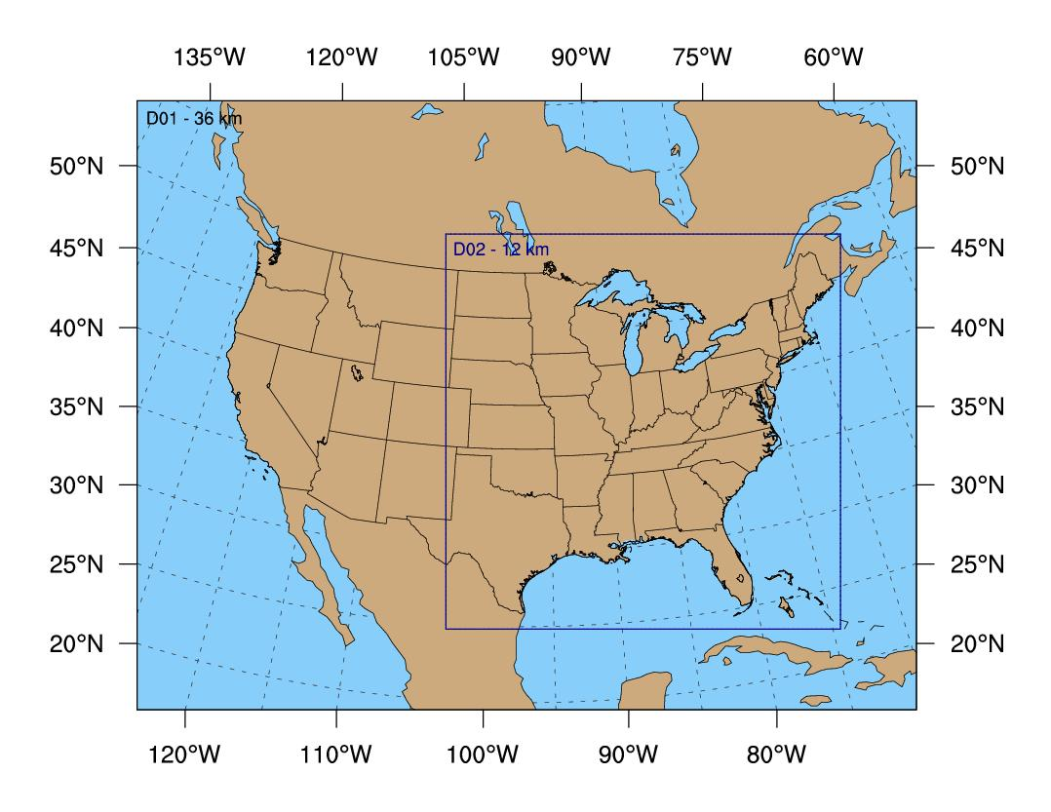
The figure illustrates the parts of the United States where the weather data were evaluated. Data are available for two areas, domain 1 and domain 2. The data from domain 2, while covering a smaller horizontal area, benefit from having a more realistic representation of the Earth’s surface.

Evaluation Period

Data for the Production Run was evaluated every day for the calendar year 2007. Analysis of Sensitivity Runs was carried out for two 20-day periods, 28 July-16 August (“Summer”) and 5-24 December (“Winter) during which air quality standards were exceeded across large parts of the region. Details of these two different types of runs follow later in this document.

Observational data and evaluation software

A set of observed weather conditions is required for comparison against the modeled weather data. A full year of observations in “prepBUFR” format was downloaded from the UCAR web server (http://dss.ucar.edu/datasets/ds337.0/). This quality-controlled dataset is used by the US government as input to its daily weather model runs. The evaluation software (available from dtcenter.org) is called WRF Model Evaluation Tools (WRF-MET) and was designed by the WRF developers specifically to evaluate their model using the prepBUFR observations.

Weather fields and error limits

Quantitative Assessment Metrics
Wind Speed | RMSE | ≤ 2 m/s
Wind Speed | Mean Bias | ≤ ±0.5 m/s
Wind Direction | Gross Error | ≤ 30 deg
Wind Direction | Mean Bias | ≤ ± 10 deg
Temperature | Gross Error | ≤ 2 K
Temperature | Mean Bias | ≤ ±0.5 K
Specific Humidity | Gross Error | ≤ 2 g/kg
Specific Humidity | Mean Bias | ≤ ±1 g/kg
The following six weather fields were evaluated by WRF-MET: temperature (degrees Celsius), dew point temperature (degrees Celsius), specific humidity (g/kg), relative humidity (%), wind speed (m s⁻¹), and wind direction (degrees). For eventual use in air quality models, errors in the atmospheric model forecasts ideally should be less than the guidelines provided by SESARM in the table. Gross Error is a measure of the overall magnitude of the errors and is thus always a positive number. RMSE means Root-Mean-Squared-Error and is similar to the Gross Error, except that it more heavily penalizes very large errors. Mean Bias indicates whether there is a chronic systematic error. For all of these measures, values near zero are desired.

Model fields and evaluation techniques

There were ten different sets of modeled weather fields: the year-long Production Run and nine Sensitivity Runs of 20 days each for the Summer and Winter Evaluation Periods. For each set of model data, AER carried out two different types of evaluations:

1) Subjective: AER closely inspected the details of how the model was run. This included reading the log files and input files that describe the choice of model parameters.

2) Objective: The WRF-MET software was applied to the model data and observations, and error statistics were computed and presented in the form of graphs and tables. WRF-MET carried out the initial steps to properly match in time the model data, which is on a grid similar in concept to the familiar latitude and longitude grid, while the observations mostly are measured at airport locations. These matched pairs of data were then combined, using the freely-available statistical analysis and plotting software called R, over many time periods (e.g., days and months) and then averaged over a selected set of states and Regional Planning Organization regions (RPOs) (shown in the accompanying map):

AL Alabama
AR Arkansas
DC District of Columbia
FL Florida
GA Georgia
IA Iowa
IL Illinois
IN Indiana
KY Kentucky
LA Lousiana
MD Maryland
MI Michigan
MS Mississippi
NC North Carolina
OH Ohio
PA Pennsylvania
SC South Carolina
TN Tennessee
VA Virgina
WI Wisconsin
WV West Virginia

MANEVU – ME, MA, VT, NH, NY, PA, NJ, MD, DE
CENRAPN – MN, IA, NE, KS, MO
CENRAPS – TX, LA, OK, AR
SEMAP (VISTAS) – VA, WV, KY, TN, NC, SC, GA, AL, MS, FL
MRPO – MI, WI, IN, IL, OH
FULL – entire model domain

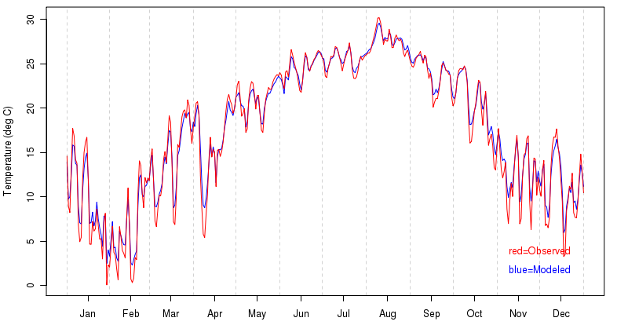
Results

Subjective
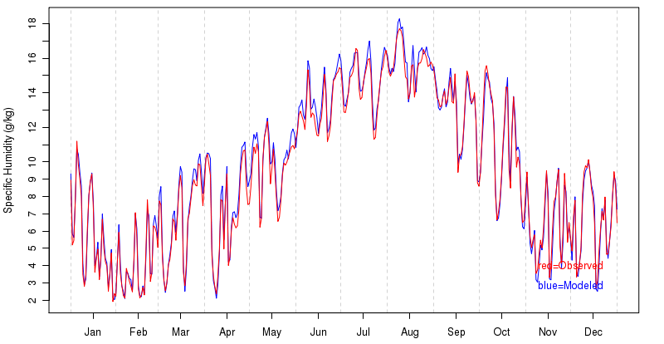
In our opinion, the WRF model configuration selected for the production run is acceptable for generation of meteorological fields to be input to air quality models. A reasonable mix of physics options and model configuration parameters were selected using an up-to-date release of the ARW-WRF model. The model configurations for the nine sensitivity runs were also set up correctly and spanned a sufficiently broad set of physics choices. Sufficient documentation was provided by SESARM to be confident that the WRF model was run in the manner designed and intended.

Objective statistical analysis of full-year production run

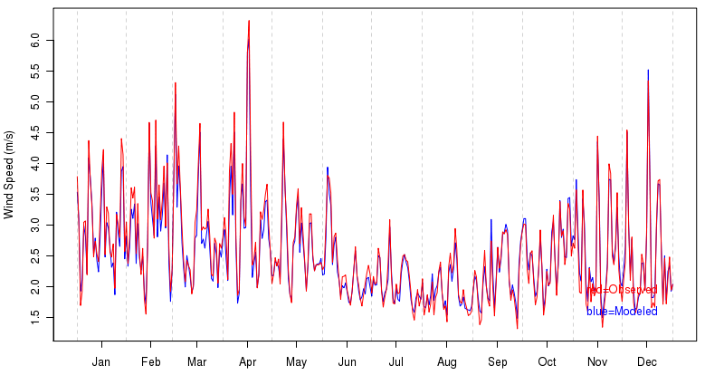
The three charts on the right for temperature, moisture and wind speed for states in SEMAP show the observed weather fields in red and the modeled fields in blue. As a broad summary statement, there is very good agreement.

Analysis of sensitivity runs

A similar subjective and objective analysis was carried out for the sensitivity runs. AER does not disagree with the process by which the “best” sensitivity run was selected. The model parameters used by this run generally produced modeled weather fields that exhibited some of the smallest errors. However, based on experience, clearly identifying a single model configuration that minimizes model error for all meteorological fields for large geographical areas and for long periods of time is frequently a difficult exercise. Analysis of the errors from the nine sensitivity runs presented to AER bear out the expectation that there is simply no clearly identifiable ‘best’ model configuration that minimizes errors in all fields for all times and in all regions.

Meteorological modeling website and data availability
The project web site (http://sesarm.aer.com) serves as the primary means for distributing and evaluating the substantial meteorological modeling results/summaries and communicating the corresponding documentation to SESARM. This web site satisfies the requirements for 'Task 5 Technical Meteorological Modeling Web Site' of contract S-2009-09-01. All content on this web site has been approved by the SESARM Project Officer prior to posting. The website presents objective evaluation results as itemized by Amendment 2 of the project Contract, signed 4 August 2011. All WRF-MET point_stat output files that represent the full set of hourly statistics files have been provided on an external drive to SESARM.

Summary and conclusions

Do the model results fit our conceptual understanding?

Meteorological fields generated during this modeling effort agree with our conceptual understanding of the physical processes of the atmosphere, and, as such, are generally representative of the observed weather conditions.

Are diurnal (i.e., day-to-night cycle) features adequately captured?

The WRF model adequately captures the diurnal cycle of temperature, moisture and wind.
Overall, though, forecast errors are minimized during periods when the surface winds are driven by the familiar transient low pressure areas. During spring and summer when strong sunshine causes warm air near the surface to mix up vertically above the surface, the model tends to underpredict surface wind speeds during the afternoon. However, this is a common model limitation and the overall effect on the value of the weather fields is relatively small.

Do the wind fields agree with the observations?

Overall surface wind fields are well-represented in the model and provide valuable estimation of the flow fields in the troposphere. Error values for wind fields well above the Earth’s surface far removed from the effects of complex land surface features were noticeably smaller.

Wind direction forecasts did not exhibit substantial biases, however, mean absolute errors for both domains were at or slightly above the critical threshold of 30 degrees. In combination, these two sets of errors suggest that the direction errors were somewhat random in nature, which is not unexpected when compared with other modeling studies.

Do the temperature and moisture fields generally match the observations?

Overall the temperature and moisture fields generally match the observations. Values of mean bias and gross error for temperature were at or below the critical thresholds.

Both mean bias and gross errors for specific humidity, a measure of the absolute content of the moisture in the atmosphere, were well within acceptable thresholds, even during the summer when levels of moisture in the atmosphere are significantly higher than in the cold winter months.

Do the meteorological fields produce acceptable air quality results?

AER recommends the future use of these WRF runs for the following reasons: 1) the fields were generated from the latest version of a state-of-the-art meteorological model, 2) proper configuration of the model was followed, 3) error magnitudes and patterns are consistent with those in the literature, and 4) there is an absence of obvious, profound, systematic modeling errors. Despite the broad recommendation, it is suggested that future users of subsets of these raw meteorological fields, and subsequent air quality fields, closely inspect the quality of the individual WRF runs, since the quality of any one run can vary considerably.

