4. Peril Analysis from Independent Data
4.1. Hail Analysis
The analysis of historical hail reports is problematic because of reporting `biases from population density and changing technology over time that makes it easier to report hail now than in the past. For these reasons, we chose the hail database of Changnon (2009) covering the period 1901 -1994, to examine long term trends in hail. The Changnon data base aggregates hail reports from ~1,100 stations in the US into the number of hail-days/month that are recorded at that location. In order to reduce the change of sampling over time, only those first-order reporting stations that had a complete record from 1901 to 1994 were chosen. (First-order reporting stations are those coincident with and operated by National Weather Service Offices.) These selection criteria resulted in 80 stations for further analysis.

Figure 4.n shows that he average number of days of hail per year experienced across the 80 selected stations is between 2-3 days/year. Over the period 1901-1994, the year-to-year variation in the average is less than +/-1 day and the mean value decreases slightly during the last 30 years of the record. The decrase in the average number of hail days/year between the last to 30-year periods is 0.5 days and this difference is significant at a confidence level of more than 99%.
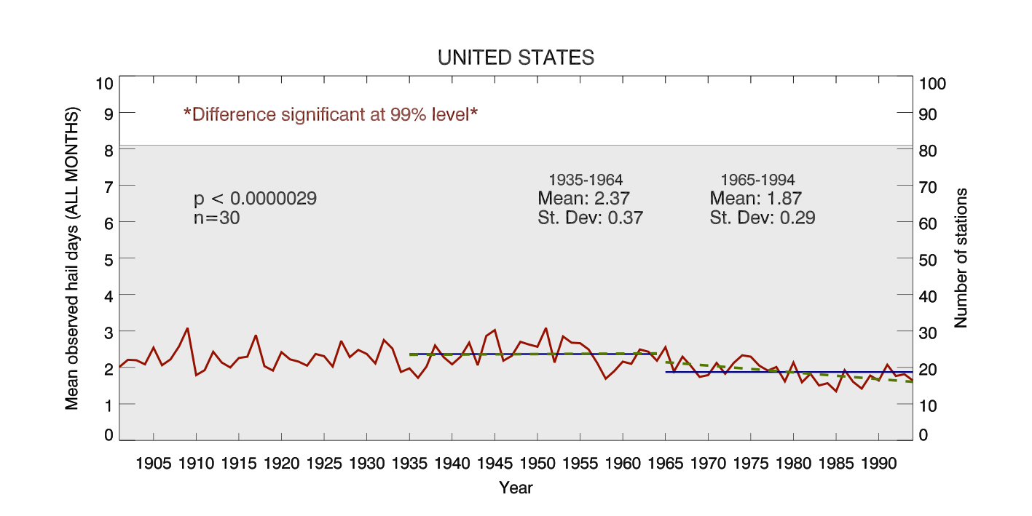
Figure 4.n Average number of hail days per year (red line, left axis) at 80 stations (gray shading, right axis) for the length of the Changnon hail data base, 1901 – 1994 (bottom axis). Mean values for the last two 30-year periods are shown as horizontal green lines. A best fit linear trend line is also fit through the last two 30-year periods (dashed green).

Figure 4.n+1 Definition of the states included in each of four US regions used to examine the regional behavior of hail-days from the Changnon data set.

The analysis is further broken down into four US regions. See Fig. 4.n+1 for the definition of the regions. Figures 4.n+2 and 4.n+3 are the same as Figure 4.n, but for the four, defined regions of the US. Each of the four regions show a modest decrease in the average number of hail-days per year over the last 30 years of the record, compared to the prior 30 year period. All of the decreases are significant within a confidence level greater than 99%.

The decreases in average number of hail days for all regions and the decrease in year-to-year variance in the last 30 years of the Changnon record are consistent with the idea of fewer overall severe weather days. The northeast drop from 1.32 to 0.69 days/year is the largest fractional decrease of any region. The decrease during the 1965-1994 period is consistent with a declining trend in hail environments detected during the same period (cf. Fig.3.5b). The large year-to-year variability in the US regional hail environments (cf. Fig,. 3.4) prevents a clear comparison between the Changnon results and other regions.

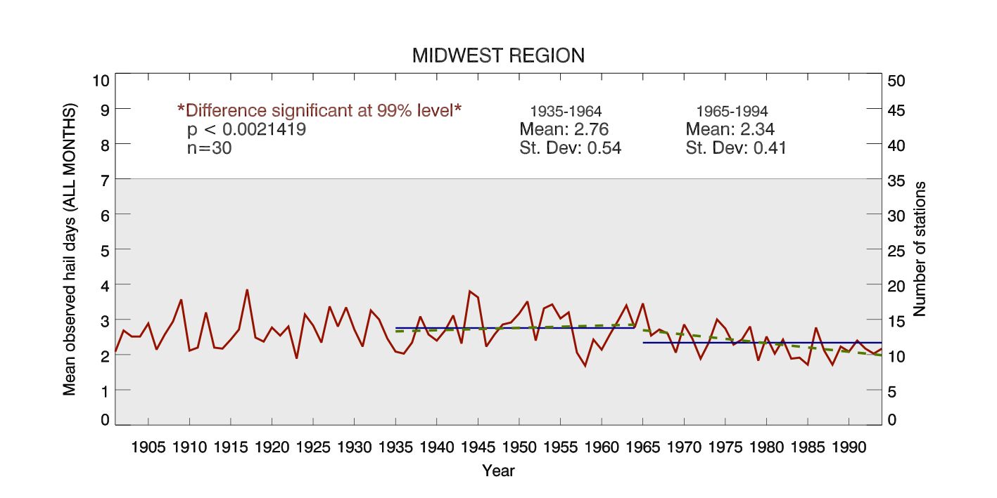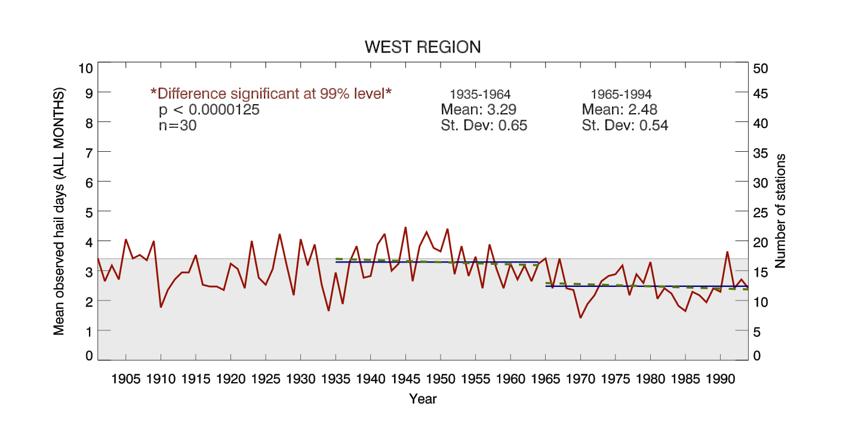
Figure 4.n+2 As in figure 4.n, but for the Midwest and West regions only.
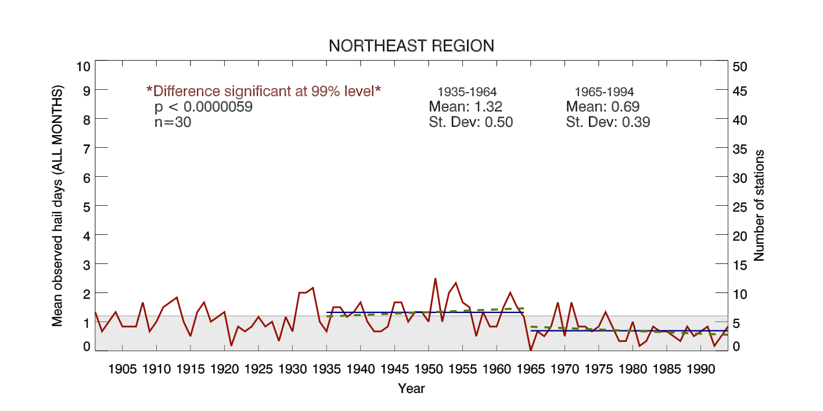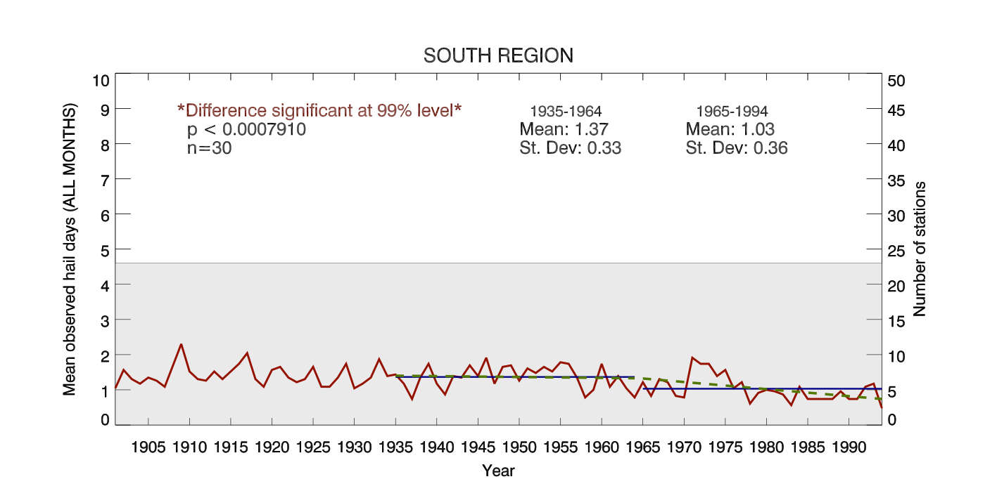
Figure 4.n+3 As in Figure 4.n, but for the Northeast and South regions.

4.2. Tornado Analysis

4.2.1. Literature Review
The starting point for analyses of tornado trends is generally a count of the number of tornadoes per year for the U.S. (in which the vast majority of all tornadoes occur). At first glance, the number of tornadoes reported per year has increased greatly over time (Talley, 2014; Diffenbaugh, Trapp, and Brooks 2008). However, this apparent increase has several sources of bias. For instance, in the U.S. colonial era, fewer tornadoes were reported simply because there were fewer settlers in tornado-prone areas (e.g, the Great Plains) to report them. Also, even in more recent times, smaller tornadoes may be underreported due to their smaller footprint and the smaller amount of damage that they produce.

For these reasons, the period over which tornado statistics may be reliably compared is relatively short, perhaps the last 50-60 years. Even over this short span, the total number of reported tornadoes has increased significantly. However, if the weakest (F0) tornadoes are excluded from the total, in order to reduce reporting biases in favor of more intense or destructive storms, the number has remained relatively constant (Doswell, 2007; Diffenbaugh, Trapp, and Brooks 2008).

Shifts in climate due to global warming may cause changes in tornado frequencies, intensities, or variability on the time scale of decades (Trapp, 2014). Such changes are thus far difficult to detect (Elsner, Jagger, and Elsner, 2011). However, some trends have been found. The interannual variation of tornado frequency has increased over the last 10 years (Thompson, 2014). The number of days per year on which tornadoes occur is decreasing, while the number of tornadoes on each of those days is increasing (Brooks, private communication). Also, some regions outside of the usual tornado-spawning grounds in the middle of the country, such as the Northeast (Talley, 2014) and Canada (Cao and Cai, 2011), are experiencing higher numbers of damaging tornadoes.

4.2.2. Tornadoes in the U.S.
Our analysis of tornadoes in the U.S. is based on the list of tornadoes at the NOAA Storm Prediction Center, covering the period 1950-2013. Figure 4.1 shows the plot of annual numbers of damaging tornadoes (F1-F5 intensity).

Figure 4.1: Annual number of tornadoes in the U.S. of intensity F1-F5 (red), using a 5-year running mean. The dashed lines above and below the red line show variations of one standard deviation.
When this is compared to our reanalysis results for the annual number of days of tornado environment, Figure 3.2b, several similarities are apparent:
- The amount of tornado "activity" has been fairly flat since 1960
- There was a rise in activity in the early '70s, and a smaller rise in the early '90s
- There was a very small variance in the mid-1990s, followed by a rise in variance from then to the present
These similarities give some encouragement that our reanalysis numbers are reflective of then frequencies of damaging tornadoes.

4.2.3. Tornadoes in Canada
There are far fewer tornadoes in Canada (perhaps 100/year) than in the U.S. Statistical analyses of Canadian tornadoes are also scarcer than studies of U.S. tornadoes. One paper by Cao and Cia (2011) of the province of Ontario showed that the numbers of tornadoes of all categories was slowly increasing, by about 1.6 tornadoes per decade. This trend persisted when the authors excluded the weak F0 category, in order to minimize reporting bias.

In order to compare their results to ours, we smoothed the data from Cao and Cia Figure 3 using a 5-year running mean (see Figure 4.2, below). Note the small number of tornadoes per year, leading to large variability most years.

Our regional results for frequencies of tornado environments, given in section 3.2.2, are not directly comparable to this plot, since Ontario is split between two Canadian regions. Therefore, in Figure 4.3 we plot the frequencies of tornado environments for just Ontario. Comparing Figures 4.2 and 4.3, we see that the trend of tornado “events” are both relatively flat. However, they both show a minimum around 1990, followed by a sharp rise.

Figure 4.2: Annual number of tornadoes in Ontario of intensity F1-F5 (red), using a 5-year running mean (from Cao and Cia, 2011, Fig. 3). The dashed lines above and below the red line show variations of one standard deviation.

Figure 4.3: Annual number of days of tornado environments in Ontario (red), using a 5-year running mean. The dashed lines above and below the red line show variations of one standard deviation.

References:
Changnon, S. A., D. Changnon, and S. D. Hilberg, 2009: Hailstorms Across the Nation: An Atlas about Hail and its Damages. Published by the Midwestern Regional Climate Center. 92 pp.

